03-WORD-document

Jim Coen

5/5/2020

## R Markdown

This is an R Markdown document. Markdown is a simple formatting syntax for authoring HTML, PDF, and MS Word documents. For more details on using R Markdown see <http://rmarkdown.rstudio.com>.

When you click the **Knit** button a document will be generated that includes both content as well as the output of any embedded R code chunks within the document. You can embed an R code chunk like this:

head(cars) # %>% kable()

|  |  |
| --- | --- |
| speed | dist |
| 4 | 2 |
| 4 | 10 |
| 7 | 4 |
| 7 | 22 |
| 8 | 16 |
| 9 | 10 |

## Including Plots

You can also embed plots, for example:

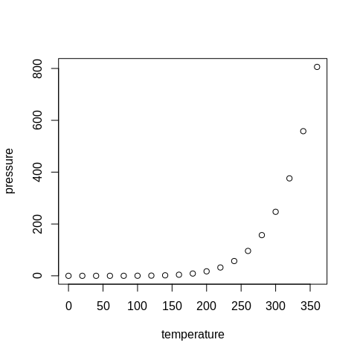

Note that the echo = FALSE parameter was added to the code chunk to prevent printing of the R code that generated the plot.