Instructions for this lab

(JAVA):

Simply open your intellij and open the project.

Run the server on tomcat

Inside of the JAXClient folder, Run 

Follow the instructions given inside the console and enjoy.

(C#)

I will assume you have visual studios 2010….

If not ….go download it please.

Once visual studios 2010 is download, click on the folder “ C#ClientCode”

Inside will be a folder name “jcoleman_Lunch”

Double click “jcoleman_Lunch.sln” file

At this point the project is now open and you can see the client code.

IMPORTANT PART: Follow the Instructions for (JAVA) and stop after you have done the instructions of “Run the server on tomcat”. Without the server running, you cannot get the information you need to run the client. It will also pop a host error saying it can’t find the endpoint I believe.

Next, once the server up and running on intellij or whatever platform you are using for java, there should be a Green Arrow.

If you can’t find the green arrow, check out the picture below

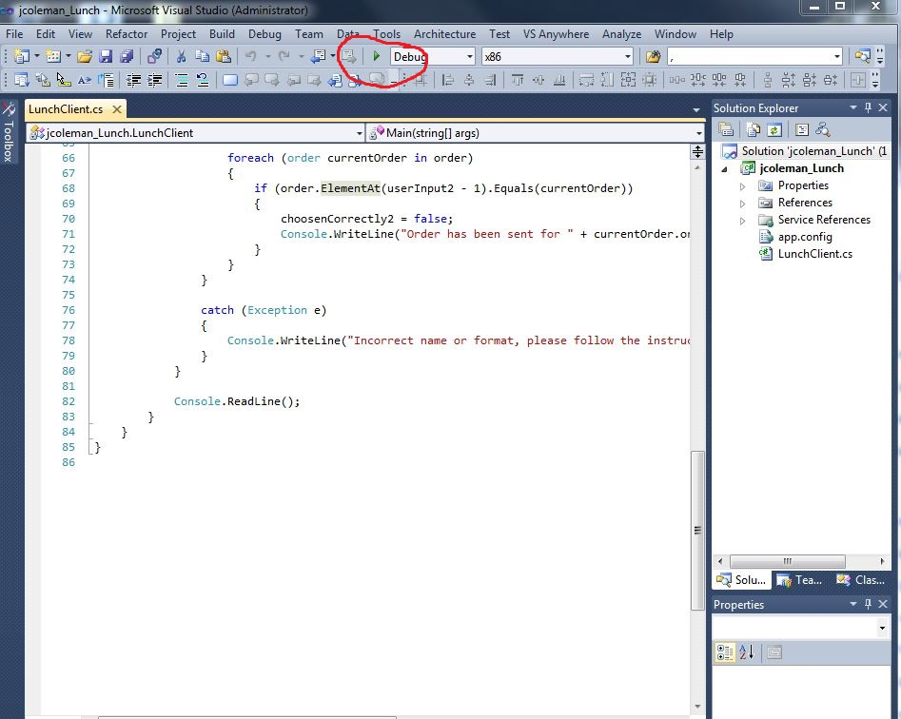

Once you see the green arrow, click it and you should be able to do the same/similar client to the one in the Java client.

If there is any trouble with the instructions or feel that it is not enough information or just something isn’t clear, feel free to contact me at [jcoleman@student.neumont.edu](mailto:jcoleman@student.neumont.edu)

Thank you.