Justin Li

4/6/21

Lab 1

#### COEN 146L: Computer Networks Lab

**Lab 1: Unix/Linux Commands and Overview of C Programming**

Step 3: We get a segmentation fault after running off the default delay (1 ms).

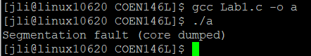

Step 4:

When running at 500, the text runs much quicker and is more jumbled and out of order, while at 5000, it runs much slower and the order seems to remain more intact.

500:

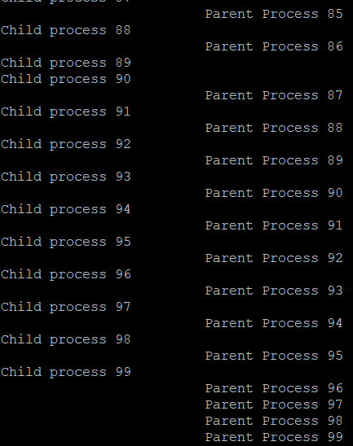

5000:

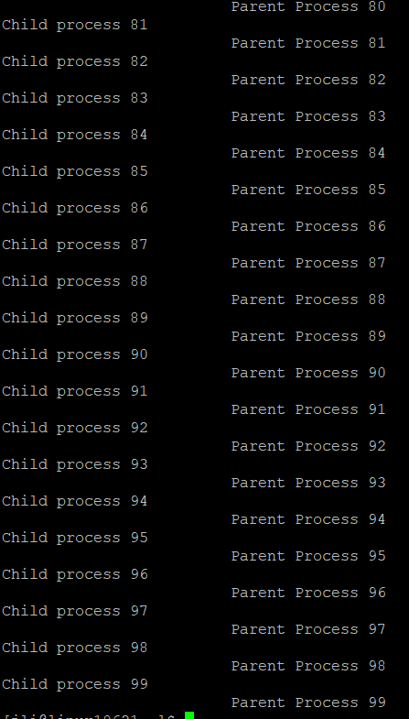

Q5:

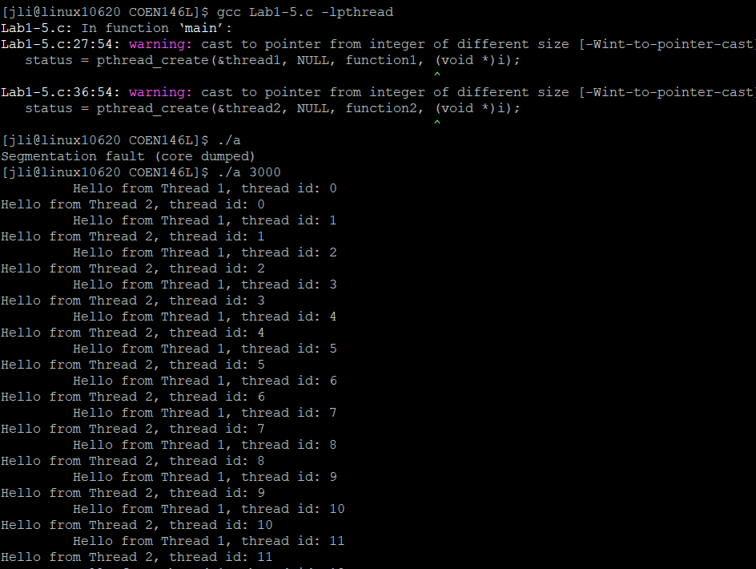

Q6:

