Justin Li

4/14/21

Lab 2

#### COEN 146L: Computer Networks Lab

**Lab 2: Multithreading in C and File transfer**

Step 1 & 2:

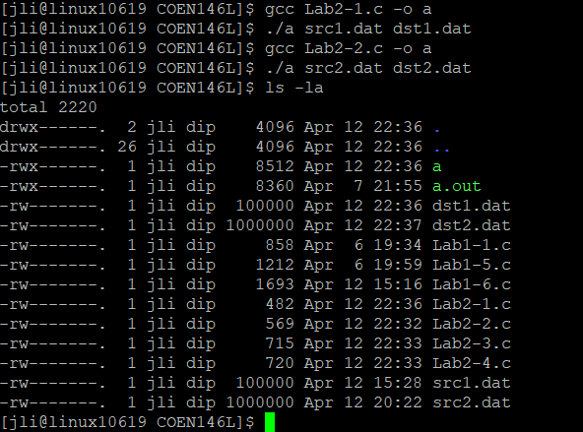

Step 3:

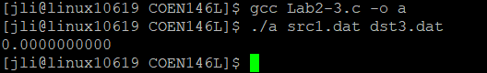

Step 4:

