Justin Li

4/21/21

Lab 3

**COEN 146L: Computer Networks Lab**

**Lab 3: Network commands and HTTP**

Step 1:

* 1. netstat: displays the contents of network interfaces, with – a option, the command displays the state of all active sockets (more to come on sockets as end points of communication). With – r option, the routing table is displayed. Please type man netstat to learn about all options.

Displays many streams, shows active internet connections

Netstat by itself doesn’t show servers

Netstat -a displays active connections with servers established

Netstat -r displays kernel IP routing table

* 1. ifconfig: configures network interface parameters. With – a option, the state of all interfaces are displayed. Other options are also used to assign a new IP address to an interface, to assign a new network mask for an interface, to disable an interface, and more. Please type man ifconfig to learn about all options.

Shows either connection with ethernet or internet, giving IP and mac addresses, as well as packet and error info.

* 1. hostname: displays and sets hostname of the system. Please type man hostname to learn about all options.

The hostname is linux11121.

* 1. ping: sends ECHO_REQUEST datagram to a network host using ICMP protocol to elicit an ECHO_RESPONSE from the host or gateway. Please type man ping to learn about all options.

Simply provides usages for ping and ping -6.

* 1. traceroute: displays the route packets trace to a network host using IP protocol “time to live”. Please type man traceroute to learn about all options.
  2. telnet: remote connection to server at a specific port (mainly 80 – http port)

connected to “telnet> ”

has many commands, such as display, open, set, toggle, quit, etc.

* 1. host/dig: performs DNS lookups.

Host provides multiples options.

Dig provides a question, answer, and additional section.

* 1. route: manipulates network routing tables.

Route, just like netstat -r, provides the kernel IP routing table, which includes destination, gateway, genmask, flag, metric ref, use , and Iface columns.

* 1. arp: displays and modifies the Internet-to-Ethernet address translation tables used by the address resolution protocol.

Displays multiple addresses from the SCU engineering department, with all HWtypes of ethernet and with many different HWaddreses. They all have flags of C and Iface eht0.

Step 2:

NA host:

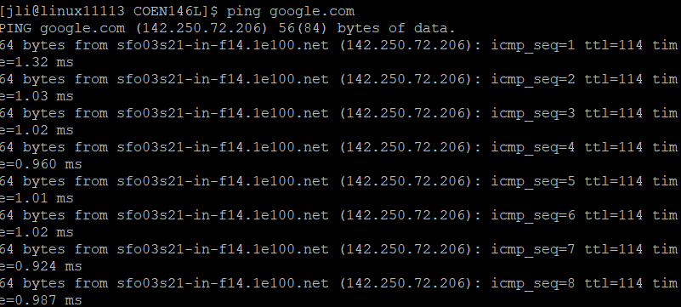

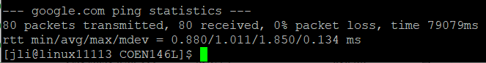

EU host:

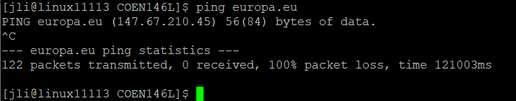

Asia host:

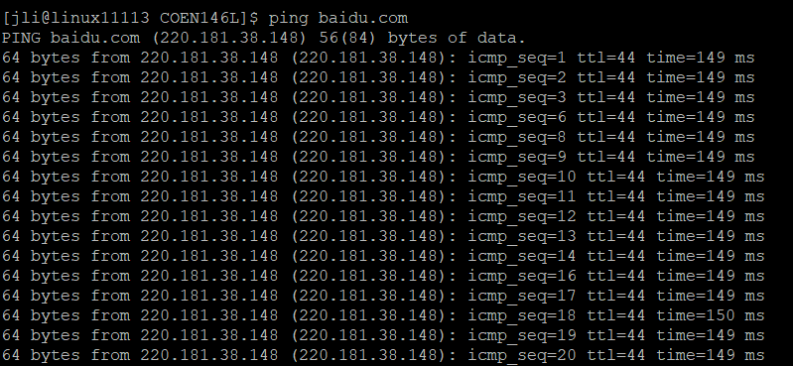



The packet loss was obviously a lot higher for hosts that were outside of NA, having 0% here, 26% from Asia, and even 100% for Europe. Additionally, the time for each packet took much longer for Asia compared to the NA host, as seen in the rtt stat differences.

Step 3:

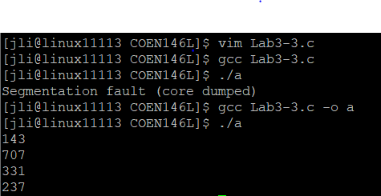

Step 4:

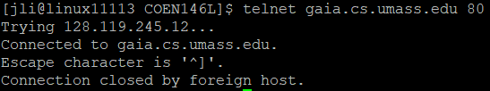

a) It tried connecting to the IP address, then connected the web server. After about a minute of being idle, a foreign host disconnected me.

b) I connected to the server, then was able to see the file HTML content from the web page.

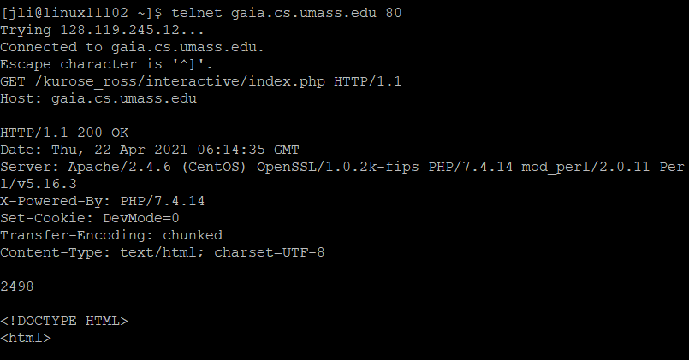

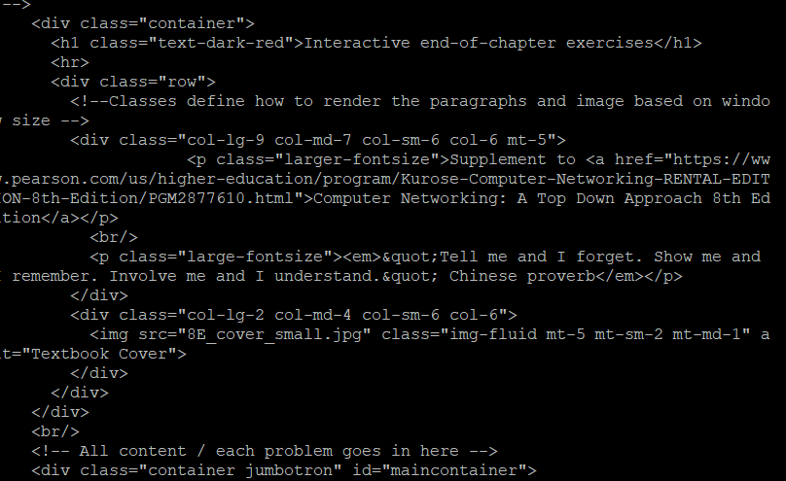

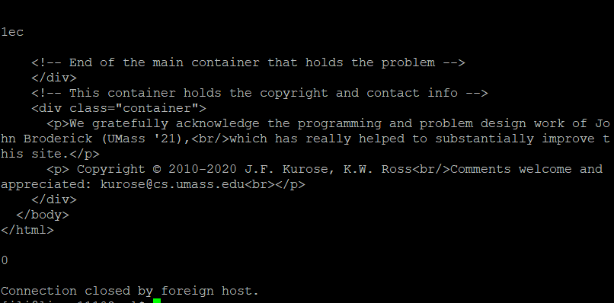

c) The name of the file that is being retrieved is /kurose_ross/interactive/index.php

The version of HTTP the client is running on is HTTP/1.1

The text is in the format of a title, header, and paragraph, all in HTML code.

There is an image in .jpg format as well.

Step 5:

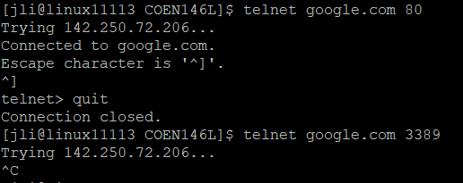

NA Connected with Port 80, not 3389

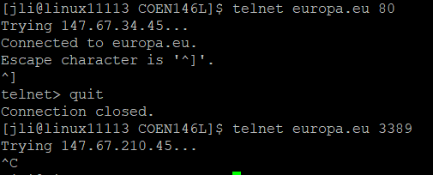

EU Connected with Port 80, not 3389

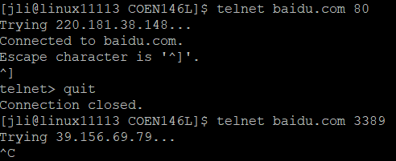

Asia Connected with Port 80, not 3389