Justin Li

1/7/21

Lab 1

Pic of Code: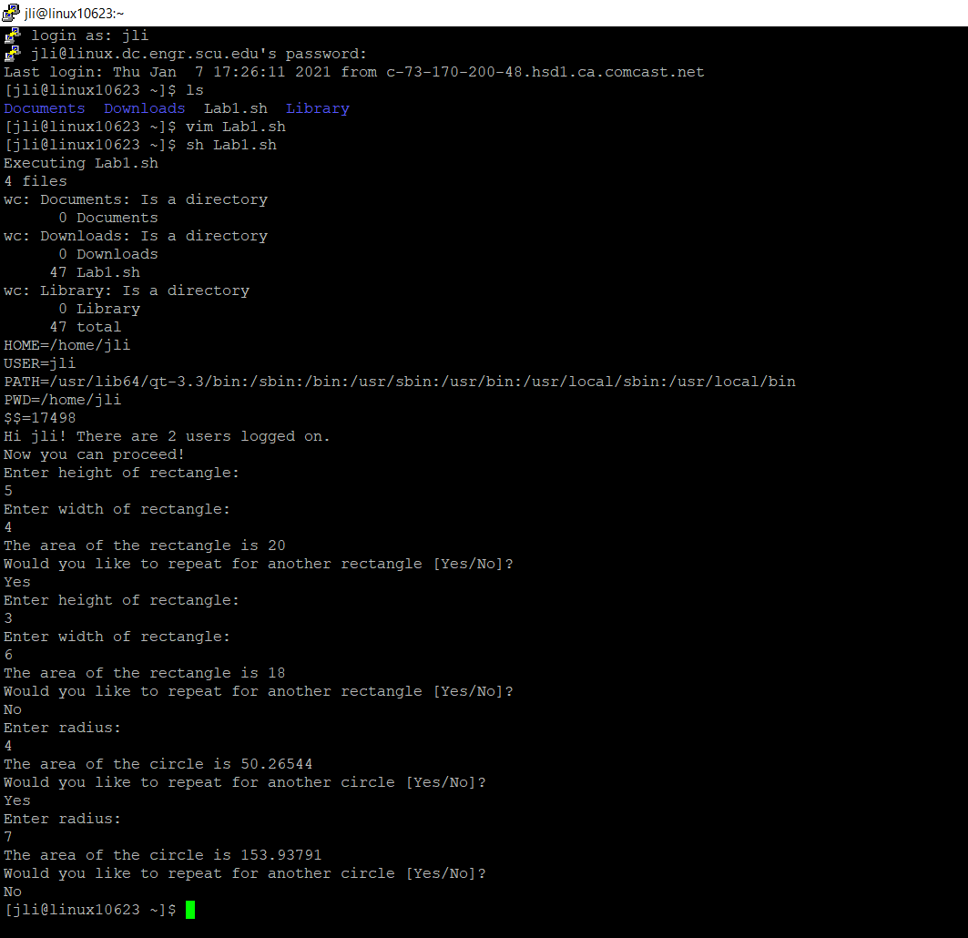

Observations:

The program starts by stating that it is being executed, tells how many files are in the account, tells whether they are a directory, gives the amount of lines per directory, and sets the different variables relating to my account. Then, it recognizes that I’m the logged in user, and tells how many total users are logged on, and lets me proceed. It asks me the height and width for a rectangle, and calculates its area. Then, I added on the same procedure for calculating the area of a circle, and ends afterwards.