Justin Li

1/7/21

Lab 2

Q3:

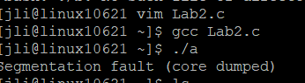

We get a segmentation fault after running off the default delay (1 ms)

Q4:

When running at 500, the text is a lot more jumbled and out of order, while at 5000, the order seems to remain more intact.

500:

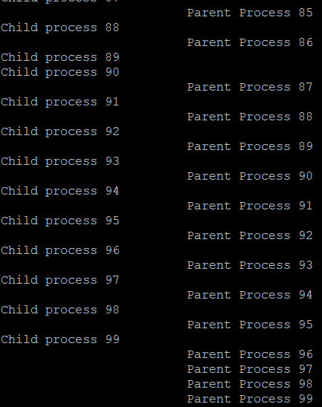

5000:

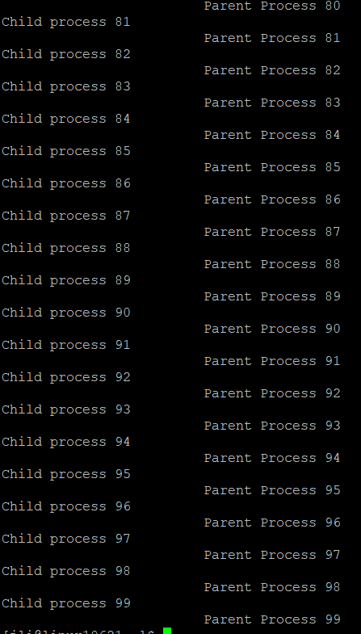

Q5:

