Justin Li

1/31/21

# Lab 3 - Pthreads and inter-process Communication – Pipes

Q1:

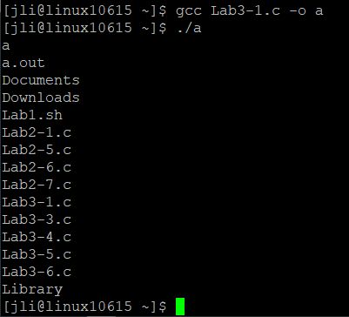

Q2:

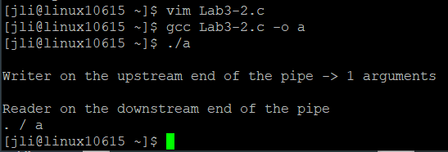

Q3:

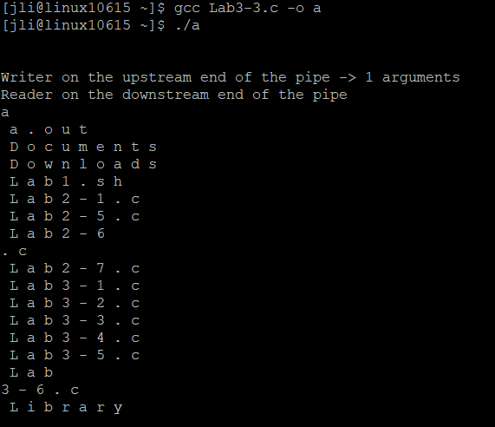

Q4:

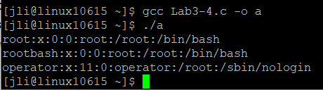

Q6:

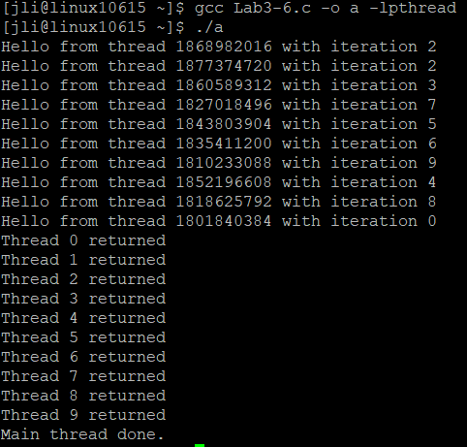

10 threads are created, with the values 0-9 being passed for i. However, they seemed to print out in a random order, and iteration 2 repeated twice.