Justin Li

2/11/21

**Lab 5: Synchronization using semaphores, lock, and condition variables**

Step 1:

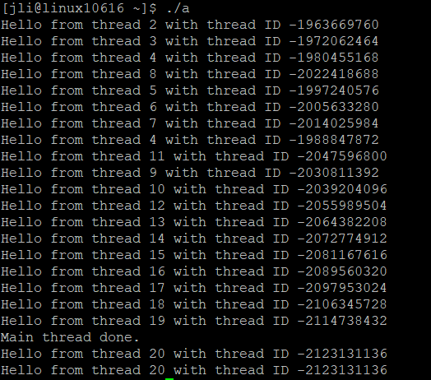

There is still the issue of when “Hello from thread 20…” gets printed twice after main thread done. However, the main difference between this code and the threadHello.c program is that threadHello did not have critical sections to protect when a thread was able to enter them, while the threadSync program has critical sections to protect threads.

Step 2:

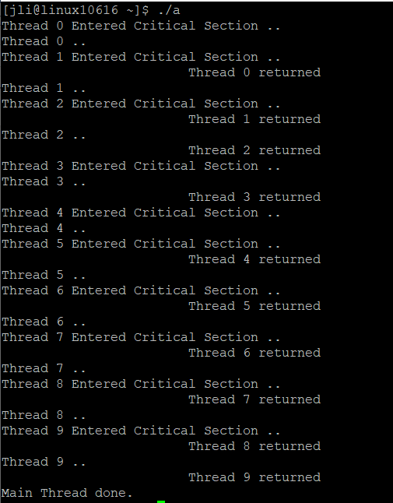

Step 3:

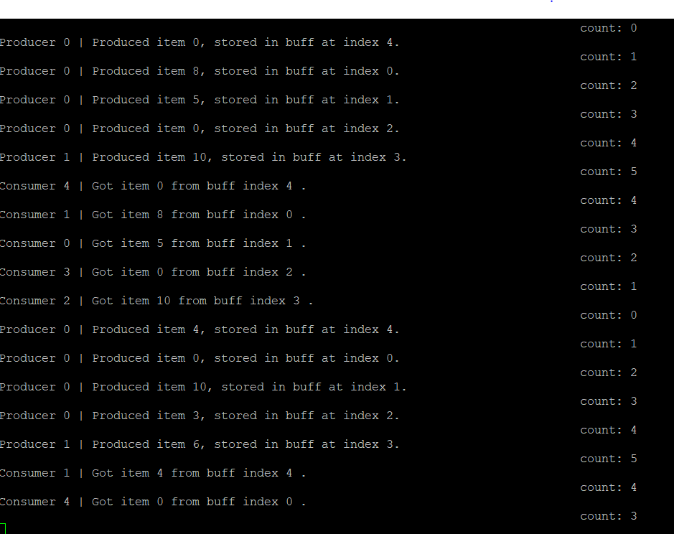

Step 4:

