**FIT3179 Data Visualization Week 9 Homework**

Name: Yuanji Jin

Student ID: 31942075

Studio: 20

Tutor: Vahid Pooryousef

https://jjdull.github.io/FIT3179/

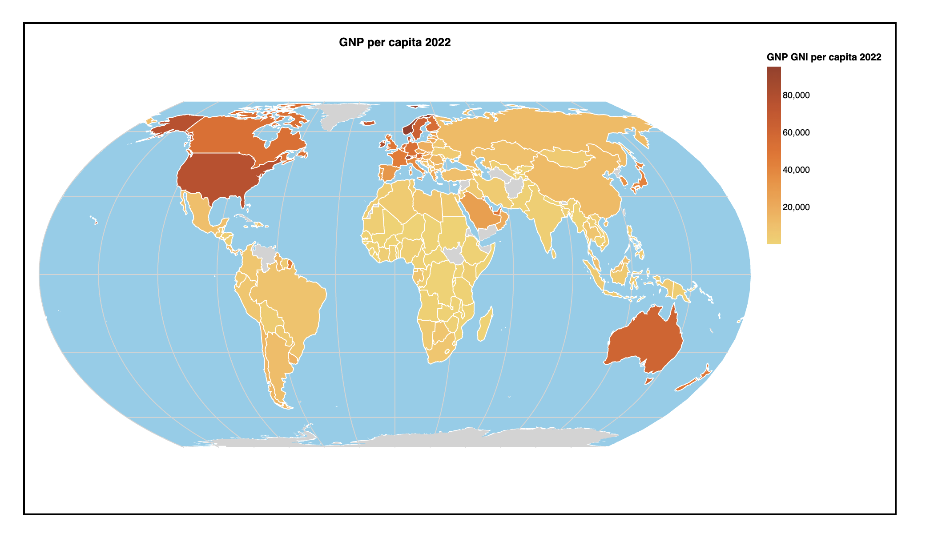

Data Source: <https://data.worldbank.org/indicator/NY.GNP.PCAP.CD>  
  
Type: Tabular data.

Attributes:

Country Code: Categorical identifier.

GNP per Capita (2022): Quantitative and ordered.

Longitude, Latitude: Quantitative and ordered

Data Transformation: Extraneous columns removed to focus on 2022 data.

Map Idiom: For comparing GNP per capita across Countries, a Choropleth map is ideal due to its proficiency in showcasing quantitative data at a countrywide scale. In contrast, proportional symbol maps excel in displaying quantitative metrics at pinpointed geographic locales, like cities or regions.