Main window

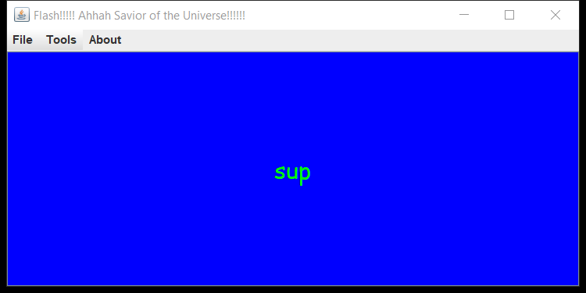

File bar has open deck, new deck, edit deck and exit. Open deck will update with no user input other then making a new file using the file name scheme

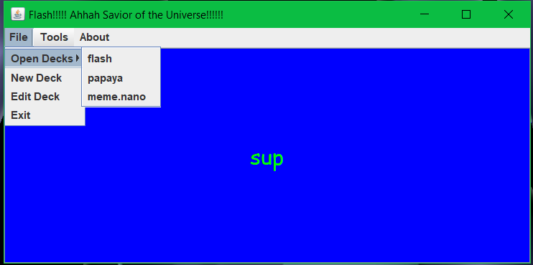

Under tools to randomize the cards Alphabetize the cards and options

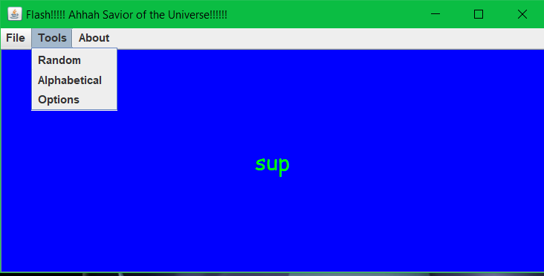

Clicking about pulls a joptionpane

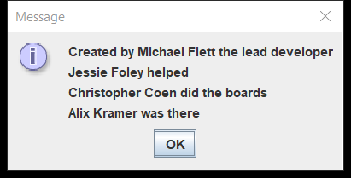

The options in tools opens a new frame to edit font, font size, font color, and card color

Clicking apply will write to a file and then the main frame will read and change settings based off the user input

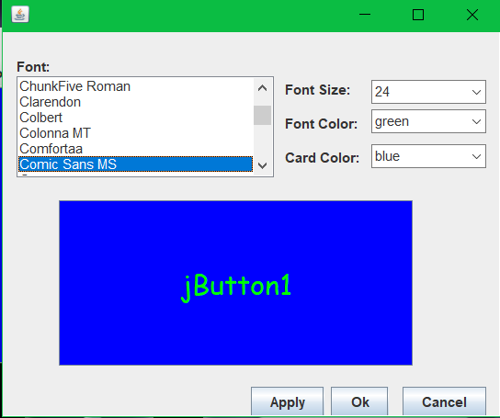

Under file, new deck opens another frame where you can add up to 1000 cards. Open decks will auto update with the new file

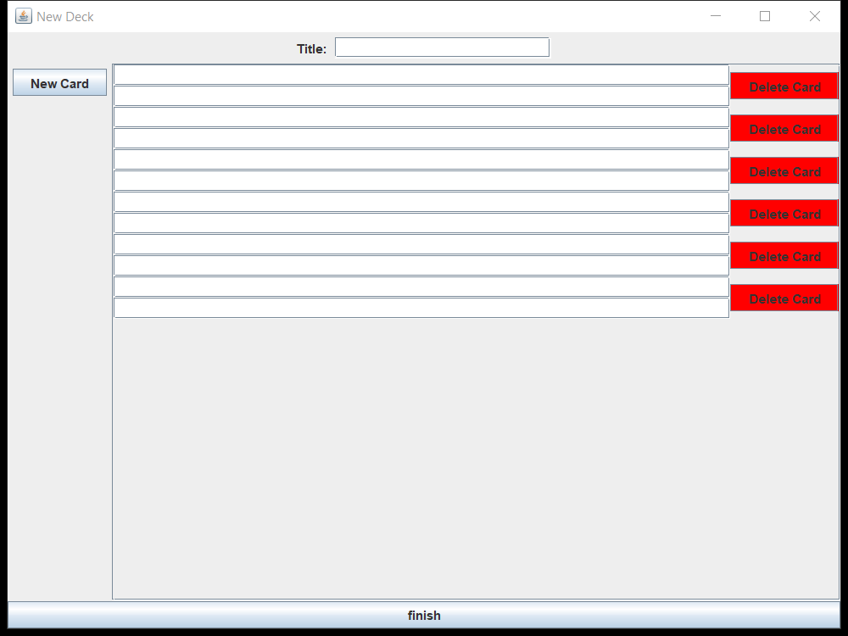

Edit deck is for if you want to have hit 1000 cards somehow and want to add more. It opens the csv in your default csv editor