Title:

PRO:Login functionality not available for UK and DE sites

Description:

When open our site https://www.manomano.co.uk/ or german version https://www.manomano.de/ no "PRO:Login" functionality is showed at top section of the page. On the other hand for italian https://www.manomano.it/, french https://www.manomano.fr/ and spanish version https://www.manomano.es/ it is showed.

Evidences:

- UK site
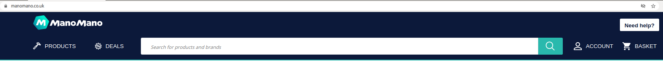
- German site
- French site
- Italian site
- Spanish site

Expected:
Really I don’t know if this is a bug or is a desired behavior, but I’m my opinion it seems a functionality that platform offers to Professionals in order to have some advantages, and should be available at any country that ManoMano is present.

Steps to reproduce:
- Access to different country sites:
- https://www.manomano.co.uk/
- https://www.manomano.de/
- https://www.manomano.fr/
- https://www.manomano.it/
- https://www.manomano.es/

Environment:
Browser: Chrome Version 90.0.4430.93 (Official Build) (64-bit)
OS: Ubuntu 18.08
Severity:
Medium
Priority:
High

