- 데이터설명 : sleep.csv (sampling data from NHANES(U.S National Health and Nutrition Examination Survey data)) We’d like to have classification model for Sleeptrouble (Yes, No).

Age : in US dollars
Gender : female, male
Poverty : A ratio of family income to poverty guidelines. Smaller numbers indicate more poverty
Depressed : Most, None, Several
BMI : Body Mass Index (체질량지수, weight/height2 in kg/m2)
PhysActive : Yes, No (Participant does moderate or vigorous-intensity sports, fitness or recreational activities)
SmokeNow : Yes, No
AlcoholYear : Estimated number of days over the past year that participant drank alcoholic beverages
SleepHrsNight : 수면시간
Sleeptrouble : Yes, No (target variable)

  - (3pt) About data summary :
How many observations? How many factor variables? How many continuous variables (including integer & numeric variables)?
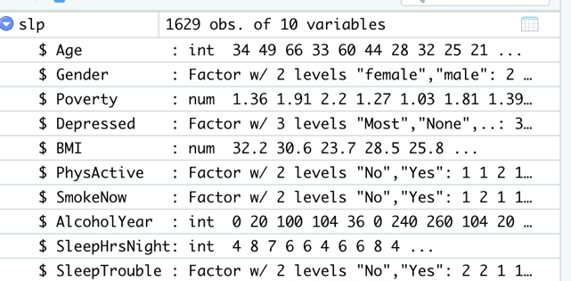
1629 observations and there are 5 factor variable, and there are 5 continuous variable.

1.2 (4pt) Split Train/Test data with 7:3 proportion (seed number 1000), Try logisitic regression. Report important(significant) variables (α=0.05) with output attached. Interpret the coefficients for Gender.
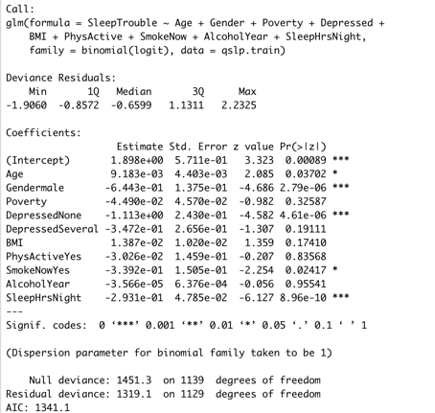
As the p-values of the Gender variable is less than 0.05, Gender variable is insignificant in the logistic regression.

1.3 (3pts) Draw some graphics to find out the relationship between Sleeptrouble and Gender. Inperpret.
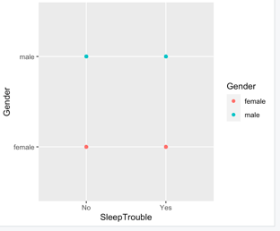
There is no relation between Gender and Sleeptrouble.

  - (4pts) Compare the performance for SVM(using RBF kernel) and logistic regression (the output for 1.2). Report accuracy, sensitivity, specificity for test data set.
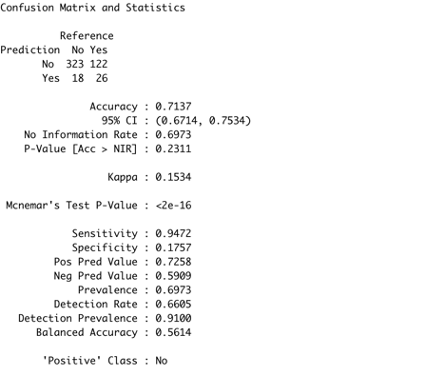
Accuracy = 0.7137 / Sensitivity 0.9472 / Specificity : 0.1757

  - (4 pts) Do random forest with ntree=20, mtry=3). Compare with 1.4 results. Which one is better? How about variable importance? Is the same with logistic regression?
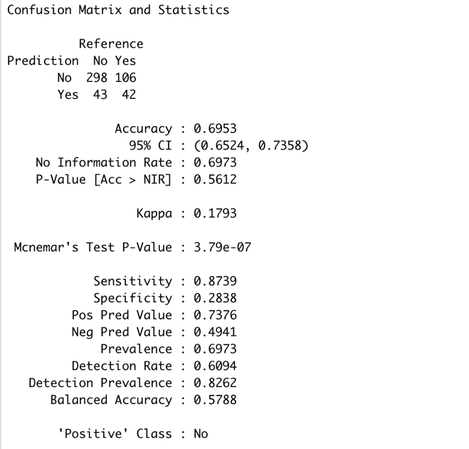
Accuracy = 0.6953 / Sensitivity 0.8739 / Specificity : 0.2838
SVM’s Accuracy is more bigger than Random Forest, so In Accuracy SVM is much better.
Variable importance is different with other regression.
Not same with logistic regression
- 데이터설명 : wine data (wine_binary.csv, this data is same data set in your project)
fixed acidity : 주석산 농도, volatile acidity : 아세트산 농도
citric acid : 구연산 농도, residual sugar : 잔류 당분 농도
chlorides : 염화나트륨 농도, free sulfur dioxide : 유리 아황산 농도
total sulfur dioxide : 총 아황산 농도, density : 밀도
pH: , sulphates : 황산칼륨 농도
alcohol : 알코올 도수
Output variable (based on sensory data):
quality (0, 1 ) p.s : original scale 1-10, classification을 위해 5->0, 7->1로 변환)

2.1 (5 pts) Do k-means with this data excluding ‘quality’ variable. (attach your R code for data handling and clustering)
wine <- read.csv("wine_binary.csv", stringsAsFactors = TRUE)
wine[,'quality'] <-as.factor(wine[,'quality'])
attach(wine)
table(quality)
str(wine)
set.seed(1000)
dat1<-wine[ , -12]
#km <- kmeans(dat1, 5, nstart = 25)
km <- kmeans(dat1, 3, nstart = 25)
km
km <- kmeans(dat1, 3, nstart=10)
km
km <- kmeans(dat1, 3)
km
pam_out <- pam(dat1, 3)
install.packages("factoextra")
library(factoextra)
library(ggplot2)
fviz_cluster(km, data = dat1, ellipse.type="convex", repel = TRUE)
fviz_cluster(pam_out, data = dat1, ellipse.type="convex", repel = TRUE)

What is the optimal k for this data? Depending on your optimal k, do clustering. For the information of centers for each cluster, try to interpret (which variable has big difference between cluster? Remark briefly)
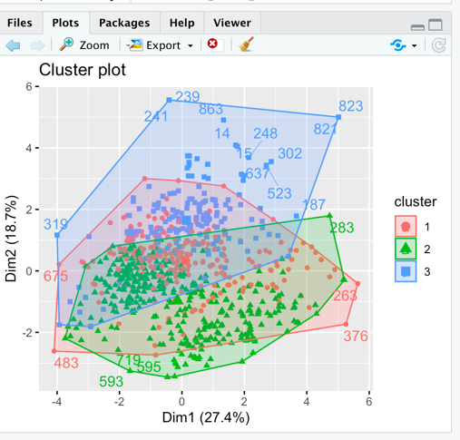
K is 2

- 다음 문항에 대해 답하시오.
3.1 (2pt) 다음 중 옳지 않은 설명을 고르시오. (2점)
(1) 다중회귀모형에서 다중공선성이 존재하는 경우 회귀계수의 분산이 커지고 예측정확도가 불안정하다.
(2) 교차검증(cross-validation)을 통해 과적합 문제를 방지할 수 있다.
(3) 100개의 데이터로 5-fold cross-validation 시 학습 데이터는 25개이다.
(4) 서포트벡터머신 수행시 데이터특성에 따라 선형/비선형 커널을 적용할 수 있다.
3번 (80/20으로 나뉨)

3.2 (2pt) 다음 중 옳지 않은 설명을 고르시오. (2점)
(1) 오분류율은 (잘못 분류한 개체 수)/(전체 데이터 수)*100이다.
(2) 의사결정나무 가지치기 할 때 , 복잡도계수 값이 최대가 되는 노드 수를 선택한다.
(3) 랜덤 포레스트는 앙상블 기법을 사용하여 의사결정나무의 과적합 문제를 개선한 알고리즘이다.
(4) 서포트벡터머신은 커널함수에 따라 성능이(분류정확도) 달라진다.
2번

3.3 (2pt) 3-fold cross validation에 대해 설명하시오.
말 그대로 교차 타당성을 검증하는 것으로 특징은 3등분을 하여 데이터를 나눈다는 것이 특징이다. 예를 들어 n=30 이라고 하면 30을 3등분으로 나누어 내고 여기서 2등분은 학습데이터로 예측모형을 만들고, 나머지 1등분은 데이터로 검증하는 것을 나타낸다.

