1.데이터설명 : diamonds.csv

A dataset containing the prices and other attributes of almost 54,000 diamonds.

price : in US dollars (326-18823)
carat : weight of diamonds (0.2-5.01)
cut : quality of cut (Fair, Good, Very good, Premium, Ideal)
color : from D(best) to J (worst)
clarity : how clear the diamonds is (I1(worst), SI2, SI1, VS2, VS1, VVS2, VVS1, IF(best))
x : length in mm
y : width in mm
z : depth in mm
depth : total depth percentage = z / mean(x, y) = 2 * z / (x + y) (43–79)
table : width of top of diamond relative to widest point (43–95)

  - (3pt) About data summary :
- How many factor variables?
0 variables

- what is mean of diamond price? (3933), In what clarity is the most closest one of the total mean of diamond price?
3932.8,

1.2 (4pt) Draw the histogram for price & carat. Draw the boxplot for price & carat
(give different colors for each variables, and give ‘Title’ on each histogram, 2 plot in 1 page, par(mfrow=c(1,2)). set width of boxplot=0.5)
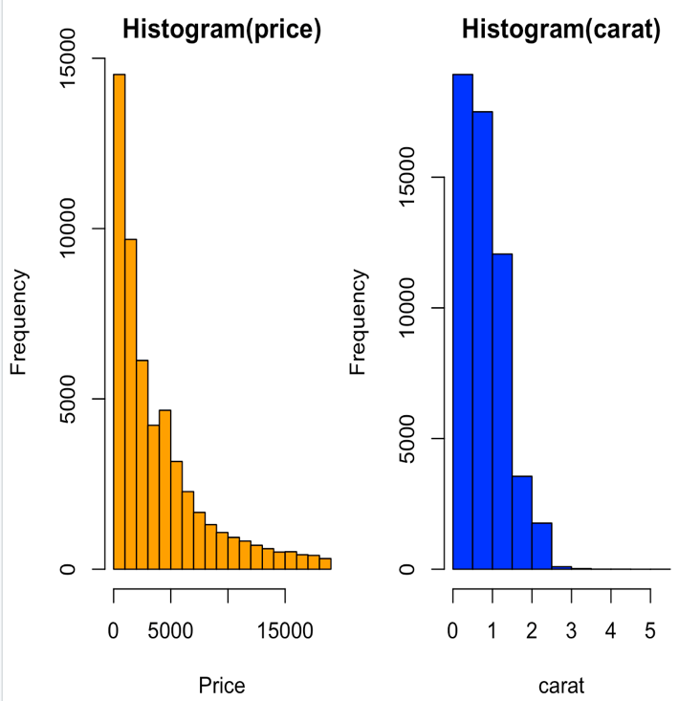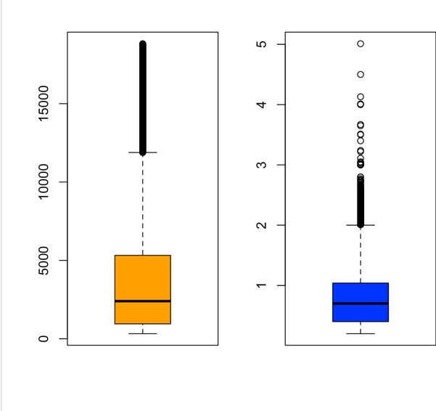

What interpretation you can give? (Write some comments with 4 plots. You may use summary statistics, too)
price가 올라갈수록 양은 적어진다는 것을 볼 수 있었고, carat도 커질수록 양이 적어진다.
median은 각각 5000이하, 1이하로 생긴다는 것을 알 수 있었다.

  - (3pt) (using ggplot : geom_boxplot)
Draw boxplot of price by cut, write some comments for it. If any idea for improvement for that plot, tell your idea.
ggplot

  - (8pt) Do data filtering using dplyr library, and execute the following
- (1pt) Make another data set with clarity (I1, SI1, VS1) : filter(clarity=="I1" | clarity=="SI1" | clarity=="VS1")

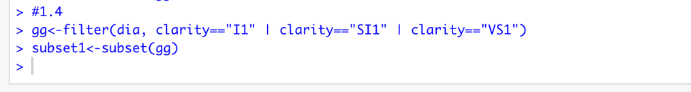
- (2pt) Do linear model between price and carat. Report R² and interpret your regression model about(R², coeff..et al)
0.851
8.51%정도의 설명력을 가지고 있다. 회귀식에 의해서 예측 적합도가 떨어지는 편이다.

- (2pt) Make data set with clarity=SI1 only and do regression between price and carat. What difference you can see with (2)? How interpret?
0.9167
91.67%의 설명력을 가지고 있다. SI1만 보았을 때, 회귀식을 이용하면 price와 carat의 선형모델 예측 적합도가 높은편이라고 할 수 있다.

- (2pt) For data (3), ggplot scatterplot, interpret for it.

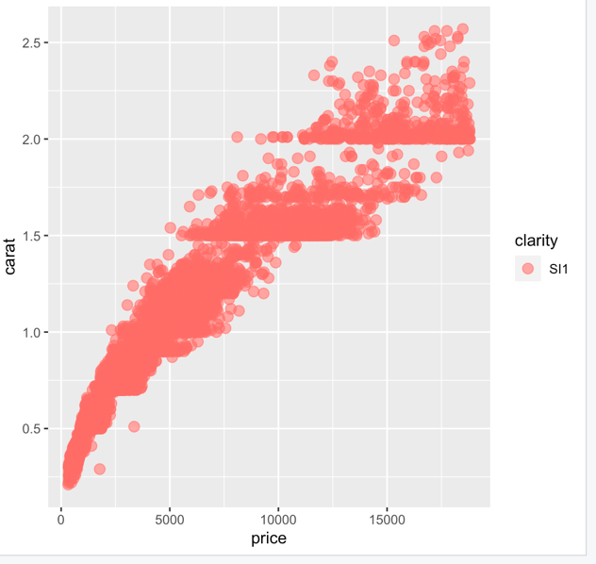
마찬가지로 3번에서 언급했듯이 설명력이 91.67으로 거의 linear 한 형태를 가지고 있어 linear model을 이용하여 price나 carat을 이용하여 거의 정확한 예측과 추정을 할 수 있다.
- (1pt) For data (3), report correlation between price and carat (four decimal points).

0.9574

2.데이터설명 : USecon.csv : 1960년 미국인구 센서스조사 데이터, State expenditure관련데이터.
EX : State의 공공지출($) YOUNG: 5-19살의 인구비율
ECAB: 경제능력 지표 OLD: 65살 이상의 인구비율
MET : 대도시 지역에 사는 인구비율 WEST: 서부(1) or 동부(0)
GROW: 1950~1960년 대의 인구 증가비율 STATE: 주의 이름

EX: Per capita state and local public expenditures ($)
ECAB: Economic ability index, in which income, retail sales, and the value of output (manufactures, mineral, and agricultural) per capita are equally weighted.
MET: Percentage of population living in standard metropolitan areas
GROW: Percent change in population, 1950-1960
YOUNG: Percent of population aged 5-19 years
OLD: Percent of population over 65 years of age
WEST: Western state (1) or not (0)
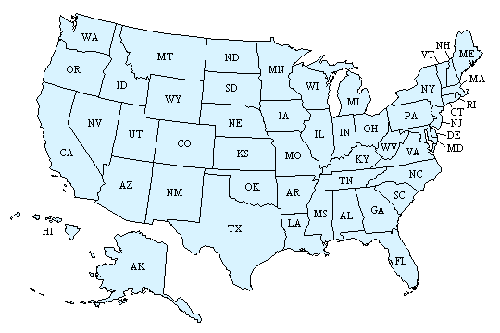
This data has N=48, 8 variables with 1 factor, 5 numeric variables.
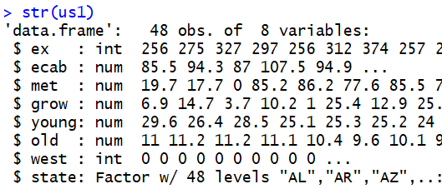
Histogram for public expenditures & Economic ability Index & MET are as the following :
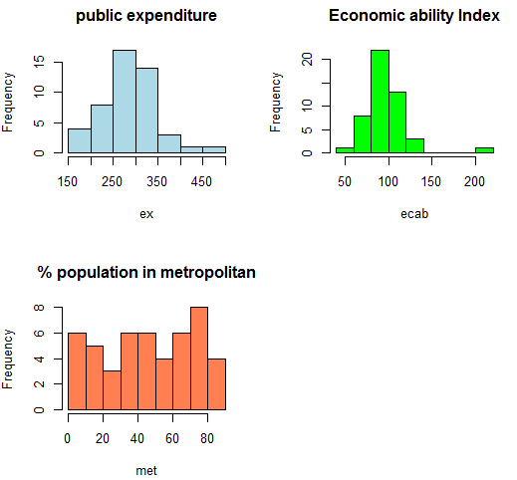

2.1 (2pt) There are two States outlying State in West which has very high Economic ability Index. There is one State in West with very low Economic ability Index.
NV(ECAB=205.0) / MS(ECAB=57.4)

(R program : make subset with Western state, and sort by ECAB, and then find out the State with very high Economic ability Index, and the State with very low Economic ability Index. Attach your R code for how you find it
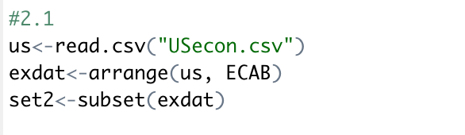
2.2 . (4pt) Do t-test : Economic ability Index between West and East using t-test. (attach your t-test output, and give the answer for the questions)
(i) What is your conclusion for t-test?
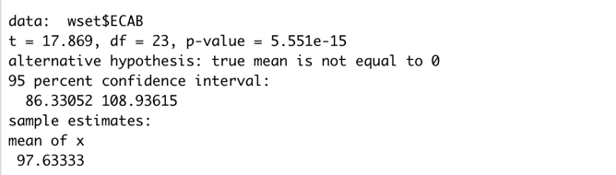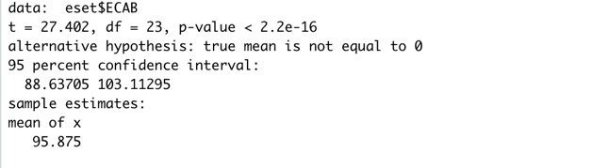

(ii) What is p-value?
East : 2.2e-16
West : 5.551e-15
(iii) What is mean of West Economic ability Index & East Economic ability Index?
West : 97.63333
East : 95.875

(iv) Where is higher Economic ability Index? East or West?
West is more Economic ability

2.3 (3pt) Correlation coefficient and scatterplot
(i) What is Correlation coefficient between GROW and ECAB?
0.4600722

Draw the scatterplot between Grow(x-axis) and ECAB(y-axis). (using ggplot, and give the color by West)
Do you think that those two variables has linear relationship?
in west state , we can see right upper part point . so , becase that point is exist so we can see linear relationship
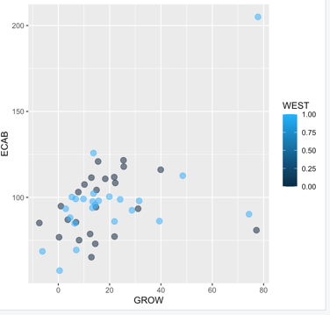

(ii) Which State is outlying in plot (i). What if the outlying State is excluded? (you may try correlation coefficient after excluding Nevada state). Show your R code how to do it (copy & paste)
no, because correlation coefficient is far from 1. and we can see the scatterplot items but there is no special relation for linear.

2.4 (3 pt) Linear regression
Using the function ‘lm’, you may run regression. We want to predict ECAB using Ex and Young variables.
- What is R-squared? What does that mean?
0.08596, 설명도가 8.5%라는 것을 의미한다.
(ii) Which variables are significant at alpha=0.01?

- Check the residual plot. What can you say about?

