 

Print

Export Word

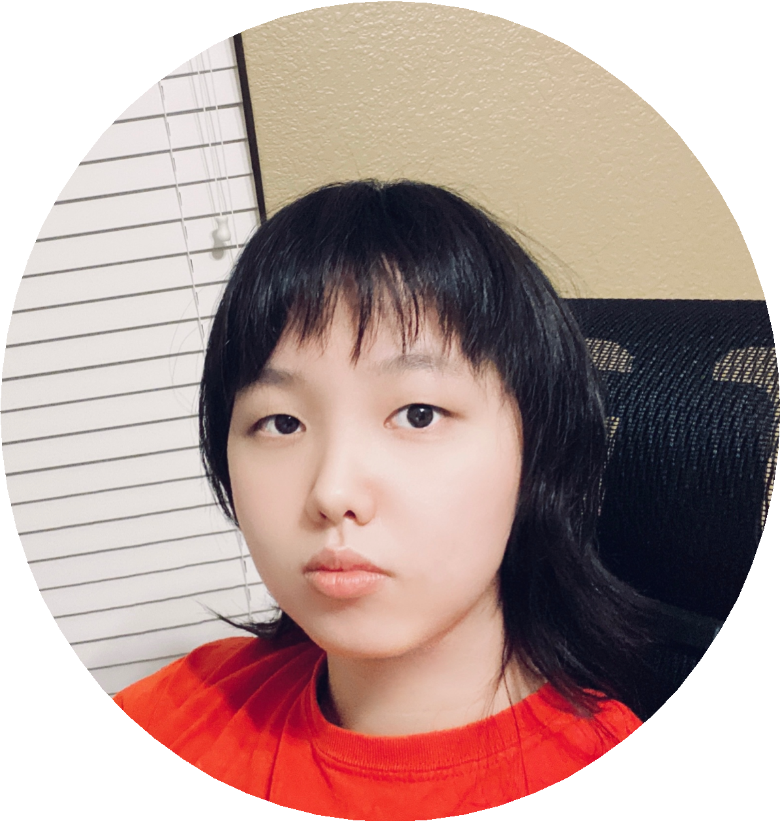





About Me

|  |  |  |  |  |  |
| --- | --- | --- | --- | --- | --- |
| Industry Equivalency | | | | | |
| **1**  **C#**  Equivalency in Months | **24**  **Python** | **6**  **Java** | **4**  **JavaScript** | **6**  **HTML/CSS** | **3**  **React** |

Jessica Hao

Fullstack Java Developer



I recently graduated from Texas Tech University with a bachelor in Integrative Studies, Computer Science, and Mathematics. After graduating, I joined in GenSpark's training program to help prepare me for my career, and now I am looking for a company at which I can continue to learn and grow as a software engineer.

Dedicated and efficient full stack developer in application layers, presentation layers, and database. Certified in Backend technology. Team worker across technology, design, and planning. Seeking for further improve Java skill as the future full stack developer.

tic



Bachelor's Degree - Integrative Studies, Computer Science, and Mathema

Texas Tech University - May 2019

Education and Certification



Skill Matrix

# Front-End Tech



**HTML/CSS (6 Months)**

**React (3 Months)**

**JavaScript (4 Months)**

**Bootstrap (4 Months)**

# Back-End Tech

**Java (6 Months)**

**Spring/SpringBoot (3 Months)**

**Python (24 Months)**

**C# (1 Months)**

# DevOps

**GitKraken (4 Months)**

**GitHub (4 Months)**

# Database

**SQL (10 Months)**

**MySQL (6 Months)**

**MongoDB (1 Months)**

# Developer Tools

**IntelliJ (4 Months)**

**Jupyter Notebook (12 Months) Visual Studio Code (18 Months) Visual Studio (3 Months)**



Locus

Worked on a team for my Capstone Project as a developer to build an app avoid children run far away from their parents. This application create groups for leader(parent) and users(children). It tracks the locations of each user once per 10 seconds. If the location is over 10 meters(avaliable to change) far from the leader,the leader's phone will receive the warning message.

Projects

Roles / Responsibilities

* Designed and implemented a program to track the location of each members in the goup.
* Follow by the project's plan and delivery ontimee for each spring meeting.
* Actively discuss and work with the team to improve program performance̶

Environment / Technologies

Android Studio with Java language, BlueTooth, Goolge Map API, Firebase

Snake Game

Worked with two teammates in GenSpark. This project is a update of classic Snake game. It mainly used Java GUI skills(JFrame, JPanel). We build three type of fruits to control and change the snake's moving speed.

Roles / Responsibilities

* design and planning the snake project.
* build board class and snake class.

Environment / Technologies

Java, JFrame, JPanel



Pyramid Academy Personal Projects

This is a pachage of projects I have done in GenSpark. Projects: Battleship, GuessTheNumber, Hangman, Hunman VS Goblins, Noughts and Crosses(TicTacToe), RPS(Rock Paper Scissors), Mavel-fsp, React-profile(this project)

Environment / Technologies

Java, Springboot, Hibernate, MySQL, React, CSS, and the AntDesign React library.

Shopping Cart Project

A full stack shopping cart Project using MySQL, SpringBoot, React, and Java.

Environment / Technologies

Java, Spring Boot, MySQL, React, and CSS.

Snake Game

A simple game using Java GUI.

Environment / Technologies

Java, Java GUI

GitHub Projects



Java Full Stack Developer

GenSpark

**April 2021 - PRESENT**

Working Experiences