Jaron Jon Javier

Professor Ahmad Hadaegh

CS443 - Database Management Systems

25 September, 2023

Lab 2

**1)**

Consider the following information:

Supplier: SupplierId, SupplierName, SupplierAddress (The address consists of StreetName, AptNo, PostalCode)

Shipment: ShipmentId, ShipmentDate, ShipmentTime

Item: ItemNo, ItemDescription, QuantityOnHand

One supplier can send many shipments; however, a particular shipment is only sent by one supplier. One item can be in many shipments and a shipment can include many items. A supplier can supply many items and a particular item can also be supplied by many suppliers.

**1a) Create your ERD**

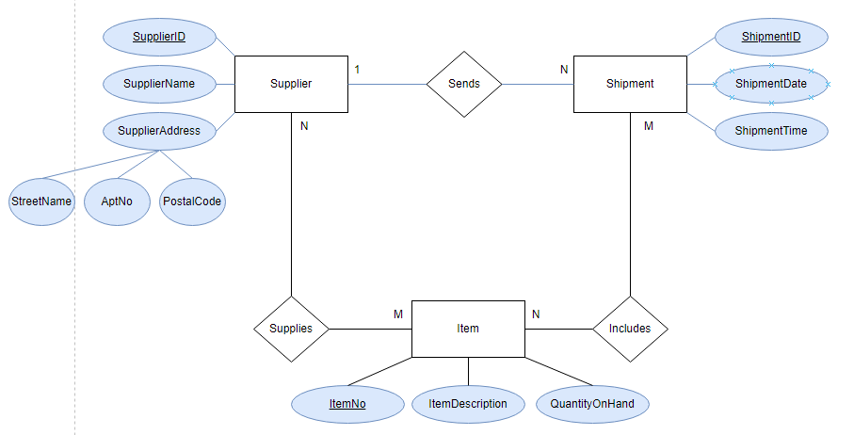

**1b) Create associated tables**

Supplier(SupID, SupName, StreetName, AptNo, PostalCode)

Shipment(ShipID, ShipDate, ShipTime, SupID*)

Item(ItemNo, ItemDes, Quantity)

Supplies(SupID*, ItemNo*)

Includes(ShipID*, ItemNo*)

**2) Provide the tables for the following ERD**

Student(StuID, StuName, StuAge, StuEmail)

Faculty(FacID, FacName, FacMajor, FacOffice, DeparID*)

Department(DeparID, DeparName, DeparLoc)

Course(CRN, CrnName, CrnDes, FacID*)

Major(MajName, DeparID*)

Dependent(FacName*, DepenName, Gender, DepenAge, FacID*)

Takes(StuID*, CRN*)

**3) Provide the tables for the following ERD**

Bank(Code, BankName, BankAddress)

Account(AccNum, Balance, AccType, (Code, BranchNum)*)

Customer(SSN, CusName, Phone, CusAddress)

Loan(LoanNum, Amount, LoanType, (Code, BranchNum)*)

BankBranch(Code*, BranchNum, BranchAddress)

AC(AccNum*, SSN*)

LC(LoanNum*, SSN*)