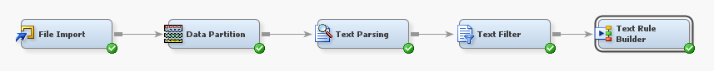
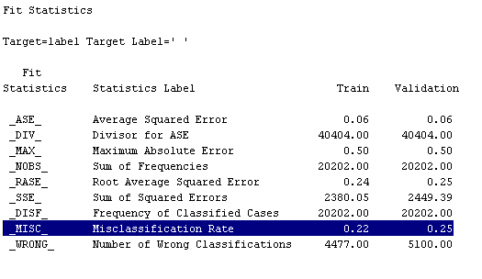
The diagram above shows a neat process flow of a supervised text classification model built using SAS Text Miner. The dataset was cleaned using Python before loading into the model and it contains 40,404 rows and 5 columns, yet only two columns are used for this modelling. The column “Label” is set as the target variable and the column “text” is set as text because these two columns are essential components for training and evaluating the model. The data has been partitioned evenly into two equal parts, with each part constituting 50% of the dataset. As fit statistics for the Misclassification Rate (MISC) show 0.22 for training and 0.25 for validation, the accuracy of the model on the training set is 0.78 (78%) and the validation set is 0.75 (75%).
Confusion matrix for Training set: | Confusion matrix for Validate set:
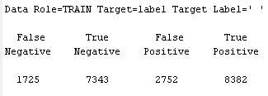 | 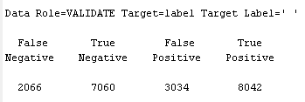

Metrics | Training set | Validation set
Precision | 8382 / (8382+2752) = 0.752 | 8042 / (8042+3034) = 0.726
Recall | 8382 / (8382+7343) = 0.533 | 8042 / (7060+8042) = 0.532
F1 score | 2 × (0.752×0.533) / (0.752+0.533)  = 0.623 | 2 x (0.726x0.532) / (0.726+0.532) = 0.614

For the evaluation matrix, recall and accuracy are combined into one metric called the F1 Score. F-score may be utilised to evaluate how well the text classification model makes the trade-off between accuracy and recall. The table above shows the evaluation matrix for the model. The results show that the model has an average recall, which shows it misses positive examples, but good precision, which indicates low false positives. The neutral F1 scores indicate a balance between recall and accuracy. Strong generalisation is shown by the consistency between training and validation sets.

