**Documentation: Implementation of Mask-RCNN using TensorFlow API**

*By: Lim Jun Jie*

**Environment Set-Up**

1. Download Anaconda from <https://www.anaconda.com/products/individual> and Python from <https://www.python.org/downloads/>. Once Anaconda has been downloaded, run *conda install -y jupyter* in cmd to install Jupyter.

#Suggestion: Remember to TICK set-up the environment path during the installation process of Anaconda

1. Copy paste the script from xxx and save it as tensorflow-gpu.yml. (Remember where you save this file)
2. Open cmd, go to the file location where you save tensorflow-gpu.yml. Then, run the following command:
3. *conda env create -v -f tensorflow.yml* (To create tensorflow environment)
4. *conda activate tensorflow* (To activate your tensorflow environment)
5. *python -m ipykernel install --user --name tensorflow --display-name "Python 3.7 (tensorflow)"* (To link your new **tensorflow** environment to Jupyter so that you can choose it as a Kernal.)
6. To test you environment, copy the script from xxx and paste it to your new python script in jupyter notebook. (Remember that you must in the tensorflow environment)

# Refer to this YouTube link to set-up the tensorflow environment with GPU card (CUDA) <https://www.youtube.com/watch?v=qrkEYf-YDyI&list=PLjy4p-07OYzulelvJ5KVaT2pDlxivl_BN>

**Mask-RCNN Project Set-up**

1. Download the project repository from xxx.
2. Download the latest tensorflow models from [*https://github.com/tensorflow/models*](https://github.com/tensorflow/models) and replace it into the project repository.
3. In your current project repository, you must have following file:
4. CP (CheckPoint for your train model)
5. dataset

- annotations

- masks (annotated masks images in png)

- xmls (xmls files for the annotated images)

* JPEGImages (train images in JPEG)
* TestImages (test images in JPEG)
* label.pbtxt

1. IG (To save inference graph of your train model)
2. models
3. pre_trained_models (To store pre-trained models, can try more models from [*https://github.com/tensorflow/models/blob/master/research/object_detection/g3doc/detection_model_zoo.md*](https://github.com/tensorflow/models/blob/master/research/object_detection/g3doc/detection_model_zoo.md))
4. Supporting_Script (Contains resize_image.py to resize and rename your dataset)
5. mask_rcnn_inception_v2_coco (or any other .config file that u want to use, search more .config files in *PATHTOPROJECT\models\research\object_detection\samples\configs*)
6. mask_rcnn_eval.ipnyb (To test your train model)
7. create_mask_rcnn_tf_record.py (Copy this file into *PATHTOPROJECT\models\research\object_detection\dataset_tools*)

**Implementation of Mask-RCNN**

1. Preparing datasets
2. Obtain your dataset. You can resize and rename your dataset using resize_images.py in Supporting_Script file.
3. Preparing annotated masks images using PixelAnnotationTool

-Download PixelAnnotationTool from [*https://github.com/abreheret/PixelAnnotationTool*](https://github.com/abreheret/PixelAnnotationTool)

-Save your annotated masks images in *PATHTOPROJECT/annotations/masks*

1. Preparing xml files for annotated images using labelImg

-Download labelImg from [*https://github.com/tzutalin/labelImg*](https://github.com/tzutalin/labelImg)

-Save your xml files in *PATHTOPROJECT/annotations/xmls*

1. Run [Check_pixel_values.ipynb](https://github.com/vijendra1125/Custom-Mask-RCNN-using-Tensorfow-Object-detection-API/blob/master/extra/Check_pixel_values.ipynb) to check the pixel of certain object.
2. Go to label.pbtxt and create_mask_rcnn_tf_record.py, label the object with its corresponding pixel value. In label.pbtxt, the last 3 digits refer to the pixel value of the object.
3. Generating tf record
4. Before generating tf record, in cmd, go to *PATHTOPROJECT/models/research* and run the following command to prevent error.

* *set PYTHONPATH=PATHTOPROJECT\models;PATHTOPROJECT \models\research;D:\ML\Project\SDDfinal\models\research\slim  
  set PATH=%PATH%;%PYTHONPATH%*
* *protoc object_detection/protos/*.proto --python_out=.*
* *python setup.py build*
* *python setup.py install*

1. Then, at the *PATHTOPROJECT\models\research*, run the following command to generate tf record.

*python object_detection/dataset_tools/create_mask_rcnn_tf_record.py --data_dir=PATHTOPROJECT/dataset --annotations_dir=Annotations --image_dir=JPEGImages --output_dir=PATHTOPROJECT/dataset/train.record --label_map_path=PATHTOPROJECT/dataset/label.pbtxt*

1. Training
2. Open the .config file in your project repository and modify 5 highlighted parts as shown in the image below according to your path. (I used mask_rcnn_inception_v2_coco.config)

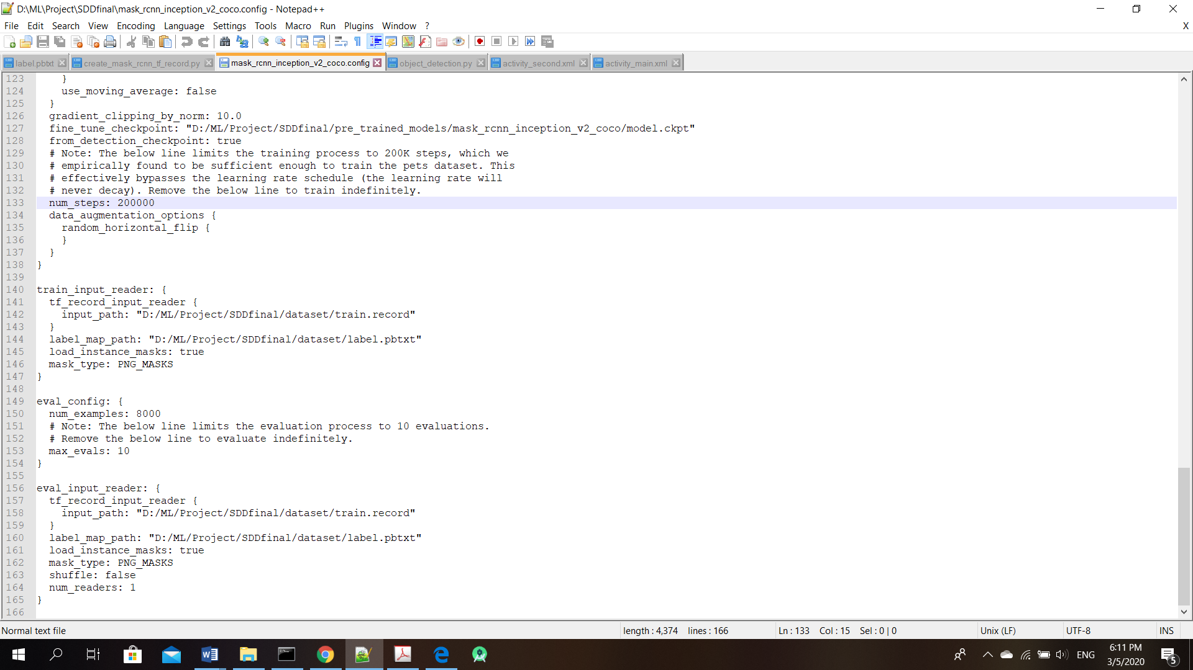

1. Download the Mask-RCNN pre-trained models from <https://github.com/tensorflow/models/blob/master/research/object_detection/g3doc/detection_model_zoo.md> (I used mask_rcnn_inception_v2_coco)
2. Run the following command to start training.

*python object_detection/legacy/train.py --train_dir=PATHTOPROJECT/CP --pipeline_config_path=PATHTOPROJECT/mask_rcnn_inception_v2_coco.config*

# Train the models until the loss is below 0.2 or lower.

1. Generating Inference_Graph

Once the training had been done, run the following command to generate inference_graph.

*python object_detection/export_inference_graph.py --input_type=image_tensor --pipeline_config_path=PATHTOPROJECT/mask_rcnn_inception_v2_coco.config --trained_checkpoint_prefix=PATHTOPROJECT/CP/model.ckpt-****20000*** *--output_directory=PATHTOPROJECT/IG*

# The highlighted test in the command above should be changed according to your steps of training

1. Test the trained models.

Open jupyter notebook and run mask_rcnn_eval.ipnyb to test the trained models. Change the PATH as commented in the script.