**Documentation: Installation of OpenCV without CUDA using Microsoft Visual Studio in Windows**

***Prepared by: Lim Jun Jie***

1. Download OpenCV from <https://opencv.org/releases/>

* Choose “Windows” under the version of OpenCV you want to download.

1. Download Microsoft Visual Studio from <https://visualstudio.microsoft.com/downloads/>

* Choose Community Version for free download
* YouTube video for how to install Microsoft Visual Studio 2019 for C++

<https://www.youtube.com/watch?v=IsAoIqnNia4>

* Remember to tick “Desktop development with C++” when configuring Microsoft Visual Studio.

1. Setting Environment Variables

* Find the path “path_to_variables\build\x64\vc14\bin” and copy it

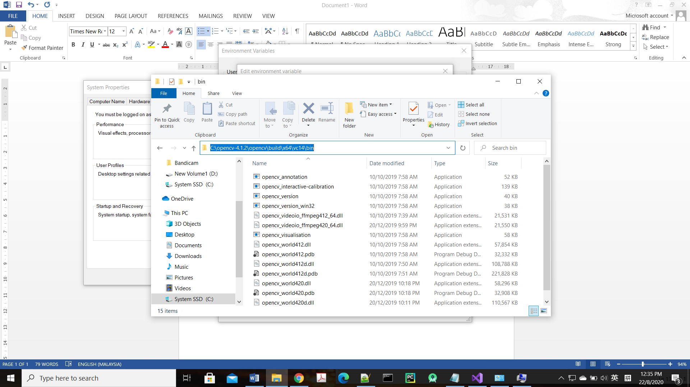

* Open Environment Variables and add this path into the **“Path”** of both **“System variables”** and **“User variables for Owner”**

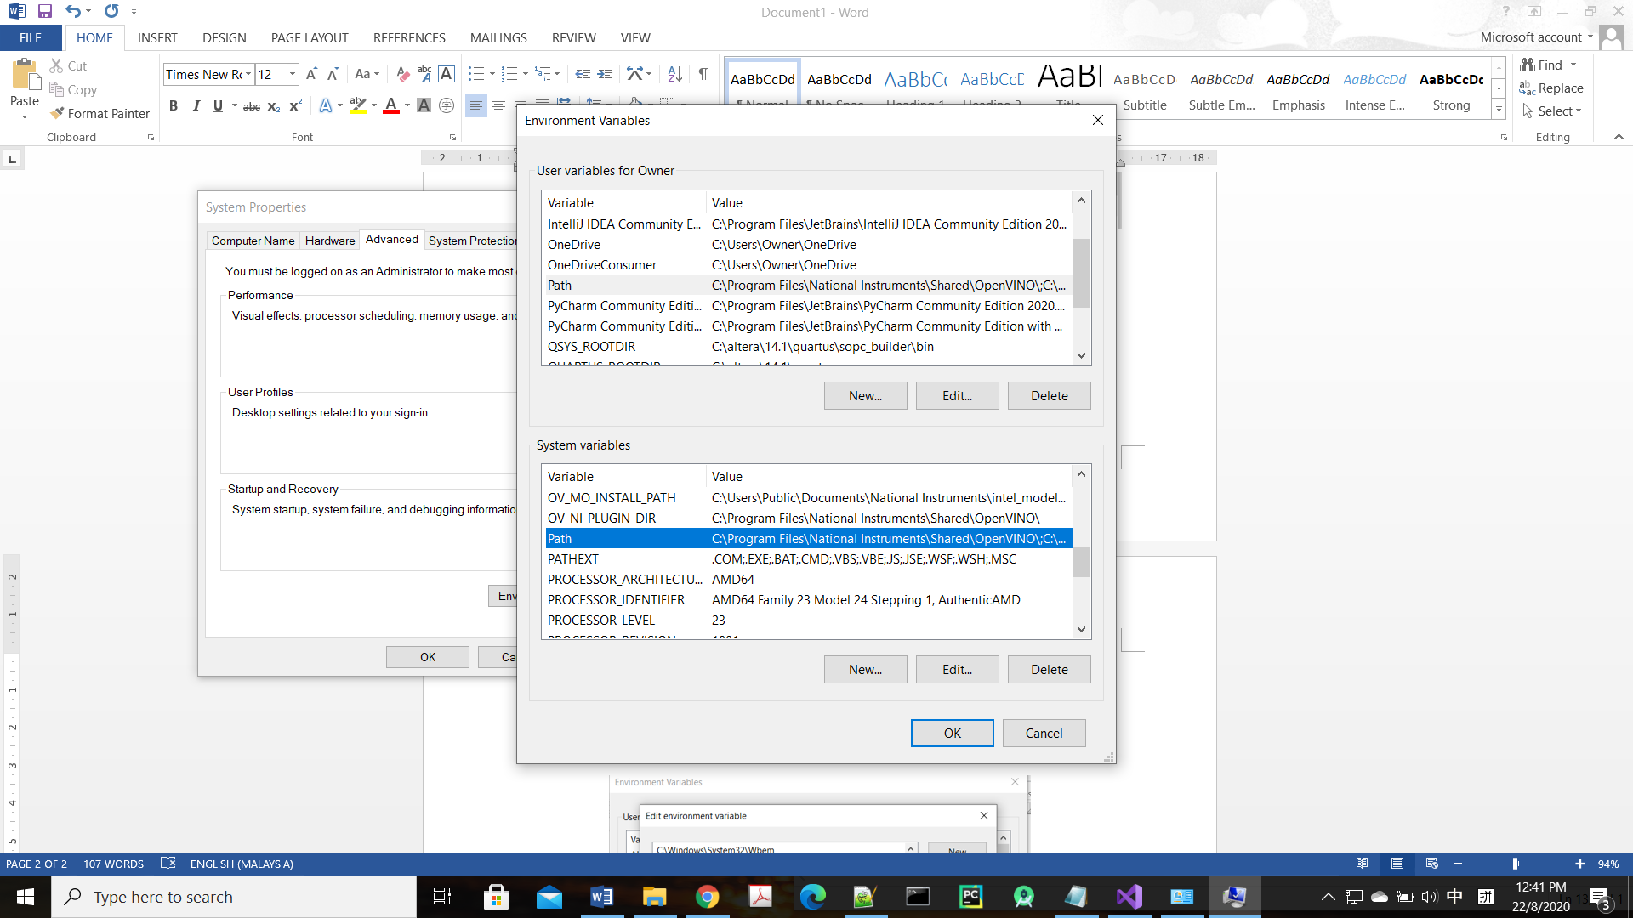

1. Double click to add Path

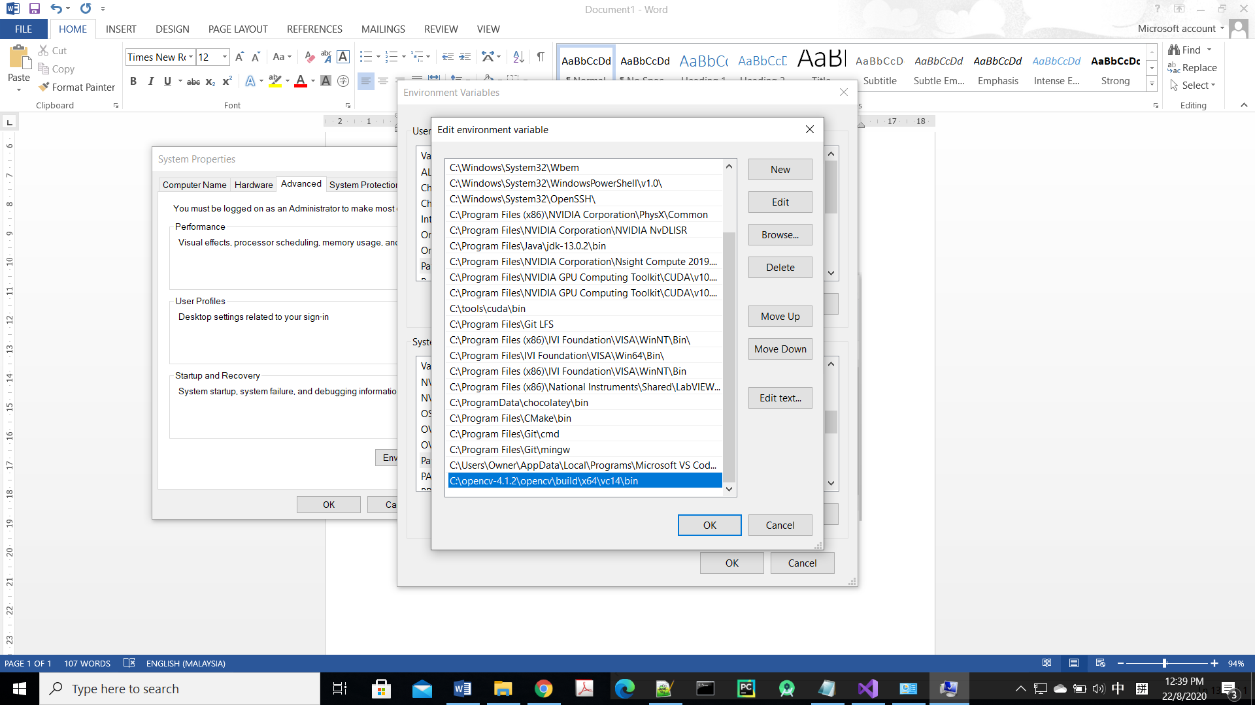

2. Click “New” to add the path

3. Click “OK” after adding the path

1. Setting path in Microsoft Visual Studio
2. Open Visual Studio and Create a new project

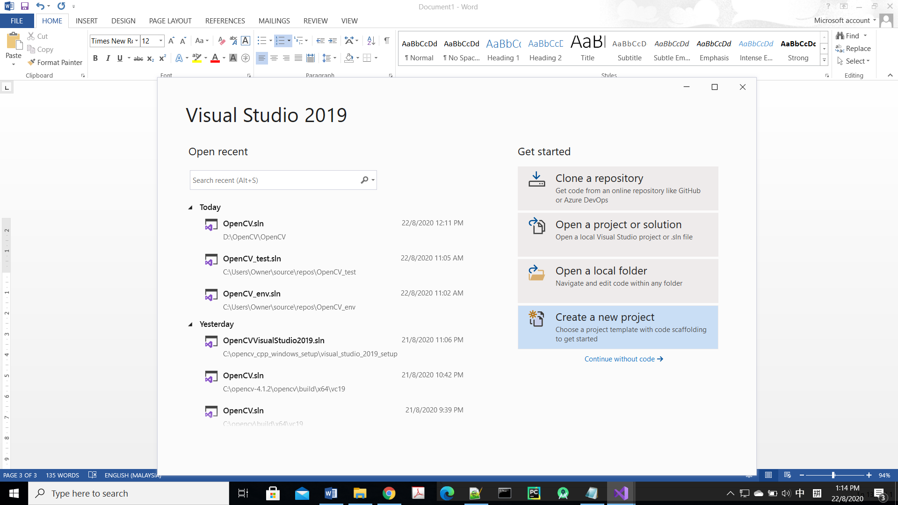

1. Choose “Console App” then click “Next”

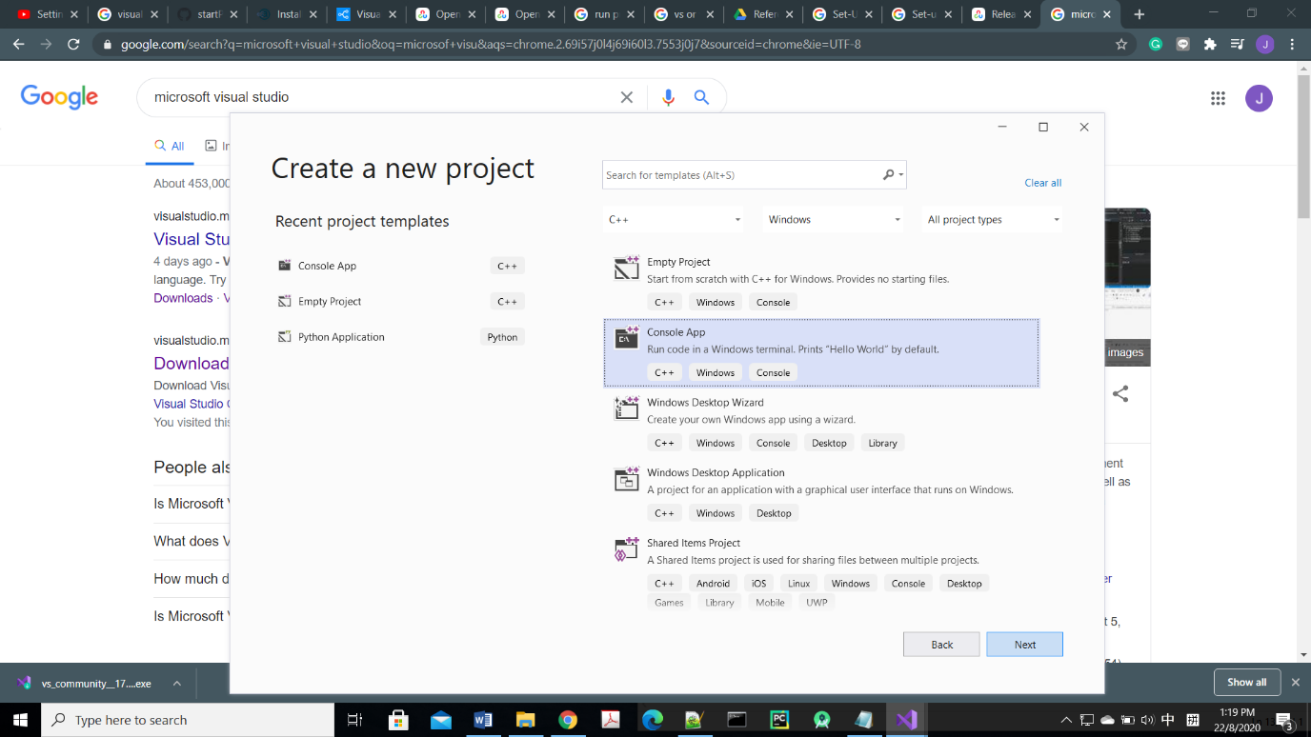

1. Give name to your Project and “Create”

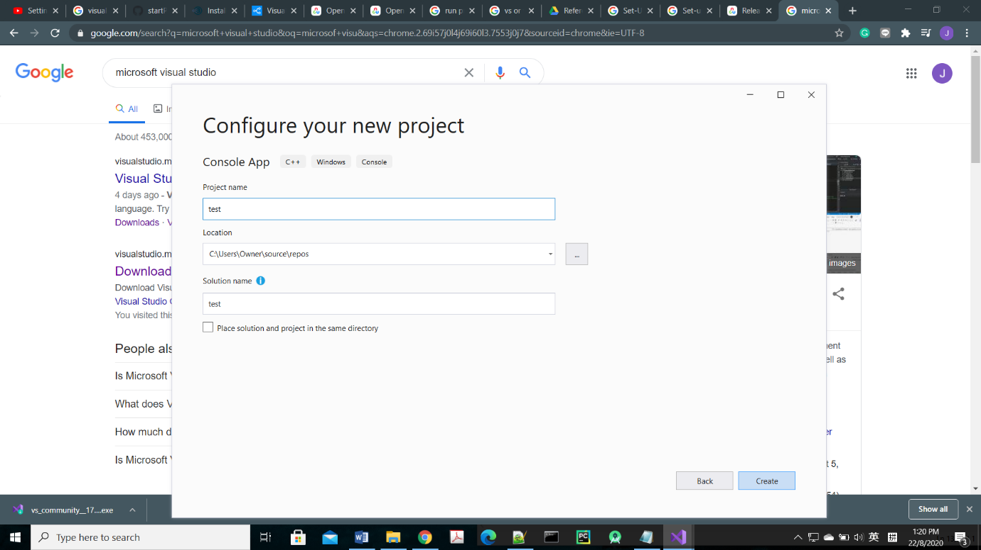

1. Right Click the Project and click “Properties” to open “Property Pages”

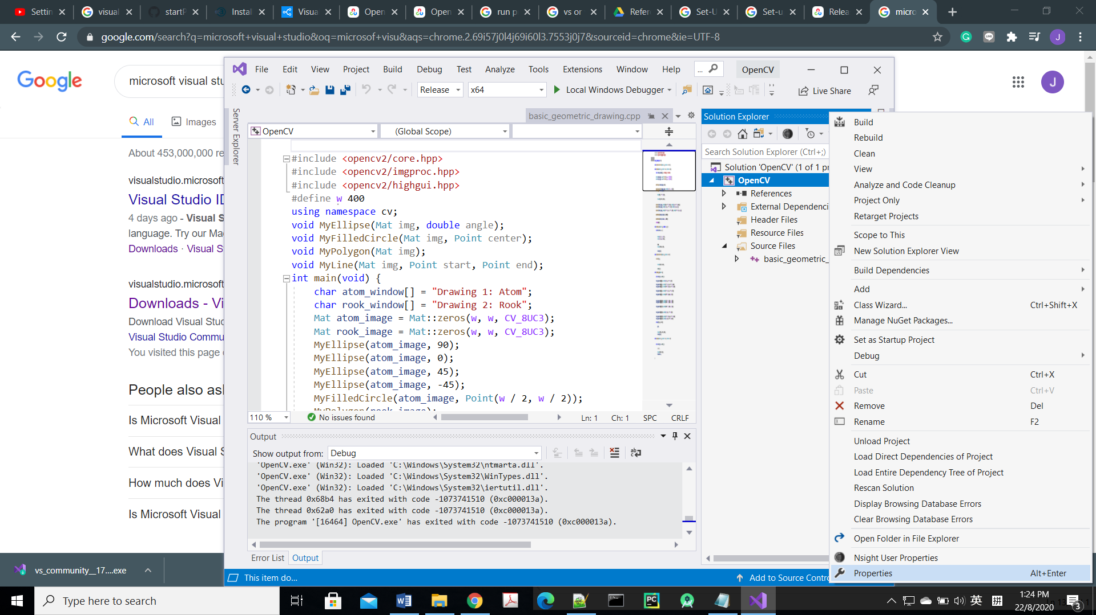

1. Make sure the Configuration is “Release” and Platform is “x64”, then adding the path as shown in the following diagram

* Go to Configuration Properties > C/C++ > General,

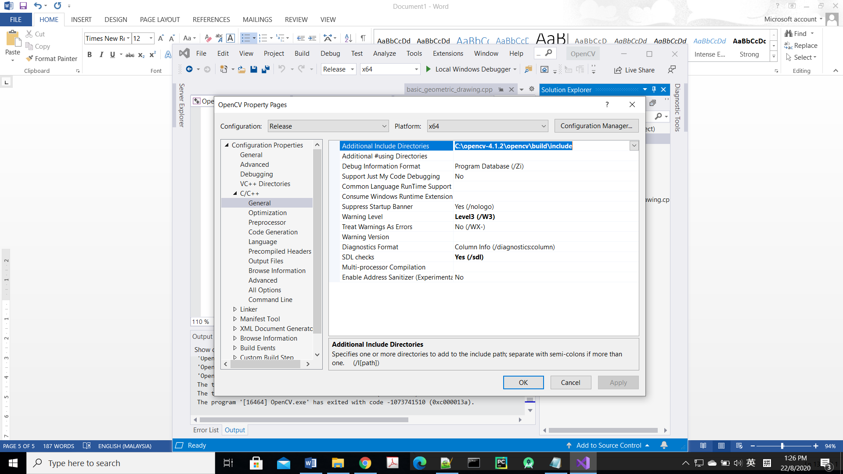add “path_to_variables\opencv\build\include” into “Additional Include Directories”

* Go to Configuration Properties > Linker > General, add “path_to_variables\opencv\build\x64\vc14\lib” into “Additional Library Directories”

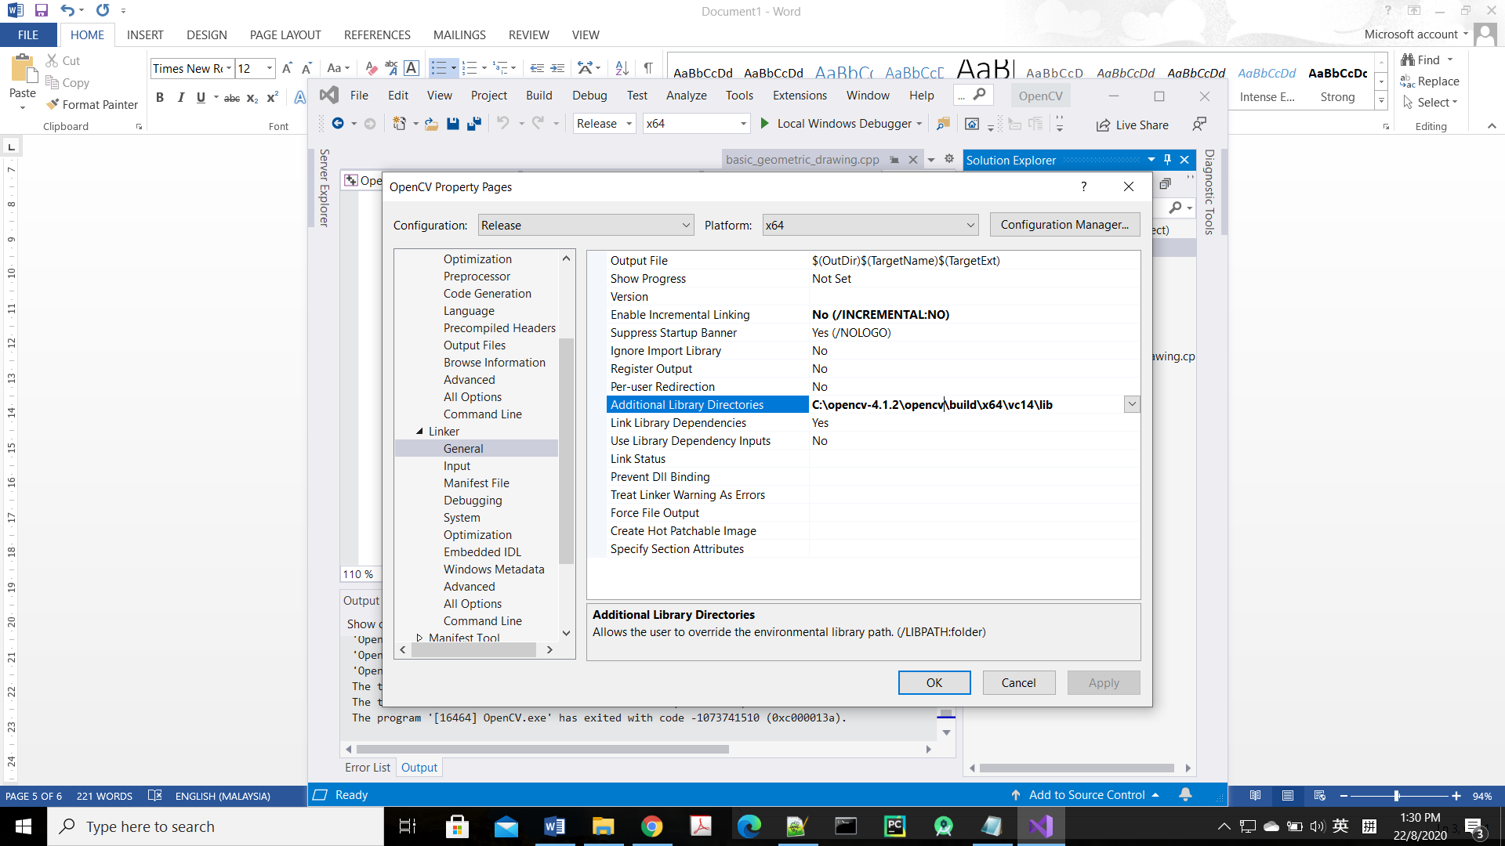

* Go to Configuration Properties > Linker > Input, add all the **\*.lib file** in the “path_to_variables\opencv\build\x64\vc14\lib” into “Additional Dependencies”

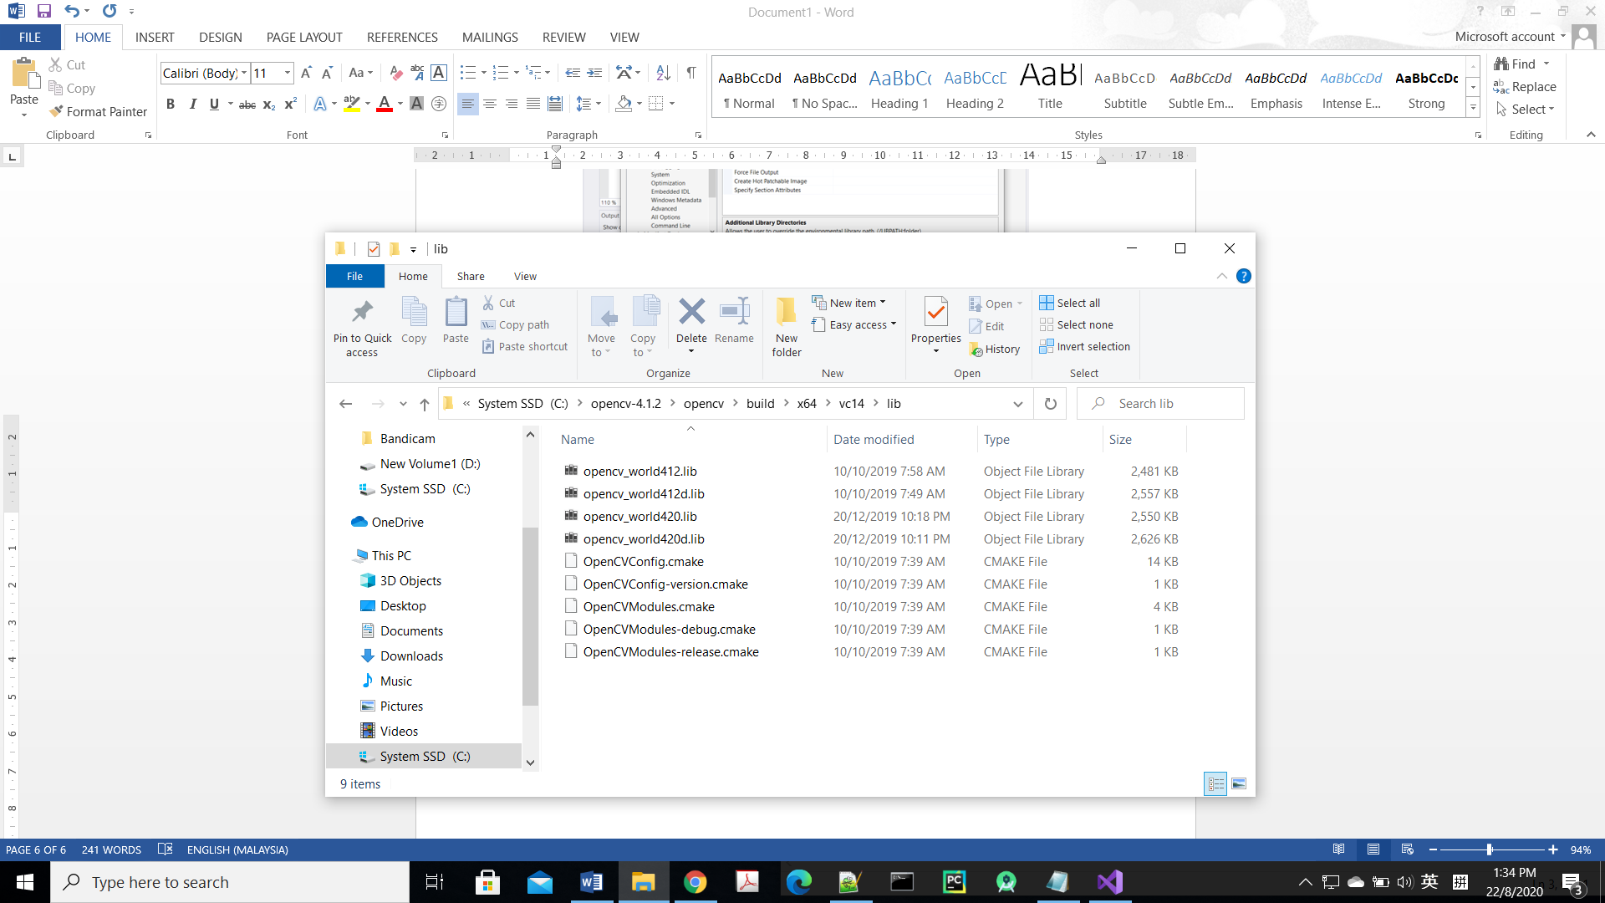

Copy the filename of all *.lib files if you are not sure the mode

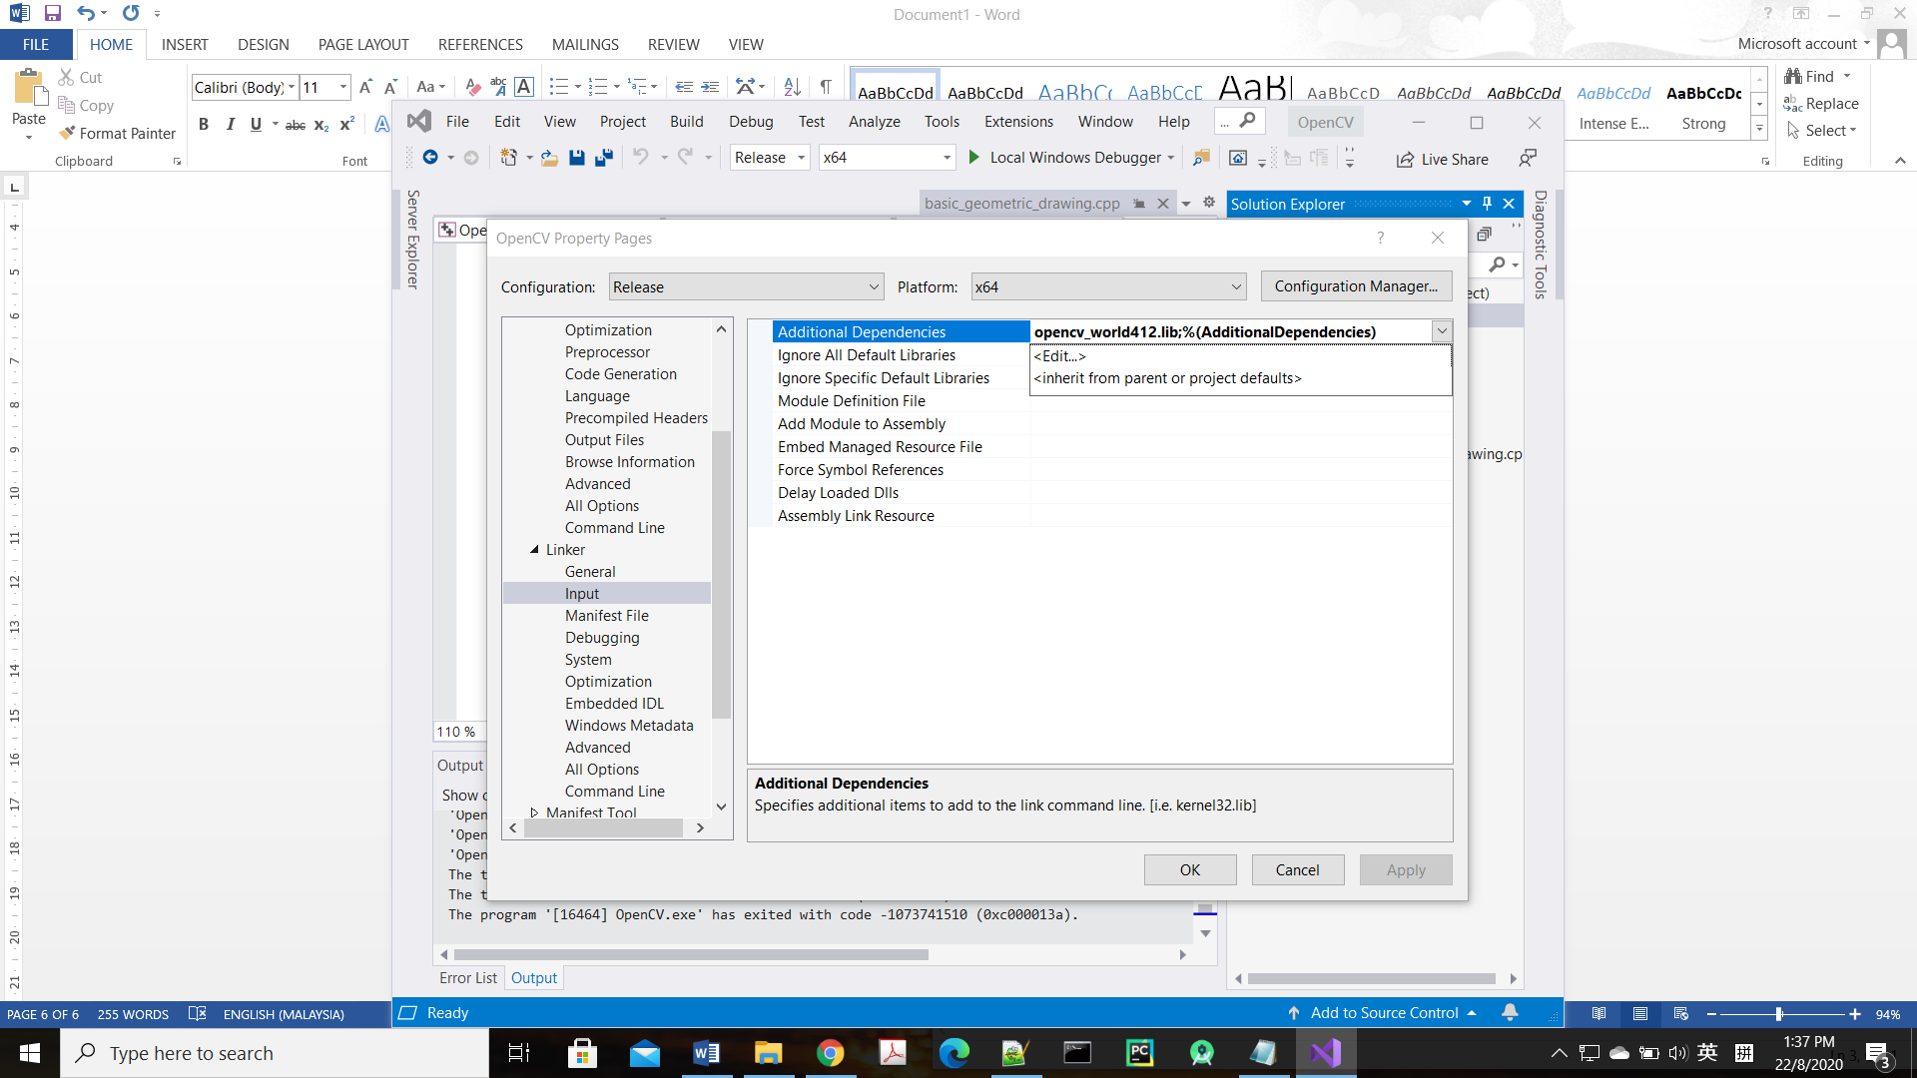

Click <Edit…>

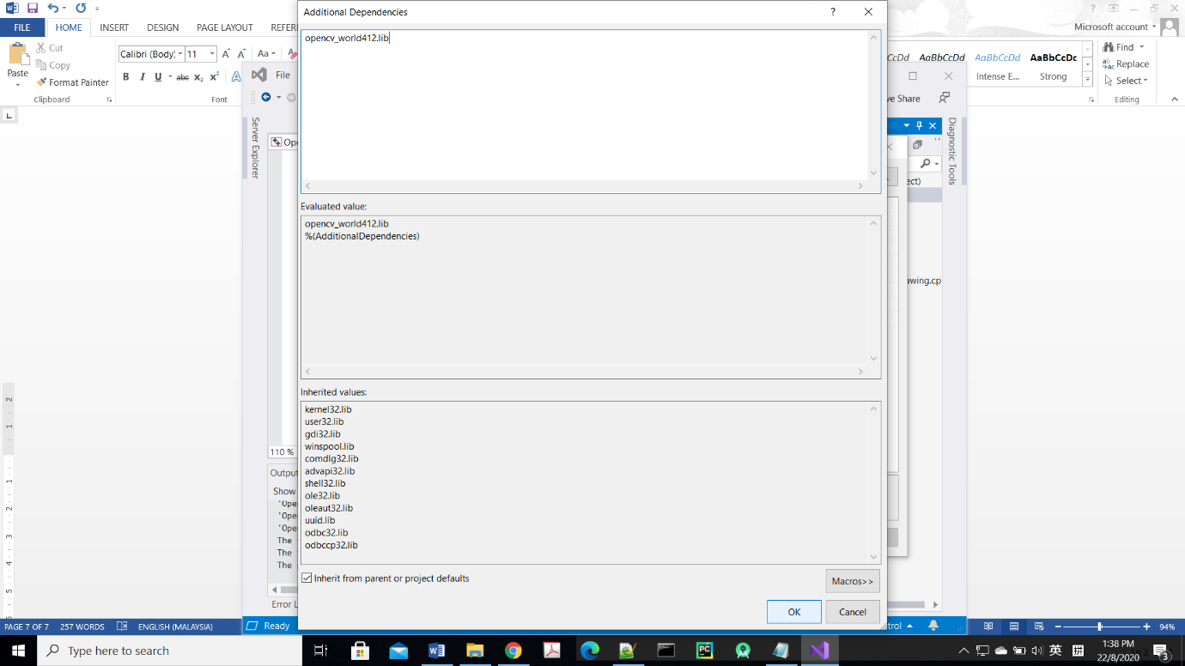

Paste the filename at here, then click “OK”

* After adding the required path, remember to click “OK” or “APPLY”

1. Testing
2. Right Click “Source Files” > Add > New item… to create new C++ file.

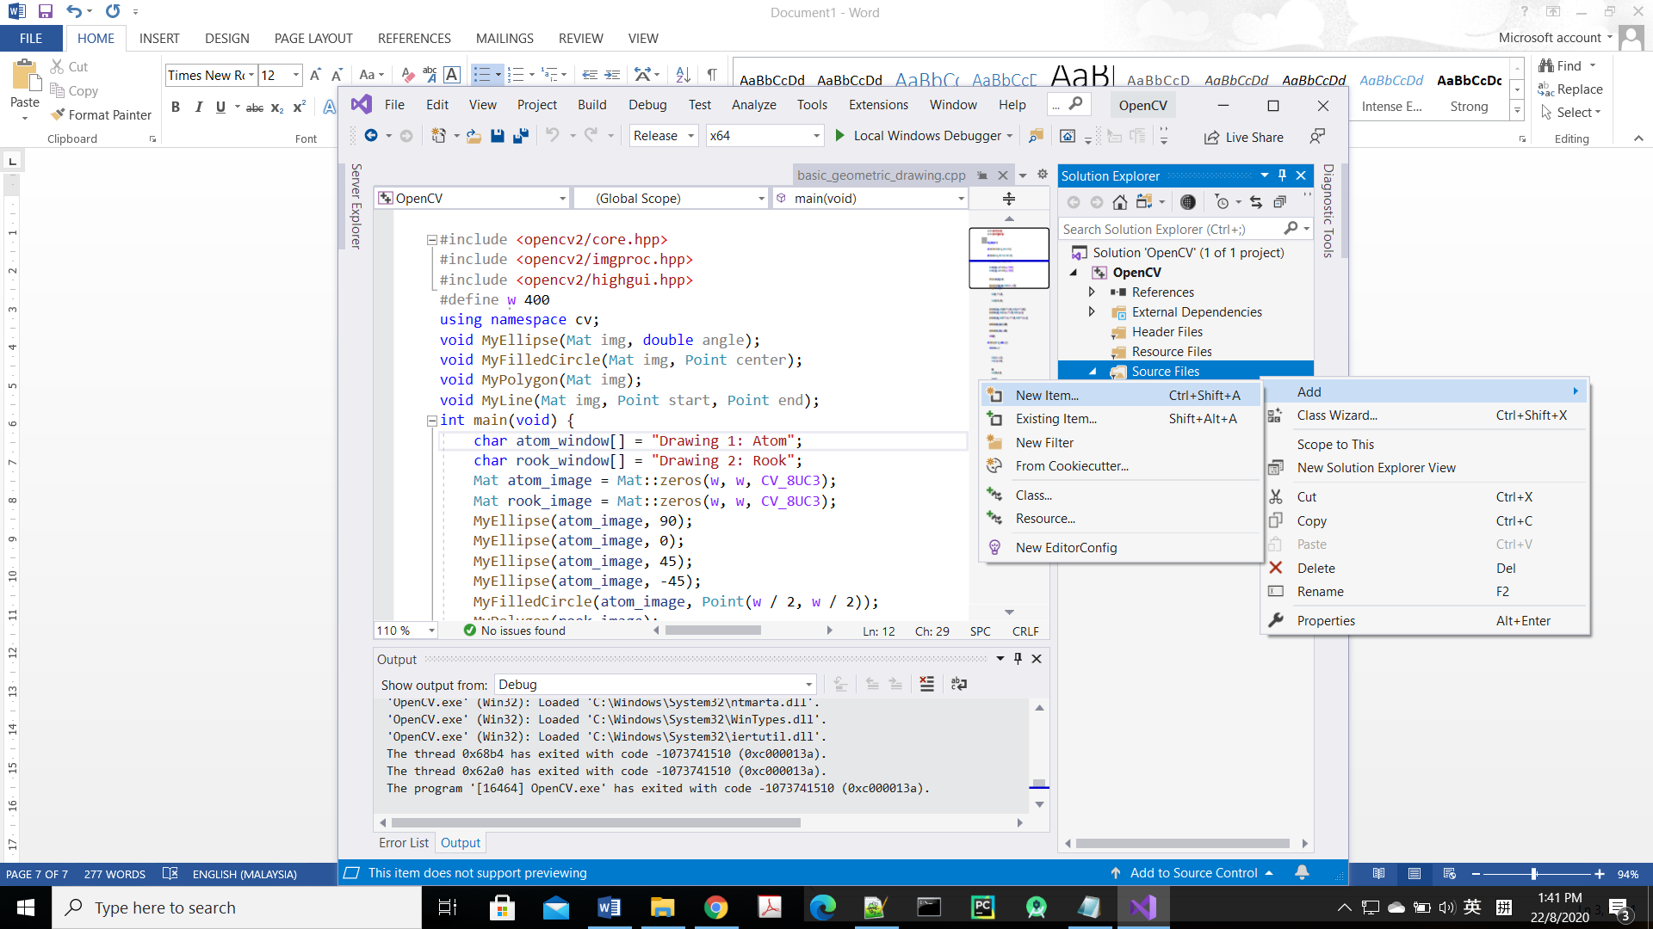

1. Copy the code in “basic_geometric_drawing.cpp” and paste it into your new created C++ file.

The code can be found in my github link <https://github.com/JJLim99/OpenCV_Micosoft_VS_for_C-.git>

More example codes can be found in <https://docs.opencv.org/master/d9/df8/tutorial_root.html>

1. 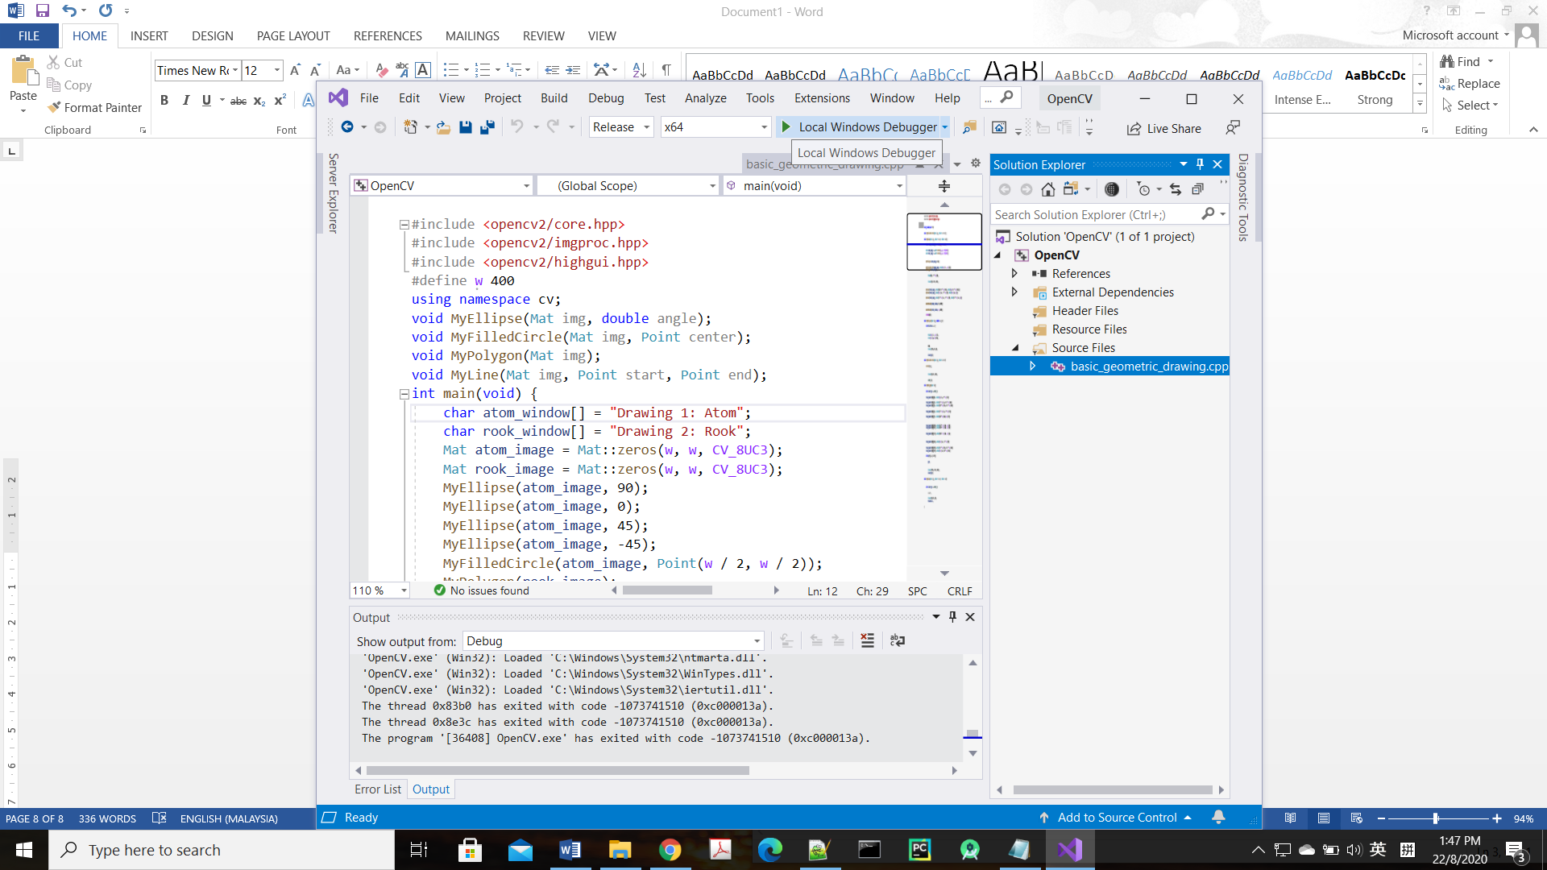Click “Local Windows Debugger” to compile and run your C++ code. Make sure you choose “Release” and “x64”.

Reference:

1. <https://www.youtube.com/watch?v=l4372qtZ4dc&t=10s>
2. <https://opencv.org/>