**Documentation: Installation and Implementation of OpenPose on Windows 10**

**Prepared by: Lim Jun Jie**

# This documentation had been prepared by assuming you had installed the dependencies of tensorflow-gpu and CUDA. If you haven’t install them, please refer to my github link for more information ( <https://github.com/JJLim99/Implementation-of-TensorFlow-GPU-CUDA-in-Windows.git> )

# The code is tested using tensorflow-gpu=1.15 and keras=2.3.1, AMD Ryzen 5 3550H, 12GB RAM, GTX 1650

**Part 1: Installation of OpenPose**

1. Open cmd, go to your desired location path and clone the repository

*git clone* [*https://github.com/ildoonet/tf-pose-estimation.git*](https://github.com/ildoonet/tf-pose-estimation.git)

1. Install Swig for Windows

* Click the link below to download Zip file of Swig

*https://jaist.dl.sourceforge.net/project/swig/swigwin/swigwin-3.0.12/swigwin-3.0.12.zip*

* Extract the Zip file to any location. ( For example: C:\swigwin-3.0.12 )
* Add the path of Swig into the *environment variables* (For both of the *User variables for Owner* and *System variables*)

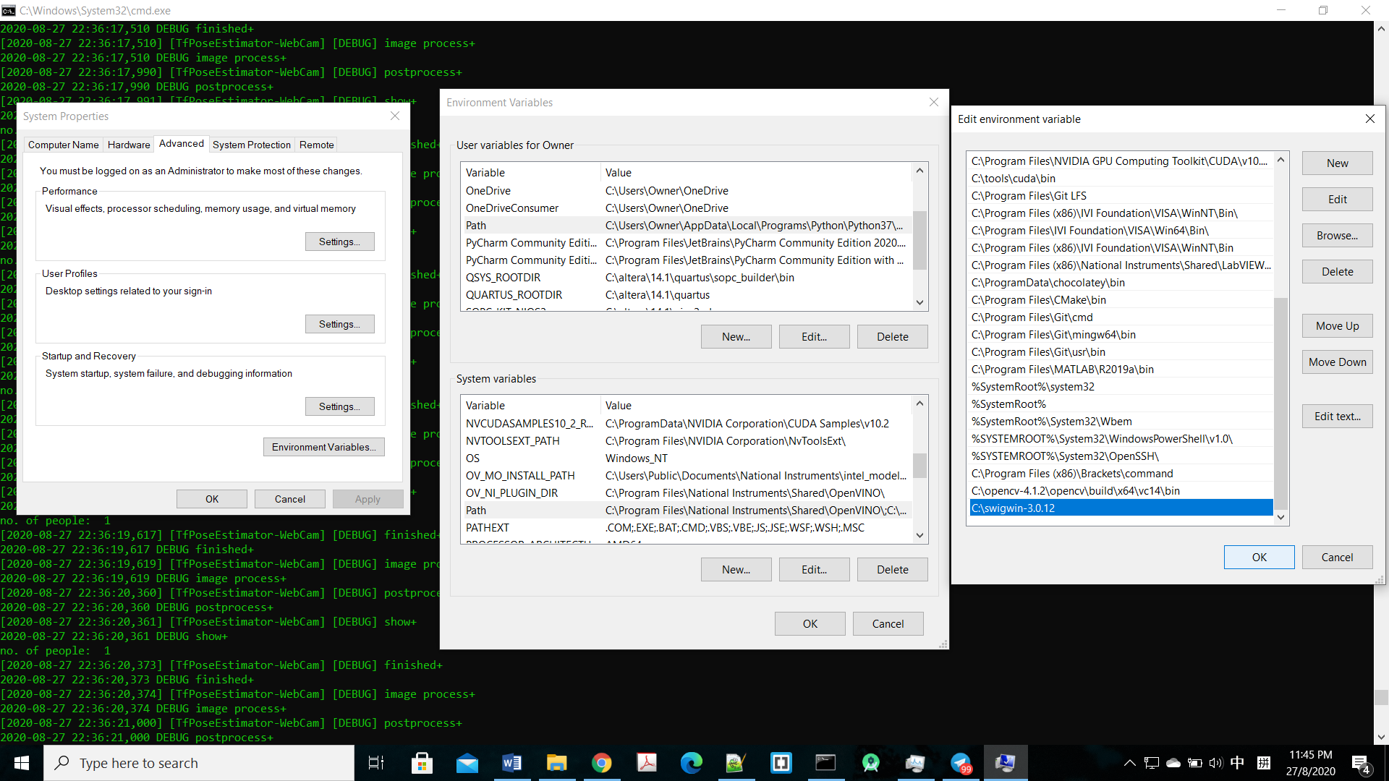

# For adding the path of Swig, go to Advanced System Settings > Environment Variables,

1. Click the Environment Variables (Red box)
2. Double click the Path for user variables for Owner (Blue box)
3. In the Edit environment variables, click New then paste the path of Swig. (Green box)
4. Then click OK at Edit environment variable (Purple box)
5. Repeat step ii. until iv. For the Path at System variables (Orange box)
6. Finally, click OK for the confirmation. (Black box)

* After that, go back to cmd and type the code below to verify the installation

*swig –version*

Example of the output is shown as below:

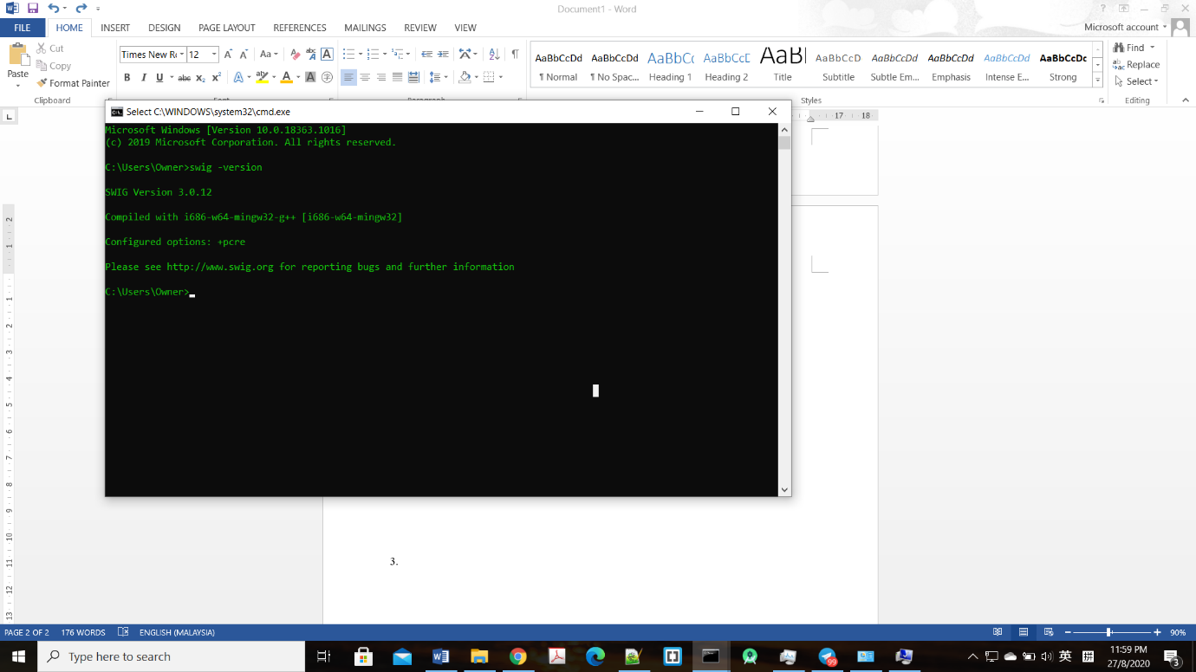

* Go back to the location path of your main repo, and type the following command

*cd tf_pose/pafprocess*

*swig -python -c++ pafprocess.i && python setup.py build_ext --inplace*

1. Download the CMU’s model graphs.

* Go to <path_to_repo>\tf-pose-estimation\models\graph\cmu, double click download.sh
* Installation will be initiated automatically
* graph_opt.pb will be downloaded

#Alternative:

* Go to the same path location as previous method by using cmd, then type

*bash download.sh*

* graph_opt.pb will be downloaded

**Part 2: Demo of OpenPose**

1. Open cmd and go to the path of the repo, and type the following command to try with saved video.

*python run_webcam.py --video <path to video.mp4>*

1. Open cmd and go to the path of the repo, and type the following command to try with your own webcam.

*python run_webcam.py --model=mobilenet_thin --resize=432x368*

# value of model and resize is optional

**# ( Optional )** If you have error by running the original python scripts of the original repo, you can download my github link as I had modified some codes to be compatible with my dependencies.

My github link: https://github.com/JJLim99/OpenPose.git