In this assignment we were assigned the task of creating a multi-threaded assignment that would use a shared variable amongst each thread. This shared variable stored a random integer. The final output of the program is a combination of the threads ID and the value that the current thread is seeing. Since this program does not contain any thread locks, the threads complete in an concurrent fashion.

The CPU can move execution resources across threads in a multi-threaded process running on a single processor, resulting in concurrent execution. Each thread in the same multi-threaded operation can execute on a distinct processor at the same time in a shared-memory multiprocessor environment, resulting in parallel processing. when a process has fewer or more threads than processors, the threads support system works with the operating environment to guarantee that each thread operates on a separate processor.

**Make:**

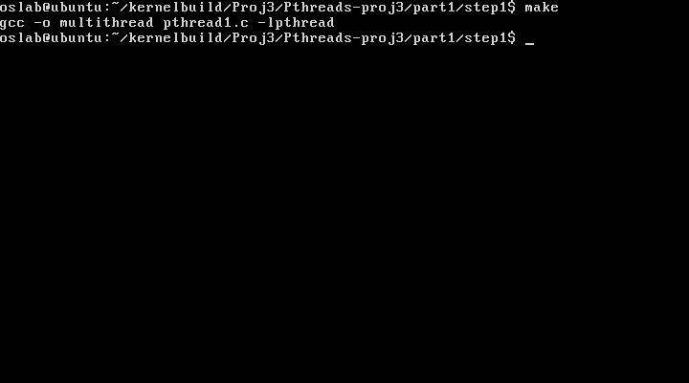

**OUTPUT:**

