Chapter 2 - Language
Σ = {a}

L = "any non-empty string of alphabet characters in a word", then
L = {a, aa, aaa, aaaa, …}, or
L = {a^{n}, for n = 1, 2, 3, 4, …}

Concatenation: Taking 2 strings and combining them
Length
- length(abba) = 3
- length(428) = 3
- length(Λ) = 0 Λ = null

Reverse
- reverse(ab) = ba
- reverse(1302) = 2031

Kleene Closure
- Kleene Closure (or Kleene Star) is an operation that can be applied to either the alphabet or language
  - Σ* is alphabet
  - S* is language
  - S* = S**, it means more Kleene Star operations is redundant

EX
Σ = {a, b}
Σ* = {Λ, Length 0
a, b, Length 1
aa, ab, ba, bb, Length 2 2² = 4 words
aaa, aab, aba, abb, baa, bab, bba, bbb, Length 3 2³ = 8 words
aaaa, …}, Length 4 2⁴ = 16 words

S = {aa, b}
S* = {Λ,
b,
aa, bb,
aab, baa, bbb,
aaaa, aabb, baab, bbaa, bbbb,
aaaab, …}
-----------------------------------------------------------------------------------------------------------------------------
Chapter 3 - Recursive Definitions
Recursive is a three step process
- First, we specify some basic objects in a set
- Second, we give rules for constructing more objects in the set from the ones we know
- Third, we declare that no objects except those constructed in this way are allowed in the set
It's easy to use recursive definition to prove that "something is possible" or "something is not possible"

EX
Recursive for Integer
INTEGER = set of integers
- Rule(Step) 1: 1 is an INTEGER
- Rule(Step) 2: if x is in INTEGER, then so is x+1 and x-1
- Rule(Step) 3: Optional. The only elements in the set INTEGER are those that can be produced from two rules(steps) above
Recursive Definition for set S*, based on language S
- Rule 1: all the words of S are in S*, Λ is also in S*
- Rule 2: if x and y are in S*, then so is their concatenation xy
-----------------------------------------------------------------------------------------------------------------------------
Chapter 4 - Regular Expression
Regular Expression vs Wildcard characters (*, ?)
- Wildcards only provide limited forms of patterns
- A regular expression, often called a pattern, is an expression that specifies a set of strings. Rules are often more concise than lists of a set's members
Regular Expression is different in this course

EX
Given a language L = {Λ, a, aa, aaa, …}
And another language S = {a}
We know L = S*
A new notation to indicate some sequence of a's, maybe none at all: a*
a* = Λ or a or aa or aaa or aaaa or …
L = language (S*)

The expression a* indicates:
- Some sequence of a's (maybe not all)
- A string of a's, but we do not specify how many
- Any string of a's in the language L
- A arbitrary concatenation of copies of a (maybe not all)
The expression a* is not
- A set
- A language

EX
- (ab)* = Λ or ab or abab or ababab or …
- ab* = a or ab or abb or abbb or abbbb or …
- a*b* = Λ or a or b or ab or aa or bb …
- ab*a = aa or aba or abba or abbba or …

The "+" is an expression that mean or
(a + aa) means a or aa
To generate a string from expression, we must decide whether to choose the left-side or the right-side of the expression

EX
- a+b: a or b
- a(a+b): aa or ab
- (a+b)b: ab or bb
- (a+b)(a+b): aa or ab or ba or bb
- (a+b)*: Λ or a or b or aa or ab or ba or bb or ..
- a(a+b)* : a followed by anything
- aa*bb*: ab or aab or abb or ..

The symbols that appear in regular expressions are letters of the alphabet, the symbol for the null string (Λ), parenthesis, the star operator, and the plus sign
- Rule 1: Λ is a regular expression and every letter in the alphabet is a regular expression (bold face)
- Rule 2: if w is a regular expression, so are (w) and w*
- Rule 3: if w and v are regular expressions, so are wv and w+v
  - Language of all words containing at least one a can be represented by (a+b)* a(a+b)*
  - Language of all words containing at least two a's can be represented by (a+b)*ab*ab*
  - Language of all words containing exactly two a's can be represented by b*ab*ab*
(a+b)* can be a or b or ab or ba…
a*+b* can be a or b or aa or bb…
-----------------------------------------------------------------------------------------------------------------------------
Chapter 5 - Finite Automata
Finite Automaton is a collection of things
- Finite set of states, includes one start state, and zero or more final states (accepting states)
- An alphabet of possible input letters
- Finite set of transitions that tell each state and each letter of the input alphabet which state it should go to next
nextState = f(input, currentState)

Finite - number of possible states and number of letters in the alphabet are finite
Automaton - change of states is automated and totally governed by the input
Automata is plural for Automaton
Use FA to represent "Finite Automaton"

Given an input string, an FA starts in the start state and then reads the symbols in the string one by one, then makes the appropriate state transitions until no input is left

Deterministic - each move is completely defined by the current spot and the input, no context info needed

Set of rules (pg. 54)
Table (pg. 55)
Transition diagram (pg. 56)
Transition function (pg. 55-56)

States
Edges with arrows
"-" start state
"+" final state
Loop
(a+b)a*ba*b(a+b)*
1-->2 needs to read a or b
2-->3 needs to read b
If it reads a, it will loop back
3-->4 needs to read b
If it reads a, it will loop back
4 needs string to be empty
If a or b is there, it will loop back

A FA can discriminate between strings that can cause it to reach a final state and those that can't
There is a language associated with an FA, namely the set of strings that transition to the final state
Can be finite or inifinite

Regular Expression
- Pros: easy to produce some arbitrary words
- Cons: difficult to recognize whether or not a string belongs to the language

FA is opposite
- Pros: easy to understand language
- Cons: difficult to produce words

Two Problems
- Given a language, how can we construct a FA recognizer (if one exists)?
- Given a FA recognizer, how can we define its language?
-----------------------------------------------------------------------------------------------------------------------------
Chapter 6 - Transition Graphs
Relaxing the restriction

Then we can assume that any other input can cause the TG to crash and not access input
Member of states reduced

Q: How does the TG know how many letters to read?
-Different ways to read letters can both accept and reject
A: Relax the operation rules and say that the machine can accept the string if there is some way that it can be processed

TG | FA
- Finite set of states, includes one  start state, zero or more final states | - Finite set of states, includes one  start state, zero or more final states
- Finite set of states, includes one start state,  zero or more final states | - Finite set of states, includes one start state,  zero or more final states
- Finite set of transitions that show how to  go from some states to others by reading  specified substrings | - A finite set of transitions that tell each state  and each letter of the input which state to  go to

GTG
Doesn't restrict ourselves to a finite list of constant strings, we allow a transition label to be a regular expression

Collection of 3 things
- Finite set of states, including one start state, zero or more final states
- An alphabet of possible input letters
- Dedicated edges connecting some pairs of states, labeled with a Regular Expression

Nondeterminism
Simply means that human interpreter rather than the machine determines the path
-----------------------------------------------------------------------------------------------------------------------------
Chapter 7 - Kleene’s Theorem Parts 1, 2, 3
Kleene’s Theorem
- Kleene’s Theorem: Finite Automata (FA), Transition Graphs (TG), and Regular Expressions (RE) have equivalent power when it comes to defining languages; that is, any language that can be defined by one can be defined by all.
- Practically, it means, for example, that if we have a language defined by regular expression we know that we can devise a Finite Automaton or Transition Graph for it.

Proof
- The proof is divided into three parts:
  - For every FA there is a corresponding TG
  - For every TG there is a corresponding RE
  - For every RE there is a corresponding FA

Proof of Kleene’s Theorem: Part 1
- Part 1 is trivially true because every FA is a TG; TGs are more general

Proof of Kleene’s Theorem: Part 2
- Show that for every TG there is a corresponding RE
- Proof is by construction
- We devise an algorithm that we can apply to any TG that will produce the RE
- Our strategy is to do some transformations:
  - Eliminate states one by one
  - Make appropriate changes to REs on the transitions
  - Until we are eft with just a start state and a final state and a RE on the transition between them

Six Transformations - 1
- If there are multiple start states, replace them by a single start state

Six Transformations - 2
- If there are multiple finish states, replace them by a single finish state

Six Transformations- 3
- If a state has more than one loop, replace the multiple loops by a single loop

Six Transformations - 4
- If there is more than one transition from state X to state Y, replace them by a single transition

Six Transformations - 5
- State bypass and elimination: If we have a single transition from state X to state Y and a single transition from state Y to state Z we can bypass state Y and go directly from X to Z

Six Transformations - 6
- A generalization of number 5. If there is a transition from state X to state Y and a single transition from state Y to states Z1, and Z2, … we can bypass state Y with transitions directly from x to Z1, Z2, …

For Every TG there is a corresponding RE
- Careful application of transitions 1 through 6 to an arbitrary TG will result in a TG having just two states, start and finish, and a RE on the single transition from the start state to the finish state. Thus, by construction we show that for every TG there is a corresponding RE.
- Cohen encapsulates the transformation process into an algorithm on pg 106

Proof of Kleene’s Theorem: Part 3
- Need to show that for any RE we can construct a FA that recognizes the language it represents.
- The strategy is to
  - Start with known FA for very simple RE
  - A complete RE can be obtained by combining simple REs using choice, sequence and iteration
  - Then we need to find methods to combine simple FA into a complicated one for choice, sequence and iteration

[(aa+bb)(aa+bb)*(aa+bb)+aa+bb]*

Choice/union Sequence/product Iteration

Proof by Recursive Definition and Parallel Construction
- Rule 1 (base cases): There is an FA that accepts a single character in Σ. There is an FA that accepts an Λ

- Rule 2 (choice/union): If FA1 accepts RE1 and FA2 accepts RE2 we can construct FA3 that accepts RE1 + RE2 (pg. 109)
  - Algorithm for constructing the Union of two machines:
    - We imagine an input string being processed simultaneously on FA1 and FA2 and each z state represents “x_something or y_something”
    - We keep track of what state the input would take us to in FA1 and what state it would take us to in FA2 and we create enough composite states to represent the reachable two-state combinations
    - This must be a finite number because the number of states in FA1 and the number of states in FA2 are both finite
    - Each new state (z-state) corresponds to some combination of x-states and y-states
- Rule 3 (sequence/product): If FA1 accepts RE1 ad FA2 accepts RE2 we can construct FA3 that accepts RE1RE2 (pg. 117)
- Rule 4 (iteration) If FA1 accepts RE1 we can construct FA2 that accepts (RE1)* (pg. 125)
——————————————————————————————————————————
Chapter 9 - Regular Language
- Regular Language: those that can be defined by a regular expression
- In this chapter, we will learn some results(Theorems) about regular languages
- Not all languages are regular
- An example of non-regular language:
  - { () (()) ()() ((())) (()()) ()()() (())() }

Theorem 10:
- If L1 and L2 are regular languages then so are the languages
  - L1L2
  - L1+L2
  - L1*
- L1L2: language of all words formed by concatenating a word from L1 with a word from L2
- L1+L2: language of all words in either L1 or L2
- L1*: strings that are the concatenation of arbitrarily many factors from L1

Proof for Theorem 10:
- Proof 1: (by regular expressions) this seems obvious given what we know about the construction of regular expressions
  - By definition there must be regular expressions that define L1 and L2. Call these regular expressions R1 and R2
  - We can make new expressions R1R2, R1+R2, (R1)* that we define the three languages above making them regular languages too

Complements:
- Definition: the complement of a language is simply the set of strings that it does not contain
- Use L’ to represent the complement of language L (L’ means L prime)
- Example: L = all words with a double a in them, for alphabet {a, b}, then its complement language L’ is all words that do not have a double a

Theorem 11:
- Proof:
  - Kleene’s Theorem showed that there must be an FA that accepts L
  - Therefore we just modify this FA to make it accept L’ instead
  - The existence of this new machine must mean that L’ is regular (again by Kleene’s Theorem)
  - The modification we make to the FA is to make the final states non-final states and vice versa
- See Example 09.01

Intersections:
- Definition: the intersection of two languages L1, L2 is simply the set of strings that occurs both in L1 and in L2
- Use L1 ∩ L2 to represent intersection
- Theorem 12: If L1 and L2 are regular then so is L1 ∩ L2

——————————————————————————————————————————
Chapter 10 - Non-regular Languages
Definition:
- Non-regular Language: those that can not be defined by regular expression
- Non-regular languages cannot be accepted by FA or TG
- Any languages are either regular or non-regular

Example 10.01: Regular and Non-regular languages
- Regular Languages:
  - a^{n}b^{n} 1 < n < 100
  - a^{n}b^{m} m,n >= 1 aa*bb*

- Non-regular languages
  - a^{n}b^{n} n > 1

Theorem 13: Pumping Lemma
- If L is a regular infinite language then there exists some three strings x, y, and x, such that all the strings of the form (xy^{n}z for n = 1 2 3 …) are words in L
  - Where x and z are strings , possibly null
  - y is a non null-string, and
  - n > 0

Proof for Theorem 13:
- If w is a string with more letters than our FA recognizer has states then we can divide w into three parts x, y, and z
  - x is that part of the string processed pre-loop (from beginning lead up to the first state that is revisited)
  - y is that part of the string processed in a loop (start at the letter after the substring x, travels around the cycle coming back to the same state the cycle began with), y contains the letters of w for exactly one loop around the cycle. Because there must be a cycle, y cannot be null
  - z is that part of the string processed post loop (rest of w starting after substring y to the end of w), the path for z could also be a cycle, and what z does is arbitrary,
- Clearly, w = xyz, it is applied to xyyz, xyyyz, …
- See Example 10.02

Example 10.03 Language {a^{n}b^{n}, n > 1}
- The Pumping Lemma says that there must be strings x, y, and z, where y is not null, such that all words of the form xy^{n}z are in L. Is there anyway we can identify x, y and z for the language a^{n}b^{n}?
  - A typical string in a^{n}b^{n} is aaabbb
  - Question revolves found the identity of y
  - If it contains only a's then where we pump it, the string will have more a's than b's
  - If it contains only b's then when we pump it, the string will have more b's than a's
  - It cannot contain both a's and b's because the only part of the string having both a and b is the part where the a's stop and the b's begin, If we set y = ab for example then when we pump it we would get abab
  - So no strings x,y,z with the appropriate properties exist
  - So a^{n}b^{n} is non-regular

Example 10.04 Language {a^{n}ba^{n}, n > 1}
- A typical string in a^{n}ba^{n} is aaabaaa
- Let us try to find a substring y:
  - If it contains only a's from the left part, then when we pump it, the string will have more a's in the left part than the right part
  - If it contains only a's from the right part, then when we pump it, the string will have more a's in the right part than the left part
  - It cannot contain both a's and b's because when we pump it, we are going to have more than one b
  - So no strings x,y,z with the appropriate properties exist
  - So a^{n}ba^{n} is non-regular

Key Points about Pumping Lemma
- Every regular infinite language satisfies the pumping lemma
- Some non-regular languages also satisfy the pumping lemma, but not all (pg. 195)
- Pumping lemma can be used to check if a language is non-regular, but cannot be used to check if a language is regular
-----------------------------------------------------------------------------------------------------------------------------
Chapter 11 - Decidability
Definition:
- A problem is decidable if there is an algorithm for it that will produce a yes/no answer in a finite number of steps

Three Problems:
- Question 1: Can we tell if two RE define the same language?
- Question 2: Can we tell if two FA define the same language?
- Question 3: Can we tell if the language accepted by a FA has:
  - Zero words?
  - A finite number of words?
  - An infinite number of words?

The Answer to Question 1 and 2:
- Question 1 is virtually the same as question 2
- To test if languages L1 and L2 are equivalent using either RE or FA, we produce an FA that accepts (L1 ∩ L2') + (L2 ∩ L1')
  - This machine accepts strings that are in one language but not the other. If this machine accepts every one word then the two languages are not equivalent

Theorem 17:
- Theorem 17: Let F be a FA with N states. Then if F accepts any words at all, it accepts some word with N or fewer letters
- Proof: This seems reasonable. It cannot accept only words with more than N letters because to do that it would have to traverse a loop because there are only N states. We can then derive a shorter word by omitting the loop circuit

Theorem 18:
- Theorem 18: There is an effective procedure to decide whether:
  - A given FA accepts any words
  - Two FAs are equivalent
  - Two REs are equivalent
- See Example 11.01

The Answer to Question 3
- Question 3: How can we tell whether a FA, or a RE, defines a finite language or infinite language?
- Theorem 17: Let F be a FA with N states. Then if F accepts any words at all, it accepts some word with N or fewer letters.
  - So try all possible inputs with N or fewer letters
- How many words does an FA accept? Note that if the FA, with N states, accepts a word w with length N <= length(w) <= 2*N, then it accepts any infinite number of words
  - This is because the acceptance must involve a loop and we can choose to go round that loop as many times as we wish
  - By using 2*N upper bound we can give ourselves a finite number of strings to test
-Consider the language Σ* , where Σ={a, b, c, d}, how many length-3 words does this language have? : 64
-How does the TG know how many letters to read from the input? : The TG may choose any way to read from the input.
-Turnstile cannot start from the locked or unlocked state; cannot lock or unlock itself without any operations, such as push or add-coin; it is a FA
-Vending maching false statements: in the state machine, each state has at most one incoming transition and at least one out-going transition : in the state machine, there is only one out-going transition for each state: in the state machine, each state requires an input single in order to move to another state
-Transition graphs, true statement: every finite automaton must be a TG. False statements: every TG is a FA, A TG may have no start states, a FA may or may not be a TG.
-A TG may choose any way to read from the input
-Vending machine True statement, there are 5 transitions
-Vending machine False statements: in the machine, there is only one out-going transition for each state, in the state machine, each state has at most one incoming transition and at least one out-going transition. In the state machine, each state requires an input single in order to move to another state.
-Chapter 7 part 3 (ch07.03 Theorem Part 3 RE to FA) discusses the algorithm to construct the union of two machines. On page 4 of the powerpoint pdf file (ch07.03 Theorem Part 3 RE to FA.pdf), it indicates that each new state in the union machine corresponds to some combination of x-states and y-states, where x-states represents the states from FA1, y-states represents the states from FA2. In this problem, FA1 has 9 states and FA2 has 12 states, what is the maximum possible number of states in the union FA1+FA2? : 108
Select the false statement. (Note: TG = Transition Graph, FA = Finite Automata, RE = Regular Expression) : When a formal language can be defined by a TG, it may not be defined by a FA.
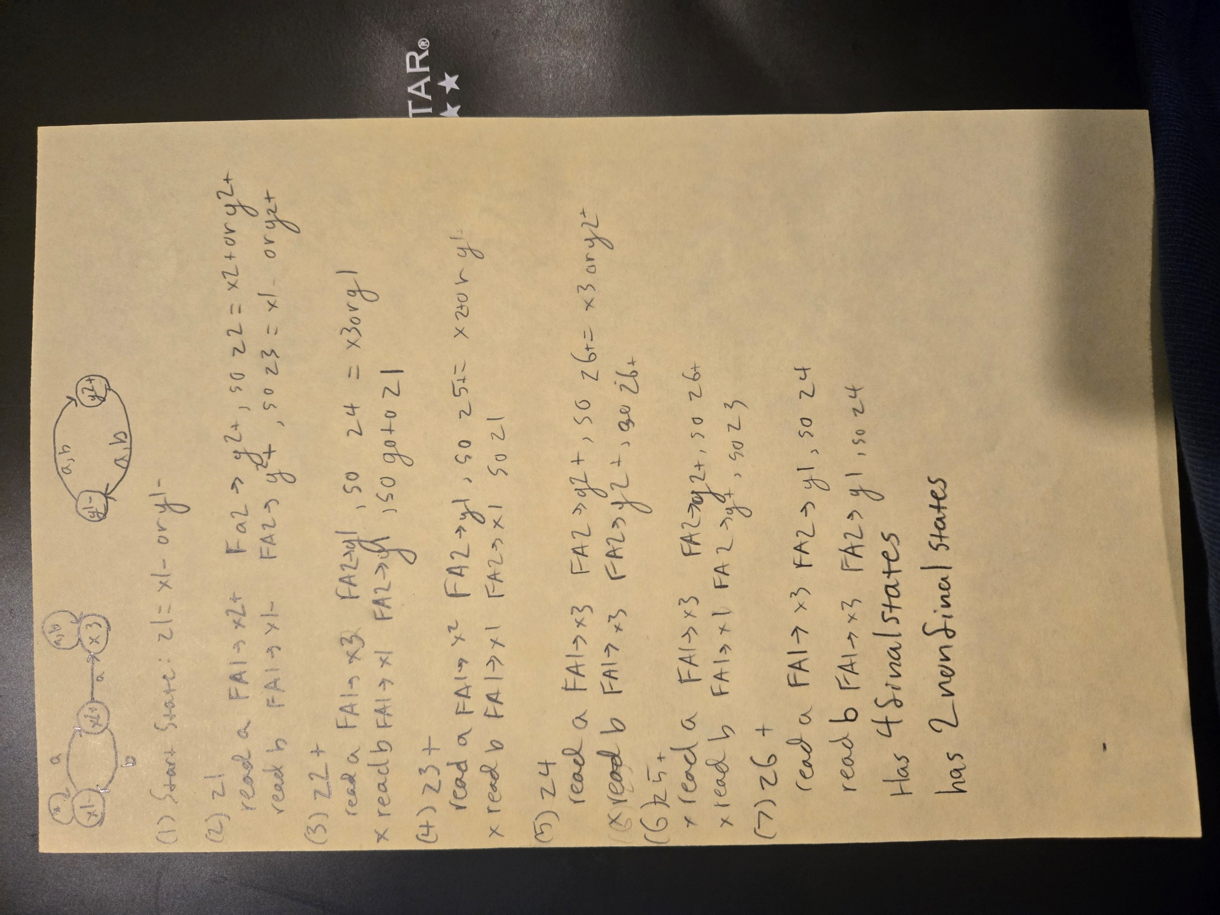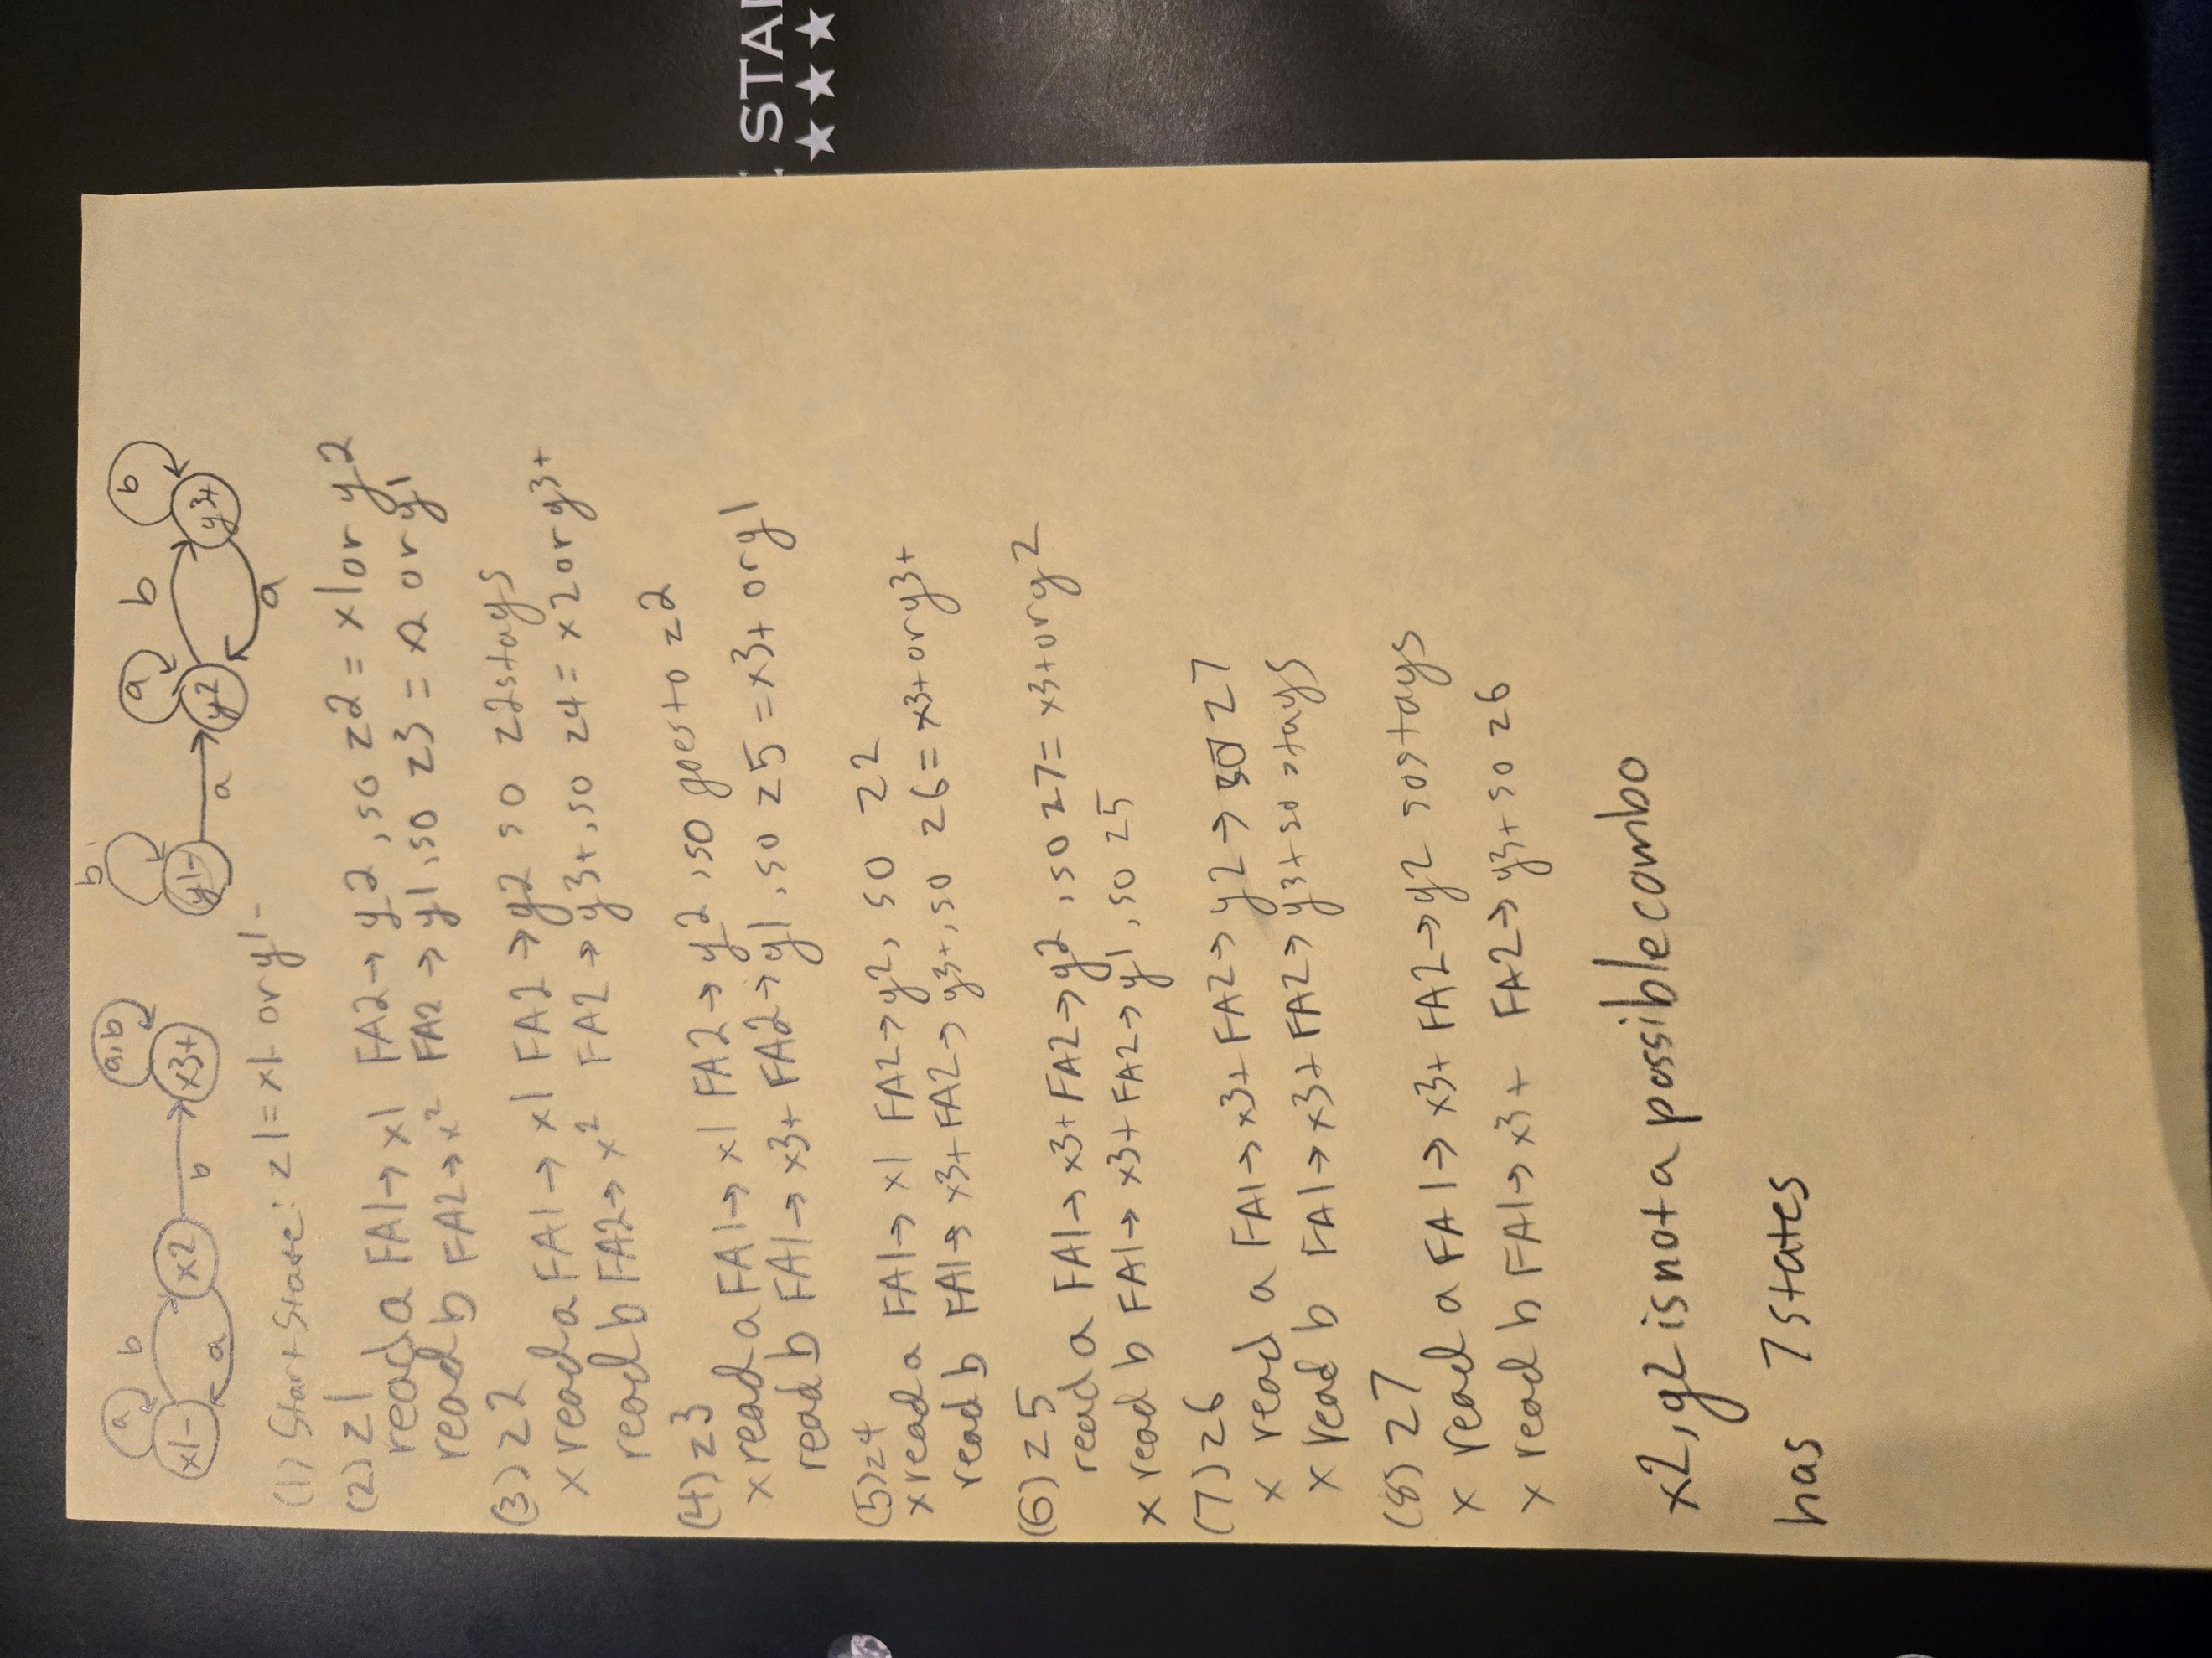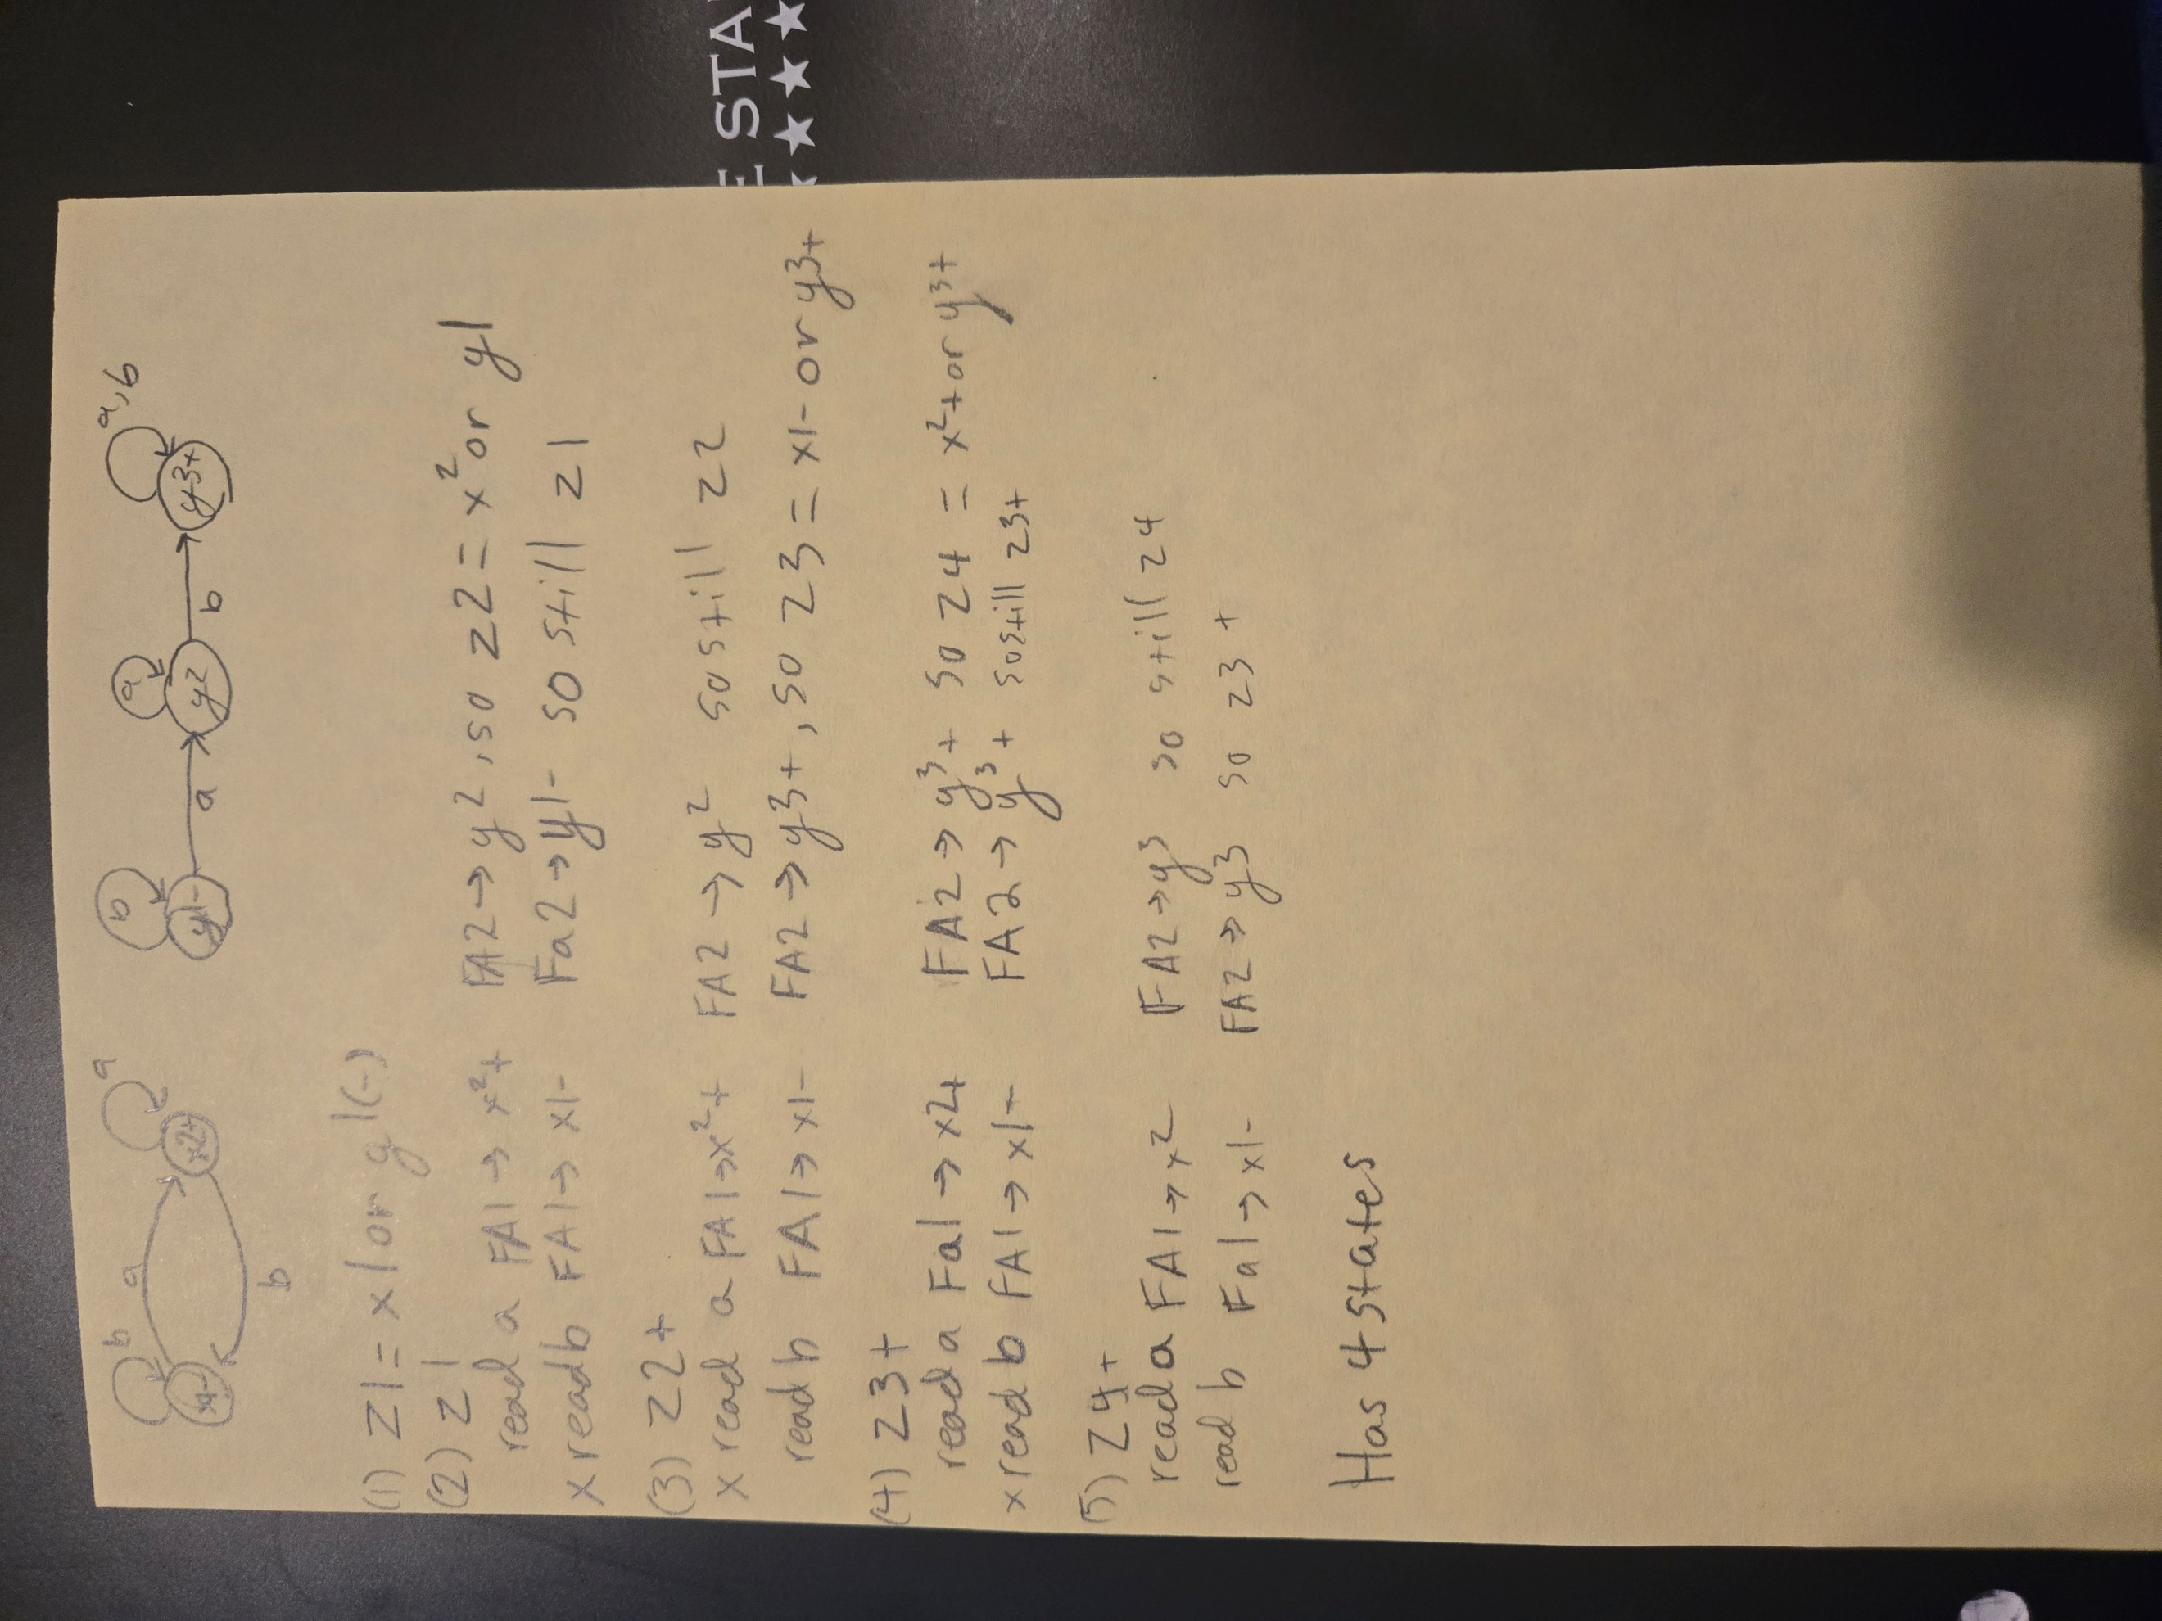

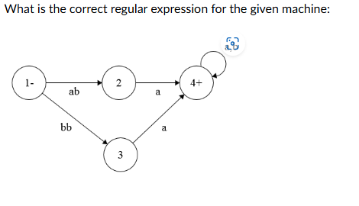(a+b)ba(a+b)* (I think) 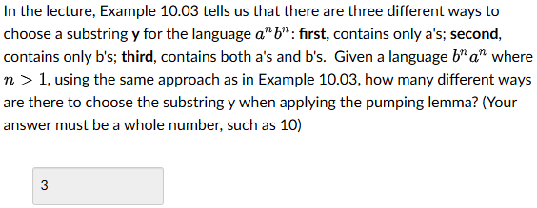

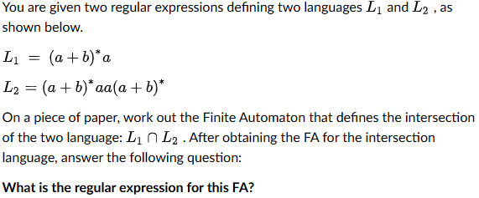(a+b)*aa(a+b)*a + (a+b)*aa, cannot jump from start to final state in one move
If a Finite Automaton has 10 states and it accepts a length-16 string, it must accept infinite number of words.
Which of the following language is a non-regular language but also satisfies the pumping lemma? Palindrome
Which of the following statements is true about decidability? There exists an algorithm to tell whether or not any Finite Automaton accepts any words.
