Team 3 Robot Specification Sheet

Team members: LIANG JIAJUN 55676605 CS, Chan Long Ting Joey 56201394 MNE, Yu Yui Lun 55704240 EE, SEW Kin Hang 56614778 CS

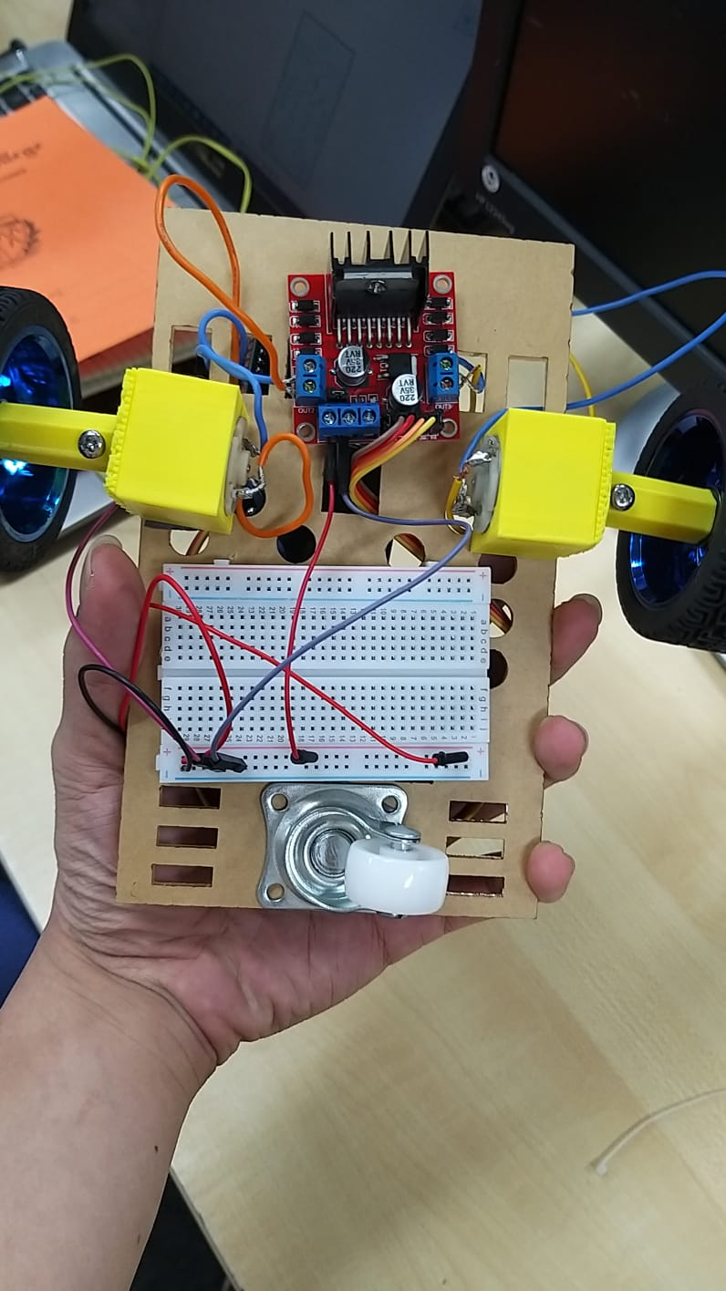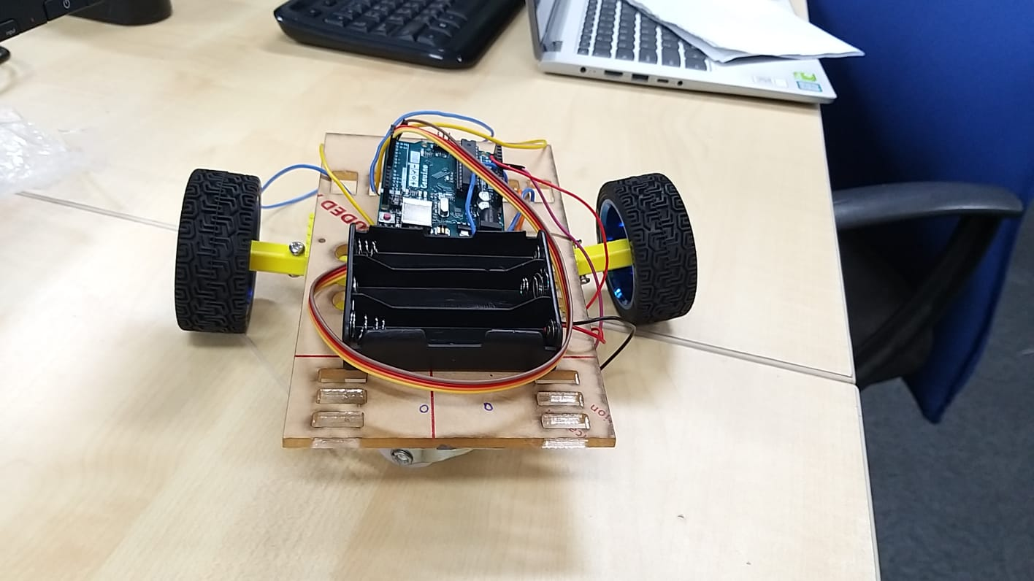

Our robot is implemented with two control modes, one manual and one automatic. For the manual control mode, the robot can perform simple directional movements, including moving forward, backward, turning left and right. For the automatic control mode, the performance involves the detection of obstacles using ultrasonic sensors, and path picking based on the detected results.

Material Used:

|  |  |
| --- | --- |
| Arduino Uno | 1 |
| Motor | 2 |
| L298N | 1 |
| Wheels | 2 |
| HC-SR04 | 2 |
| Breadboard | 1 |
| HC-06 | 1 |
| Omni-directional wheel | 1 |
| 18650 Battery Box | 1 |
| 18650 Battery | 3 |
| Acrylic Board | 1 |

Task 1 Introduction

In task 1, we implemented a left-handed wall follower algorithm.

Attached two ultrasonic sensors at the front and at the left, the robot follows these

rules:

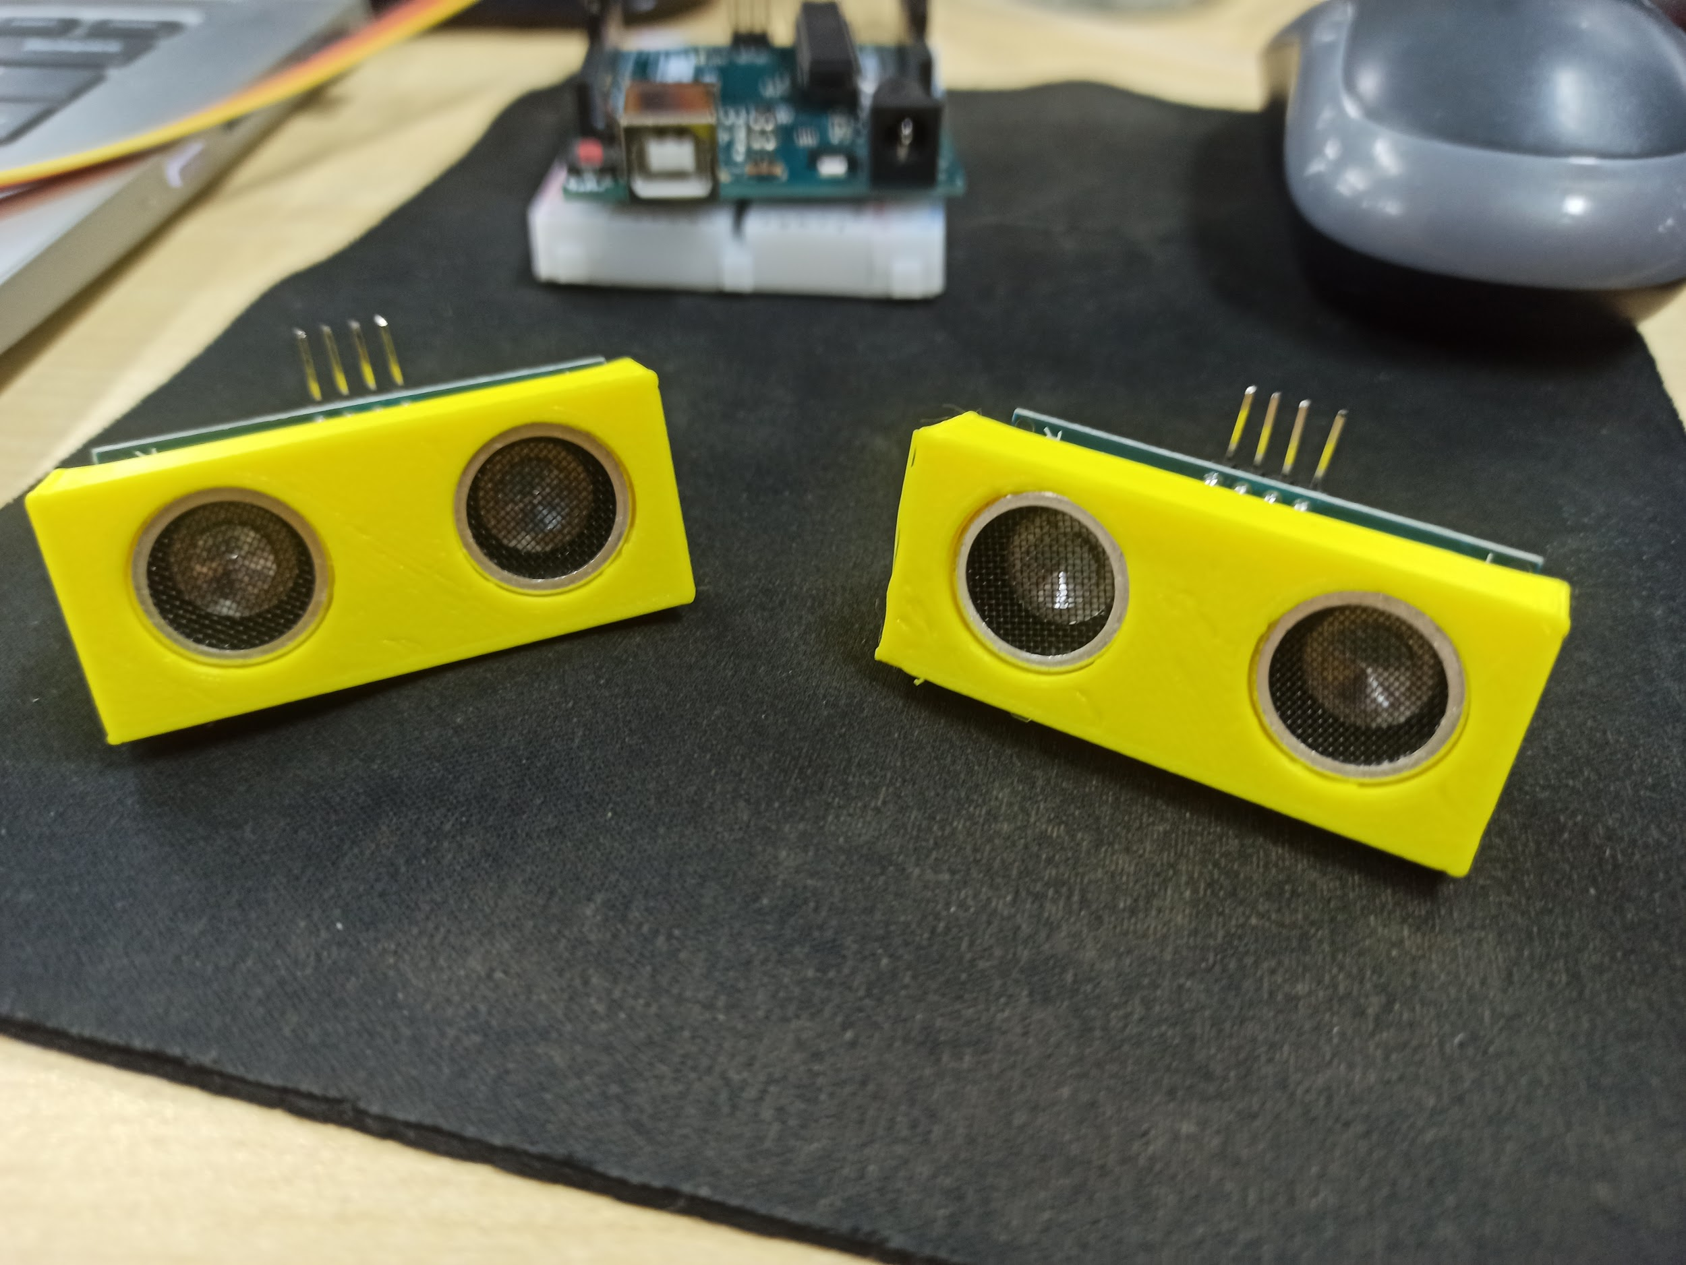

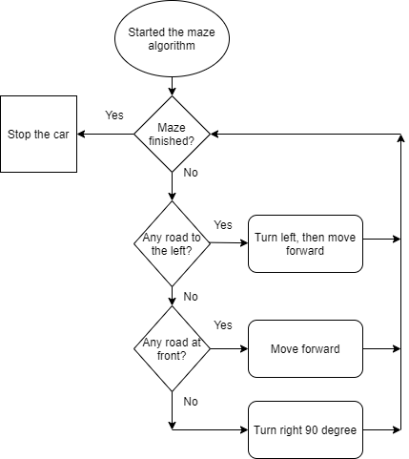

The right photo shows ultrasonic sensor holders from 3D printing.

Task 2 Introduction

During task 2, the manual mode will be used. Operations will only involve movements in forward and backward and turning left and right. The operation will be done by driving the vehicle towards the objects while avoiding the obstacles and bringing the objects back to the starting point through the action of pushing the 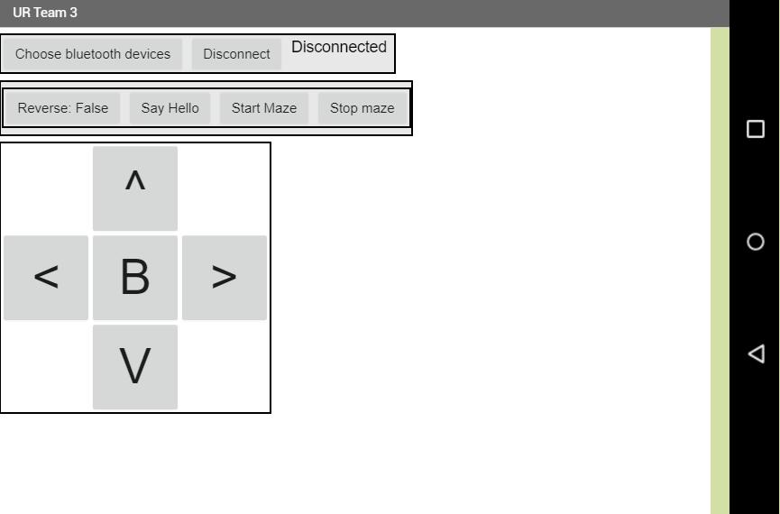objects through the spade. 