

**Meiosis Lab**

Mitosis

Review mitosis by matching each of the phases of mitosis to the corresponding pictures.

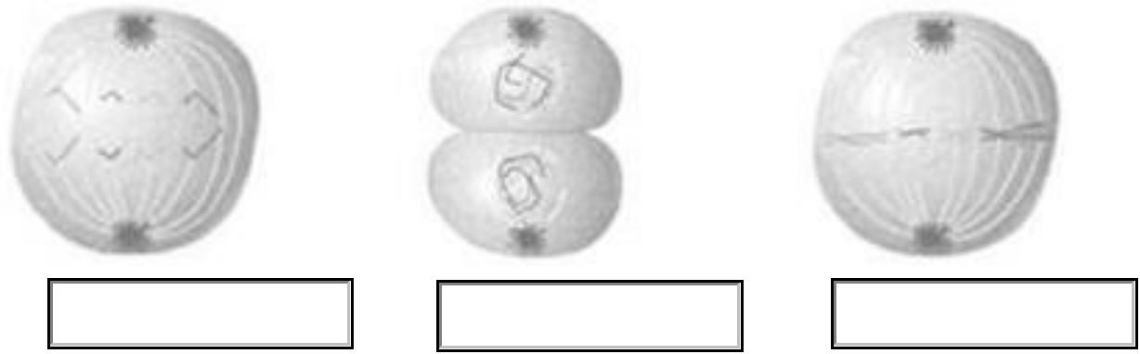

1. Anaphase 2. Telophase 3. Metaphase

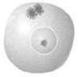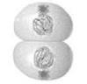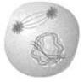

|  |  |  |
| --- | --- | --- |
| 4. Prophase | 5. Cytokinesis | 6. Interphase |
| The Phases of Mitosis |  |  |
| A. Anaphase B. Cytokinesis | C. Interphase | D. Metaphase E. Prophase F. Telophase |



Next, review MEIOSIS by reading the material in the lessons and modeling the phases IF you have pipe cleaners and beads.

Two very good animations of MEIOSIS are on the following sites: http://www.biology.arizona.edu/cell_bio/tutorials/meiosis/page3.html http://www.stolaf.edu/people/giannini/flashanimat/celldivision/meiosis.swf

The following site compares the two processes:

http://www.pbs.org/wgbh/nova/body/how-cells-divide.html

The following are features of mitosis or meiosis:

allows for transmission of chromosomes to offspring, necessary for growth and regeneration, allows for regeneration of an organism, two identical diploid cells are formed, found in organisms that contain male and female, allows for sexual reproduction, asexual reproduction, Four haploid cells are formed, necessary for species survival, performed in all organisms

© K12 Inc.



Which of these features corresponds to mitosis?



Necessary for growth and regeneration, two identical diploid cells are formed, allows for regeneration

Of an organism, asexual reproduction, necessary for species survival, performed in all organisms.

Which of the features below corresponds to meiosis?



Four haploid cells are formed, necessary for species survival, found in organisms that contain male and

Female, allows for sexual reproduction, allow for transmission of chromosome to offspring.

Phases of Meiosis

Answer choices for A-H in the diagrams below. Use each once for the diagram group: prophase I, prophase II, metaphase I, metaphase II, anaphase I, anaphase II, telophase I, telophase II.

Label each of the following phases of meiosis:

A.

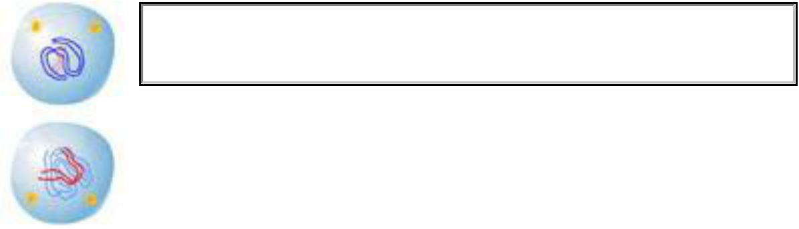

Prophase II



B.



Anaphase I



C.

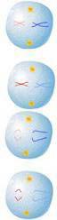

Metaphase II

D.



Anaphase II

© K12 Inc.

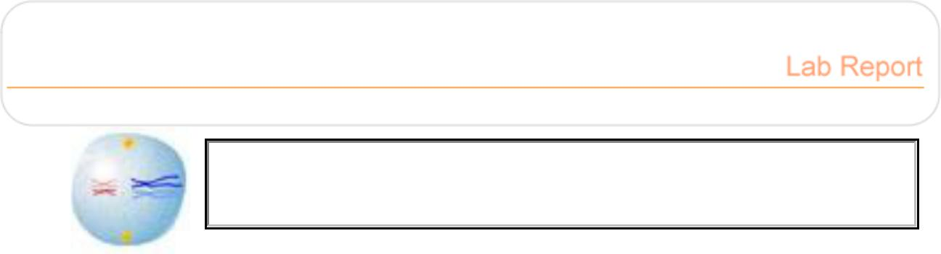

E.

Metaphase I

F.

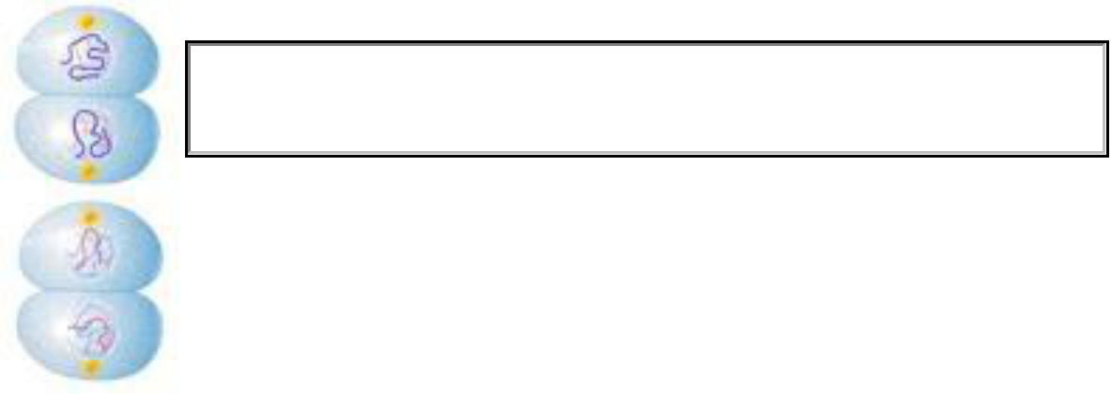

Telophase II

G.

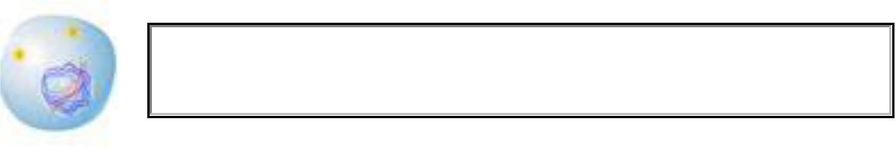

Prophase I

H.

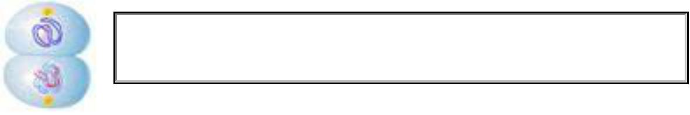

Telophase I

Place each of the phases of meiosis in the correct order. You may use the letter labels or names.



1. Prophase I
2. Metaphase I
3. Anaphase I
4. Telophase I
5. Prophase II
6. Metphase II
7. Anaphase II
8. Telophase II

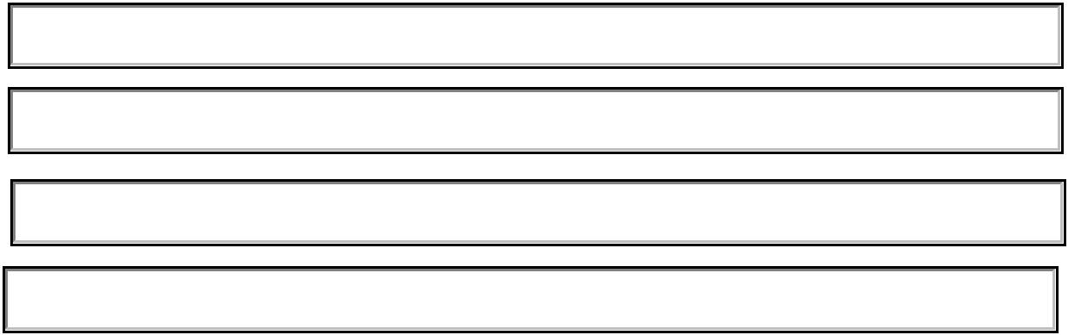

© K12 Inc.



What is the result of each phase of meiosis?



After Prophase I we obtain condensed homologous chromosomes pairs joined by a process called Synapsis forming tetrads and with some genetic material being crossed by a process called Crossin-over.

In metaphase I these tetrads are positioned at the cell’s equator and spindle fibers attach to the centromeres of each pair.

During anaphase I tetrads are split up and each replicate of chromosomes move to opposite sides of the cell. It is important to notice that centromeres remain intact.

On telophase I cell membrane might reform, spindle fibers detach and the cell is split.

Then comes cytokinesis which produces 2 haploid cells

Next during Prophase II spindle fibers reform and chromosomes and their duplicates are present. But not the other set of chromosomes so there is now haploid cells with duplicate genetic material.

During metaphase II chromosomes are positioned at the equated and the spindle fibers attach to the centromere.

In anaphase II the centromeres split and the separate chromosomes are pulled to opposite sides.

In telophase II nucleolus reforms, the chromosomes uncoil into chromatin and the nuclear envelop reappears. Cytokinesis happens next and separates the new cells.

Refer to the diagram BELOW to answer the following:

Compare the number of male and female diploid cells needed to produce equal amounts of sperm and egg cells.

Spermatogenesis produces 4 cells, oogenesis produces 1 cell.

Therefore you need 4 female diploid cells per male diploid cell to produce the same amount of ovum and sperm. Because they have a ratio of 1:4

Which cell is bigger the male or female? Why?



The female Egg. There are 2 major types of Gametogenesis: Spermatogenesis (which produces sperms) and Oogenesis (that produces Ova).

Spermatogenesis produces 4 haploid cells that only have some chromosomes and a small portion of mitochondria.

While Oogenesis output only one ‘oocyte’ and three small polar bodies. This process places most of the cytoplasm (organelles, materials, nutrition) into one large cell (the egg).

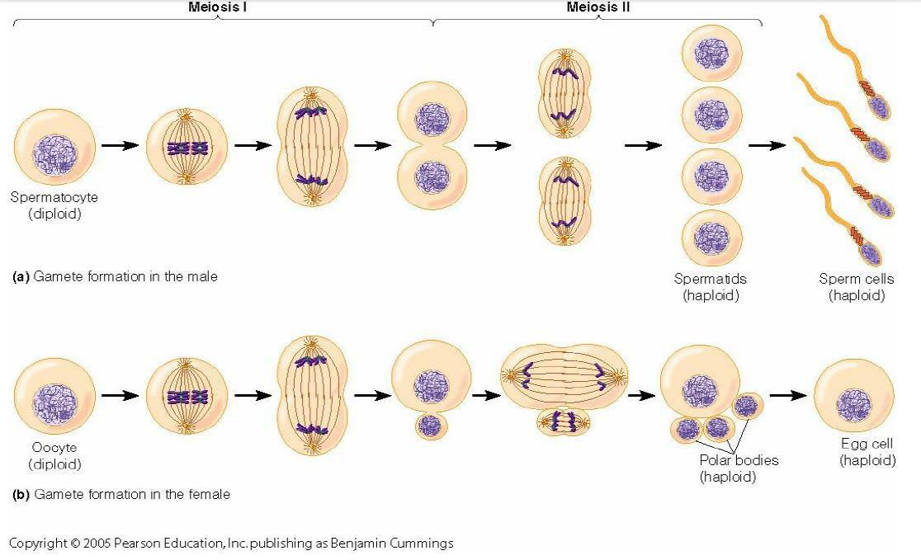

© K12 Inc.