Mitosis Lab

Mitosis in Onion Root Tips
Make a sketch of a representative cell in each of the four stages of mitosis in the space provided below.
Prophase | Metaphase | Anaphase | Telophase
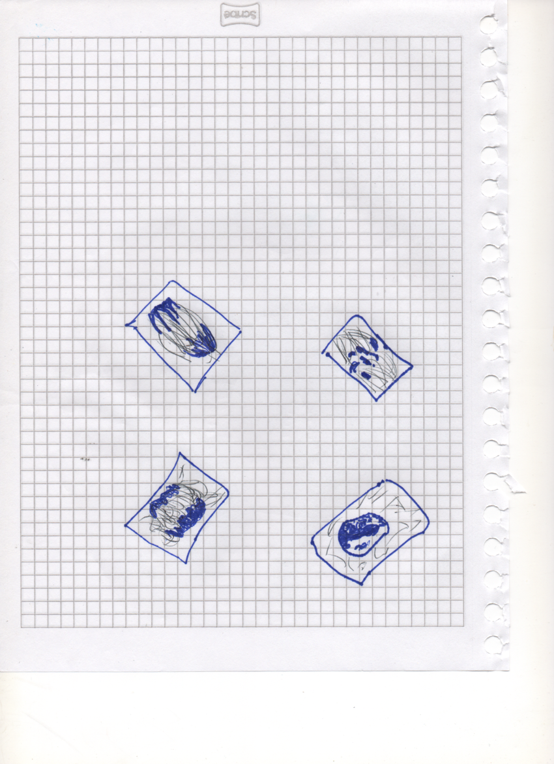

Can you distinguish any cells?
Ashleigh183

Are some cells longer than others?

Looking near the root tip (but not at the root cap), can you see any cells in the process of cell division?

 | Interphase | Prophase | Metaphase | Anaphase | Telophase | Total
Number of cells | 20 | 10 | 3 | 2 | 1 | 36
Percent of cells |  |  |  |  |  | 100%
Number of minutes spent in phase |  |  |  |  |  | 960 min

Insert your pie chart here:

Mitosis in Animal Cells
Summarize the differences between mitosis in plants and animals.

Modeling the Stages of Mitosis
Note: This part is optional. If you do not have the materials necessary, please search for animations of mitosis using an Internet search engine.

Searching Websites:

Conduct a keyword search to find websites. To begin a keyword search, start by searching broad terms such as mitosis, cell division, mitosis animation. The resulting list of websites can give you a lot of information, but how do you know if it is reliable? Some basic guidelines can help you when you open a website and try to determine its reliability.

Always consider a site's:

- Objectivity - Excessive expressions of emotion, opinions, and stereotyping are tip-offs that the information on a site may be biased.
- Ownership and contributors - Go to the Home or About page of the website and find out who sponsors and writes for the site. Look for contributors who have reliable credentials, such as "Harvey Jones, Professor, University of Wisconsin—Madison."
- Writing style and mechanics - Check the grammar, spelling, and writing style on the site. Errors and awkwardness are signs of a nonprofessional website.
- Currency - Look for publication or copyright dates associated with the site; the more current the better.
- Links - What links does the site contain? A reliable website will offer links to other reliable websites, not to "junk" sites.

Keyword Search: mitosis, cell division, mitosis animation

