

**Assignment: Correcting Polynomial Root Responses**

Part 1 – Who’s Right?

Each of the following questions has been answered by two students, Edgar and Emily. In each case, one student’s answer is correct, and the other student’s answer is incorrect. Decide which student is right and then describe the other student’s misconceptions.

For each question:

1. State which student’s response is correct.
2. Identify and correct the misconceptions in the incorrect student’s response.
3. Write 2-3 sentences describing the incorrect student’s mistakes and how it should be corrected.

Problem 1 is an example. Use it as a guide for answering the problems that follow. 1. Write a polynomial equation of the smallest degree with roots 1, 5, and -2.

|  |  |
| --- | --- |
| Edgar | Emily |

|  |  |  |  |  |  |  |  |  |  |  |  |  |  |  |  |  |  |  |  |  |  |  |  |  |  |  |  |  |  |  |  |  |
| --- | --- | --- | --- | --- | --- | --- | --- | --- | --- | --- | --- | --- | --- | --- | --- | --- | --- | --- | --- | --- | --- | --- | --- | --- | --- | --- | --- | --- | --- | --- | --- | --- |
| *r* |  |  1, *r* | |  |  |  5, *r* | | |  |  2 | | |  |  |  | *r* |  |  1, *r* | |  |  |  5, *r* | | | |  2 | | |  |  |  |  |
| 1 | |  | 2 | |  |  |  | 3 | |  |  |  |  |  |  | 1 | |  | 2 | |  |  |  |  | 3 |  |  |  |  |  |  |  |
| *x* 1*x*  5*x*  2  0 | | | | | | | | | | | | | |  |  | *x*  1*x*  5*x*  2  0 | | | | | | | | | | | | | |  |  |  |
|  |  |  |  |  |  |  | 2 |  |  |  |  |  |  |  |  |  |  |  |  |  |  | 2 |  |  |  |  |  |  |  |  |
|  | *x* | | 1 | *x* | | |  2*x*  5*x* 10 | | | | | |  |  0 |  | *x* | | 1 | *x* | | | − 2*x*  5*x* 10 | | | | | |  |  0 |  |
|  |  |  |  |  |  |  | 2 |  |  |  |  |  |  |  |  |  |  |  |  |  |  |  | 2 |  |  |  |  |  |  |  |  |  |
|  | *x* | | 1 | *x* | | | − 3*x* 10 | | | |  |  0 |  |  |  | *x* | | 1 | *x* | | |  3*x* 10 | | | |  |  0 |  |  |  |
| *x* | | 3 | − 3*x* | 2 | |  | 10*x*  *x* | | | | 2 |  3*x* | |  10  0 | | *x* | | 3 |  3*x* | 2 | |  | 10*x*  *x* | | | | 2 | − 3*x* | |  10  0 | |  |
|  |  |  |  |  |  |  |  |  |  |  |
| *x* | | 3 | − 4*x* | 2 | |  | − 7*x*  10  0 | | | | | | |  |  | *x* | | 3 |  2*x* | 2 | |  | 13*x*  10  0 | | | | | | |  |  |  |
|  |  |  |  |  |  |  |  |  |  |  |  |  |
| *f* (*x* ) *x* | | | | | 3 | | − 4*x* | | 2 | − 7*x* | | |  10 | |  | *f* (*x* ) *x* | | | | | 3 | |  2*x* | | 2 | 13*x*  10 | | | | |  |  |
|  |  |  |  |  |  |  |  |  |

Answers:

1. Emily’s answer is incorrect.
2. Emily made the following mistake:

*x* 1 *x*  5 *x*  2   0

The corrected answer is:

*x* 1 *x*  5 *x*  2   0

c. Emily’s mistake was in changing the roots of the polynomial into factors. When writing the factors, it is important to take the opposite of the root. For example, the first root was *r1* ** *1* .

This makes the corresponding root

*x*

1

.

© K12 Inc.



2. Write a polynomial equation of the smallest degree with roots 3, 4*i*, and -4*i*.

|  |  |
| --- | --- |
| **Edgar** | **Emily** |

|  |  |  |  |  |  |  |  |  |  |  |  |  |  |  |  |  |  |  |  |  |  |  |
| --- | --- | --- | --- | --- | --- | --- | --- | --- | --- | --- | --- | --- | --- | --- | --- | --- | --- | --- | --- | --- | --- | --- |
| *r* |  3,*r* | |  4*i* , *r* | | | |  |  4*i* |  |  | *r* |  3,*r* | |  4*i* , *r* | | | |  |  4*i* |  |  |  |
| 1 |  | 2 |  |  |  | 3 | |  |  |  | 1 |  | 2 |  |  |  | 3 | |  |  |  |  |
| *x*  3*x*  4*i* *x*  4*i*   0 | | | | | | | | |  |  | *x*  3*x*  4*i* *x*  4*i*   0 | | | | | | | | |  |  |  |
| *x*  3*x* | | | | 2 |  4*ix*  4*ix* 16*i* | | | | 2 |   0 | *x*  3*x* | | | | 2 |  4*ix*  4*ix* 16*i* | | | | 2 |   0 |  |
|  |  |  |  |  |
| *x*  3*x* | | | | 2 | − 16 | | |   0 |  |  | *x*  3*x* | | | | 2 |  16 | | |   0 |  |  |  |
|  |  |  |  |  |  |  |
| *x* | 3 | 16*x*  3*x* | | | | 2 | |  48  0 |  |  | *x* | 3 |  16*x*  3*x* | | | | 2 | | − 48  0 |  |  |  |
|  |  |  |  |  |  |  |  |  |  |  |
| *f* (*x* ) *x* | | | 3 | − 3*x* | | | 2 | 16*x*  48 |  |  | *f* (*x* ) *x* | | | 3 | − 3*x* | | | 2 |  16*x*  48 |  |  |  |
|  |  |  |  |  |  |  |  |  |



kjm

3. Identify the roots for the equation

*x*  2 *x*  6*i* *x*  6*i* 



0

.

|  |  |
| --- | --- |
| **Edgar** | **Emily** |

|  |  |
| --- | --- |
| *x  2x  6i x  6i   0* | *x  2x  6i x  6i   0* |
| *x  2  0* | *x  2  0* |
| *x  2* | *x  2* |
| *x  6i  0* | *x  6i  0* |
| *x  6i* | *x  6i* |
| *x  6i  0* | *x  6i  0* |
| *x  6i* | *x  6i* |
| *r1  2,r2  6i , r3  6i* | *r1  2,r2  6i , r3  6i* |
|  |  |
|  |  |



© K12 Inc.



4. Identify the zeros of the function graphed below.

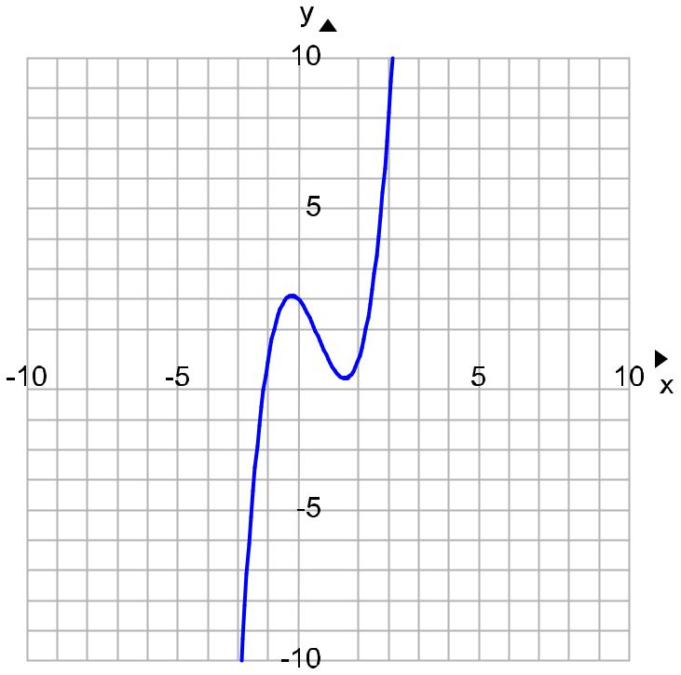

|  |  |  |  |
| --- | --- | --- | --- |
|  | **Edgar** | **Emily** |  |
|  | The zeros are x = -2, x = 0, and x = 1. | The zeros are x = -1.25 and x = 0.5. |  |
|  |  |  |  |
|  |  |  |  |



© K12 Inc.



5. Write a polynomial equation of the smallest degree with roots 0, 5, and -2.

|  |  |
| --- | --- |
| **Edgar** | **Emily** |

|  |  |  |  |  |  |  |  |  |  |  |  |  |  |  |  |  |  |
| --- | --- | --- | --- | --- | --- | --- | --- | --- | --- | --- | --- | --- | --- | --- | --- | --- | --- |
| *r* |  0,*r* | | | |  |  5,*r* | |  |  2 | | *r* |  0, *r* | | |  5, *r*  2 | |  |
| 1 |  |  |  | 2 | |  | 3 |  |  |  | 1 |  |  | 2 |  | 3 |  |
| *x*  0*x*  5*x*  2  0 | | | | | | | | | | | *x*  0 *x*  5 *x*  2   0 | | | | | |  |
| *x* *x* | | | 2 |  2*x*  5*x* 10  0 | | | | | | | *x* | | 2 |  2 *x*  5 *x* 10   0 | | |  |
|  |  |  |
| *x* *x* | | | 2 | − 3*x* 10 | | | | |  |   0 | *x* | 2 | − 3 *x* | | 10  0 | |  |
|  |  |  |  |
| *x* | 3 | − 3*x* | | | 2 | | − 10*x* | |  |  0 | *f* ( *x* ) *x* | | | | 2 | − 3 *x* 10 |  |
|  |  |  |
|  |  |  |  |  |  |  |  |  |  |  |
| *f* (*x* ) *x* | | | | | | 3 | − 3*x* | 2 | | 10*x* |  |  |  |  |  |  |  |
|  |  |  |  |  |  |  |  |  |  |
|  |  |  |  |  |  |  |  |  |  |  |  |  |  |  |  |  |  |
|  |  |  |  |  |  |  |  |  |  |  |  |  |  |  |  |  |  |



© K12 Inc.



Part 2 – Common Mistakes

The problems above describe some of the most common mistakes made when first studying the roots of polynomial equations and using the fundamental theorem of algebra.

In your opinion, which mistake do you think occurs most often? Which mistake will you be most cautious of as you complete these types of problems? In your response be sure to include the following:

Explain and tell why you think a particular mistake occurs the most.

Explain and tell why you think a particular mistake is the easiest to make.

What steps can you take that will help you avoid these types of mistakes in the future?



© K12 Inc.