Dear Delegates and Faculty Advisors,

Welcome to Thomas Jefferson’s International Summit Model UN & OAS!

I am thrilled and humbled to invite you to this year’s edition of TJMUN & OAS that will take place on December 8th, 9th, and 10th at the Thomas Jefferson Campus Querétaro.

For over 20 years, Instituto Thomas Jefferson has hosted several UN Model’s in Mexico City and is about to go for its eighth edition on its Queretaro campus. It has been a very ambitious journey from the first year until today, and it grows larger every year. Last year, we had the honor of hosting a pioneer model that included both simulations of the United Nations and the Organization of the American States. It was an aspiring step and a successful achievement; however, this year we are aiming even higher. With competitive and quality committees, as well as social spaces to meet new people from all over Mexico and other countries, this year’s secretariat promises to do its best to make TJMUN & OAS 2016 the most enriching experience for delegates.

High school students get engaged in issues currently debated by world leaders, while developing leadership skills such as diplomacy, cooperation, debate, critical thinking, empathy and innovation. This increases the delegate's knowledge and broadens his/her point of view, not only during the debate, but in the whole experience of the model, on very important issues such as climate change, the fight against poverty, war, and the urge of having sustainable economies around the world.

On behalf of the Secretariat of TJMUN & OAS 2016 and our entire staff, I hope you can join us in December. Should you have any inquiries, don’t hesitate to contact us through [tjmun@itjqro.edu.mx](mailto:tjmun@itjqro.edu.mx). On our website, you will find all the information you need about committees or any other specific information about the school and Queretaro.

I’m looking forward to meeting you this December at TJMUN & OAS 2016.

Sincerely,

Humberto G. Salinas

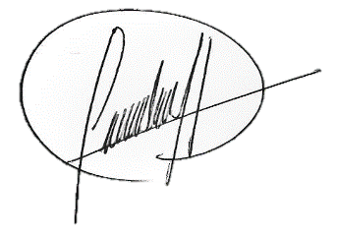President TJMUN & OAS 2016