**http://flexdx2.modeltb.org**

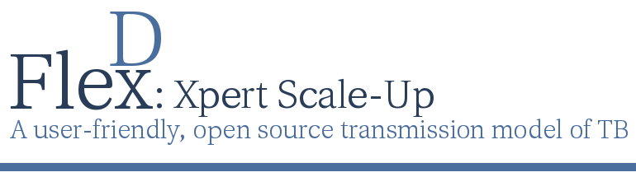

## Scaling-Up Xpert in a Township in Cape Town

## A Case Study from South Africa with User Input Values

**The TB Modeling and Translational Epidemiology Group**

**Johns Hopkins Bloomberg School of Public Health**

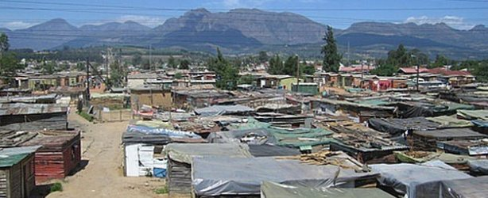*The following case study is written in the form of a concept note for a funding proposal to aid in scale-up of Xpert in a local setting. We will use a primary-care health center in a Township of Cape Town, South Africa to illustrate how the FlexDx TB Model could help inform decisions to scale-up the Xpert MTB/RIF assay for TB diagnostic testing. To populate the local parameter estimates for this setting, we will use a combination of local estimates and Country Pre-set Values.*

**Local Disease Context**

In the Western Cape Province of South Africa, the reported incidence rate of TB continues to be among the highest in the world with 885 incident TB cases per 100,000 in 2010.2 However, estimates of TB incidence in the Cape Town Metro district, which accommodates approximately 66% of the province’s 5.2 million residents, may be even higher with studies reporting incidence rates of 600 to 1,622 cases per 100,000 persons.3 While the prevalence of HIV among antenatal women is reported to be approximately 17.9%, the estimated rate of HIV co-infection in patients with TB is approximately 76.1% in Cape Town.3,4 This staggering rate of TB/HIV makes diagnosis of TB in patients in this setting even more difficult because 24 to 61% of TB/HIV patients are smear-negative under sputum smear microscopy.5 Thus, the epidemic in South Africa demands better methods for diagnosing TB in the context of this high HIV prevalence setting.

**Program Areas**

* High Tuberculosis burden
* High MDR TB burden
* High HIV/AIDS prevalence
* Guidance for Implementation

**Public Health Applications**

* Local Budget Forecasting
* Funding Applications
* Health Services Prioritization
  + Local TB Resources
  + Local Diagnostic Scale-Up
* Policy and Advocacy

**The TB Modeling and Translational Epidemiology Group at Johns Hopkins**

615 N. Wolfe Street  
Room E6531   
Baltimore, Maryland 21205 U.S.A.  
tel: +001 410.614.5022

email: [ddowdy1@jhmi.edu](mailto:ddowdy1@jhmi.edu)

web: http://flexdx2.modeltb.org

tb group: http://modeltb.org

Xpert is currently being implemented nationwide in South Africa; however, despite the great promise the Xpert shows as a diagnostic tool, questions regarding implementation, training, and incorporation in diagnostic testing algorithms remain. These questions become more complex when focusing on the smaller scale of individual health facilities that have setting-specific challenges and differences in the drivers on the TB epidemic.

**National Strategic Plan (NSP)**

The South African National Department of Health began rolling out the GeneXpert rapid molecular testing system Xpert MTB/RIF (Xpert) assay in 2011.7 The South African National and the Western Cape Provincial 2012-2016 Strategic Plans on HIV, STIs, and TB identified the following areas as research priorities for efforts in TB control2,8: (1) Reducing the number of new TB infections as well as the number of TB deaths by 50%, (2) Addressing the social and structural drivers of HIV, STI, and TB prevention, care and impact, (3) Preventing new HIV, STI, and TB infections, and (4) Sustaining health and wellness to ensure access to quality treatment, care and support services for those with HIV, STIs, and TB. A key component to each of these priority areas includes mitigating the transmission of TB, which can be achieved through early diagnosis and effective treatment of TB.

**Implementation of the NSP**

Currently, Xpert assays are placed in 207 testing centers across all nine provinces of South Africa.7 In the Western Cape Province in 2013, there were 131,349 tests performed using Xpert with 15.4% detecting mycobacterium tuberculosis and 5.0% detecting rifampin resistance.7 However, questions persist as to where Xpert should be implemented, how to best incorporate Xpert testing into the existing diagnostic algorithms, and how to adapt the implementation to address setting-specific challenges.

**Funding Request Justification**

The objective of this funding request is to scale-up the TB diagnostic testing capacity in a Primary-Care Health Center serving a Township in Cape Town, South Africa. Specifically, this funding is needed to improve access to TB diagnostic testing and treatment services in this health center by improving laboratory capacity for rapid diagnosis of TB using the Xpert MTB/RIF assay. With a TB incidence rate of 1622 per 100,000, 3.3% prevalence of MDR-TB among new cases, and 76.1% TB/HIV co-infection rate, the Township Primary-Care Health Center is responding to patient needs that represent a greater TB burden than that observed in the country overall. It is critical that we increase the number of patients receiving timely and effective treatment by improving our diagnostic capabilities in order to reduce the burden of TB transmission both within our facility, community, and country. However, it is unclear how best to maximize the impact of implementing Xpert in our facility and whether Xpert will be productive if it not implemented as a point-of-care testing (POCT) program whereby results are used for rapid, same-day treatment initiation. The FlexDx TB Model9,10 can aid in estimating the potential impact of implementation of Xpert under different nine different diagnostic strategies within the Township Primary-Care Health Center.



*\*Values were extracted from the FlexDx TB Model output and entered into the table above for reporting purposes.*

The following parameter estimates based on WHO country estimates for South Africa and local epidemiological estimates were used in the FlexDx TB Model to assess the impact of the nine diagnostic strategies for scale-up of Xpert:

* Target TB incidence, per 100,000: 1622
* Target MDR-TB prevalence among

new cases, %: 3.3

* Target adult HIV prevalence, %: 38
* Treatment of one patient with

first-line drugs, $: 96.04

* Treatment of one patient with

retreatment/cat 2 regimen, $: 192.09

* Treatment of one patient with

second-line (MDR) drugs, $: 960.43

* One outpatient visit (e.g., for TB

diagnosis), $: 10.05

* Full sputum smear evaluation (e..g,

evaluation of 2 smears), $: 2.01

* Single Xpert MTB/RIF test, $: 15
* Single Xpert, including extra costs to

make results available same day, $: 23.04

In this high TB, MDR-TB, and HIV

burden setting, the FlexDx TB Model

calculates the projected incremental

5-year cost and impact comparing 9

diagnostic strategies to scale-up Xpert.

This table summarizes the results

projected by the FlexDx TB Model for

implementation in the Township

Primary-Care Health Center.

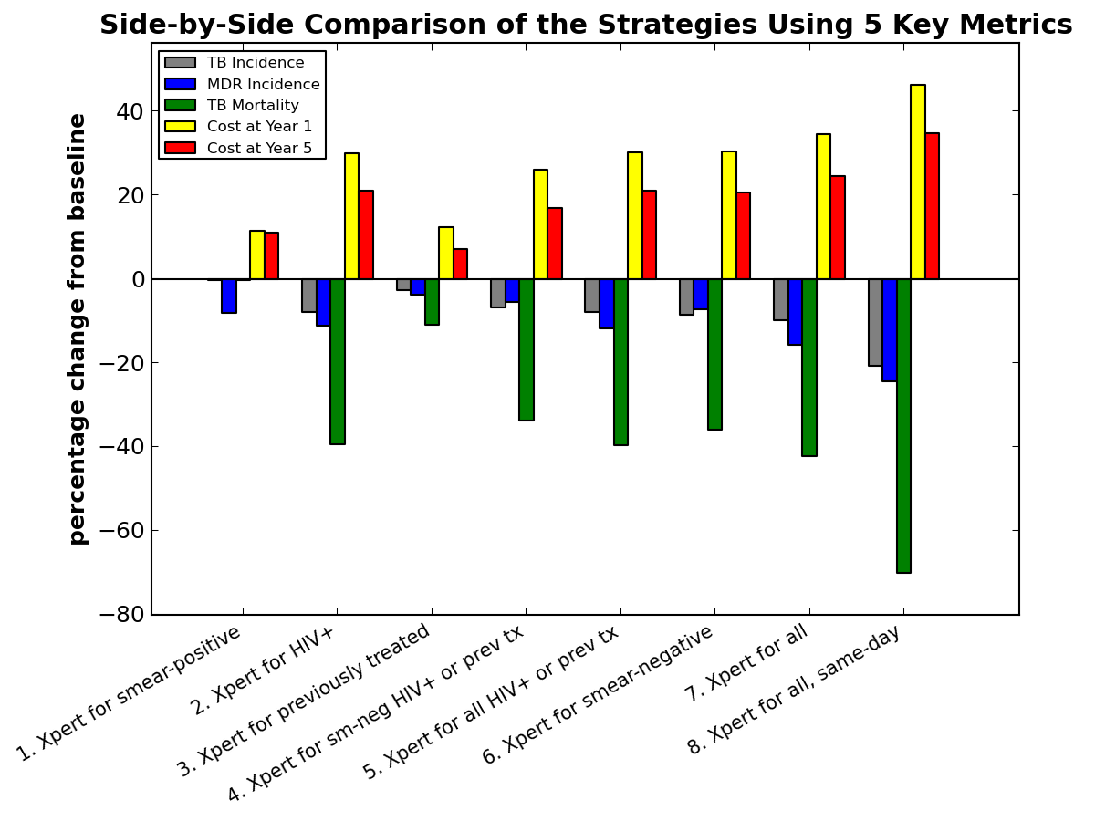

**for scale-up in a primary-care health center in a Township in Cape Town, South Africa**

Given the epidemiologic estimates of TB burden for the Township Primary-Care Health Center and the current costs of Xpert nationwide TB epidemic and using smear microscopy as the baseline for comparison, the FlexDx TB Model projects that the current South African National TB Program (SA NTP) strategy of using Xpert as the initial screening test for all patients with presumptive TB (i.e., (7) Xpert for all) will have a considerable impact in our setting. The model projects (7) Xpert for all will produce moderate reductions in TB incidence (estimated change: -9%), MDR TB incidence (estimated change: -13.7%), and a large decrease in TB mortality (estimated change: -29.8%) albeit with a 52.6% increase in cost initially in Year 1 that decreases to a 32.3% increase in cost by Year 5 for our Health Center. If we were able to implement (8) Xpert for all same-day diagnosis in our setting, the impact would be even more substantial. The FlexDx TB Model projects that (8) Xpert for all same-day would result in a 17.2% reduction in TB incidence, 19.6% decrease in MDR TB incidence, and a 41.2% decrease in TB mortality at our Health Center. However, the cost to scale-up Xpert for all same-day will require a 85.8% increase in in Year 1 that would decrease to a 53% increase in cost by Year 5 of implementation.

If we implemented Xpert using more targeted strategies, namely (2) Xpert for HIV-infected patients, (4) Xpert for smear-negative HIV-infected or previously treated patients, and (5) Xpert for all HIV-infected or previously treated patients, to address the high HIV prevalence in our setting, the FlexDx TB Model projects decreases in TB incidence of 6.4 to 7.9%, decreases in MDR TB incidence of 5.2 to 10.6%, and decreases in TB mortality of 25.2 to 28.4% with Year 1 cost increases of 35.1 to 43.1% for implementation.

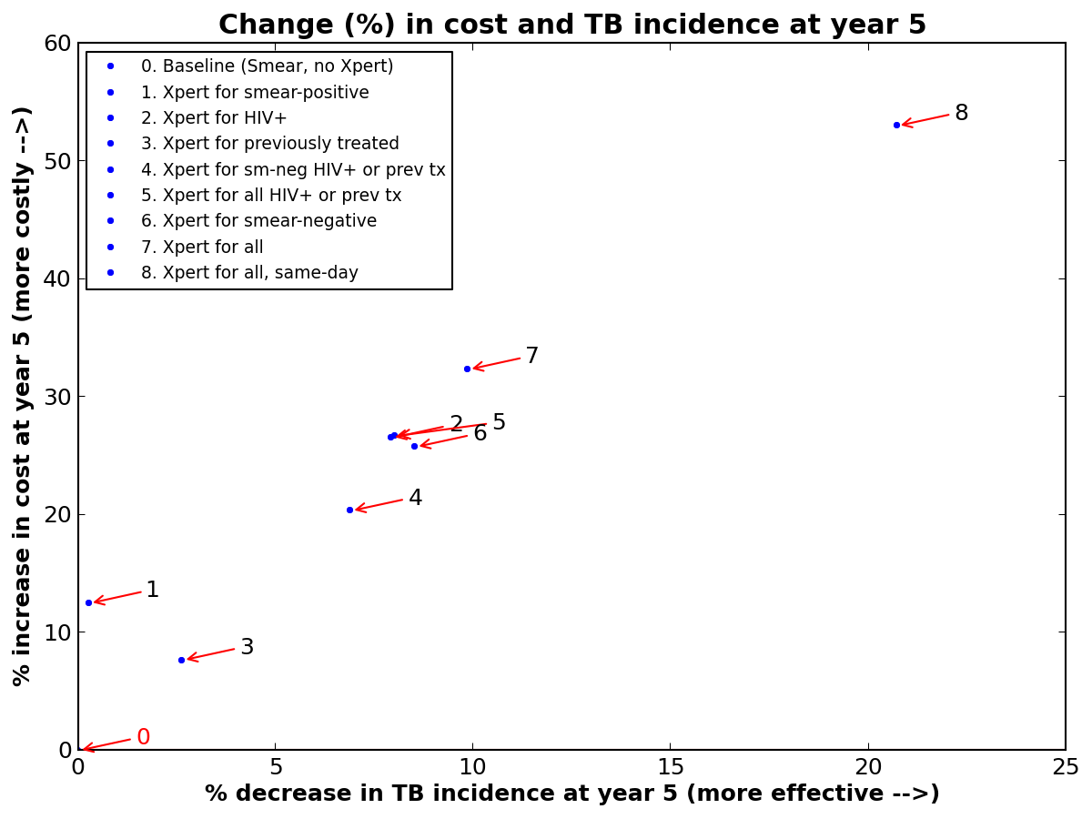

**for scale-up in a primary-care health center in a Township in Cape Town, South Africa**

While HIV-targeted strategies may achieve a similar impact on our TB burden for a lower cost, the broader strategies involving Xpert for all are better aligned with the SA NTP strategic plan. The Xpert for all strategies are estimated to produce a greater impact in our severely high burden setting, but they will require a large amount of additional funding for scale-up of Xpert within our Health Center. Additionally, if we are able to implement the (7) Xpert for all strategy initially, our health center will be better positioned for subsequent scale-up of same-day diagnosis using Xpert, which is projected to achieve even greater reductions in TB and MDR TB incidence, and mortality. While these broader Xpert implementation strategies require a significant increase in funding to achieve the estimated reductions, they also have the greatest promise to make a true impact on the TB epidemic unfolding in our health center. Regardless of the selected strategy for Xpert scale-up, these gains in our TB control efforts will not be achieved if funding remains at its current level.

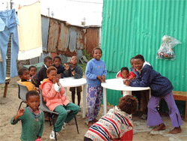With the evidence provided by the FlexDx TB Model, the priority request is to achieve access to TB diagnostic services using Xpert for all patients with presumptive TB at the Township Primary-Care Health Center. This priority is in line with the SA NTP’s overriding objective to decrease TB deaths by 50%. Given the critical role of HIV and drug-resistance in the TB epidemic in South Africa, Xpert for all patients with presumptive TB stands out as having potential to change the course of the TB epidemic. The prioritization of this strategy is enhanced by its potential to lead the way for subsequent scale-up of same-day diagnosis using Xpert, which is projected to achieve even greater reductions in TB and MDR TB incidence, and mortality.

References: 1. WHO, 2013; 2. Western Cape DOH, 2012; 3. Boehme, Lancet 2011; 4. Gupta, IJTLD 2013; 5. Meyer-Rath, Plos One 2012; 6. Boehme, NEJM 2010; 7. NHLS SA, July 2014; 8. SA MOH, 2012; 9. FlexDx, 2014; 10. Dowdy, eLife 2014.

The TB Modeling and Translational Epidemiology Group at Johns Hopkins Bloomberg School of Public Health is group from all academic levels and locations that exists to help its members learn more about TB modeling and translational epidemiology and to make a contribution to the TB research and public health community. For more information, please visit http://modeltb.org and http://flexdx2.modeltb.org.