**Quick Start Guide**

**Running the model with Country Pre-set Values**

**http://flexdx2.modeltb.org**

**The TB Modeling and Translational Epidemiology Group**

**Johns Hopkins Bloomberg School of Public Health**

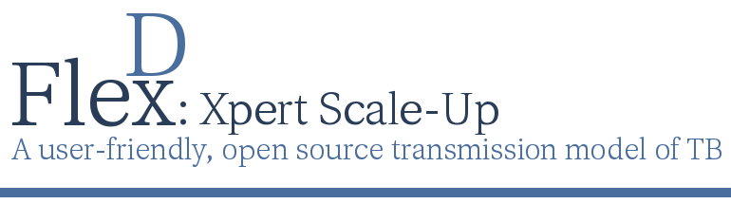

The Flexible Diagnostics (FlexDx) TB Model is a flexible, simple, transmission modeling tool that allows users without modeling expertise to generate evidence to aid decision-making related to implementation of tuberculosis (TB) diagnostics under locally defined conditions.

Using a simple web-based interface, FlexDx incorporates local estimates of TB incidence, MDR-TB, HIV, and costs into a combined decision analysis-transmission modeling framework to generate five-year projections of the epidemiological impact and cost-effectiveness of nine diagnostic strategies in reducing TB transmission and mortality.

Users can run the FlexDx TB Model using country pre-set values from WHO for their country of interest to return pre-calculated model results for all diagnostic strategies, including uncertainty ranges and exploration of key alternative scenarios in which important parameters are doubled.

**Using the FlexDx TB Web Interface**

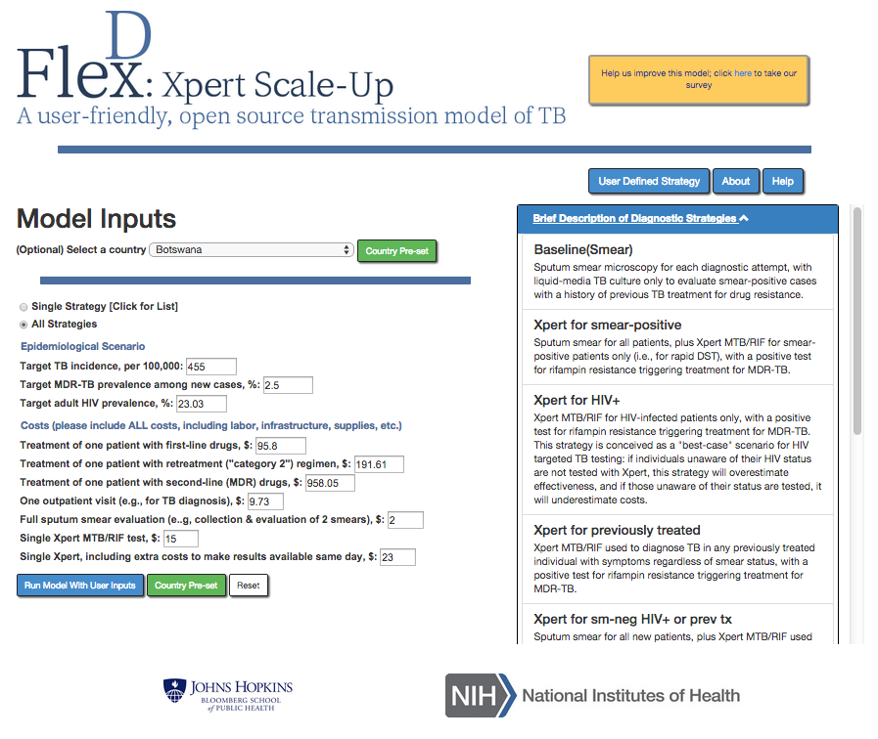

**Scroll to view the diagnostic strategy descriptions**

**Click here to define your own diagnostic strategy**

**Click here for Help Files or more information about the model’s creators**

Selecting a country will populate the model input parameters using the pre-set values for the country

**3. Running with country pre-set values will return results for All Strategies**

**1. Select country from drop down list**

**2. Click to run the model**

**Interactive Incidence/Cost and MDR/Cost Tabs**

The results using the Country Pre-set values are displayed below. Note that the model projections using the Country Pre-set values are based on relative rather than absolute changes in costs and outcomes.

**Click to return to model inputs page**

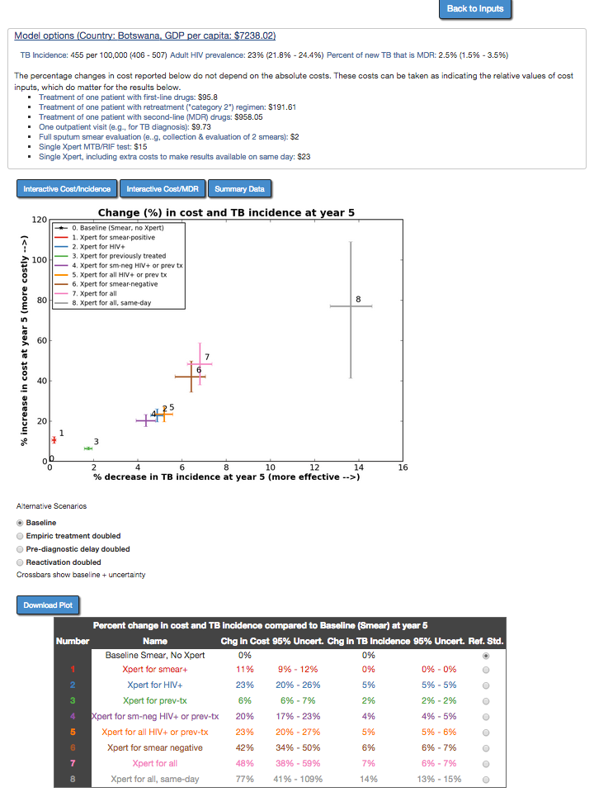

**Click to view the different results Tabs**

Changing the reference standard will cause the number and cross bars corresponding the selected reference strategy to turn black in the graph. The Cost and Incidence estimates in the table will change to reflect the selected reference standard.

The cross bars represent 95% uncertainty ranges for the model’s projected percent change estimate for TB incidence (vertical bar) and cost (horizontal bar). 95% uncertainty ranges result from varying the values of all parameters in the model simultaneously by +/- 10% of their original value (and thus may underestimate true uncertainty, if those values truly vary by more than 10%).

This graph displays the percent ***increase*** in cost for implementing the diagnostic strategy at year 5 [cost] vs. the percent ***decrease*** in TB incidence at year 5 [effectiveness] for all strategies compared to baseline (smear). The table below the graph reports the same data in numerical form.

**Epidemiological Scenario and Cost parameter values used to generate the model’s results are displayed here.**

**\*If the values for any of the parameters are not appropriate for your setting, users can click ‘Back to Inputs’ to return to the model inputs page and adjust the values as necessary.**

**Click to select one of the Alternative Scenarios**

**Click to download plot**

**Click to change the reference standard (default is Smear)**

**Alternative Scenario Options and Output**

The Alternative Scenarios are designed to show the effect of doubling key parameters (empiric treatment, reactivation, pre-diagnostic period) on model outputs. Importantly, these three variables have strong influence on the model’s results and likely vary by more than +/-10% from one setting to the next. These parameters are key to the model’s impact estimates, and the effect of varying these parameters is not fully captured within the uncertainty ranges provided. Thus, the 95% uncertainty cross bars for the range of diagnostic strategy outputs represent the range that might be expected if inputs are varied to a certain pre-specified extent (here, +/-10% of the underlying value). *They are not 95% confidence intervals in the statistical sense.*

* **Baseline:** No change to input values
* **Empiric treatment doubled:** Double the probability of empiric treatment in someone who tests negative for active TB (but actually has TB) from 25% to 50%.
* **Pre-diagnostic delay doubled:** Double the period of infectiousness before seeking care from 9 months to 18 months
* **Reactivation doubles:** Double the rate of reactivation, which likewise increases the probability that a case of active TB is due to reactivation vs. recent infection

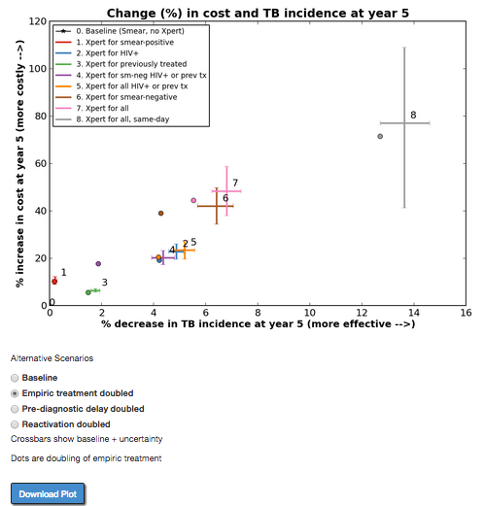

**Click to download plot with Alternative Scenario dots**

Selecting one of the alternative scenarios will cause dots to appear on the graph that demonstrate the potential impact of doubling one of these parameters.

If users think that empiric treatment, pre-diagnostic delay, and reactivation as a cause of active TB are high in their setting, then the model likely overestimates the impact of better diagnostic testing in that setting. These options allow users to see the impact of doubling each of these input variables to help give an idea of how great this overestimation is likely to be.

**Dots representing doubling of selected scenario**

**Alternative Scenario selected**

**Summary Tab**

The Summary Data Tab provides the user with a summary of the FlexDx TB Model results for TB and MDR Incidence, Mortality, Year 1, and Year 5 projections.

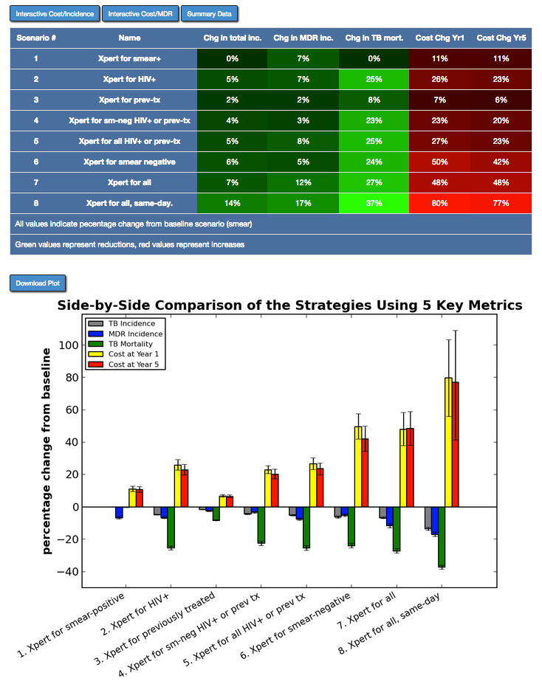

This table displays the projected changes in TB Incidence, MDR Incidence, TB Mortality, Year 1 Costs, and Year 5 Costs as a percent *decrease* (***green***) or *increase* (***red***) for All Strategies compared to the Baseline (smear) diagnostic scenario.

To extract the data in this table, users may take a screen shot of the table or manually extract and copy the data into a program of their choice.

**Click to download plot**

**Click to view Tab**

**Limitations of the FlexDx TB Model**

As with any modeling analysis, the FlexDx TB Model and the user generated results from the model have important limitations. Thus, while FlexDx can be a very useful tool to provide access to “first-pass” estimates in epidemiological settings (e.g., sub-district level data) that will never be captured by more detailed and closely-calibrated TB transmission models, it does not eliminate the necessity for more detailed models.

For more information or to access the help files for the FlexDx Model, users can click on the ‘About’ and ‘Help’ buttons on the model input page. See the full FlexDx TB Model User’s Manual for more details on using the model.