**Quick Start Guide**

**Running the model with User Input Values**

**http://flexdx2.modeltb.org**

**The TB Modeling and Translational Epidemiology Group**

**Johns Hopkins Bloomberg School of Public Health**

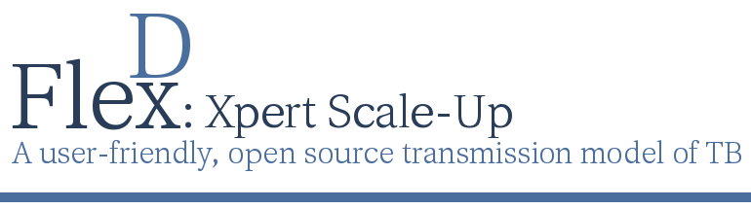

The Flexible Diagnostics (FlexDx) TB Model is a flexible, simple, transmission modeling tool that allows users without modeling expertise to generate evidence to aid decision-making related to implementation of tuberculosis (TB) diagnostics under locally defined conditions.

Using a simple web-based interface, FlexDx incorporates local estimates of TB incidence, MDR-TB, HIV, and costs into a combined decision analysis-transmission modeling framework to generate five-year projections of the epidemiological impact and cost-effectiveness of nine diagnostic strategies in reducing TB transmission and mortality.

Users can run the FlexDx TB Model using their own values for key epidemiological parameters and local unit costs of TB diagnosis and treatment. Running the model with User Inputs will return projected results for key epidemiologic indicators. Users can run the model for a Single (diagnostic) Strategy or for All Strategies.

**Using the FlexDx TB Web Interface**

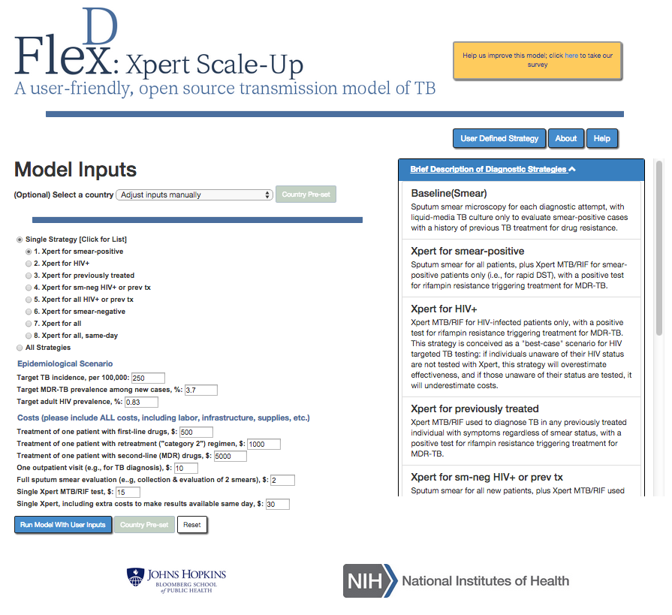

**\*Tip - If you know the Epidemiologic Scenario parameter estimates for your setting but do not know the Costs, you can:**

**1) Select your country from the drop down list**

**2) Select diagnostic strategy**

**3) Enter epidemiologic data for your setting**

**4) Click ‘Run with user inputs’**

**3. Click to run the model**

**2. Enter Epidemiological**

**Scenario and Costs data**

**1. Select a Single Diagnostic**

**Strategy or All Strategies**

**Scroll to view the diagnostic strategy descriptions**

**Click here for Help Files or more information about the model’s creators**

**Click here to define your own diagnostic strategy**

**Single Strategy Output**

The results using User Input values are displayed below for all strategies. Note that this is the output returned when the model is run for a single strategy as well. The estimates displayed reflect projections that are expected in Year 5 of the strategy’s implementation.

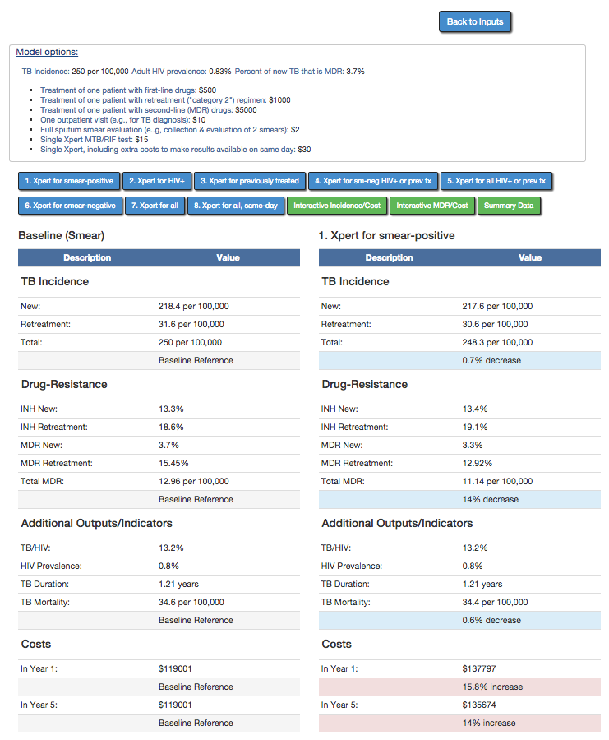

**Click to return to model inputs page**

**Click to view the different single strategy results Tabs**

**Click to view all strategies and summary results Tabs**

**Epidemiological Scenario and Cost parameter values used to generate the model’s results are displayed here.**

**\*If the values for any of the parameters are not appropriate for your setting, users can click ‘Back to Inputs’ to return to the model inputs page and adjust the values as necessary.**

See the full FlexDx TB Model User’s Manual for a more detailed description of the output.

**Interactive Incidence/Cost and MDR/Cost Tabs**

The FlexDx TB Model will generate an interactive TB Incidence graph and summary table that allows the user to change the reference standard.

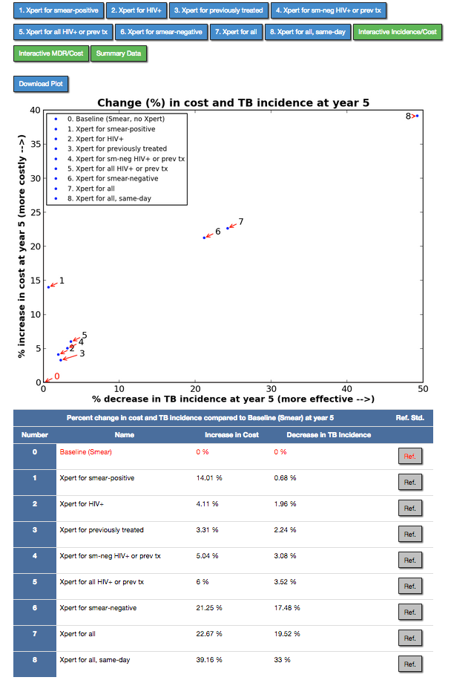

**Reference Standard**

Changing the reference standard will cause the number corresponding the selected reference strategy to turn red in the graph. The Cost and Incidence estimates in the table will change to reflect the selected reference standard.

**Click to change the reference standard (default is Smear)**

**Click to view Tab**

**Click to download plot**

This graph displays the percent ***increase*** in cost for implementing the diagnostic strategy at year 5 [cost] vs. the percent ***decrease*** in TB incidence at year 5 [effectiveness] for all strategies compared to baseline (smear). The table below the graph reports the same data in numerical form.

**Summary Tab**

The Summary Data Tab provides the user with a summary of the FlexDx TB Model results for TB and MDR Incidence, Mortality, Year 1, and Year 5 projections.

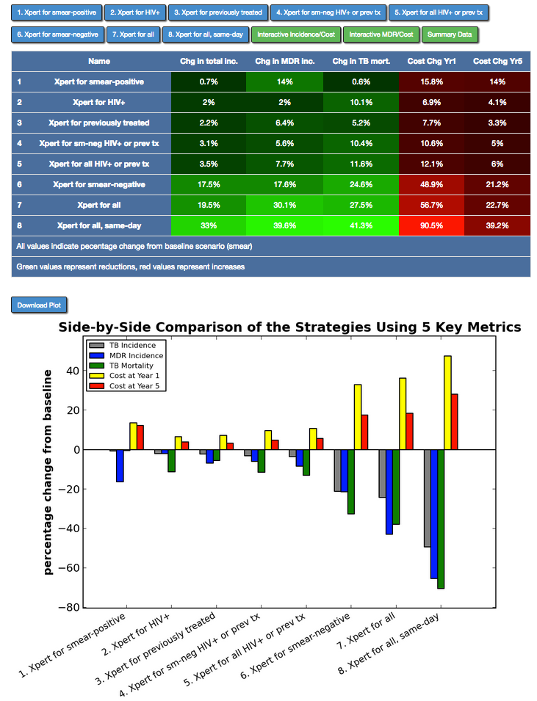

This table displays the projected changes in TB Incidence, MDR Incidence, TB Mortality, Year 1 Costs, and Year 5 Costs as a percent *decrease* (***green***) or *increase* (***red***) for All Strategies compared to the Baseline (smear) diagnostic scenario.

To extract the data in this table, users may take a screen shot of the table or manually extract and copy the data into a program of their choice.

**Click to view Tab**

**Click to download plot**

**Limitations of the FlexDx TB Model**

As with any modeling analysis, the FlexDx TB Model and the user generated results from the model have important limitations. Thus, while FlexDx can be a very useful tool to provide access to “first-pass” estimates in epidemiological settings (e.g., sub-district level data) that will never be captured by more detailed and closely-calibrated TB transmission models, it does not eliminate the necessity for more detailed models.

For more information or to access the help files for the FlexDx Model, users can click on the ‘About’ and ‘Help’ buttons on the model input page. See the full FlexDx TB Model User’s Manual for more details on using the model.