avancos realizados

Comando | Tempo (minutos)
Sudo apt update | 2
Sudo apt install python3 idle3 | 2
Sudo apt-get update | 2
curl -sSL https://get.docker.com | sh  sudo usermod -aG docker pi | 6
sudo systemctl enable docker
sudo reboot -h now

Conexão via rj45

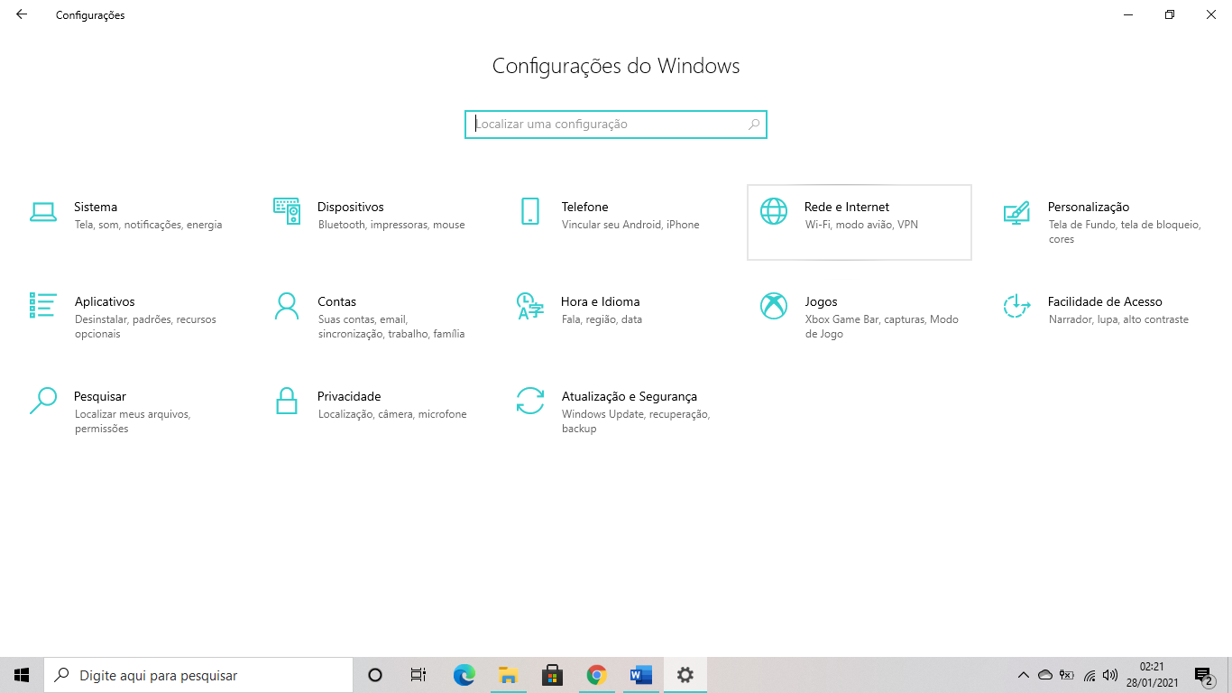

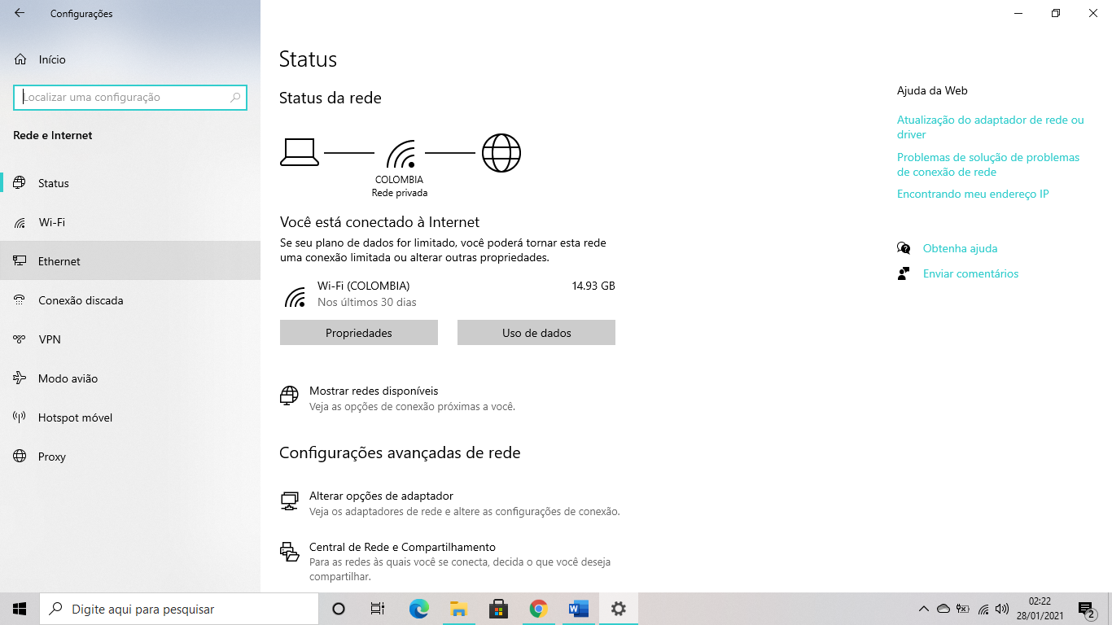
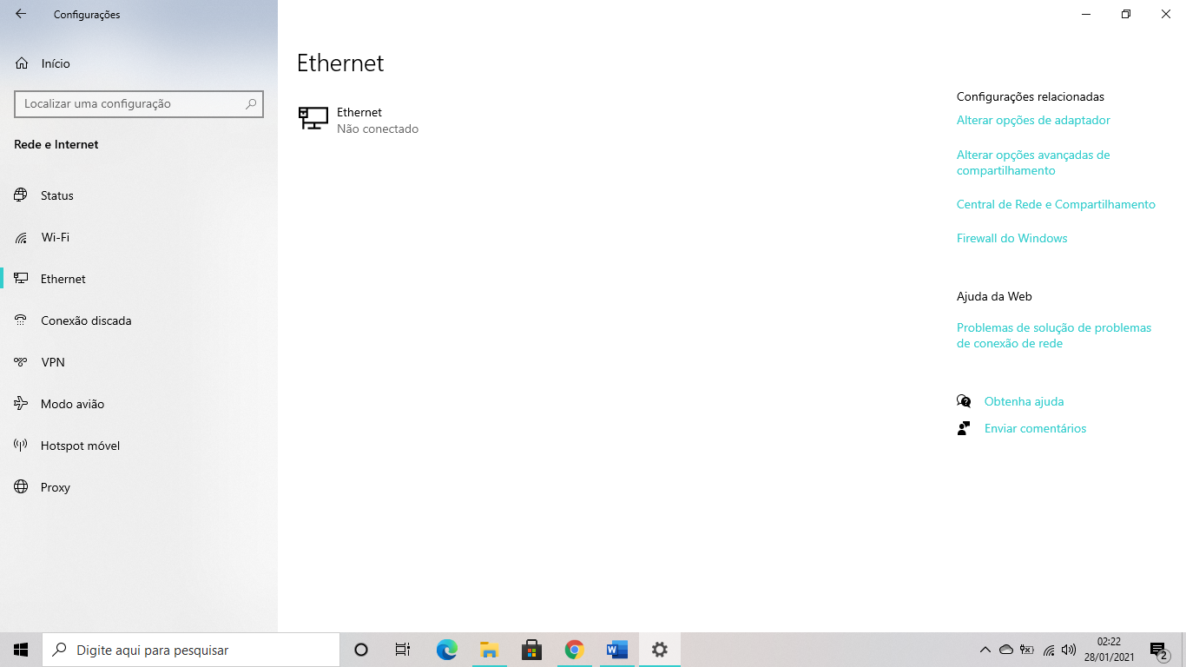

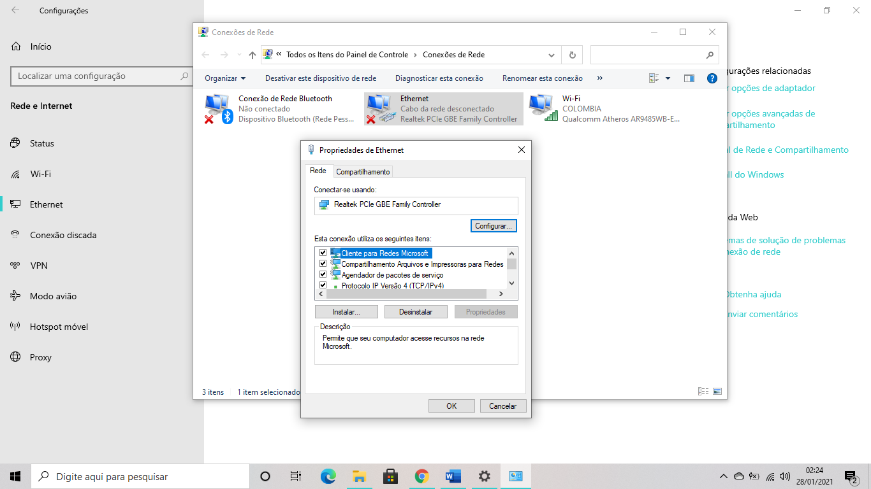
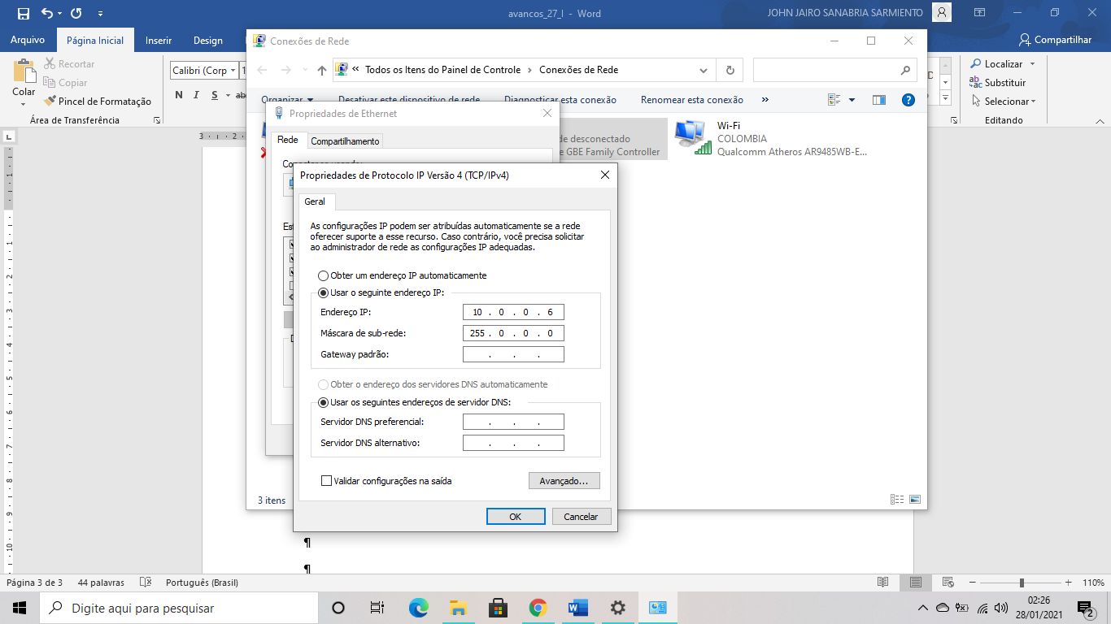

On terminal
Ifconfig
Wlan0 inet
Putty ssh...inet (wlan0)+x1 enabled

Curl -sSL https://get.docker.com ! sh (genera error)
curl -sSL https://get.docker.com | sed 's/docker-ce/docker-ce=5:19.03.13~3-0~raspbian-buster/' | sh

Sudo usermod -aG Docker ${USER}
Su - ${USER}
Passworluiz

Docker run hello-world (test)
sudo docker pull portainer/portainer:linux-arm

sudo docker run -d -p 9000:9000 -v /var/run/docker.sock:/var/run/docker.sock -v portainer_data:/data portainer/Portainer

Sudo apt-get install tightvncserver
Vncserver :1 -> password reverse3d

https://www.youtube.com/watch?v=0m9o6-KqeeU
https://www.youtube.com/watch?v=YjszoDGsqfo
https://www.youtube.com/watch?v=7Esk0QKURIk
trouble

ssh connection refused
sudo raspi-config 3 interface options

