Team09_Lab2_Report

File Structure:

* team09_lab2/team09_lab2_report : This file contains information about the source code in the directory and the instructions of lab2.
* team09_lab2/src/Rsa256Core.sv : We have implemented RSA256 with Montgomery Algorithm of lab2 in this file.
* team09_lab2/src/Rsa256Wrapper.sv : We have implemented RSA256 Wrapper with RS232 Protocol of lab2 in this file.
* team09_lab2/src/DE2_115 : For the files in this folder, we have only modified DE2_115.sv to replace the module with the rsa_qsys module we generated.

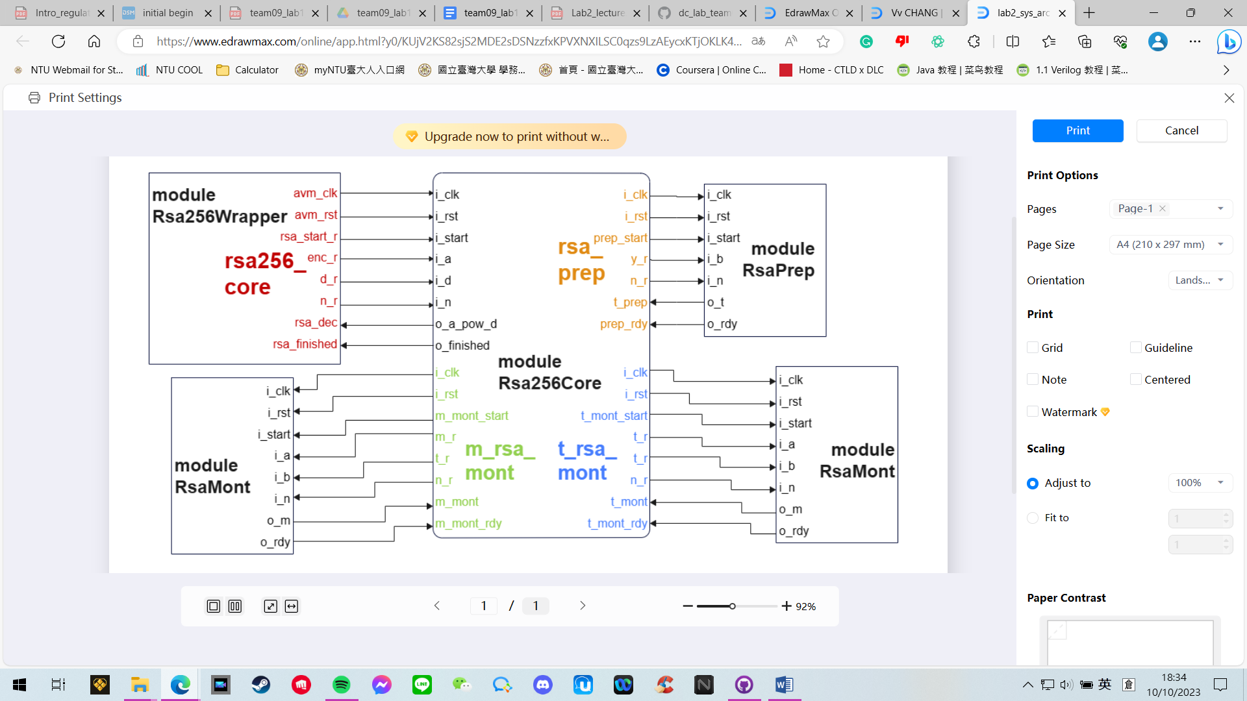System Architecture:

Hardware Scheduling:

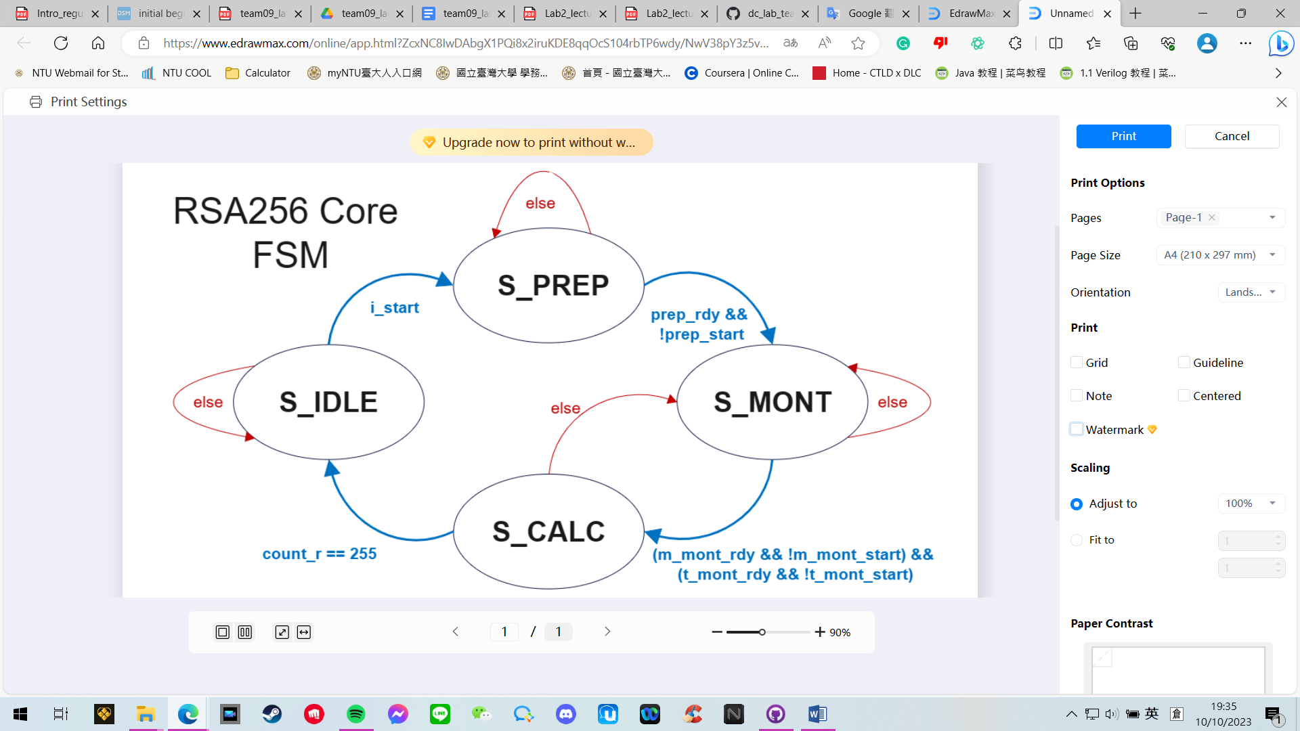

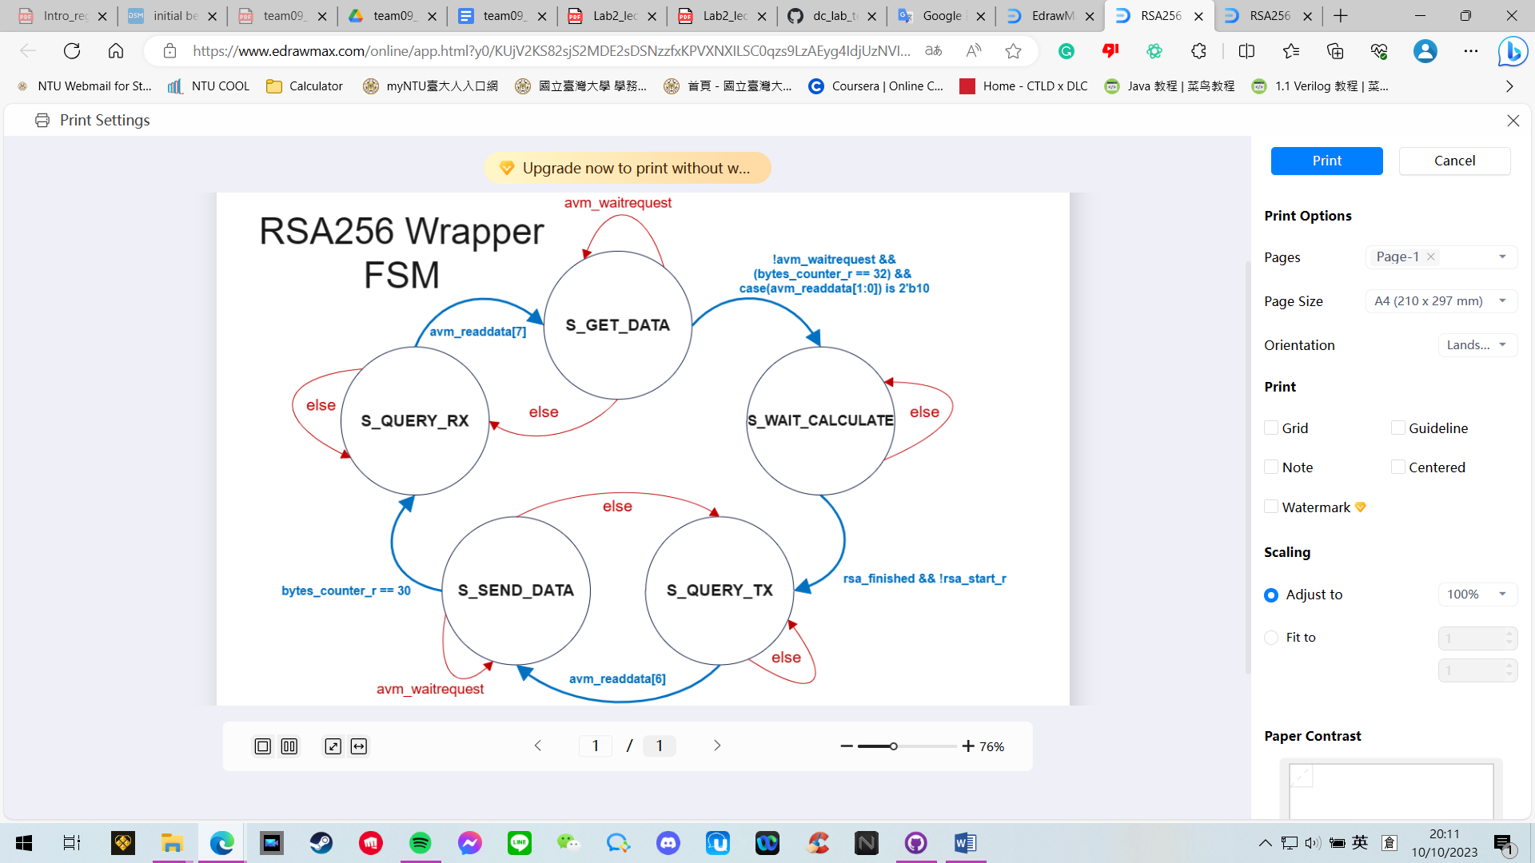

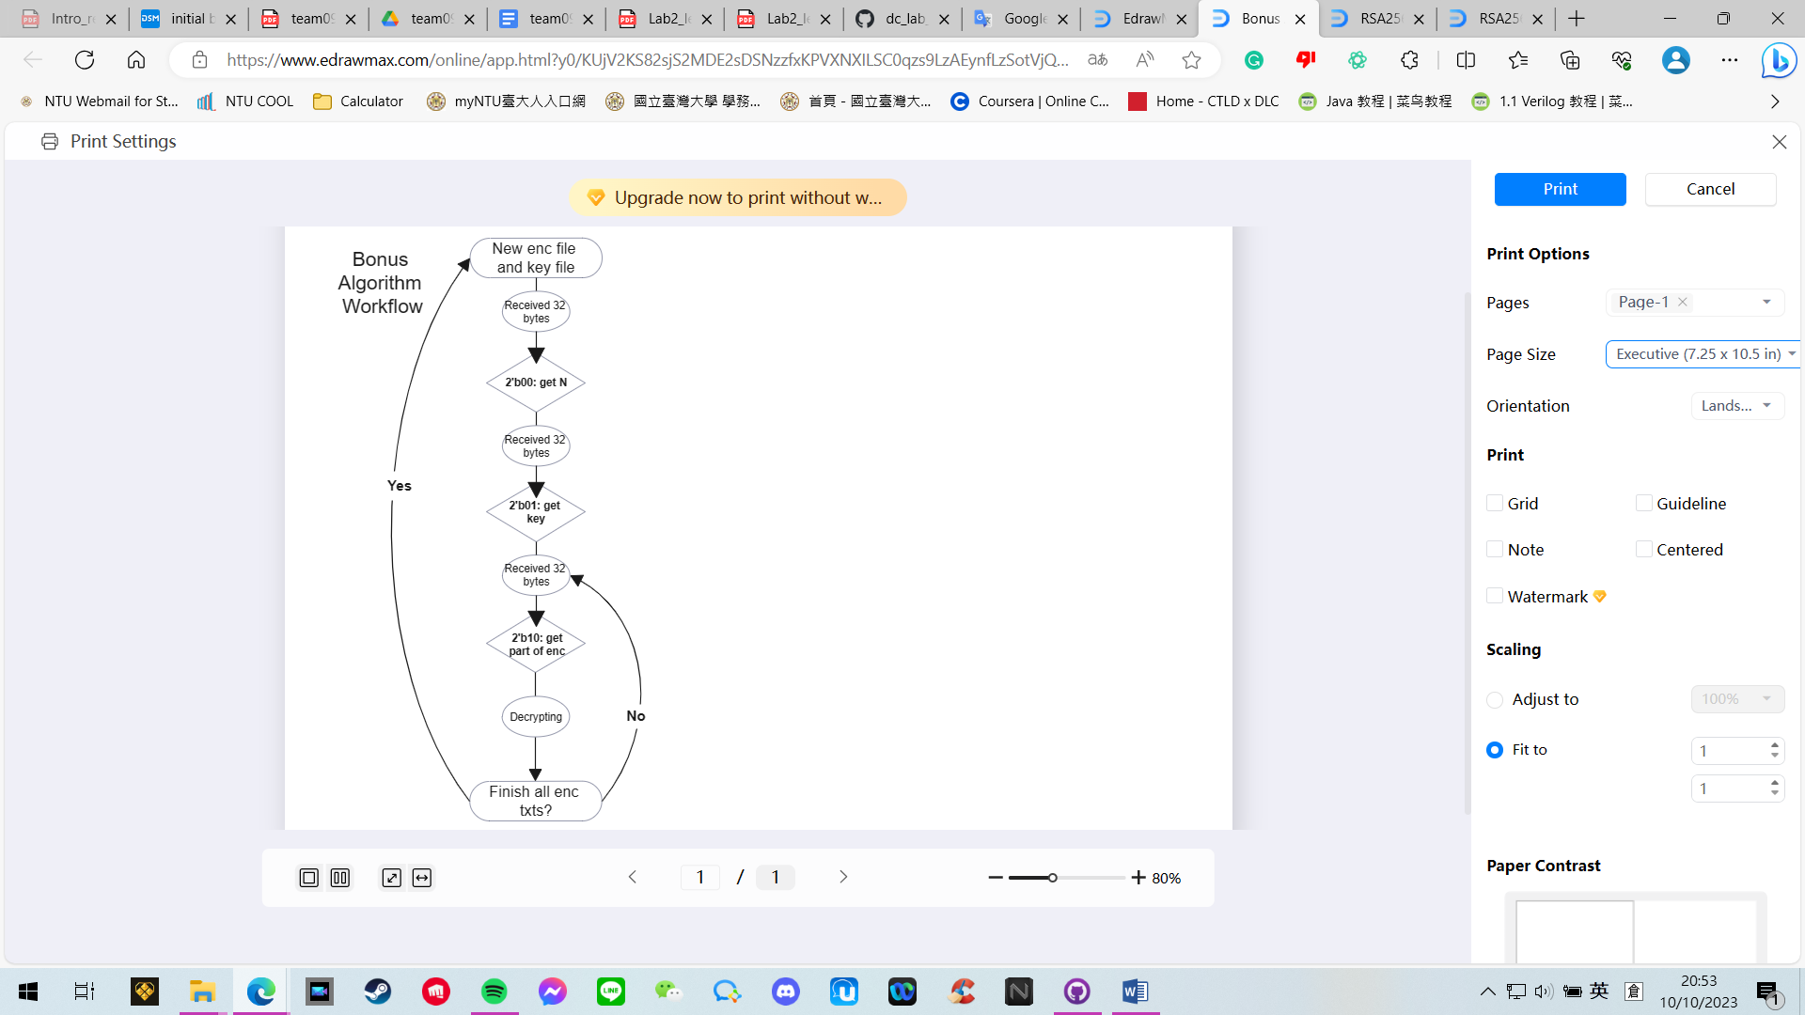**Bonus**

We have implemented another dataflow such that multiple ciphertexts can be decrypted continuously without reset.

Python rs232.py:

* One byte is added after each 32 bytes segment
* Add s.write(b”0x00”) after key[0:32]
* Add s.write(b”0x01”) after key[32:64]
* Add s.write(b”0x02”) after every iteration of enc[i:i+32]

Module Rsa256Wrapper.sv:

* At the state S_GET_DATA, if the bytes_counter reaches 32, we determine the type of data of the previously received 32 bytes by switching cases on avm_readata since this byte is intentionally inserted every 32 bytes in rs232.py by us.
* For case 2'b00, this means that the 32 bytes we received previously were N, so we save it in n_w.
* For case 2'b01, this means that the 32 bytes we received previously were key, so we save it in d_w.
* For case 2'b02, this means that the 32 bytes we received previously were ciphertext, so we save it in enc_w.

Fitter Summary:

Timing Analyzer:

Problem & Solution:

1. Simulation Abort : "Protocol not met %m"
   1. Check whether there are unassigned signals leading to x
   2. Find documents on the protocol and design signals accordingly
   3. Try to read the provided testbench for more information
2. Simulation Fxxx : "Simulation time too long."
   1. Check whether state transition logics are correct
   2. Use less clock cycles for calculation by refactoring the flow of algorithm
3. Timing assignment not met
   1. Extract chained combinational logic to be calculated at the next clock
4. 其他
   1. 其他

Conclusion & Suggestion: