DCG user manual

McCowan Lab & Fushing Lab

December 28, 2015

#### Introduction

The R code for data cloud geometry is designed to find multi-level structure in undirected network data (e.g. edgelist or matrix)[Chen and Fushing 2012]. This multi-level structure is equivalent to finding community structure, similar to the Girvan-Newman method of finding network modularity [Newman and Girvan 2004]. This method begins with a similarity matrix, where the entries of the matrix are a measure of how similar a pair of individuals is with respect to a particular feature. Similarity can be measured based on grooming relationships (where the strength of grooming per dyad is the measure of similarity) or other affiliative relationships. Similarity can also be measured using physical traits or genetic code. The data cloud geometry method involves performing a random walk across all nodes in the network. The probability of making a step from one node to another is based upon their strength of similarity (i.e. from the value in the similarity matrix). Such random walks proceed locally, going to and from a local subset of nodes. Once a subset of nodes has been visited sufficiently (e.g. when one node from that community has been visited at least 5 times, m = 5) that node is removed from the network such that it may no longer be visited. Once all nodes from a community have been removed in this manner, the random walk is forced to jump to another community. This is how communities are defined – the subset of nodes that is each visited 5 times before jumping to a new set of nodes is one community.

#### Installing the package

To install "DCG" package in R, you need to put the package file in your working directory and run install.packages("./DCG_0.12.tar.gz", repos = NULL, type = "source").

#### Importing data

DCG package works on similarity matrices. It required the raw data to be an edgelist or a matrix. DCG is designed for undirected networks, i.e. where the direction of the interaction doesn’t matter. The function as.simMat is used to convert the raw data to a similarity matrix whose values range from 0 to 1 by dividing values in the raw matrix by the maximum value of the matrix. You could assess help for all functions by running ?functionName, for example, ?as.simMat.

library(DCG)  
head(myData)

## Initiator Recipient  
## 1 35281 35510  
## 2 35281 35510  
## 3 35281 36003  
## 4 35281 36003  
## 5 35281 36003  
## 6 35281 36182

Sim <- as.simMat(myData) # as.simMat checked. # documented

#### Selecting temperatures

Because the random walk proceeds based upon similarity, the range of variance in similarity will influence how close two nodes appear to be. Therefore, the similarity matrix must be evaluated at several different ‘temperatures’. For example, the similarity matrix Sim can be transformed to Sim^0.5, Sim^2, Sim^5, and Sim^10; the scale of variance within each matrix will allow the random walk to assess similarity at different levels.

To generate several different temperatures, we use the function temperatureSample with arguments start and end which define the lowest and highest temperatuers respectively. The argument n defined the number of temperatures you want to sample, with default being 20. It is recommended to use at least 20-30 different temperatures. Because the number of distinct clusters in the network may be different at each temperature, and these values can be plotted to note which cluster numbers hold stable for multiple temperatures (meaning this number is likely a logical division of the network) and which cluster numbers are ephemeral. The method argument of temperatureSample allows you to choose how you want to sample the temperatures: randomly ("random") or based on fixed intervals ("fixedInterval").

set.seed(1)  
  
temperatures <- temperatureSample(start = 0.01, end = 20, n = 20, method = 'random') # documented

#### Generating ensemble matrices

The function getEnsList involves two steps. It first transforms the similarity matrix Sim into a list of matrices of different scaled variances based on temperatures. Then it performed n-times of consecutive regulated random walks (defined by MaxIt, MaxIt = 1000 by default) with the node removal parameter m (m = 5 by default) on each matrix in the list. It returned a list of ensemble matrices which is used later on in determining clusters. We used MaxIt = 5 for illustration purpose only because it ran quickly.

Ens_list <- getEnsList(simMat = Sim, temperatures = temperatures, MaxIt = 5, m = 5)

The process of transforming similarity matrix into a list of ensemble matrices is illustrated in the following flow chart. 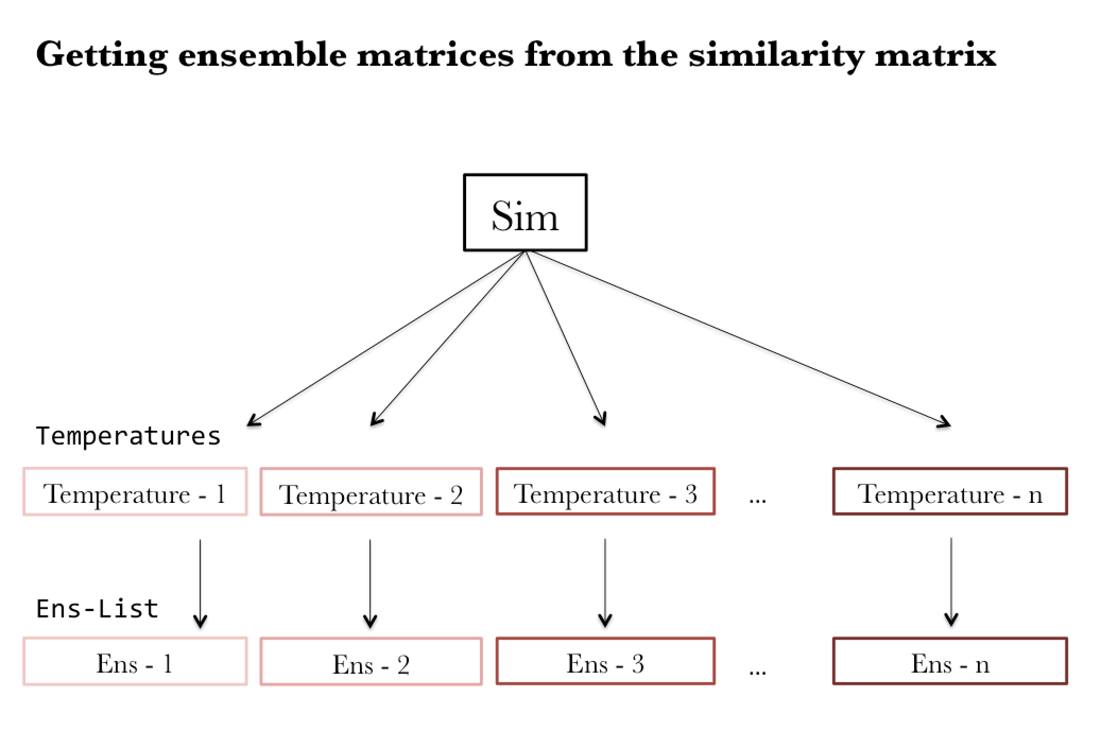

#### Generating eigenvalue plots

The appropriate number of clusters is determined by examining the eigenvalue plots. The function plotMultiEigenvalues is used to plot eigenvalues corresponding to each ensemble matrix in the list of ensemble matrix (Ens_List). These plots show the approximate number of clusters. Red dots connected by a red line represent a cluster. The plot below shows two red lines that connect three red dots on the left, which indicates the presence of two clusters.

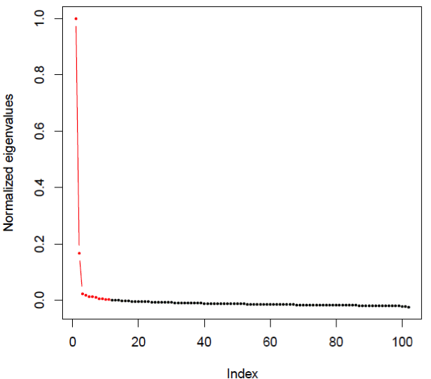

The function plotEnsList takes two arguments, Enslist and name, and exported a .pdf file in your working directory containing all eigenvalue plots. The argument Enslist is the output from the function getEnsList. The argument name is the name given to the exported .pdf file.

plotEnsList(Ens_list, name = "eigenvalue_plots")

## eigen value plots can be found at './eigenvalue_plots.pdf'

?plotEnsList

Note, the plots in your "eigenvalue_plots.pdf" file look messy because we ran only 5 iterations (MaxIt = 5) in getEnsList. Try using MaxIt = 1000 and see if your plots are of any difference.

The process generating eigenvalue plots from ensemble matrices is shown in the flow chart below. 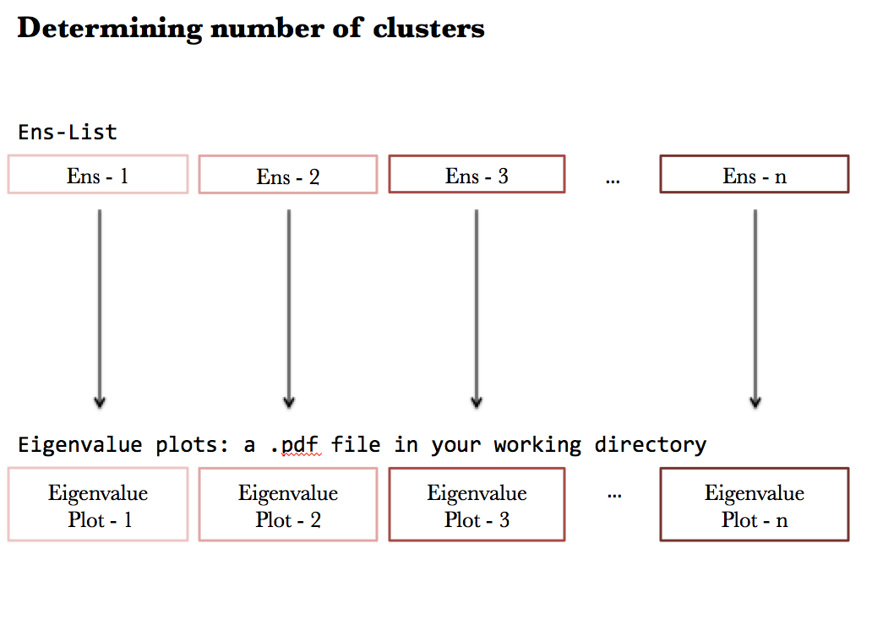

After inspecting the eigen plots, choose an ensemble matrix (Ens1, Ens2….Ens20) whose number of clusters appears to be stable across multiple temperatures. For example, if matrices Ens1 – Ens4 all show two clusters, Ens5 shows three clusters, and Ens6 – Ens20 all show four clusters, then the divisions of two or four clusters are likely reasonable divisions of your network. Once you know which ensemble matrix to choose, you'll need to generate tree plots to examine clusters.

#### Generating tree plots

To generate tree plot of specific ensemble matrix, you could use plotTheTree function. For example, if you want to create the tree plot from only the first ensemble matrix, you'll need to run the following codes:

plotTheTree(Ens_list, index = 1)

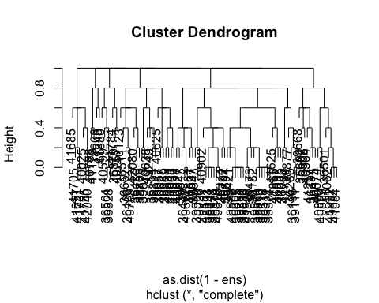

The function plotTrees is used to plot tree plots from a list of ensemble matrices and export the plots in a .pdf file in your working directory. Its first argument EnsList is the output from the function getEnsList. Its second argument name is the name given to the .pdf file. These plots allow you to examine the differences between cluster divisions corresponding to each of the ensemble matrix. You could find the exported .pdf file in your working directory.

plotTrees(EnsList = Ens_list, name = "myTrees")

## tree plots can be found at './myTrees.pdf'