**Chapter 3: Canine Distemper virus in wild mesocarnivores in the South-eastern united states**

# INTRODUCTION

Human land use change has a significant impact on the dynamics of infectious diseases at the wildlife-domestic-human interface (Bradley and Altizer 2007, Gottdenker et al. 2014). the displacement of wildlife, changes in the population dynamics can also lead to overcrowding and poor sanitation, which can facilitate the spread of diseases. Furthermore, changes in land use can alter the distribution and abundance of disease vectors, such as mosquitoes and ticks, leading to an increased incidence of vector-borne diseases. These impacts are further compounded by climate change, which can further change the range of disease vectors and timing of disease outbreaks. Therefore, it is crucial to understand the relationship between urbanization and infectious disease in wildlife in order to develop effective management and conservation strategies to mitigate the negative impacts and protect affected species and their ecosystems

Canine distemper virus (CDV) is a significant cause of morbidity and mortality in a wide range of wildlife and domestic species. and been implicated in severe population declines in multiple species, including the near-extinction of the black-footed ferret in the US (Williams et al. 1988). It is also an important disease in domestic dogs, and CDV can be transmitted between wildlife and dogs, and vice-versa (Kapil and Yeary 2011). CDV has also been proposed as a risk to human health, it has been hypothesized that waning population level measles immunity may leave humans susceptible to CDV infection.(Martinez-Gutierrez and Ruiz-Saenz 2016). However, there is an incomplete understanding of the dynamics of CDV infection within many multi-host systems, such as carnivore communities. The role that particular species plays in the maintenance and spread of CDV is not understood, and consequently the targeting of mitigation measures is not well informed.

The southeastern US is a multi-host system for CDV, with wide variety of potential canine distemper virus host species. Raccoons are frequently the most reported wild carnivore species in distemper outbreaks and have been suggested as the possible reservoir host (Roscoe 1993). Preliminary work from necropsy data of CDV-infected wild carnivores has demonstrated that CDV is widely spread in the SE USA with at least 9 carnivore species experiencing mortality as a result of infection. In the most commonly infected species, raccoons and gray foxes, there appeared to be a trend of cases clustering in suburban areas with fewer cases occurring in highly urbanized and in rural areas(Taylor et al. 2021). Studies in other parts of the world have suggested that the dynamics of CDV outbreaks can vary over time and space (Bianco et al., 2020). Given the propensity of CDV to infect synanthropic mesocarnivores I, it is important to investigate whether there are human land use features which affect the likelihood of the virus occurring in wildlife.

Here, we measure the phylogenetic structure and spatial patterns of CDV infection wild mesocarnivores in the Southeastern United states using, using carcasses submitted to the Southeastern Cooperative Wildlife Disease study between January 2020 and December 2022. Animals were diagnosed as CDV positive or negative during postmortem examination at SCWDS. From the positive cases a subset were sampled for CDV and had a partial H gene sequence isolated for phylogentic analysis. The objectives of this study were to;

(1) explore the CDV genetic diversity in wild mesocarnivores submitted to SCWDS

(2) investigate the spatial distribution of CDV in free-ranging mesocarnivores from the same region from 2019 to 2022

(3) develop a model to idenitify specific ecological factors with may increase the rosk of CDV

Specifically we aimed to investigate how different land use types influence the likelihood of wild mesocarnivores being diagnosed with CDV at necropsy.

# MATERIALS AND METHODS

The Southeastern Wildlife Disease Study study incorporates 17 states generally located in the southeast of the USA. Here, we used a data set that included the cause of death of 270 mesocarnivores from January 2019 to December 2022. 158 of these samples were diagnosed as having CDV at necropsy. The raw data from SCWDS includes the variables state, county, area, coordinates, species, date, sex, age, weight, diagnosis. Additionally, the land cover data for each location was extracted from raster maps available from the National Land Cover Database (NLCD). The different land cover types are described in supplementary table X. The classification system used by NLCD is modified from the [Anderson Land Cover Classification System](https://pubs.usgs.gov/pp/0964/report.pdf" \t "_blank) (Anderson 1976).  Along with elevation data from the `elevatr` REFpackage and average temperature and precipitation values accessed from the PRISM REFdatabase. Further variables calculated for each data point were distance to nearest hydrological feature and distance to the nearest other distemper case in the data. The hydrological maps were accessed from TIGRIS database REF. The R script for the data collection, cleaning and analysis is included at XXX.

Cases of CDV infection were identified at necropsy by one or more of the following diagnostic features: CDV positive by fluorescent antibody testing (Fairchild et al. 1971) or immunohistochemistry (Palmer et al. 1990) and characteristic histopathology. CDV causes necrosis of lymphatic tissue, interstitial pneumonia, and intranuclear and intracytoplasmic inclusion bodies in respiratory, urinary, and gastrointestinal epithelium. Brain lesions include neuronal degeneration, gliosis, demyelination, perivascular cuffing, leptomeningitis, and inclusion bodies in glial cells. Lesions vary depending on the stage of the disease and affected organ, and may include mild inflammation in early stages, and severe inflammation and necrosis in later stages. Respiratory tract may show diffuse inflammation, thickening, and hyperplasia of the epithelial cells, accumulation of inflammatory cells in the lumen of the airways. Nervous system may show inflammation, degeneration, and perivascular cuffing. Gastrointestinal tract may show inflammation, necrosis, and presence of lymphocytes and macrophages in the lumen of the gut. REFS

 Histologically, canine distemper virus produces necrosis of lymphatic tissues, interstitial pneumonia, and cytoplasmic and intranuclear inclusion bodies in respiratory, urinary, and GI epithelium.

Lesions found in the brains of dogs with neurologic complications include:

* neuronal degeneration
* gliosis
* noninflammatory demyelination
* perivascular cuffing
* nonsuppurative leptomeningitis
* intranuclear inclusion bodies, predominantly within glial cells

(including intranuclear and intracytoplasmic inclusions). Histopathological lesions of canine distemper are varied and depend on the stage of the disease and the specific organ affected. In the early stages of the disease, there may be mild inflammation of the lymphoid tissue, such as lymphoid depletion or hyperplasia in the lymphoid follicles of the tonsils, lymph nodes, and spleen. In the later stages of the disease, there may be more severe inflammation and necrosis in these organs.

In the respiratory tract, there may be diffuse inflammation of the epithelial lining of the trachea and bronchi, with thickening and hyperplasia of the epithelial cells. There may also be accumulation of inflammatory cells, such as lymphocytes and macrophages, in the lumen of the airways.

In the nervous system, there may be inflammation and degeneration of the brain and spinal cord, with the presence of perivascular cuffing, neuronal vacuolation and neuronophagia.

In the gastrointestinal tract, there may be inflammation and necrosis of the epithelial lining of the stomach and intestines, with the presence of lymphocytes and macrophages in the lumen of the gut.

One of the most important reference for the histopathological diagnosis of canine distemper is "Comparison of histopathological changes in canine distemper virus infections in wild and domestic carnivores" by J.F.X. Wiederhold and J.F.X. Wiederhold

Succinct

**Nucleic acid detection/sequencing/analysis**

A subset of 31 of the CDV positive necropsy cases had clinical samples taken, mostly brain, but also lung, liver, spleen, for viral RNA extraction. CDV RNA was extracted from necropsy samples with a commercially available extraction kit (RNeasy Mini Kit, Qiagen, Valencia, CA, USA) according to manufacturer’s instructions. Extracted RNA was stored at −80 °C. The forward and reverse Primer pair used to amplify the approximately 1000bp region of H-gene (fig X) were synthesized based on primer pair 7? In REF. A single step process was used for CDNA production and PCR amplification in this case using a commercially available master mix (SuperScript III Platinum One-Step RT-PCR kit, Invitrogen, Life Technologies, Grand Island, NY, USA). Two microliters of extracted RNA per sample were run in 25 μL total volume reactions using 300 nM of each primer and one unit of RNAse inhibitor (RNAse Out, Invitrogen, Life Technologies, Grand Island, NY, USA) for RT-PCR. Samples were amplified in a thermal cycler with a RT step at 50 °C for 30 min., activation step at 94 °C for 2 min., followed by 35 cycles of denaturation at 94 °C for 30 s., annealing at 60 °C for 1 min., and elongation at 72 °C for 3 min., with an additional elongation step at 72 °C for 10 min. The RT-PCR products were electrophoresed on a 2 % TAE agarose gel stained with SYBR Safe® and visualized. Products with a single band at ¬1000 bases were purified using QIaquick PCR purification kit (Affymetrix, Santa Clara, CA, USA). All products were capillary sequenced at the Eurofins Genomics, KY USA, using the same primers as in the PCR reactions. Chromatograms edited and assembled using Geneious© software.

1. Take raw chrotamogram results for forward and reverse primer reads
2. First, trim the poor quality sequence off your reads using **Annotate and Predict - Trim Ends.**Set the **Error probability limit**to 0.05 to trim bases with a quality score of less than approximately 13.  Annotate the trimmed regions so that you can see what has been trimmed and adjust it if you wish.
3. Next, go to **Align/Assemble - De novo assemble**to open the de novo assembly options.  Select the option **Assemble by name**and then choose the part of your sequence name that is identical between the F and R pairs, plus the symbol that separates this part from the non-identical part of the name.
4. A consensus sequence for each pair of reads can be generated either during the de novo assembly process, by selecting the **Save consensus sequences** option in the de novo assembly setup window, or after the contigs have been generated and visually inspected.  To generate a consensus sequence from the contig assembly documents, select all of the assemblies and go to **Tools > Generate Consensus Sequences.**

Further available H-gene sequences for the USA were downloaded from GenBank and aligned in Geneious with the study isolates using the MUSCLE algorithm. Geneious tree builder was then used with the Jukes-Cantor genetic distance model and the UPGMA method with 1000 bootstraps to generate a phylogenetic tree from this alignment.

**Statistical analysis**

Diagnostic data from SCWDS cases were imported into R Studio (version 1.3.1056). A detailed description of data analysis is contained in the scripts within the project repository (XXX). All analyses described below were conducted in the R programming environment (version 3.5.3.). References to packages in this methods section indicate specific packages used within the R programming environment.

DESCIBE THE RIP K ANALYSIS THAT WAS CONDUCTED HERE PLEASE

 Analysis of spatial clustering of cases in Georgia was performed using Ripley’s K from the *spatstat* package (Baddeley et al. 2015). This analysis identifies if, and at what spatial scale, spatial point data are more clustered or dispersed compared to a random distribution.

Ripleys' K-function analysis is a method used to assess spatial point pattern analysis. The analysis can be conducted in R using the "spatstat" package. The following is an example of how Ripleys' K-function analysis could be described in the methods section of a journal article manuscript:

1. Data preparation: The first step is to prepare the data for analysis. The data should be a set of x and y coordinates for the points of interest. The data can be loaded into R as a "ppp" object (a point pattern dataset object) using the "as.ppp" function in the "spatstat" package.
2. K-function analysis: Once the data is loaded, the K-function analysis can be conducted using the "Kest" function in the "spatstat" package. This function calculates the K-function for a given set of points and a set of distances. The function takes the following arguments:

* x: the x-coordinates of the points
* y: the y-coordinates of the points
* r: a vector of distances at which the K-function should be calculated
* correction: the type of edge correction to apply (e.g. "isotropic" for isotropic edge correction)

1. Plotting the results: The output of the Kest function is a list containing the estimated K-function and the observed K-function. These can be plotted using the "plot" function in R.
2. Model fitting: Ripley's K-function is a way to test for complete spatial randomness. The fitted model can be done by using the "fit.kppm" function in the "spatstat" package. The output of this function will be a fitted model object that can be used to make inferences about the spatial point pattern.
3. Conclusion: The K-function analysis can be used to assess the spatial point pattern of the data. The results of the analysis can be used to determine if the point pattern is random or not. Additionally, the fitted model can be used to make inferences about the spatial point pattern.

A generalized linear model was developed to identify factors associated with the positive diagnosis of CDV in wild mesocarnivores in R using the `stats` package.

A positive or negative diagnosis of CDV was the response variable, whereas Species, location, sex, age, month received, distance to nearest distemper case, elevation, precipitation, temperature, distance to water source, surface imperviousness and land cover type were explanatory factors. The GLM was then fit to the data using the glm() function. The model was fit using maximum likelihood estimation. To select the best model, different models were fitted and compared based on their AIC (Akaike Information Criterion) REF

Model fitting

Variable interaction

Add1 function from `stats` package to test for intesacting variables

Remove insignificant variables

Used dropterm from `MASS` package to evaluate impact of reoving each variable on AIC. Removed those 4 which improved AIC.

Remove outliers

Test for outliers with influencePlot and outlierTest fro `car` package. use AIC to evaluate improvement. 3 outliers removed that resulted in significant improvement.

Model evaluation

Test for fit to data and overfitting by comparing residual distrubtion from the training tand test data.

Finally using the test data the predictive ability of the model was tested.

modelviz

Model diagnostics: After fitting the model, diagnostic plots were created to check for model assumptions and to identify any potential outliers or influential observations.

Model interpretation: Finally, the model coefficients and their standard errors were interpreted to understand the relationships between the predictor variables and the response variable. The significance of the predictor variables was determined using p-values.

The glm function in R uses a technique called "dummy coding" to convert categorical variables into a set of binary variables, also known as "indicator variables" or "dummy variables". This is done so that the categorical variable can be included in the model as a predictor. When a categorical variable is used in a model, it is split into one binary variable for each level of the categorical variable, with a value of 1 indicating membership in that level, and a value of 0 indicating non-membership. The summary function then displays each of these binary variables as a separate factor in the output. This allows the user to see the effect of each level of the categorical variable on the response variable.

Model fitting: In this way, a clear and detailed description of the model fitting process can be provided in the methods section of a scientific manuscript. This allows other researchers to understand and replicate the analysis, and to evaluate the validity and robustness of the results.

# RESULTS

A total of 270 mesocarnivores were present in this dataset from January 2019 to December 2022. 158 out of the 270 mesocarnivores (58.5%) were diagnosed as CDV positive at necropsy. There were four host species present in this data: raccoon, gray fox, striped skunk, red fox. These animals came from 13 states. The breakdown of the state and species distribution is shown in table X.

Table X: Summary table of necropsy cases by species and state submitted to SCWDS between January 2019 and December 2022

|  |  |  |  |  |  |
| --- | --- | --- | --- | --- | --- |
|  | Gray Fox | Raccoon | Red Fox | Striped Skunk | Sum |
| AR | 3 | 14 | 0 | 0 | 17 |
| FL | 0 | 6 | 2 | 0 | 8 |
| GA | 9 | 25 | 3 | 0 | 37 |
| KS | 0 | 14 | 3 | 12 | 29 |
| KY | 0 | 18 | 1 | 1 | 20 |
| LA | 4 | 14 | 1 | 3 | 22 |
| MO | 2 | 19 | 2 | 9 | 32 |
| NC | 15 | 53 | 3 | 2 | 73 |
| NE | 0 | 1 | 0 | 2 | 3 |
| PA | 1 | 5 | 0 | 0 | 6 |
| TN | 2 | 1 | 0 | 0 | 3 |
| VA | 0 | 3 | 3 | 0 | 6 |
| WV | 0 | 9 | 5 | 0 | 14 |
| Sum | 36 | 182 | 23 | 29 | 270 |

****

Figure X: Map of distribution of necropsy cases submitted to SCWDS by species

**SPATILA**

**#insert ripleys K plots?**

Ripley's K function is a statistical tool used to measure the spatial autocorrelation of a point pattern. In a Ripley's K plot, the x-axis represents the distance between the points, and the y-axis represents the number of points within that distance. The plot of K(r) against r is a measure of the spatial distribution of points.

Interpreting the shape of the plot is the key to understanding the spatial autocorrelation of the point pattern. Here are some general guidelines:

* If the plot is flat, it indicates that the point pattern is a random pattern, and there is no spatial autocorrelation.
* If the plot increases linearly with distance, it indicates that the point pattern is a regular pattern, and there is a positive spatial autocorrelation.
* If the plot increases more than linearly with distance, it indicates that the point pattern is a clustered pattern, and there is a strong positive spatial autocorrelation.
* If the plot decreases with distance, it indicates that the point pattern is a regular pattern, and there is a negative spatial autocorrelation.
* If the plot reaches a peak at some distance, it indicates that the point pattern is a clustered pattern, and there is a strong positive spatial autocorrelation at the peak distance.

It is important to note that these are general guidelines, and the shape of the Ripley's K plot can be affected by the size and shape of the window, the presence of edge effects, and other factors. Therefore, it's essential to always include the simulated envelope (confidence interval) when interpreting the results. The envelope shows a range of values that would be expected by chance, and it helps to distinguish between real and random patterns.

Please let me know if you have any other question or if any further clarification is needed.

If the line on a Ripley's K plot stays above the "no clustering" line but is parallel to it, this could indicate that the points are clustered in a specific area or region, rather than being randomly distributed throughout the entire study area. The parallel line shape indicates that the clustering is consistent throughout the range of distance values on the x-axis, rather than being concentrated at specific distances.

**CDV Phylogeny**

31 CDV partial H-gene (¬1200 bp) isolates from 5 state from this study, in addition to 55 additional sequences downloaded from GenBank were aligned in Geneious and used to build a phylogenetic tree.22 of the isolates from eastern states (NC, FL, GA) grouped together in one large cluster. Isolates from Missouri and Arkansas clustered quite distinctly from this large eastern clade although, one NC and one GA isolate did group with these isolates.The large cluster from eastern states was most closely related to an isolate from a European dog.

Figure X: Phylogenetic tree of…

Sequences obtained in this work are in coloured text.

**Generalized Linear Model of CDV diagnosis**

The results of the GLM did not include location, sex, elevation, temperature, distance to water source as significant explanatory variables. However, age, month received, distance to nearest distemper case, precipitation, surface imperviousness and land cover type were confirmed to be statistically significant factors according to GLM (Table X).

|  |  |  |  |  |  |
| --- | --- | --- | --- | --- | --- |
| Model | Residual Deviance | Residual d.f. | AIC | deltaic | AIC weight |
| Best fit |  |  |  |  |  |
| Global model | 179.05 | 173 | 237.05 | 87.46 | 1.02x10-19 |
| Interactions | 101.37 | 163 | 179.37 | 29.78 | 3.41x10-7 |
| dropterms | 103.17 | 168 | 175.17 | 25.58 | 2.79x10-6 |
| outliers | 77.59 | 165 | 149.59 | - |  |

Animals closer to another CDV case were significantly more likely to be positive for CDV, as were animals that were juveniles. Additionally, those found in areas of high. medium and low intensity areas of human development. There was a less strong relationship, but still significant between greater surface imperviousness.

|  |  |  |  |  |  |  |
| --- | --- | --- | --- | --- | --- | --- |
| Explanatory Variable | Estimate | 2.50% | 97.50% | Std. Error | z value | Pr(>|z|) |
| SpeciesRaccoon:Temperature | 4.296854 | 2.370153 | 7.260268 | 1.182571 | 3.633485 | 0.00028 |
| lat:Elevation | 0.004873 | 0.002497 | 0.007868 | 0.00135 | 3.610439 | 0.000306 |
| SpeciesStriped Skunk:Temperature | 4.741659 | 2.589425 | 8.075528 | 1.333282 | 3.556382 | 0.000376 |
| SpeciesRaccoon | -73.3049 | -124.918 | -39.2485 | 20.9445 | -3.49996 | 0.000465 |
| SpeciesStriped Skunk | -78.5665 | -133.088 | -41.7943 | 22.4632 | -3.49757 | 0.00047 |
| Elevation | -0.1585 | -0.26241 | -0.07577 | 0.046851 | -3.38301 | 0.000717 |
| Elevation:Imperviousness | -0.00027 | -0.00044 | -0.00013 | 7.93E-05 | -3.34629 | 0.000819 |
| SpeciesStriped Skunk:knn.dist | -0.00016 | -0.00029 | -8.4E-05 | 5.27E-05 | -3.03961 | 0.002369 |
| AgeJuvenile | -8.02765 | -13.8458 | -2.39898 | 2.872082 | -2.79506 | 0.005189 |
| Precipitation | 0.00533 | 0.001752 | 0.009342 | 0.001914 | 2.784664 | 0.005358 |
| Imperviousness | 0.11912 | 0.034926 | 0.213466 | 0.044956 | 2.649723 | 0.008056 |

Table X

Summary statisitatics for significant (p<0.01) explanatory variables for xyz glm. Full summary of model in supplementary table X

Prediction accuracy =0.61

#Plot predictions

Precison,=0.56 recall,=0.75 F1 score=0.64

# DISCUSSION

Data from wild mesocarnivores submitted to the SCWDS was analyzed based on their CDV diagnosis at necropsy with a subset of these cases being sampled for CDV for phylogenetic analysis of the virus in wild mesocarnivores in the southeast. Ecological variables including human land use type at the location of each case submitted were included in the data with a generalized linear model developed to identify factors that increased the risk of CDV in these animals.

The phylogenetic analysis of CDV isolates showed a very distinct cluster from animals in states east of the Mississippi river. The vast majority Isolates from NC, GA and FL clustered closely together within the phylogenetic tree. Isolates from western states, AR and MO clustered quite separately from these eastern isolates and in a much less clear ly defined cluster. This suggests the eastern isolates are all quite closely related and given that the states of GA, FL and NC are contiguousd, may all have originated from one large ongoing outbreak in the area. Secondly, that the Mississippi river forms a much more difficult barrier for the virus to traverse than other smaller rivers. This would make sense given that the virus is not transmitted by birds or airborne transmission, so would need to be brought across the river by an infected mammal. This results in distinct strains evolving on each side of the river. The Mississippi as a barrier to disease dispersal in wildlife has been demonstrated before with rabies (Kuzmina et al. 2013). However, based on this study, and others, it is not an impenetrable barrier, as there was one GA isolate and one NC isolate that clustered with isolates from Missouri, suggesting that at some point in time these were able to spread across the river, whether this be through an infected wild mammal swimming or inside a truck, or perhaps via an infected dog or even via a fomite.

The GLM for CDV diagnosis and ecological variables revealed a number of significant results. The most significant explanatory variable was distance to another positive CDV case. This makes perfect sense from a disease ecology standpoint as it is a directly transmitted pathogen and does not persist in the environment for any great length of time so an animal is not going to spontaneously contract the virus from the environment. Being close to another existing case likely means being close to an existing outbreak.

The most important result of the GLM from the objectives of this study are that land cover type was a significant factor in CDV diagnosis, specifically High, medium and low intensity developed were a risk factor for CDV diagnosis. There are a number of reasons why urban and suburban areas could be resulting in higher likelihood of CDV in wild mesocarnivores. Urban areas often possess abundant resources for anthropophilic species, such as raccoons, which may not be prone to seasonal fluctuations. These resources include food supplies (e.g., household waste) but also shelter. As a result, urban and suburban areas are capable of supporting much greater raccoon population densities (Prange et al. 2003). In addition to there being a greater quantity of resources in urban areas, there tends to be greater aggregation of resources. This clumping of resources, for example at a large landfill site, results in two factors which are of importance in disease transmission; they result in migration of individuals into the area and in exceptionally high contact rates between not only member of the same species but between members of different species. Contact rates play a vitally important role in disease transmission with higher population density resulting in greater contact rates and consequently greater rates of disease transmission (Hu et al. 2013). One particular study showed this higher population density in response to resource availability resulted in higher parasite richness and increased prevalence of the zoonotic nematode *B. procyonis*  in raccoons(Wright and Gompper 2005). A Study by Hwang et al showed higher prevalence of severe fever with thrombocytopenia syndrome virus antibodies in urban dwelling feral cats than in their rural counterparts (Hwang et al. 2017). And canine distemper virus cases are more prevalent in urban and suburban counties than in rural counties, which support a much lower population density of raccoons (Taylor et al. 2021). There is an added potential layer of complexity to additional resource provision as increased birth rates in this situation increase the abundance of susceptible juvenile hosts compared to a natural environment. Finally, there is the question on how the quality of this diet (Schulte-Hostedde et al. 2018) affects the immune response of these individuals and whether this may also result in greater amount of pathogen shedding. There is also the possibility that closer contact with domestic dogs in an urban setting results in more CDV spillover events into wildlife populations than in rural areas. However, there may also be potential sources of bias in urban area skewing the results. As this is passively collected data that generally comes from animals found dead or moribund, or exhibiting neurological signs (in which case they are first submitted for rabies testing) then these are more likely to be seen and reported to the appropriate state authority in an urban area as there are more people there who would see the animal.

Some of the less significant factors in the model were surface imperviousness, age of animal, month animal received. Whilst one would think that imperviousness would correlate with level of development discussed above, it is probably less significant because of the fact that many of these animals would have been found on roads and carparks etc., which even in rural areas are an impervious surface which may have reduced the significance of this factor. The age of the animals, specifically being a juvenile showed some significance. This may be due to waning maternal antibodies, making them susceptible to diseases (REF) or that these young animals were more likely to be killed by other means and also happened to have CDV concurrently. As discussed in Taylor and Wilson 2021, there maybe I higher risk for CDV during the breeding season, which may explain the significance of the month received

The results of this study may have important implications for surveillance and conservation efforts. By identifying areas of intense human development as areas of highest risk for disease it may be possible to focus surveillance efforts in these areas, allowing outbreaks to be identified earlier. It may even be possible in these urban areas to instigate a citizens science program using a reporting application similar to that used for rabies in skunks in Colorado (Pepin et al. 2017). This may allow for vaccination programs in the face of outbreaks which threaten more vulnerable mammal species.

**Limitations**

The limitations of this study mostly apply to the type of sampling. The samples are collected passively through submissions to SCWDS by Georgia DNR and the other equivalent departments in other states. This is dependent on a number of factors; a dead or ill animal being reported to the authorities or being seen by them and a willingness to submit for necropsy, so there are likely to be large numbers of subclinical cases which are missed. This also leads to a number of potential areas of sampling bias, with more populated areas and areas with state/national parks likely to have more cases submitted as there are more people and/or officers present in these areas. Additionally, areas with rabies concerns are likely to submit more cases as the two diseases present very similarly and frequently a case will in fact have been submitted as a query rabies case and after that has been ruled out will then be tested for CDV.

Additionally, the raster data from NLCD is from 2019 which is before most of our samples were taken, however the landcover is unlikely to have changed much in this timeframe, particular with the economic impact of the COVID-19 pandemic, the effects of this time lag are likely to be minimal.

# CONCLUSION

The conclusions of this study are twofold. Firstly, it provides further evidence of widespread CDV infection in wild mesocarnivores within the southeastern US and that there is significant genetic diversity within this virus in the area, particularly divided by the Mississippi river. Secondly, human land use may play an important role in the disease ecology of this virus with areas of intense human development being shown to be of higher risk for CDV infection in wild mesocarnivores. Land use change is a complex problem when it comes to disease dynamics at the wildlife-domestic-human interface with no solution that fits every disease. Social responsibility and responsible urban planning with biodiversity at the forefront of development can mitigate future problems. Additionally, surveillance and control measures, such as vaccination, particularly regarding diseases in synanthropic species can also play a crucial role in dynamics of wildlife disease in urban environments.

# REFERENCES

ANDERSON, J. R. 1976. A Land use and land cover classification system for use with remote sensor data. U.S. Govt. Print. Off., Washington iii, 28 p. pp

BRADLEY, C. A., ANDS. ALTIZER. 2007. Urbanization and the ecology of wildlife diseases. Trends Ecol Evol 22: 95-102.

GOTTDENKER, N. L., D. G. STREICKER, C. L. FAUST, ANDC. R. CARROLL. 2014. Anthropogenic land use change and infectious diseases: a review of the evidence. Ecohealth 11: 619-632.

HU, H., K. NIGMATULINA, ANDP. ECKHOFF. 2013. The scaling of contact rates with population density for the infectious disease models. Math Biosci 244: 125-134.

HWANG, J., J. G. KANG, S. S. OH, J. B. CHAE, Y. K. CHO, Y. S. CHO, H. LEE, ANDJ. S. CHAE. 2017. Molecular detection of severe fever with thrombocytopenia syndrome virus (SFTSV) in feral cats from Seoul, Korea. Ticks Tick Borne Dis 8: 9-12.

KAPIL, S., ANDT. J. YEARY. 2011. Canine distemper spillover in domestic dogs from urban wildlife. Vet Clin North Am Small Anim Pract 41: 1069-1086.

KUZMINA, N. A., P. LEMEY, I. V. KUZMIN, B. C. MAYES, J. A. ELLISON, L. A. ORCIARI, D. HIGHTOWER, S. T. TAYLOR, ANDC. E. RUPPRECHT. 2013. The phylogeography and spatiotemporal spread of south-central skunk rabies virus. PLoS One 8: e82348.

MARTINEZ-GUTIERREZ, M., ANDJ. RUIZ-SAENZ. 2016. Diversity of susceptible hosts in canine distemper virus infection: a systematic review and data synthesis. BMC Vet Res 12: 78.

PEPIN, K. M., A. J. DAVIS, D. G. STREICKER, J. W. FISCHER, K. C. VERCAUTEREN, ANDA. T. GILBERT. 2017. Predicting spatial spread of rabies in skunk populations using surveillance data reported by the public. PLoS Negl Trop Dis 11: e0005822.

PRANGE, S., S. D. GEHRT, ANDE. P. WIGGERS. 2003. Demographic Factors Contributing to High Raccoon Densities in Urban Landscapes. The Journal of Wildlife Management 67.

ROSCOE, D. E. 1993. Epizootiology of canine distemper in New Jersey raccoons. J Wildl Dis 29: 390-395.

SCHULTE-HOSTEDDE, A. I., Z. MAZAL, C. M. JARDINE, ANDJ. GAGNON. 2018. Enhanced access to anthropogenic food waste is related to hyperglycemia in raccoons (Procyon lotor). Conserv Physiol 6: coy026.

TAYLOR, K., J. J. WILSON, A. W. PARK, N. M. NEMETH, M. J. YABSLEY, H. FENTON, M. K. KEEL, ANDN. L. GOTTDENKER. 2021. Temporal and Spatial Patterns in Canine Distemper Virus Cases in Wildlife Diagnosed at the Southeastern Cooperative Wildlife Disease Study, 1975-2019. J Wildl Dis 57: 820-830.

WILLIAMS, E. S., E. T. THORNE, M. J. APPEL, ANDD. W. BELITSKY. 1988. Canine distemper in black-footed ferrets (Mustela nigripes) from Wyoming. J Wildl Dis 24: 385-398.

WRIGHT, A. N., ANDM. E. GOMPPER. 2005. Altered parasite assemblages in raccoons in response to manipulated resource availability. Oecologia 144: 148-156.

# SUPPLEMENTARY MATERIALS

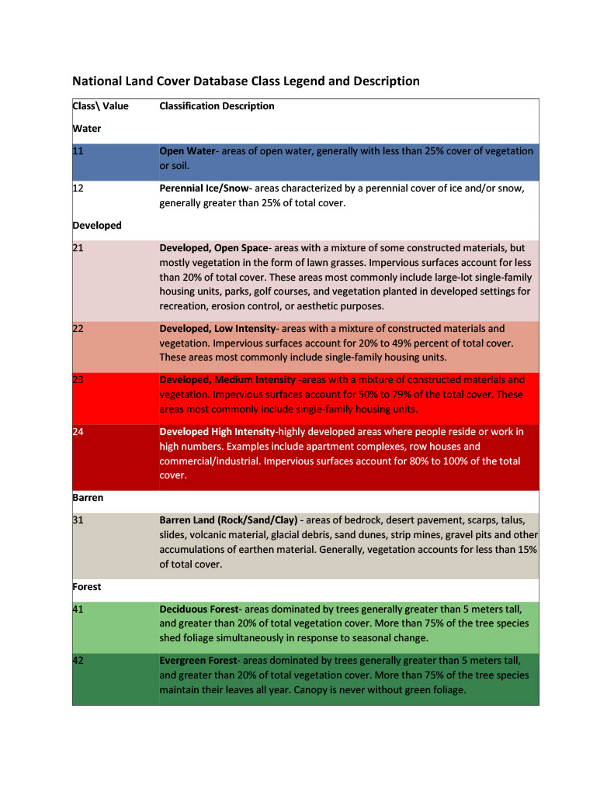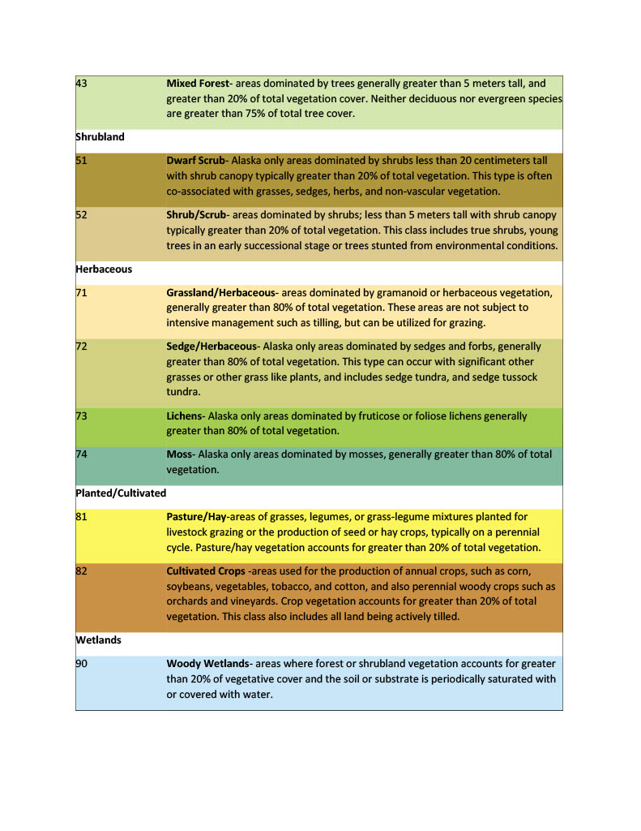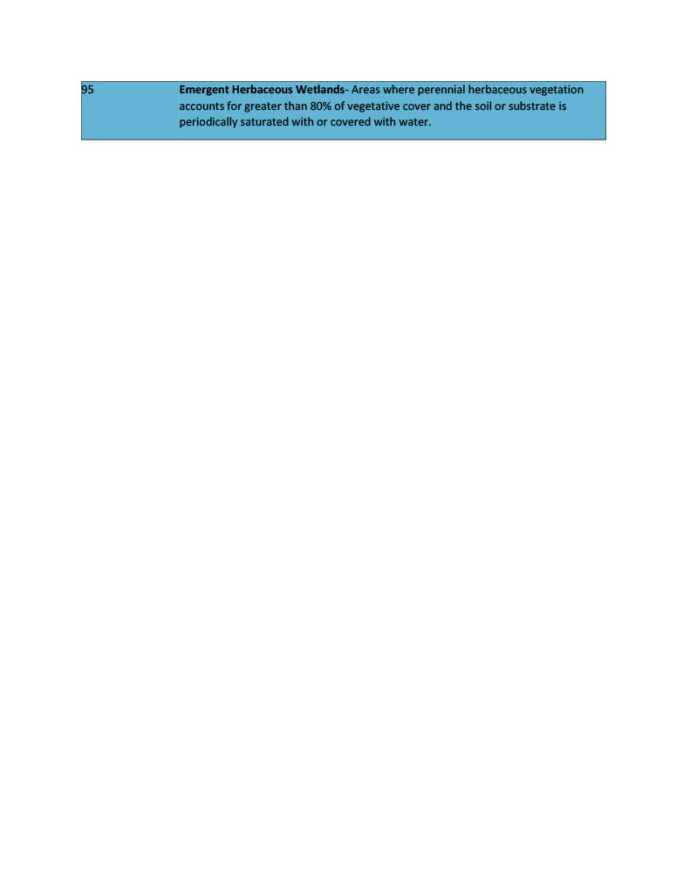

Supplemetary Table X: National Land Cover Database Class Legend and Description. Detailed descriptions of landcover classes designated to each pixel of the national landcoever database for the united states. Original source: https://www.mrlc.gov/data/legends/national-land-cover-database-class-legend-and-description

|  |  |  |  |  |
| --- | --- | --- | --- | --- |
|  | Estimate | Std. Error | z value | Pr(>|z|) |
| SpeciesRaccoon:Temperature | 4.296854 | 1.182571 | 3.633485 | 0.00028 |
| lat:Elevation | 0.004873 | 0.00135 | 3.610439 | 0.000306 |
| SpeciesStriped Skunk:Temperature | 4.741659 | 1.333282 | 3.556382 | 0.000376 |
| SpeciesRaccoon | -73.3049 | 20.9445 | -3.49996 | 0.000465 |
| SpeciesStriped Skunk | -78.5665 | 22.4632 | -3.49757 | 0.00047 |
| Elevation | -0.1585 | 0.046851 | -3.38301 | 0.000717 |
| Elevation:Imperviousness | -0.00027 | 7.93E-05 | -3.34629 | 0.000819 |
| SpeciesStriped Skunk:knn.dist | -0.00016 | 5.27E-05 | -3.03961 | 0.002369 |
| AgeJuvenile | -8.02765 | 2.872082 | -2.79506 | 0.005189 |
| Precipitation | 0.00533 | 0.001914 | 2.784664 | 0.005358 |
| Imperviousness | 0.11912 | 0.044956 | 2.649723 | 0.008056 |
| AgeJuvenile:month | 0.856084 | 0.356134 | 2.403827 | 0.016224 |
| descriptionDeveloped, Medium Intensity | -6.04146 | 2.778377 | -2.17446 | 0.029671 |
| Temperature | -2.76154 | 1.287085 | -2.14558 | 0.031907 |
| descriptionDeveloped, Low Intensity | -3.66313 | 1.847468 | -1.98279 | 0.047391 |
| descriptionMixed Forest | 16.69947 | 10.46531 | 1.595698 | 0.110556 |
| descriptionWoody Wetlands | -3.24403 | 2.400264 | -1.35153 | 0.176525 |
| descriptionEvergreen Forest | -3.95826 | 3.050739 | -1.29748 | 0.194467 |
| month | -0.11836 | 0.098538 | -1.20115 | 0.229691 |
| SpeciesRed Fox | -102.014 | 87.06704 | -1.17167 | 0.24133 |
| lat | 0.569104 | 0.517027 | 1.100724 | 0.271017 |
| SpeciesRaccoon:knn.dist | -2.6E-05 | 2.93E-05 | -0.87108 | 0.383713 |
| AgeSubadult:month | -3.2532 | 3.943849 | -0.82488 | 0.409441 |
| SpeciesRed Fox:Temperature | 4.956784 | 6.420792 | 0.77199 | 0.440121 |
| descriptionDeveloped, High Intensity | -3.15043 | 4.13097 | -0.76264 | 0.445679 |
| AgeSubadult | 32.36474 | 43.01389 | 0.752425 | 0.451795 |
| descriptionPasture/Hay | 12.49099 | 17.43858 | 0.716285 | 0.473816 |
| (Intercept) | 21.30329 | 36.93669 | 0.576751 | 0.564107 |
| descriptionDeveloped, Open Space | -0.69567 | 1.303719 | -0.53361 | 0.593614 |
| descriptionDeciduous Forest | -0.41913 | 1.584585 | -0.2645 | 0.791393 |
| knn.dist | -1.1E-06 | 2.89E-05 | -0.03921 | 0.968719 |
| SpeciesRed Fox:knn.dist | 1.67E-06 | 0.000139 | 0.012031 | 0.990401 |
| descriptionGrassland/Herbaceous | -24.3637 | 3956.198 | -0.00616 | 0.995086 |
| descriptionOpen Water | 15.08734 | 2796.828 | 0.005394 | 0.995696 |
| descriptionScrub/Shrub | 17.26584 | 3956.181 | 0.004364 | 0.996518 |
| descriptionEmergent Herbaceous Wetlands | -15.1971 | 3956.181 | -0.00384 | 0.996935 |