**Chapter 3: Canine Distemper virus in wild mesocarnivores in the South-eastern united states**

# INTRODUCTION

Human land use change has a significant impact on the dynamics of infectious diseases at the wildlife-domestic-human interface (Bradley and Altizer 2007, Gottdenker et al. 2014). The displacement of wildlife and changes in the population dynamics can facilitate the spread of diseases. Furthermore, changes in land use can alter the distribution and abundance of disease vectors leading to an increased incidence of vector-borne diseases(Norris 2004, Gottdenker et al. 2011). These impacts are further compounded by climate change, which can further change the range of disease vectors and timing of disease outbreaks(Lafferty 2009). Therefore, it is crucial to understand the relationship between land use change and in particular the role of human development and infectious disease in wildlife in order to develop effective management and conservation strategies to mitigate the negative impacts and protect affected species and their ecosystems. The change in land use with the drive towards urban development alters the dynamics of wildlife populations. For directly transmitted pathogens the density of hosts drives contact rates and spread of the disease (Tompkins et al. 2011). High densities usually result in increased contact within and between species and subsequently greater prevalence of infection(Ditchkoff et al. 2006, Almberg et al. 2009). This idea of higher density populations and greater contact rates leading to more disease is of particular importance in synanthropic species. These species thrive in human disturbed environments where resource availability, shelter and lack of predation allows the environment to harbor large populations (Cavallini 1996, Prange et al. 2003, Contesse et al. 2004). Despite this other studies have suggested that highly urbanized areas may hamper disease spread of infectious diseases in wildlife due to reduced populations in these areas (Gras et al. 2018). Thus it remains unclear how continued urban development effects the dynamics of directly transmitted pathogens in synanthropic species. Raccoons are a notable synanthropic species as they are a reservoir for several pathogens of human interest; rabies, canine distemper virus, raccoon roundworm, leptospirosis to name a few. They are also notable in being able to exist in very dense and well connected populations in urbanized areas (Smith and Engeman 2002, Hirsch et al. 2013). Canine distemper virus (CDV) is a significant cause of morbidity and mortality in a wide range of wildlife and domestic species. Morbilliviruses have a tendency to have a narrow host range, but CDV goes against this trend by its ability to infect a wide variety of carnivore hosts. and has been implicated in severe population declines in multiple species, including the near-extinction of the black-footed ferret in the US (Williams et al. 1988). It is also an important disease in domestic dogs, and CDV can be transmitted between wildlife and dogs, and vice-versa (Kapil and Yeary 2011). CDV has also been proposed as a risk to human health, it has been hypothesized that waning population level measles immunity may leave humans susceptible to CDV infection.(Martinez-Gutierrez and Ruiz-Saenz 2016). However, there is an incomplete understanding of the dynamics of CDV infection within many multi-host systems, such as carnivore communities. The role that particular species plays in the maintenance and spread of CDV is not understood, and consequently the targeting of mitigation measures is not well informed. The southeastern US is a multi-host system for CDV, with wide variety of potential CDV host species. Raccoons are frequently the most reported wild carnivore species in distemper outbreaks and have been suggested as the possible reservoir host (Roscoe 1993). Preliminary work from necropsy data of CDV-infected wild carnivores has demonstrated that CDV is widely spread in the SE USA with at least 9 carnivore species experiencing mortality as a result of infection. In the most commonly infected species, raccoons and gray foxes, there appeared to be a trend of cases clustering in suburban areas with fewer cases occurring in highly urbanized and in rural areas(Taylor et al. 2021). Studies in other parts of the world have suggested that the dynamics of CDV outbreaks can vary over time and space (Bianco et al., 2020). Given the propensity of CDV to infect synanthropic mesocarnivores, it is important to investigate whether there are human land use features which affect the likelihood of the virus occurring in wildlife.

Here, we investigate the phylogenetic structure and spatial patterns of CDV infection in wild mesocarnivores in the Southeastern United states using carcasses submitted to the Southeastern Cooperative Wildlife Disease study between January 2020 and December 2022.. The objectives of this study were to;

(1) explore the CDV genetic diversity in wild mesocarnivores submitted to SCWDS

(2) investigate the spatial distribution of CDV in free-ranging mesocarnivores from the same region from 2019 to 2022

(3) develop a model to idenitify specific ecological factors with may increase the rosk of CDV

Specifically we aimed to investigate how land use influences the likelihood of wild mesocarnivores being diagnosed with CDV at necropsy.

# MATERIALS AND METHODS

The South-eastern Cooperative Wildlife Disease Study incorporates 17 states generally located in the southeast of the USA. Here, we used a data set that included the cause of death of 270 mesocarnivores from January 2019 to December 2022. 158 of these samples were diagnosed as having CDV at necropsy. The raw data from SCWDS includes the variables state, county, area, coordinates, species, date, sex, age, weight, diagnosis. Additionally, the land cover data for each location was extracted from raster maps available from the National Land Cover Database (NLCD). The different land cover types are described in supplementary table X. The classification system used by NLCD is modified from the Anderson Land Cover Classification System (Anderson 1976).  Along with elevation data from the `elevatr` package (Hollister 2021) and average temperature and precipitation values accessed from the PRISM database (PRISM Climate Group 2022). Further variables calculated for each data point were distance to nearest hydrological feature and distance to the nearest other distemper case in the data. The hydrological maps were accessed from TIGER database (U.S. Census Bureau 2022).The R script for the data collection, cleaning and analysis is included at XXX.

Many of the animals submitted were found dead or were found moribund and were subsequently euthanized. Cases of CDV infection were identified at necropsy by one or more of the following diagnostic features: CDV positive by fluorescent antibody testing (Fairchild et al. 1971) or immunohistochemistry (Palmer et al. 1990) and characteristic histopathology. CDV causes necrosis of lymphatic tissue, interstitial pneumonia, and intranuclear and intracytoplasmic inclusion bodies in respiratory, urinary, and gastrointestinal epithelium. Brain lesions include neuronal degeneration, gliosis, demyelination, perivascular cuffing, leptomeningitis, and inclusion bodies in glial cells. Lesions vary depending on the stage of the disease and affected organ, and may include mild inflammation in early stages, and severe inflammation and necrosis in later stages. Respiratory tract may show diffuse inflammation, thickening, and hyperplasia of the epithelial cells, accumulation of inflammatory cells in the lumen of the airways. Nervous system may show inflammation, degeneration, and perivascular cuffing. Gastrointestinal tract may show inflammation, necrosis, and presence of lymphocytes and macrophages in the lumen of the gut. (Van Moll et al. 1995, Jubb et al. 2012).

**Nucleic acid detection/sequencing/analysis**

A subset of 31 of the CDV positive necropsy cases had clinical samples taken, mostly brain, but also lung, liver, spleen, for viral RNA extraction. CDV RNA was extracted from necropsy samples with a commercially available extraction kit (RNeasy Mini Kit, Qiagen, Valencia, CA, USA) according to manufacturer’s instructions. Extracted RNA was stored at −80 °C. The forward and reverse Primer pair used to amplify the approximately 1000bp region of H-gene (fig X) were synthesized based on primer pair 7 in (Riley and Wilkes 2015). A single step process was used for CDNA production and PCR amplification in this case using a commercially available master mix (SuperScript III Platinum One-Step RT-PCR kit, Invitrogen, Life Technologies, Grand Island, NY, USA). Two microliters of extracted RNA per sample were run in 25 μL total volume reactions using 300 nM of each primer and one unit of RNAse inhibitor (RNAse Out, Invitrogen, Life Technologies, Grand Island, NY, USA) for RT-PCR. Samples were amplified in a thermal cycler with a RT step at 50 °C for 30 min., activation step at 94 °C for 2 min., followed by 35 cycles of denaturation at 94 °C for 30 s., annealing at 60 °C for 1 min., and elongation at 72 °C for 3 min., with an additional elongation step at 72 °C for 10 min. The RT-PCR products were electrophoresed on a 2 % TAE agarose gel stained with SYBR Safe® and visualized. Products with a single band at ¬1000 bases were purified using QIaquick PCR purification kit (Affymetrix, Santa Clara, CA, USA). All products were capillary sequenced at the Eurofins Genomics, KY USA, using the same primers as in the PCR reactions. Chromatograms edited and assembled using Geneious© software. This involved taking raw chromatogram results for forward and reverse primer reads and trimming the ends to remover poor quality regions. The error probability limit was set to 0.05 to trim bases with a quality score less than ~13. Next forward and reverse pairs were assembled using the de novo assembly feature. Finally, a consensus sequence was generated for each pair. Further available H-gene sequences for the USA were downloaded from GenBank and aligned in Geneious with the study isolates using the MUSCLE algorithm. Geneious tree builder was then used with the Jukes-Cantor genetic distance model and the UPGMA method with 1000 bootstraps to generate a phylogenetic tree from this alignment. The full list of isolates from this study are listed in supplementary table X.

**Statistical analysis**

Diagnostic data from SCWDS cases were imported into R Studio (version 2022.12.0+353 ) (Posit team 2022). A detailed description of data analysis is contained in the scripts within the project repository (XXX). All analyses described below were conducted in the R programming environment (version 4.2.0.)(R Core Team 2022). References to packages in this methods section indicate specific packages used within the R programming environment.

 Analysis of spatial clustering for all necropsy cases was performed using Ripley’s K analysis from the *spatstat* package (Baddeley et al. 2015). This analysis identifies if, and at what spatial scale, spatial point data are more clustered or dispersed compared to a random distribution.

A generalized linear model was developed to identify factors associated with the positive diagnosis of CDV in wild mesocarnivores in R using the *stats* package(R Core Team 2022). A logistic link function was applied, and a binomial error distribution was assumed.

A positive or negative diagnosis of CDV was the response variable, whereas Species, location, sex, age, month received, distance to nearest distemper case, elevation, precipitation, temperature, distance to water source, surface imperviousness and land cover type were explanatory factors. The GLM was then fit to the data using the glm() function. The model was fit using maximum likelihood estimation. To select the best model, different models were fitted and compared based on their AIC (Akaike Information Criterion) (Akaike 1981). The general workflow involved creating a global model involving all the variables at a basic level. The `add1()` function from the stats package was then used to test for interacting variables. Interacting variables which made a significant improvement to the AIC were added to the model. Next the `dropterm()` function from the MASS package (Venables 2002)was used to evaluate the impact of removing each variable from the model. Once again the impact on AIC was used to evaluate this. Those four variables that had a negative influence on AIC were removed from the model. `influencePlot()` and `outlierTest()` from the *car* package (Fox 2019)were used to test for outliers in the data which may have had a significant impact on the model fit. AIC was again used to evaluate the model improvements. Ultimately three outliers were removed from the data which had a significant influence on the model. The final model was test for fit with the data and for over fitting by plotting Pearson’s residuals and fitted values . The data set had initially been split into a training and test set. The predictive ability of the model was then tested on the test data. Finally, the model coefficients and their standard errors were interpreted to understand the relationships between the predictor variables and the response variable. The significance of the predictor variables was determined using p-values.

# RESULTS

A total of 270 mesocarnivores were present in this dataset from January 2019 to December 2022. 158 out of the 270 mesocarnivores (58.5%) were diagnosed as CDV positive at necropsy. There were four host species present in this data: raccoon, gray fox, striped skunk, red fox. These animals came from 13 states. The breakdown of the state and species distribution is shown in table X.

Table X: Summary table of necropsy cases by species and state submitted to SCWDS between January 2019 and December 2022

|  |  |  |  |  |  |
| --- | --- | --- | --- | --- | --- |
|  | Gray Fox | Raccoon | Red Fox | Striped Skunk | Sum |
| AR | 3 | 14 | 0 | 0 | 17 |
| FL | 0 | 6 | 2 | 0 | 8 |
| GA | 9 | 25 | 3 | 0 | 37 |
| KS | 0 | 14 | 3 | 12 | 29 |
| KY | 0 | 18 | 1 | 1 | 20 |
| LA | 4 | 14 | 1 | 3 | 22 |
| MO | 2 | 19 | 2 | 9 | 32 |
| NC | 15 | 53 | 3 | 2 | 73 |
| NE | 0 | 1 | 0 | 2 | 3 |
| PA | 1 | 5 | 0 | 0 | 6 |
| TN | 2 | 1 | 0 | 0 | 3 |
| VA | 0 | 3 | 3 | 0 | 6 |
| WV | 0 | 9 | 5 | 0 | 14 |
| Sum | 36 | 182 | 23 | 29 | 270 |

The entire data set for all necropsy cases, both CDV positive and negative, showed spatial clustering with Ripley’s K analysis Fig X. This pattern was most obvious at shorter distances, whereas the plot has almost returned to a point of being randomly spatially distributed at greater distances. The CDV positive cases show a greater degree of clustering, especially at larger distances compared to the whole dataset. When the negative cases are examined there is only a small degree of clustering at short distances before the graph returns to normal limits.

Figure X: Map of distribution of necropsy cases submitted to SCWDS by species

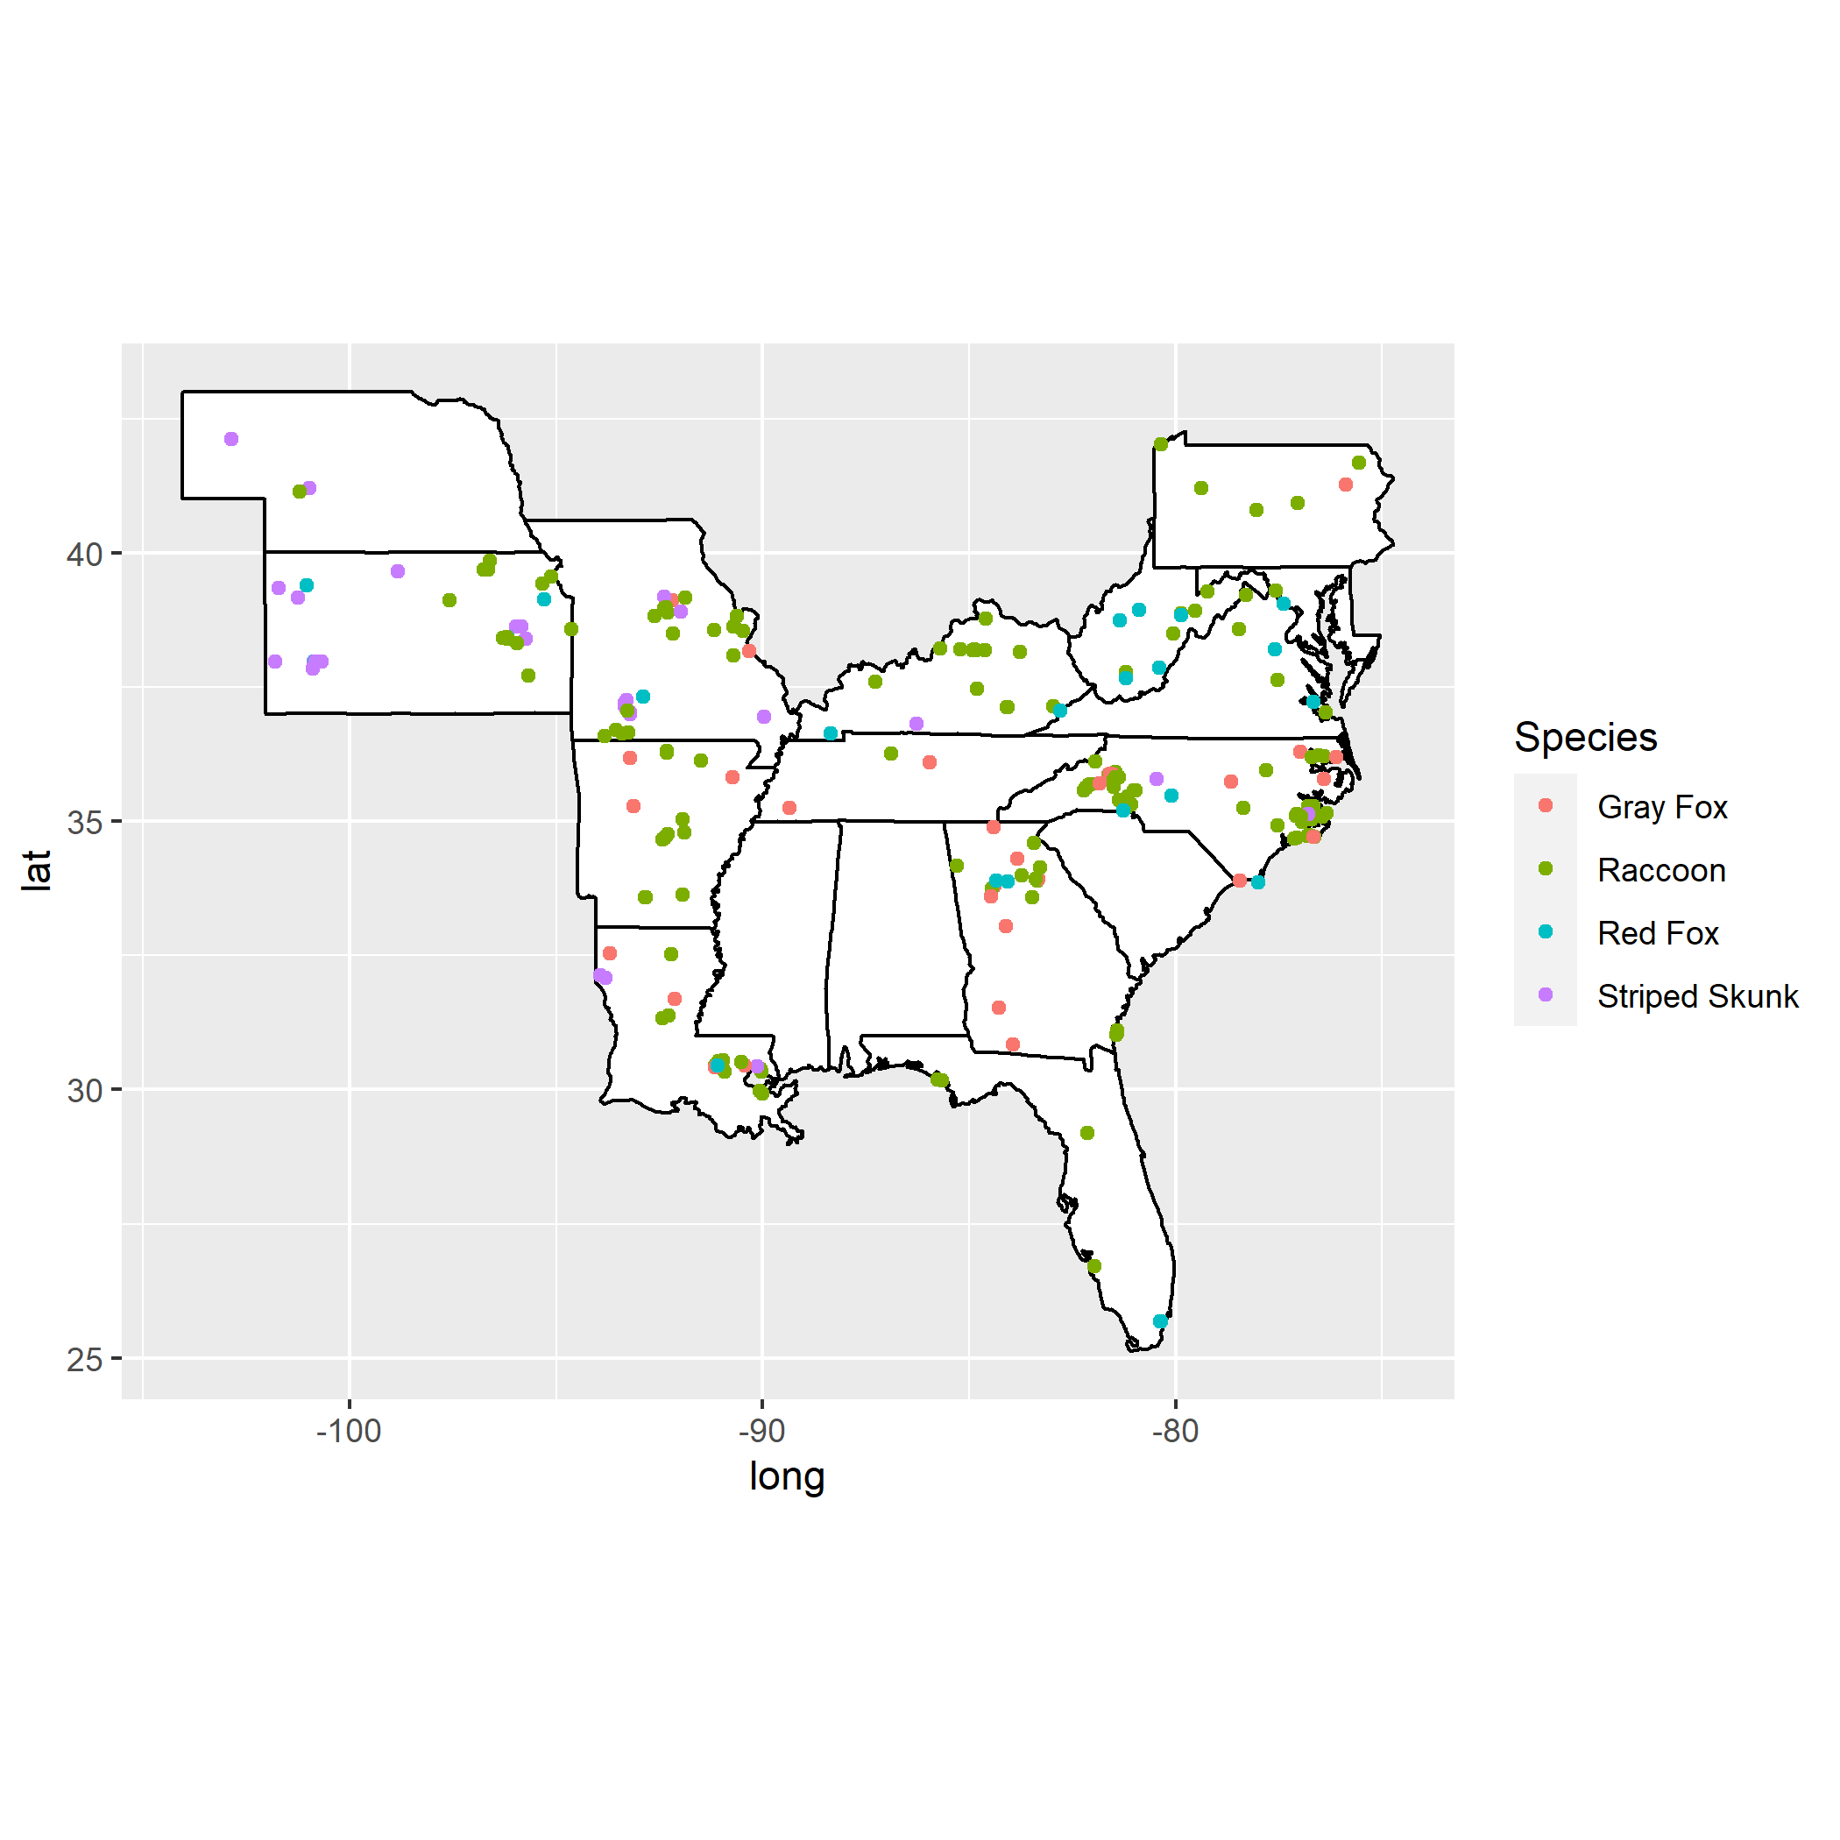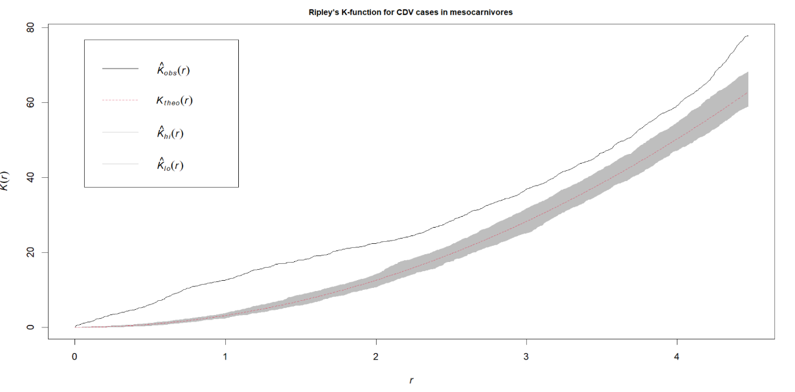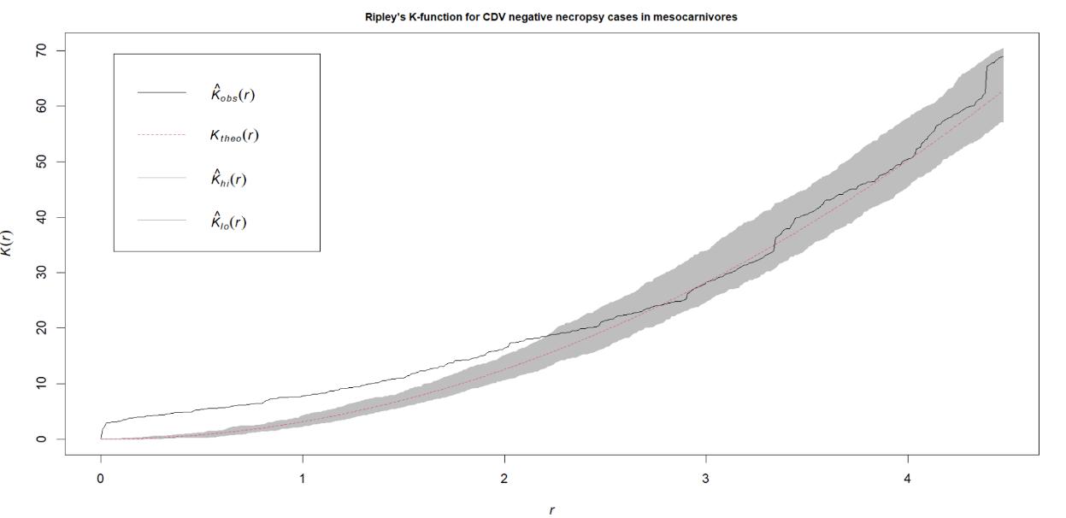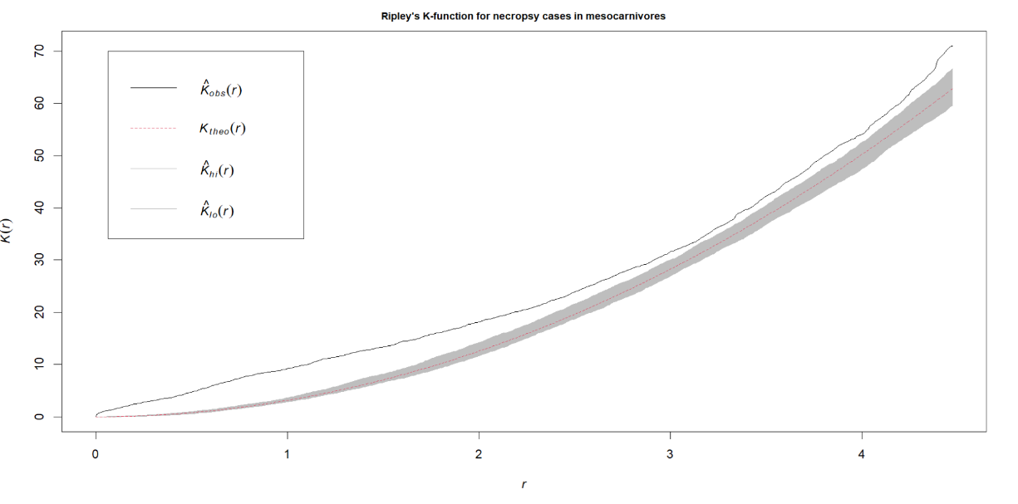

Figure X Ripley’s K analysis of mesocarnivore necropsy cases submitted to SCWDS between January 2019 and December 2022. Plot A: Entire data set. Plot B: CDV positive cases. Plot C: CDV negative cases.

**CDV Phylogeny**

31 CDV partial H-gene (~1200 bp) isolates from 5 state from this study, in addition to 55 additional sequences downloaded from GenBank were aligned in Geneious and used to build a phylogenetic tree. 22 of the isolates from eastern states (NC, FL, GA) grouped together in one large cluster. Isolates from Missouri and Arkansas clustered quite distinctly from this large eastern clade although, one NC and one GA isolate did group with these isolates. The large cluster from eastern states was most closely related to an isolate from a European dog.

Figure X: Phylogenetic tree of…

Sequences obtained in this work are in colored text.

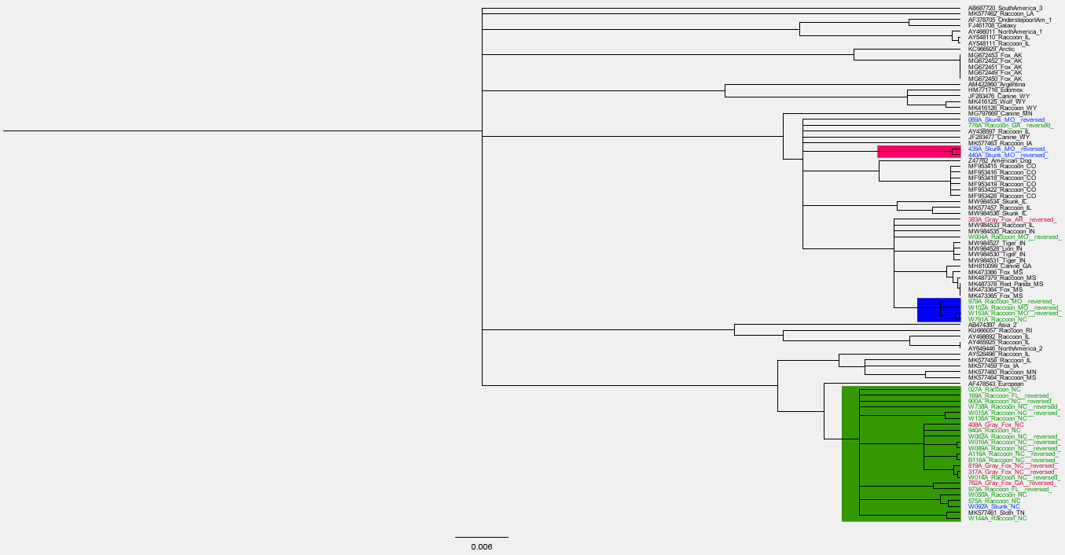

**Generalized Linear Model of CDV diagnosis**

The results of the model showed surface imperviousness, precipitation, elevation, age and species to be the most statistically significant(p<0.01) explanatory variables in the model. The full results of model analysis for all explanatory variables are shown in supplementary figure X.

The best fitting model from the data is described below:

**formula = Distemper ~ Species + Age + month + latitude + knn.dist +**

**Elevation + Precipitation + Temperature + Imperviousness +**

**descriptionLandUse + Species:knn.dist + Species:Temperature + lat:Elevation +**

**Elevation:Imperviousness + Age:month**

|  |  |  |  |  |  |
| --- | --- | --- | --- | --- | --- |
| Model | Residual Deviance | Residual d.f. | AIC | Deltaic | AIC weight |
| Global model | 179.05 | 173 | 237.05 | 87.46 | 1.02x10-19 |
| Interactions | 101.37 | 163 | 179.37 | 29.78 | 3.41x10-7 |
| dropterms | 103.17 | 168 | 175.17 | 25.58 | 2.79x10-6 |
| outliers | 77.59 | 165 | 149.59 | - |  |
| Best fit | 77.59 | 165 | 149.59 | - |  |

The model improvements throughout the fitting process are summarized in table X, the full list of models is included in supplementary table X. The statistically significant (p<0.01) explantiry variables from the results of the best fitting GLM are summarized in table X.

Table X: Summary of the model improvements throughout the model fitting process

|  |  |  |  |  |  |  |
| --- | --- | --- | --- | --- | --- | --- |
| Explanatory Variable | Estimate | 2.50% | 97.50% | Std. Error | z value | Pr(>|z|) |
| SpeciesRaccoon:Temperature | 4.296854 | 2.370153 | 7.260268 | 1.182571 | 3.633485 | 0.00028 |
| lat:Elevation | 0.004873 | 0.002497 | 0.007868 | 0.00135 | 3.610439 | 0.000306 |
| SpeciesStriped Skunk:Temperature | 4.741659 | 2.589425 | 8.075528 | 1.333282 | 3.556382 | 0.000376 |
| SpeciesRaccoon | -73.3049 | -124.918 | -39.2485 | 20.9445 | -3.49996 | 0.000465 |
| SpeciesStriped Skunk | -78.5665 | -133.088 | -41.7943 | 22.4632 | -3.49757 | 0.00047 |
| Elevation | -0.1585 | -0.26241 | -0.07577 | 0.046851 | -3.38301 | 0.000717 |
| Elevation:Imperviousness | -0.00027 | -0.00044 | -0.00013 | 7.93E-05 | -3.34629 | 0.000819 |
| SpeciesStriped Skunk:knn.dist | -0.00016 | -0.00029 | -8.4E-05 | 5.27E-05 | -3.03961 | 0.002369 |
| AgeJuvenile | -8.02765 | -13.8458 | -2.39898 | 2.872082 | -2.79506 | 0.005189 |
| Precipitation | 0.00533 | 0.001752 | 0.009342 | 0.001914 | 2.784664 | 0.005358 |
| Imperviousness | 0.11912 | 0.034926 | 0.213466 | 0.044956 | 2.649723 | 0.008056 |

Table X

Summary statistics for significant (p<0.01) explanatory variables for xyz glm. Full summary of model in supplementary table X. Interaction terms are those separated by a colon.

Note: The glm function in R uses a technique called "dummy coding" to convert categorical variables into a set of binary variables, also known as "indicator variables" or "dummy variables". This is done so that the categorical variable can be included in the model as a predictor. When a categorical variable is used in a model, it is split into one binary variable for each level of the categorical variable, with a value of 1 indicating membership in that level, and a value of 0 indicating non-membership. The summary function then displays each of these binary variables as a separate factor in the output. This allows the user to see the effect of each level of the categorical variable on the response variable.

Model testing showed a prediction accuracy for the best fir model for predicting distemper cases of 0.61. The model had a precision of 0.56 and a recall of 0.75 with an F1 score of 0.64.

# 

# DISCUSSION

This study demonstrated significant genetic diversity in CDV H-gene sequences amongst wild mesocarnivores in the southeastern united states that seemed to be separated into groups east and west of the Mississippi river. Additionally a generalized linear model for wild mesocarnivores diagnosed with CDV at necropsy showed that surface imperviousness, precipitation and species were significant positive explanatory variables whilst elevation and age being juvenile showed a significant negative association with the likelihood of the animal being CDV positive at necropsy.

The phylogenetic analysis showed there to be significant in the H gene sequence of CDV isolates, which appear to form regional clusters . this is supported in the literature where there has been shown to be significant genetic diversity in CDV in wild carnivores in North America (Anis et al. 2020) and virus lineages have been shown to form regional clusters (Anis et al. 2018). The phylogenetic analysis of CDV isolates showed a very distinct cluster from animals in states east of the Mississippi river. The vast majority of isolates from NC, GA and FL clustered closely together within the phylogenetic tree. Isolates from western states, AR and MO clustered separately from these eastern isolates and in a less clearly defined group. This suggests the eastern isolates are all quite closely related and given that the states of GA, FL and NC are geographically contiguous, may all have originated from one large ongoing outbreak in the area. Secondly, that the Mississippi river forms a much more difficult barrier for the virus to traverse than other smaller rivers. This would make sense given that the virus is not transmitted by birds or airborne transmission, so would need to be brought across the river by an infected mammal. This results in distinct strains evolving on each side of the river. The Mississippi as a barrier to disease dispersal in wildlife has been demonstrated before with rabies (Kuzmina et al. 2013). However, based on this study, and others, it is not an impenetrable barrier, as there was one GA isolate and one NC isolate that clustered with isolates from Missouri, suggesting that at some point in time these were able to spread across the river, whether this be through an infected wild mammal swimming or using a bridge, inside a truck, or perhaps via an infected dog or even via a fomite.

The Ripley’s K analysis showed more spatial clustering of CDV cases compared to the rest of the necropsy data, particularly at larger distances. This follows the ecology of the disease as it is a directly transmitted pathogen so an outbreak will spread through an in-contact population, resulting in clusters of cases. There is generally some spatial autocorrelation in the data at shorter distances which is to be expected given the passive nature of the sample collection and that a person submitting cases will likely have a radius within which they submit cases and then there may be a gap until the next person, resulting in this clustering pattern.

Surface imperviousness is a significant explanatory variable in the model with a positive relationship between increased imperviousness and likelihood of being CDV positive. This is the most important result of the GLM from the objectives of this study, being that land use plays a role in the disease ecology. In general higher surface imperviousness corresponds to areas of greater human development (Sutton et al. 2009). There are a number of reasons why these areas could be resulting in higher likelihood of CDV in wild mesocarnivores. Urban areas often possess abundant resources for anthropophilic species, such as raccoons, which may not be prone to seasonal fluctuations(Bozek et al. 2007). These resources include food supplies (e.g., household waste) but also shelter. As a result, urban and suburban areas are capable of supporting much greater raccoon population densities (Prange et al. 2003). In addition to there being a greater quantity of resources in urban areas, there tends to be greater aggregation of resources. This clumping of resources, for example at a large landfill site, results in two factors which are of importance in disease transmission; they result in migration of individuals into the area and in exceptionally high contact rates between not only member of the same species but between members of different species(Becker et al. 2015). Contact rates play a vitally important role in disease transmission with higher population density resulting in greater contact rates and consequently greater rates of disease transmission (Hu et al. 2013). One particular study showed this higher population density in response to resource availability resulted in higher parasite richness and increased prevalence of the zoonotic nematode *B. procyonis*  in raccoons(Wright and Gompper 2005). A Study by Hwang et al showed higher prevalence of severe fever with thrombocytopenia syndrome virus antibodies in urban dwelling feral cats than in their rural counterparts (Hwang et al. 2017). And canine distemper virus cases are more prevalent in urban and suburban counties than in rural counties, which support a much lower population density of raccoons (Taylor et al. 2021). There is an added potential layer of complexity to additional resource provision as increased birth rates in this situation increase the abundance of susceptible juvenile hosts compared to a natural environment. Finally, there is the question on how the quality of this diet (Schulte-Hostedde et al. 2018) affects the immune response of these individuals and whether this may also result in greater amount of pathogen shedding. Theoretical studies have also shown that resource provisioning can have significant effects on pathogen prevalence in urban environments (Becker and Hall 2014). Directly transmitted parasites were shown to respond more strongly to provisioning which has direct consequences on this system as CDV is a directly transmitted pathogen(Erazo et al. 2022). There is also the possibility that closer contact with domestic dogs in an urban setting results in more CDV spillover events into wildlife populations than in rural areas as spillover from dogs into wildlife is often reported(Gowtage-Sequeira et al. 2009, Bianco et al. 2020). However, there may also be potential sources of bias in urban area skewing the results. As this is passively collected data that generally comes from animals found dead or moribund, or exhibiting neurological signs (in which case they are first submitted for rabies testing) then these are more likely to be seen and reported to the appropriate state authority in an urban area as there are more people there who would see the animal. The model also revealed a significant interaction between imperviousness and elevation, with this actually being a negative relationship with CDV diagnosis. This is likely because impervious surfaces at high elevation are actually referring to natural stoney surfaces and not developed areas. This leads into elevation as a single variable being negatively associated so that higher elevation is less likely to result in a positive diagnosis. As previously discussed this is a density dependent disease with higher population densities producing larger outbreaks and being more able to sustain outbreaks. At higher elevations population densities of mesocarnivores tend to be significantly lower for a number of reasons; harsher conditions, temperature, food availability (Slate et al. 2020). Increased precipitation also had a significant positive association with CDV diagnosis. This can be explained from two stand points, from the virus and from the host. Higher rainfall may increase the humidity in that location. As CDV is primarily aerosol transmitted this may increase the risk of this mode of transmission (Lowen et al. 2007), additionally, increased humidity may prolong survival of the virus on fomites, allowing transmission to new susceptibles(Boone and Gerba 2007). From the host behavioral standpoint increased precipitation my result in increased denning behaviors which could results in increased spreading of a directly transmitted pathogen like CDV.

While species was shown to be significant in this model, it is difficult to know if this is a genuine result, given the size of the error in these cases, a larger data set would be need to test this hypothesis as once the data is split into individual species the groups are quite small for foxes and skunks(<40).

The age of the animals, specifically being a juvenile showed a negative association. This may be due to protection from maternal antibodies, making them less susceptible to the disease (Junge et al. 2007) or that these young animals were more likely to be killed by other means which skews the numbers.

From the standpoint of developing a future surveillance system, whilst the more specific landcover data did improve the model as a whole the individual landcover types were not significant explanatory factors. Perhaps for a streamlined system the imperviousness data would be more prudent to use, not only for this reason but the data is also simpler to handle.

The results of this study may have important implications for surveillance and conservation efforts. By identifying areas of intense human development as areas of highest risk for disease it may be possible to focus surveillance efforts in these areas, allowing outbreaks to be identified earlier. It may even be possible in these urban areas to instigate a citizens science program using a reporting application similar to that used for rabies in skunks in Colorado (Pepin et al. 2017). This may allow for vaccination programs in the face of outbreaks which threaten more vulnerable mammal species.

**Limitations**

The limitations of this study mostly apply to the type of sampling. The samples are collected passively through submissions to SCWDS by Georgia DNR and the other equivalent departments in other states. This is dependent on a number of factors; a dead or ill animal being reported to the authorities or being seen by them and a willingness to submit for necropsy, so there are likely to be large numbers of subclinical cases which are missed. This also leads to a number of potential areas of sampling bias, with more populated areas and areas with state/national parks likely to have more cases submitted as there are more people and/or officers present in these areas. Additionally, areas with rabies concerns are likely to submit more cases as the two diseases present very similarly and frequently a case will in fact have been submitted as a query rabies case and after that has been ruled out will then be tested for CDV and there will occasionally be coinfection(Jardine et al. 2018).

Additionally, the raster data from NLCD is from 2019 which is before most of our samples were taken, however the landcover is unlikely to have changed much in this timeframe, particular with the economic impact of the COVID-19 pandemic, the effects of this time lag are likely to be minimal.

# CONCLUSION

The conclusions of this study are twofold. Firstly, it provides further evidence of widespread CDV infection in wild mesocarnivores within the southeastern US and that there is significant genetic diversity within this virus in the area, particularly divided by the Mississippi river. Secondly, human land use may play an important role in the disease ecology of this virus with areas of intense human development being shown to be of higher risk for CDV infection in wild mesocarnivores. Land use change is a complex problem when it comes to disease dynamics at the wildlife-domestic-human interface with no solution that fits every disease. Social responsibility and responsible urban planning with biodiversity at the forefront of development can mitigate future problems. Additionally, surveillance and control measures, such as vaccination (Wilkes 2023), particularly regarding diseases in synanthropic species can also play a crucial role in dynamics of wildlife disease in urban environments.

# REFERENCES

AKAIKE, H. 1981. Citation Classic - a New Look at the Statistical-Model Identification. Current Contents/Engineering Technology & Applied Sciences: 22-22.

ALMBERG, E. S., L. D. MECH, D. W. SMITH, J. W. SHELDON, ANDR. L. CRABTREE. 2009. A serological survey of infectious disease in Yellowstone National Park's canid community. PLoS One 4: e7042.

ANDERSON, J. R. 1976. A Land use and land cover classification system for use with remote sensor data. U.S. Govt. Print. Off., Washington iii, 28 p. pp

ANIS, E., D. B. NEEDLE, B. STEVENS, L. YAN, ANDR. P. WILKES. 2020. Genetic Characteristics of Canine Distemper Viruses Circulating in Wildlife in the United States. J Zoo Wildl Med 50: 790-797.

ANIS, E., T. K. NEWELL, N. DYER, ANDR. P. WILKES. 2018. Phylogenetic analysis of the wild-type strains of canine distemper virus circulating in the United States. Virology Journal 15: 118.

BECKER, D. J., ANDR. J. HALL. 2014. Too much of a good thing: resource provisioning alters infectious disease dynamics in wildlife. Biology letters 10: 20140309.

BECKER, D. J., D. G. STREICKER, ANDS. ALTIZER. 2015. Linking anthropogenic resources to wildlife–pathogen dynamics: a review and meta-analysis. Ecology Letters 18: 483-495.

BIANCO, A., B. ZECCHIN, A. FUSARO, A. SCHIVO, S. ORMELLI, M. BREGOLI, C. V. CITTERIO, F. OBBER, D. DELLAMARIA, K. TREVISIOL, M. LORENZETTO, P. DE BENEDICTIS, ANDI. MONNE. 2020. Two waves of canine distemper virus showing different spatio-temporal dynamics in Alpine wildlife (2006-2018). Infect Genet Evol 84: 104359.

BOONE, S. A., ANDC. P. GERBA. 2007. Significance of Fomites in the Spread of Respiratory and Enteric Viral Disease. Applied and Environmental Microbiology 73: 1687-1696.

BOZEK, C. K., S. PRANGE, ANDS. D. GEHRT. 2007. The influence of anthropogenic resources on multi-scale habitat selection by raccoons. Urban Ecosystems 10: 413-425.

BRADLEY, C. A., ANDS. ALTIZER. 2007. Urbanization and the ecology of wildlife diseases. Trends Ecol Evol 22: 95-102.

CAVALLINI, P. 1996. Variation in the social system of the red fox. Ethology Ecology & Evolution 8: 323-342.

CONTESSE, P., D. HEGGLIN, S. GLOOR, F. BONTADINA, ANDP. DEPLAZES. 2004. The diet of urban foxes (Vulpes vulpes) and the availability of anthropogenic food in the city of Zurich, Switzerland. Mammalian biology 69: 81-95.

DITCHKOFF, S. S., S. T. SAALFELD, ANDC. J. GIBSON. 2006. Animal behavior in urban ecosystems: modifications due to human-induced stress. Urban Ecosystems 9: 5-12.

ERAZO, D., A. B. PEDERSEN, ANDA. FENTON. 2022. The predicted impact of resource provisioning on the epidemiological responses of different parasites. Journal of Animal Ecology 91: 1719-1730.

FOX, J. W., S. 2019. An {R} Companion to Applied Regression. Sage, Thousand Oaks CA. pp.

GOTTDENKER, N. L., J. E. CALZADA, A. SALDAÑA, ANDC. R. CARROLL. 2011. Association of anthropogenic land use change and increased abundance of the Chagas disease vector Rhodnius pallescens in a rural landscape of Panama. The American journal of tropical medicine and hygiene 84: 70.

GOTTDENKER, N. L., D. G. STREICKER, C. L. FAUST, ANDC. R. CARROLL. 2014. Anthropogenic land use change and infectious diseases: a review of the evidence. Ecohealth 11: 619-632.

GOWTAGE-SEQUEIRA, S., A. C. BANYARD, T. BARRETT, H. BUCZKOWSKI, S. M. FUNK, ANDS. CLEAVELAND. 2009. Epidemiology, pathology, and genetic analysis of a canine distemper epidemic in Namibia. Journal of Wildlife Diseases 45: 1008-1020.

GRAS, P., S. KNUTH, K. BÖRNER, L. MARESCOT, S. BENHAIEM, A. AUE, U. WITTSTATT, B. KLEINSCHMIT, ANDS. KRAMER-SCHADT. 2018. Landscape Structures Affect Risk of Canine Distemper in Urban Wildlife. Frontiers in Ecology and Evolution 6.

HIRSCH, B. T., S. PRANGE, S. A. HAUVER, ANDS. D. GEHRT. 2013. Raccoon social networks and the potential for disease transmission. PLoS One 8: e75830.

HOLLISTER, J. W. 2021. elevatr: Access Elevation Data from Various APIs. pp.

HU, H., K. NIGMATULINA, ANDP. ECKHOFF. 2013. The scaling of contact rates with population density for the infectious disease models. Math Biosci 244: 125-134.

HWANG, J., J. G. KANG, S. S. OH, J. B. CHAE, Y. K. CHO, Y. S. CHO, H. LEE, ANDJ. S. CHAE. 2017. Molecular detection of severe fever with thrombocytopenia syndrome virus (SFTSV) in feral cats from Seoul, Korea. Ticks Tick Borne Dis 8: 9-12.

JARDINE, C. M., T. BUCHANAN, D. OJKIC, G. D. CAMPBELL, ANDJ. BOWMAN. 2018. Frequency of Virus Coinfection in Raccoons (Procyon lotor) and Striped Skunks (Mephitis mephitis) During a Concurrent Rabies and Canine Distemper Outbreak. Journal of Wildlife Diseases 54: 622-625.

JUBB, K. V. F., P. C. KENNEDY, ANDN. PALMER. 2012. Pathology of domestic animals. Academic press

JUNGE, R. E., K. BAUMAN, M. KING, ANDM. E. GOMPPER. 2007. A serologic assessment of exposure to viral pathogens and Leptospira in an urban raccoon (Procyon lotor) population inhabiting a large zoological park. Journal of Zoo and Wildlife Medicine 38: 18-26.

KAPIL, S., ANDT. J. YEARY. 2011. Canine distemper spillover in domestic dogs from urban wildlife. Vet Clin North Am Small Anim Pract 41: 1069-1086.

KUZMINA, N. A., P. LEMEY, I. V. KUZMIN, B. C. MAYES, J. A. ELLISON, L. A. ORCIARI, D. HIGHTOWER, S. T. TAYLOR, ANDC. E. RUPPRECHT. 2013. The phylogeography and spatiotemporal spread of south-central skunk rabies virus. PLoS One 8: e82348.

LAFFERTY, K. D. 2009. The ecology of climate change and infectious diseases. Ecology 90: 888-900.

LOWEN, A. C., S. MUBAREKA, J. STEEL, ANDP. PALESE. 2007. Influenza Virus Transmission Is Dependent on Relative Humidity and Temperature. PLOS Pathogens 3: e151.

MARTINEZ-GUTIERREZ, M., ANDJ. RUIZ-SAENZ. 2016. Diversity of susceptible hosts in canine distemper virus infection: a systematic review and data synthesis. BMC Vet Res 12: 78.

NORRIS, D. E. 2004. Mosquito-borne diseases as a consequence of land use change. Ecohealth 1: 19-24.

PEPIN, K. M., A. J. DAVIS, D. G. STREICKER, J. W. FISCHER, K. C. VERCAUTEREN, ANDA. T. GILBERT. 2017. Predicting spatial spread of rabies in skunk populations using surveillance data reported by the public. PLoS Negl Trop Dis 11: e0005822.

POSIT TEAM. 2022. RStudio: Integrated Development Environment for R. Posit Software, Boston, MA. pp.

PRANGE, S., S. D. GEHRT, ANDE. P. WIGGERS. 2003. Demographic Factors Contributing to High Raccoon Densities in Urban Landscapes. The Journal of Wildlife Management 67.

PRISM CLIMATE GROUP. 2022. Oregon State University. pp.

R CORE TEAM. 2022. R: A language and environment for statistical computing. R

Foundation for Statistical Computing, Vienna, Austria. pp.

RILEY, M. C., ANDR. P. WILKES. 2015. Sequencing of emerging canine distemper virus strain reveals new distinct genetic lineage in the United States associated with disease in wildlife and domestic canine populations. Virol J 12: 219.

ROSCOE, D. E. 1993. Epizootiology of canine distemper in New Jersey raccoons. J Wildl Dis 29: 390-395.

SCHULTE-HOSTEDDE, A. I., Z. MAZAL, C. M. JARDINE, ANDJ. GAGNON. 2018. Enhanced access to anthropogenic food waste is related to hyperglycemia in raccoons (Procyon lotor). Conserv Physiol 6: coy026.

SLATE, D., B. D. SAIDY, A. SIMMONS, K. M. NELSON, A. DAVIS, T. P. ALGEO, S. A. ELMORE, ANDR. B. CHIPMAN. 2020. Rabies Management Implications Based on Raccoon Population Density Indexes. The Journal of Wildlife Management 84: 877-890.

SMITH, H. T., ANDR. M. ENGEMAN. 2002. An extraordinary raccoon, Procyon lotor; density at an urban park. USDA National Wildlife Research Center-Staff Publications: 487.

SUTTON, P. C., S. J. ANDERSON, C. D. ELVIDGE, B. T. TUTTLE, ANDT. GHOSH. 2009. Paving the planet: impervious surface as proxy measure of the human ecological footprint. Progress in Physical Geography 33: 510-527.

TAYLOR, K., J. J. WILSON, A. W. PARK, N. M. NEMETH, M. J. YABSLEY, H. FENTON, M. K. KEEL, ANDN. L. GOTTDENKER. 2021. Temporal and Spatial Patterns in Canine Distemper Virus Cases in Wildlife Diagnosed at the Southeastern Cooperative Wildlife Disease Study, 1975-2019. J Wildl Dis 57: 820-830.

TOMPKINS, D. M., A. M. DUNN, M. J. SMITH, ANDS. TELFER. 2011. Wildlife diseases: from individuals to ecosystems. Journal of Animal Ecology 80: 19-38.

U.S. CENSUS BUREAU. 2022. TIGER/Line Shapefiles. U.S. Department of Commerce, Census Bureau. pp.

VAN MOLL, P., S. ALLDINGER, W. BAUMGÄRTNER, ANDM. ADAMI. 1995. Distemper in wild carnivores: an epidemiological, histological and immunocytochemical study. Veterinary microbiology 44: 193-199.

VENABLES, W. N. R., B. D. 2002. Modern Applied Statistics with S. Fourth

Edition. Springer, New York. pp.

WILKES, R. P. 2023. Canine Distemper Virus in Endangered Species: Species Jump, Clinical Variations, and Vaccination. Pathogens 12: 57.

WILLIAMS, E. S., E. T. THORNE, M. J. APPEL, ANDD. W. BELITSKY. 1988. Canine distemper in black-footed ferrets (Mustela nigripes) from Wyoming. J Wildl Dis 24: 385-398.

WRIGHT, A. N., ANDM. E. GOMPPER. 2005. Altered parasite assemblages in raccoons in response to manipulated resource availability. Oecologia 144: 148-156.

# SUPPLEMENTARY MATERIALS

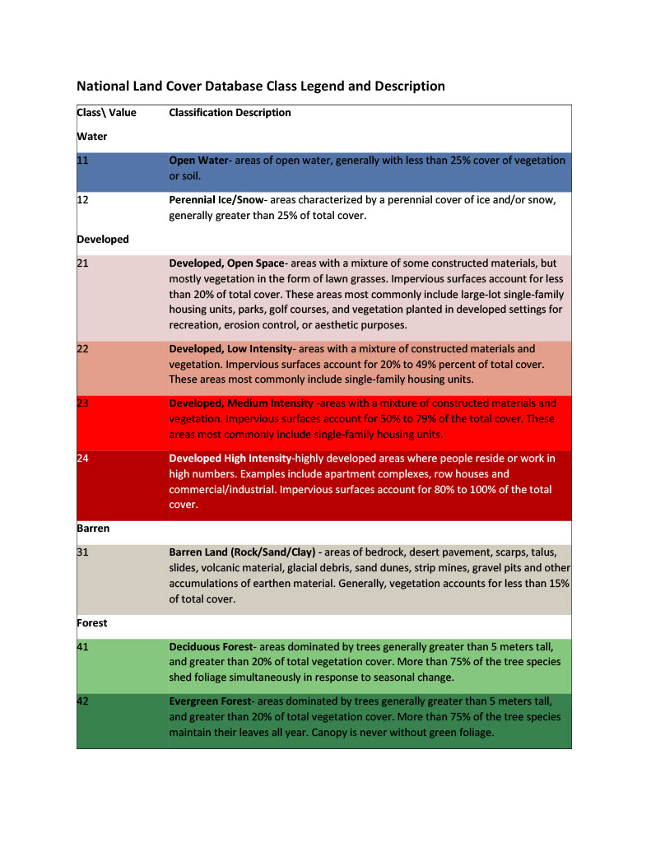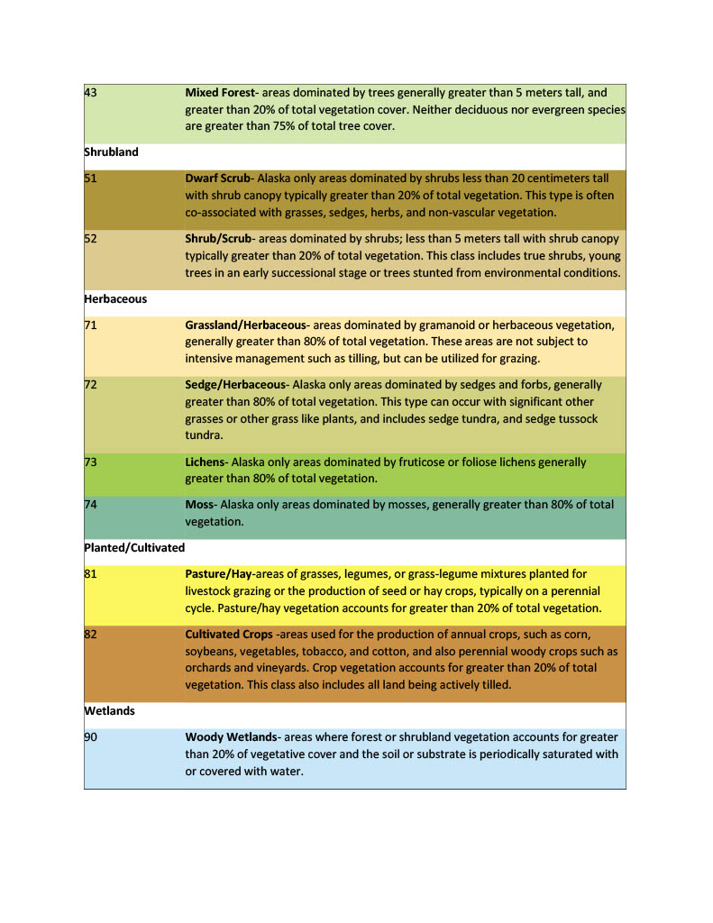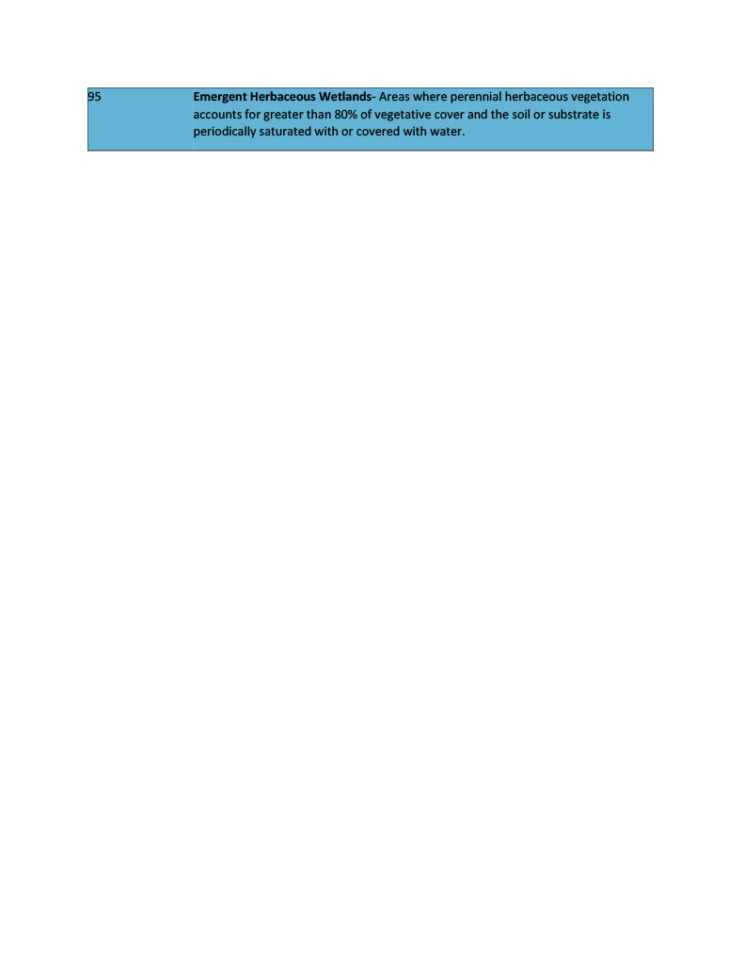

Supplementary Table X: National Land Cover Database Class Legend and Description. Detailed descriptions of landcover classes designated to each pixel of the national land cover database for the united states. Original source: https://www.mrlc.gov/data/legends/national-land-cover-database-class-legend-and-description

Supplemetary table X: Full list of models and summary statistics included in fitting process

|  |  |  |  |  |  |
| --- | --- | --- | --- | --- | --- |
|  | Residual Deviance | Residual d.f | AIC | delataISC | AIC weight |
| Global Model | 179.05 | 173 | 237.05 | 87.46 | 1.02x10-19 |
| Interactions |  |  |  |  |  |
| +Species:knn.dist | 155.84 | 170 | 219.84 | 70.25 | 5.56x10-16 |
| +Species:Temperature | 136.42 | 167 | 206.42 | 56.83 | 4.57x10-13 |
| +Latitude:Elevation | 123.28 | 166 | 195.28 | 45.69 | 1.20x10-10 |
| +Elevation:Imperviousness | 110.59 | 165 | 184.6 | 35.01 | 2.50x10-8 |
| +Age:Month | 101.37 | 163 | 179.26 | 29.78 | 3.41x10-7 |
| Drop terms |  |  |  |  |  |
| -longitutde | 101.48 | 164 | 177.48 | 27.89 | 8.79x10-7 |
| -Sex | 101.95 | 167 | 175.95 | 26.36 | 1.89x10-6 |
| -Distance to water | 103.17 | 168 | 175.17 | 25.58 | 2.79x10-6 |
| Remove outlying data (x3) | 77.59 | 165 | 149.59 | - | - |
| Best Fit Model | 77.59 | 165 | 149.59 | - | - |

|  |  |  |  |  |
| --- | --- | --- | --- | --- |
|  | Estimate | Std. Error | z value | Pr(>|z|) |
| SpeciesRaccoon:Temperature | 4.296854 | 1.182571 | 3.633485 | 0.00028 |
| lat:Elevation | 0.004873 | 0.00135 | 3.610439 | 0.000306 |
| SpeciesStriped Skunk:Temperature | 4.741659 | 1.333282 | 3.556382 | 0.000376 |
| SpeciesRaccoon | -73.3049 | 20.9445 | -3.49996 | 0.000465 |
| SpeciesStriped Skunk | -78.5665 | 22.4632 | -3.49757 | 0.00047 |
| Elevation | -0.1585 | 0.046851 | -3.38301 | 0.000717 |
| Elevation:Imperviousness | -0.00027 | 7.93E-05 | -3.34629 | 0.000819 |
| SpeciesStriped Skunk:knn.dist | -0.00016 | 5.27E-05 | -3.03961 | 0.002369 |
| AgeJuvenile | -8.02765 | 2.872082 | -2.79506 | 0.005189 |
| Precipitation | 0.00533 | 0.001914 | 2.784664 | 0.005358 |
| Imperviousness | 0.11912 | 0.044956 | 2.649723 | 0.008056 |
| AgeJuvenile:month | 0.856084 | 0.356134 | 2.403827 | 0.016224 |
| descriptionDeveloped, Medium Intensity | -6.04146 | 2.778377 | -2.17446 | 0.029671 |
| Temperature | -2.76154 | 1.287085 | -2.14558 | 0.031907 |
| descriptionDeveloped, Low Intensity | -3.66313 | 1.847468 | -1.98279 | 0.047391 |
| descriptionMixed Forest | 16.69947 | 10.46531 | 1.595698 | 0.110556 |
| descriptionWoody Wetlands | -3.24403 | 2.400264 | -1.35153 | 0.176525 |
| descriptionEvergreen Forest | -3.95826 | 3.050739 | -1.29748 | 0.194467 |
| month | -0.11836 | 0.098538 | -1.20115 | 0.229691 |
| SpeciesRed Fox | -102.014 | 87.06704 | -1.17167 | 0.24133 |
| latitude | 0.569104 | 0.517027 | 1.100724 | 0.271017 |
| SpeciesRaccoon:knn.dist | -2.6E-05 | 2.93E-05 | -0.87108 | 0.383713 |
| AgeSubadult:month | -3.2532 | 3.943849 | -0.82488 | 0.409441 |
| SpeciesRed Fox:Temperature | 4.956784 | 6.420792 | 0.77199 | 0.440121 |
| descriptionDeveloped, High Intensity | -3.15043 | 4.13097 | -0.76264 | 0.445679 |
| AgeSubadult | 32.36474 | 43.01389 | 0.752425 | 0.451795 |
| descriptionPasture/Hay | 12.49099 | 17.43858 | 0.716285 | 0.473816 |
| (Intercept) | 21.30329 | 36.93669 | 0.576751 | 0.564107 |
| descriptionDeveloped, Open Space | -0.69567 | 1.303719 | -0.53361 | 0.593614 |
| descriptionDeciduous Forest | -0.41913 | 1.584585 | -0.2645 | 0.791393 |
| knn.dist | -1.1E-06 | 2.89E-05 | -0.03921 | 0.968719 |
| SpeciesRed Fox:knn.dist | 1.67E-06 | 0.000139 | 0.012031 | 0.990401 |
| descriptionGrassland/Herbaceous | -24.3637 | 3956.198 | -0.00616 | 0.995086 |
| descriptionOpen Water | 15.08734 | 2796.828 | 0.005394 | 0.995696 |
| descriptionScrub/Shrub | 17.26584 | 3956.181 | 0.004364 | 0.996518 |
| descriptionEmergent Herbaceous Wetlands | -15.1971 | 3956.181 | -0.00384 | 0.996935 |

Supplememtary table X: Full list of explanatory variables from best fit model with summary statistics ranked in order of p-value from most to least significant.

Note: The glm function in R uses a technique called "dummy coding" to convert categorical variables into a set of binary variables, also known as "indicator variables" or "dummy variables". This is done so that the categorical variable can be included in the model as a predictor. When a categorical variable is used in a model, it is split into one binary variable for each level of the categorical variable, with a value of 1 indicating membership in that level, and a value of 0 indicating non-membership. The summary function then displays each of these binary variables as a separate factor in the output. This allows the user to see the effect of each level of the categorical variable on the response variable.