Data Analysis Project

Yang Zhang

2019-12-06

# Summary/Abstract

# Introduction

Kinetoplastids are protozoan parasites that can cause devastating cutaneous and systemic diseases, such as Human African trypanosomiasis, Chagas disease, and the Leishmaniases, and affect over 23 million people all over the world. However, there are no effective vaccines against these parasites, and increasing drug resistance challenges the efficacy of drug treatment. Novel therapeutic strategies are therefore urgently needed. Development of new therapeutics is reliant on a better understanding to trypanosomatid biology.

*Trypanosoma brucei* is one of the disease-causing parasites in this group. It has a complex life cycle involving different developmental life stages within the insect and mammalian host. In mammals, *T. brucei* exists in two forms: the slender form which is dividing in the mammalian host, and the stumpy form, which is a non-dividing form and is pre-adapted for transmission into a teste fly host upon an insect bite. In the teste fly, stumpy *T. brucei* differentiates into procyclic form that colonizes the insect midgut. Two populations of procyclic forms are found in the midgut of teste flies; early and late procyclic forms. Early procyclic *T. brucei* is found around one week after transmisison into the insect, and late procyclic form allows persistent infection of the midgut. After further differentiation, *T. brucei* cells colonize the salivary gland of the teste fly, and are ready to infect a mammalian host when the insect takes a blood meal.

Given the complex life stages *T. brucei* has to go through, significant changes in its morpholgy, energy source, and gene expression are required. Perturbation of the life cycle of *T. brucei* has been studied as a novel chemotherapeutic approach to kill the parasites. *In vitro* induction of bloodstream *T. brucei* differentiation into procyclic form has been shown to cause cell death at low concentration, indicating its medical potential.

In contrast to many eukaryotes, Trypanosmatids, including *T. brucei*, have genes of unrelated function organized into gene arrays, which are transcribed from a single promoter into long polycistronic transcription units (PTUs). PTUs are then trans-spliced into monocistonic transcription units for protein translation. *Cis-* and *trans*-acting elements in transcription regulation are lacking. Post-transtrcriptional regulation of gene expression therefore has the largest contribution top individual gene regulation, with the exception of two epigenetic markers, base J and histone 3 variant (H3.V).

Base J, β-D-glucosyl-hydroxymethyluracil, is a modified thymidine residue found in the genome of kinetoplastids. It is mainly enriched in telomeric and subtelomeric regions. A minor subset of base J is also enriched in the regions between diverging and converging gene arrays, where transcription starts and terminates. Ablation of base J from the genome leads to transcription termination defects, including transcription readthrough into the transcription termination region, and derepression of genes downstream of transcirption termination sites that are silent in wild type cells. This evidence suggests that base J plays a role in regulating transcirption terimination. Base J is developmentally-regulated DNA modification: it is present in blood stream form *T. brucei*, but it is absent from the procyclic form *T. brucei*. Taking together its role in regulating transcription termination and therefore silencing genes downstream, a premature transcription termination model is proposed, in which genes downstream of transcription termination sites are silent when base J is present, while they are expressed when base J is absent in other *T. brucei* life stages, rendering developmental regulation of these genes.

DNA is wrapped around core histones into nucleosomes. Histone variants and post-translational modificaitons have been shown to regulate transcription from different aspects. *The T. brucei* histone 3 variant(H3.V) shares only 45% sequence identity with the canonical histone 3. It is enriched in centromeres, and it is found to co-localize with base J at the transcription termination region. Ablation of H3.V has a similar effect on transcrition as base J ablation, leading to increased readthrough transcription into transcription termination region and de-repression of genes downstream of transcription terminaiton sites. Furthermore, H3.V knockout has an additive effect to base J ablation on transcription termination, suggesting that the two epigenetic markers may regulate transcription synergistically.

In this study, I will test the hypothesis that genes downstream of transcription termination sites, within PTUs, that are regulated by premature transcription termination by base J and H3.V, are genes related to development.

To test this hypothesis, I will use published RNA-seq results from Naguleswaran et al. In this data RNA-seq analysis was performed on *T. brucei* cells in four culturable life stages: slender, stumpy, early and late procyclic forms. This data will allow me to analyze the gene expression profile across the four *T. brucei* life stages. The change in gene expression after base J and/or H3.V knockout was obtained from another study by Schulz et al. in which they sequenced poly(A)+ mRNA derived from *T. brucei* mutants lacking either base J or H3.V or both epigentic markers. The genes with upregulated expression in the mutant *T. brucei* cells are compared to the list of genes with highest expression level in each of the four *T. brucei* life stage to analyze whether base J and/or H3.V knockout has any effect on a particular set of genes.

# Methods and Results

## Data qcquisition

RNA-seq results were obtained from Naguleswaran et al. and Schulz et al. Both are in readable excel format and can be easily imported into R studio for further analysis.

## Data import and cleaning

Find the Data cleaning code in ./code/processing_code. Run Yang_data_processing.Rmd to obtain the data processing results.

## Data analysis

First, I want to know which genes are up-regulated in each of the four *T. brucei* life stages. To answer this question, if a certain gene has the highest transcripts read in one of the life stage, then I regard the gene to be over-represented in that life stage. For example, for gene Tb927.4.4520, the transcript reads for slender, stumpy, early and late procyclic form are 3.77, 4.17, 3.99, and 2.06, respectively. This gene is upregulated in the stumpy stage according to this definition. There are 2612, 2853, 2819, and 1420 genes that have their max expression levels in slender, stumpy form, early and late procyclic forms, respectively (supplementary tables: Gene_upregulated_Early, Gene_upregulated_Late, Gene_upregulated_slender, _Gene_upregulated_stumpy).

Table: Genes affected by Base J and/or H3.V mutants

Table 1: Result Table.

|  |  |  |  |
| --- | --- | --- | --- |
|  | base J alone | H3V alone | either |
| number of genes | 34 | 6 | 2 |

It shows here that base J and H3.V knockout leads to upregulation of gene expression for 36 and 8 genes, respecively, with 2 genes shared between them.

I then cross-compared the genes affected by base J and/or H3.V knockout to the list of genes that have the highest expression level in each of the four stages. Figure: The distribution of genes affected by base J knockout in slender, stumpy form, early and late procyclic T. brucei.  
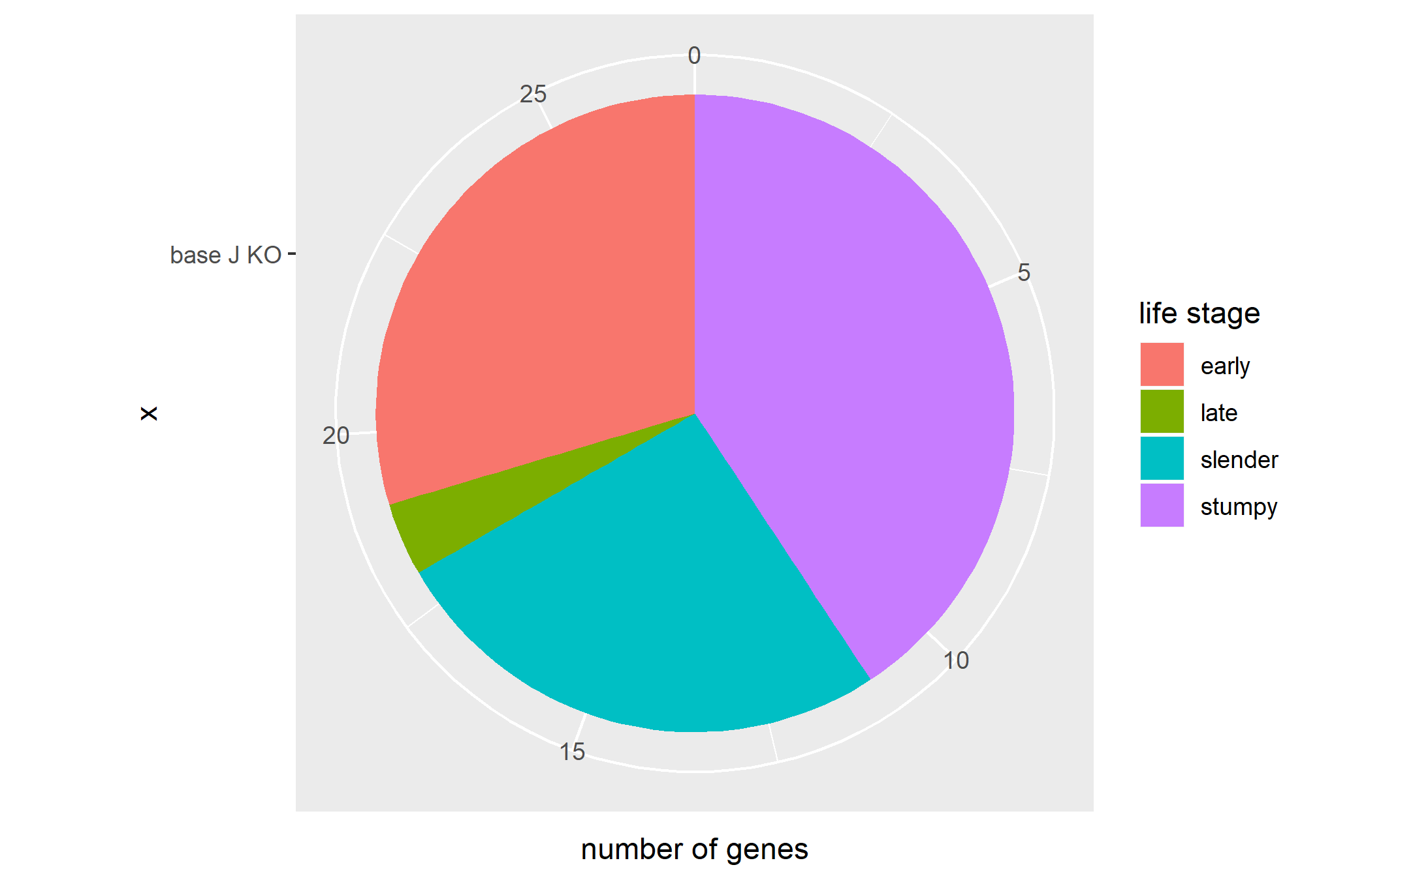

The figure shows that base J ablation leads to upregulation of genes with a maximum gene expression primarily in early procyclic form, slender and stumpy blood stream forms. The majority of the genes affected have a maximum expression level in the blood stream form, which fits our expectation. As reported before, base J regulates expression of genes downstream of transcription termination within the PTU in blood stream forms of *T. brucei*, leading to the hypothesis that the regulation of gene expression is by premature transcription termination. After the ablation of base J, it is expected that genes normally downstream of chromosomal-internal base J will be de-repressed in the blood stream forms.

Figure: the distribution of genes affected by H3.V knockout to the list of genes that have the highest expression level in each of the four stages. 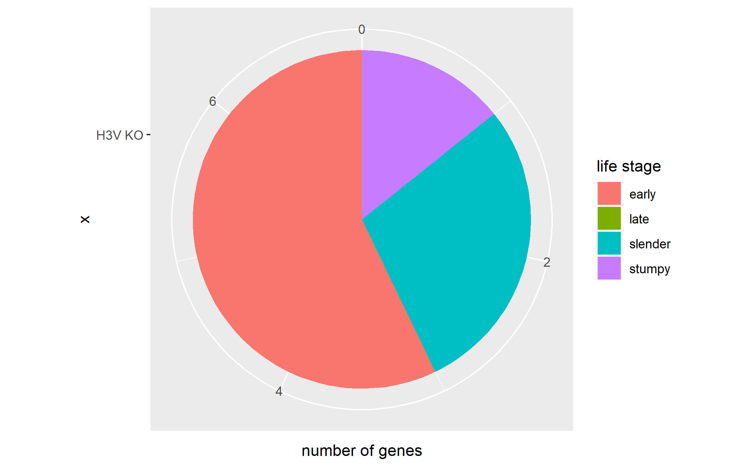 H3.V has been established as an epigenetic marker for regulating transcription termination. Its ablation leads to increased transcription readthrough into the transcription termination region, and de-repression of genes downstream of base J/H3.V peaks. As shown in the figure, H3.V affected the genes primarily in early procyclic form, and blood stream forms, with no genes affected in late procyclic form. Unlike base J, H3.V is not a developmentally regulated epigenetic marker, and the parasite will not naturally remove it during certain life stages. Therefore, it is expected that genes affected by H3.V knockout do not fall into a specific category.

Figure: the distribution of genes affected by basee J/H3.V double knockout to the list of genes that have the highest expression level in each of the four stages. 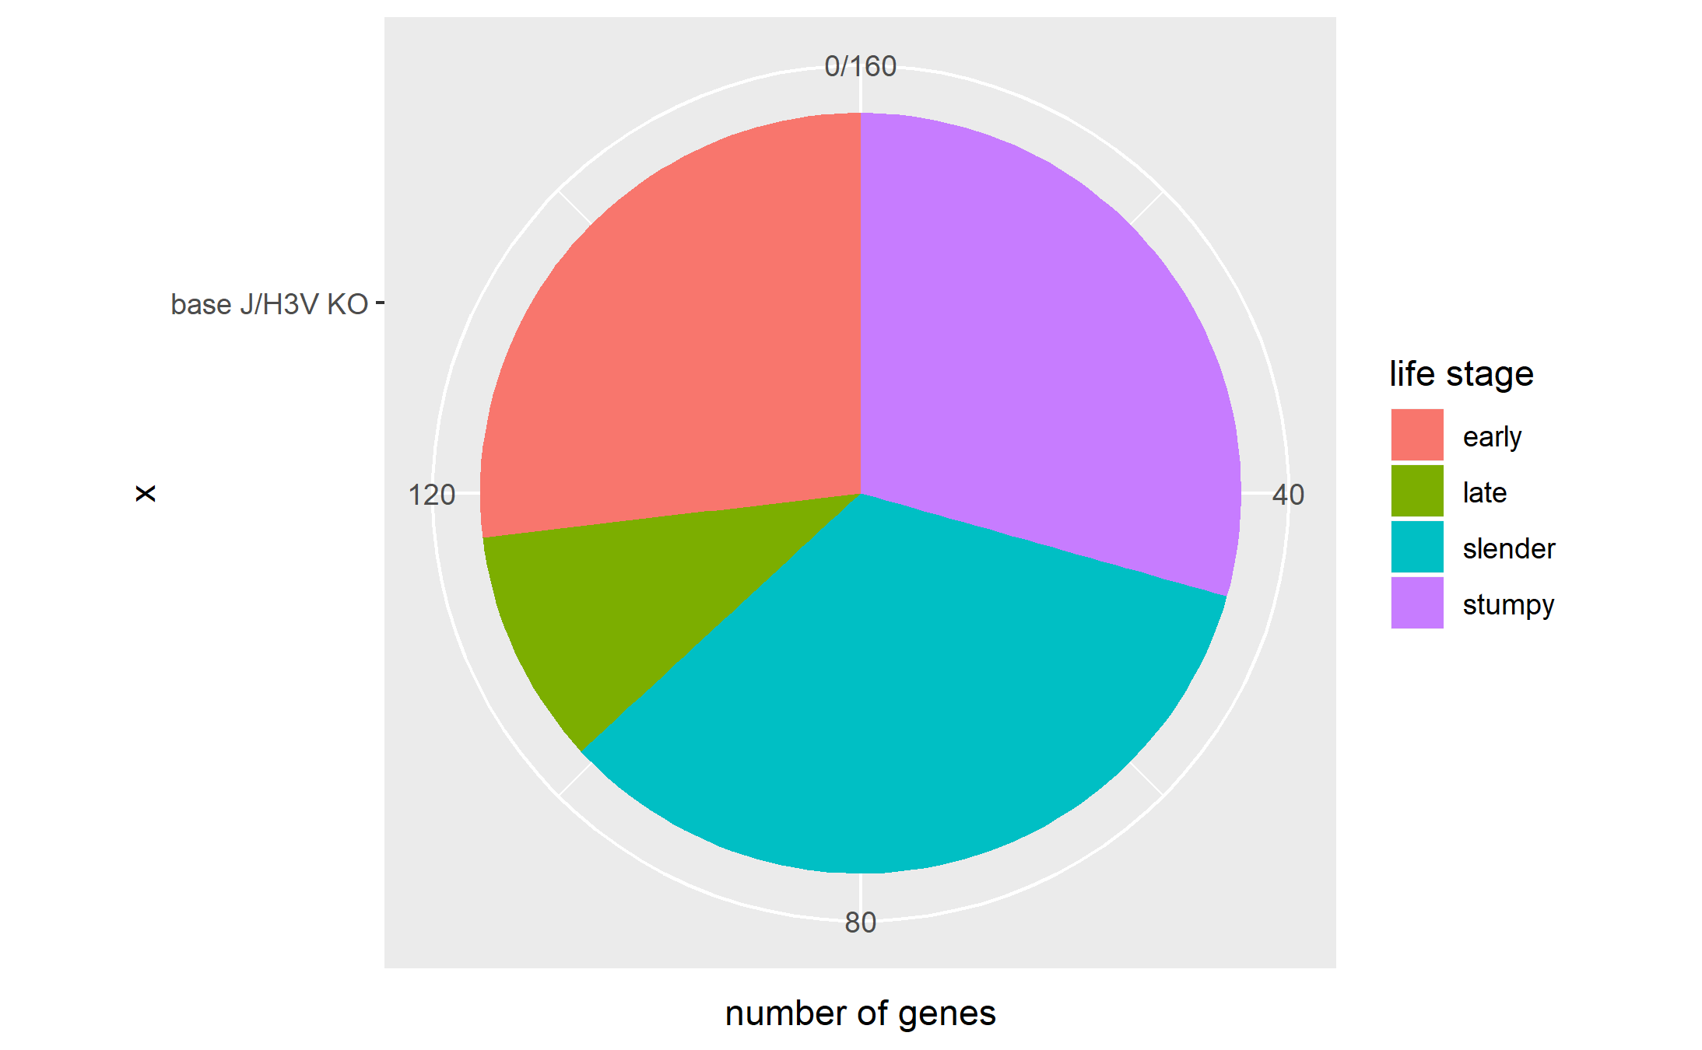 Base J and H3.V double knockout affected much more genes than either knockout alone. This is consistent with the idea that base J and H3.V act synergistically to regulate transcription termination, and thereby silence genes downstream of base J/H3.V peak within PTUs. As shown in the figure, the majority of the affected genes belong to the slender and stumpy forms.

# Discussion

## Summary and Interpretation

*Summarize what you did, what you found and what it means.*

## Strengths and Limitations

*Discuss what you perceive as strengths and limitations of your analysis.*

## Conclusions

*What are the main take-home messages?*

*Include citations in your Rmd file using bibtex, the list of references will automatically be placed at the end*

# References