

INSTITUTO POLITECNICO NACIONAL

ESCUELA SUPERIOR DE CÓMPUTO

ARQUITECURA DE COMPUTADORAS

PRACTICA 5

MEMORIA DE DATOS

CRUZ MONDRAGON DIEGO

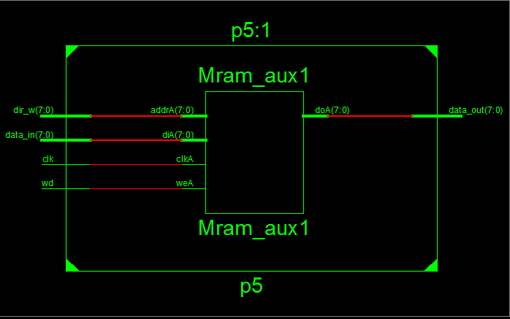

**Código Practica 5**

library IEEE;

use IEEE.STD_LOGIC_1164.ALL;

use IEEE.STD_LOGIC_arith.ALL;

use IEEE.STD_LOGIC_unsigned.ALL;

entity p5 is

generic (

bus_dir : integer := 8;

bus_datos : integer:= 8

);

Port ( --dir_r : in STD_LOGIC_VECTOR (bus_dir-1 downto 0);

dir_w : in STD_LOGIC_VECTOR (bus_dir-1 downto 0);

data_in : in STD_LOGIC_VECTOR (bus_datos-1 downto 0);

data_out : out STD_LOGIC_VECTOR (bus_datos-1 downto 0);

clk, wd : in STD_LOGIC);

end p5;

architecture Behavioral of p5 is

type ejemplo is array (0 to (2**bus_dir)-1) of std_logic_vector(bus_Datos-1 downto 0);

signal aux : ejemplo := (others=>(others=> '0'));

begin

process(clk)

begin

if (rising_edge(clk)) then

if (WD = '1') then --escritura

aux(conv_integer(dir_w)) <= data_in;

end if;

else

end if;

end process;

data_out <= aux(conv_integer(dir_w));

end Behavioral;

Código Simulación

LIBRARY ieee;

USE ieee.std_logic_1164.ALL;

use std.textio.all;

use ieee.Numeric_std.all;

use ieee.std_logic_unsigned.all;

use ieee.std_logic_arith.all;

use ieee.std_logic_textio.all;

ENTITY t_p5 IS

END t_p5;

ARCHITECTURE behavior OF t_p5 IS

-- Component Declaration for the Unit Under Test (UUT)

COMPONENT p5

PORT(

dir_w : IN std_logic_vector(7 downto 0);

data_in : IN std_logic_vector(7 downto 0);

data_out : OUT std_logic_vector(7 downto 0);

clk : IN std_logic;

wd : IN std_logic

);

END COMPONENT;

--Inputs

signal dir_w : std_logic_vector(7 downto 0) := (others => '0');

signal data_in : std_logic_vector(7 downto 0) := (others => '0');

signal clk : std_logic := '0';

signal wd : std_logic := '0';

--Outputs

signal data_out : std_logic_vector(7 downto 0);

-- Clock period definitions

constant clk_period : time := 10 ns;

BEGIN

-- Instantiate the Unit Under Test (UUT)

uut: p5 PORT MAP (

dir_w => dir_w,

data_in => data_in,

data_out => data_out,

clk => clk,

wd => wd

);

-- Clock process definitions

clk_process :process

begin

clk <= '0';

wait for clk_period/2;

clk <= '1';

wait for clk_period/2;

end process;

-- Stimulus process

stim_proc: process

--Entradas

FILE archivoEntrada : TEXT;

VARIABLE lineaEntrada : LINE;

VARIABLE var_wd : STD_LOGIC;

VARIABLE var_Din, var_Dir: STD_LOGIC_VECTOR ( 7 DOWNTO 0 );

--Salidas

FILE archivoSalida : TEXT;

VARIABLE lineaOut : LINE;

VARIABLE var_Dout: STD_LOGIC_VECTOR ( 7 DOWNTO 0 );

VARIABLE cadena : STRING ( 1 TO 4 );

VARIABLE cadena1 : STRING ( 1 TO 5 );

begin

FILE_OPEN (archivoEntrada, "in.txt", READ_MODE);

FILE_OPEN (archivoSalida, "out.txt", WRITE_MODE);

cadena := " DIN";

WRITE ( lineaOut, cadena, RIGHT, cadena'LENGTH+1 );

cadena := " DIR";

WRITE ( lineaOut, cadena, RIGHT, cadena'LENGTH+1 );

cadena := " WD";

WRITE ( lineaOut, cadena, RIGHT, cadena'LENGTH+1 );

cadena := "DOUT";

WRITE ( lineaOut, cadena, RIGHT, cadena'LENGTH+1 );

WRITELINE (archivoSalida, lineaOut);

WAIT FOR 10 NS;

--Se lee hasta encontrar el fin del archivo

WHILE NOT ENDFILE (archivoEntrada) LOOP

READLINE (archivoEntrada,lineaEntrada);

HREAD(lineaEntrada, var_Din);

data_in <= var_Din;

HREAD(lineaEntrada, var_Dir);

dir_w <= var_Dir;

READ(lineaEntrada, var_wd);

wd <= var_wd;

WAIT UNTIL RISING_EDGE ( clk );

var_Dout := data_out;

--Se escriben entradas

HWRITE(lineaOut, var_Dir, RIGHT, 5 );

HWRITE(lineaOut, var_Din, RIGHT, 5 );

WRITE(lineaOut, var_wd, RIGHT, 5 );

--Se escriben salidas

HWRITE(lineaOut, var_Dout, RIGHT, 5 );

WRITELINE(archivoSalida, lineaOut);

END LOOP;

--Se cierran archivos de texto

FILE_CLOSE(archivoEntrada);

FILE_CLOSE(archivoSalida);

WAIT;

end process;

END;

Imágenes simulaciones

