Jairo Jurado

Professor Kevin Imhoff

DWS

5 June 2013

The Benefits of Using CSS

In the early years of the Web, HTML was not advanced. The language was not focused on aesthetics/presentation. It was more involved with presenting the content the website was made for. As the popularity of the web increased, so did the need for “eye-pleasing” websites. The easy “band-aid” fix was to include a way to do this in HTML. That’s exactly what they did and after many years of doing this, the mess of the code was unbearable. A solution was needed and World Wide Web Consortium (W3C) jumped to create this solution. (Meyer, p.1-2)

W3C came up with a language called Cascading Style Sheets or CSS for short. The benefits were rich; there were 10 benefits to be exact. The most obvious one was how much more organized and readable the HTML code was. Websites using CSS load faster because all the code is usually done in another file. CSS also makes the code, efficient and easy. It is also consistent, SEO friendly because search engines can finally just find your headers and such with no inline presentation code. CSS also gives accessibility because it is separate from the HTML code, it is also easy to maintain, it emphasizes usability, it gives a sophisticated layout and design, it is bandwidth efficient, and it separates content. (Imhoff, p. 13)

CSS can be written inline, embedded, or linked to the HTML file. Inline is self-explanatory; the CSS code will be inside the HTML tag (this is not recommended, it’ll be almost the same as how the presentation used to be done; the sole purpose of CSS was to divide the presentation part of web from HTML). Writing CSS embedded will be writing CSS at the top of the HTML document inside a style tag that goes inside the head of the HTML code. Finally, writing CSS using the linked style is what is mainly used nowadays. It involves writing the code in a separate file specifically made for CSS. It will basically be the same code as embedded but without any HTML tags; just straight CSS code. (Imhoff, p. 22-29)

The way CSS works is by using a *selector*, a *property*, and a *value*. This diagram will give a visual representation of how this works:

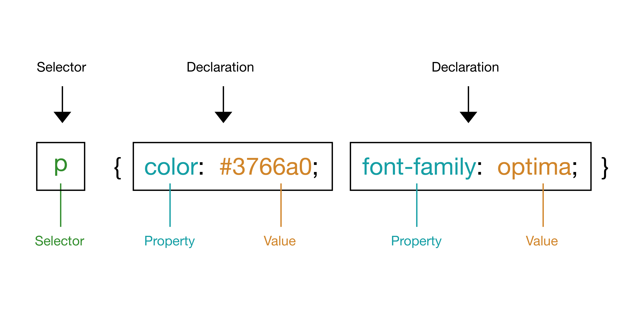

Basically, the *selector* will be the html tag you are going to “stylize”. Then open a brace; now in the declaration call the *property* or what you are changing in the selector. For example it could be color, font-family, text-align, etc. (the property should always be followed by a semicolon “;”). The *value* will be what you are changing the property into. For example, the exact color you are changing (the value should also be followed by a semicolon “;”). Finally, end with a closing brace. (Imhoff, p. 15-20)

Works Cited

Imhoff, Kevin. “Welcome to DWS”. *Designing for Web Standards*. 2013. PDF file.

Meyer, Eric. *CSS: The Definitive Guide 3rd Edition*. O’Reilly Media, Inc., 2007. 1-24. Print.