Report on the second part of the first personal assignment for the course
Speech recognition and generation
Vorsin Egor

Index
1. Data 3
2. Baseline 3
3. Experiment with different n_mels 4
4. Experiment with different groups 5

Data
The data is audio recordings in the .wav format. The data is converted to Log MelFilterbanks spectrograms, limited to one second (with padding), before being transmitted to the model. Frequency = 16 kHz, Filter window = Hann.

Baseline
This architecture was chosen as the baseline model:
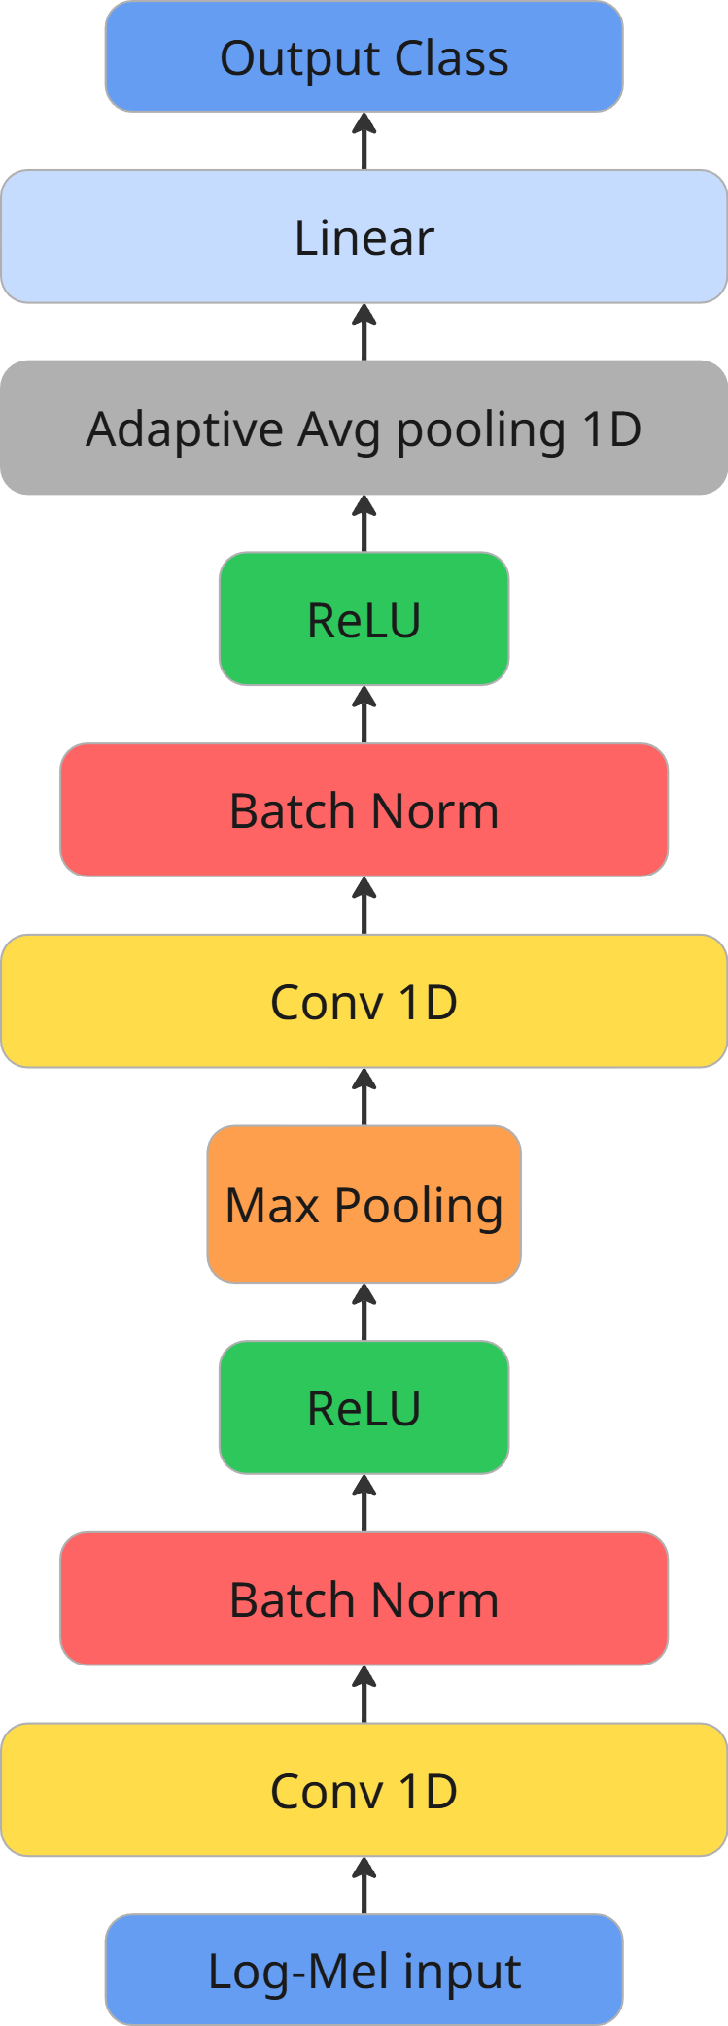
Fig. 1. Model diagram.
The model takes n_mels=80 as an input parameter. The loss function is BCE-loss, the target metric is Accuracy, and the Optimizer is Adam with a learning rate = 0.001. The baseline and all subsequent versions of the models were trained on 5 epochs.
Learning outcomes:
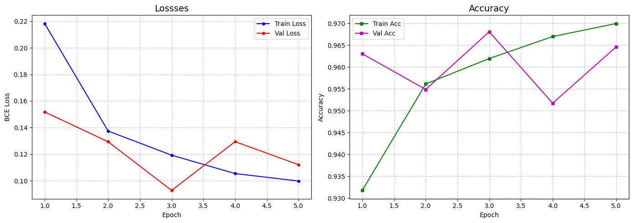
Fig. 2. Dynamics of Loss and Accuracy on samples for training and validation.

Experiment with different n_mels
Grid n_mels: [20, 40, 80]. The architecture of the Model and the learning process coincide with the Baseline.
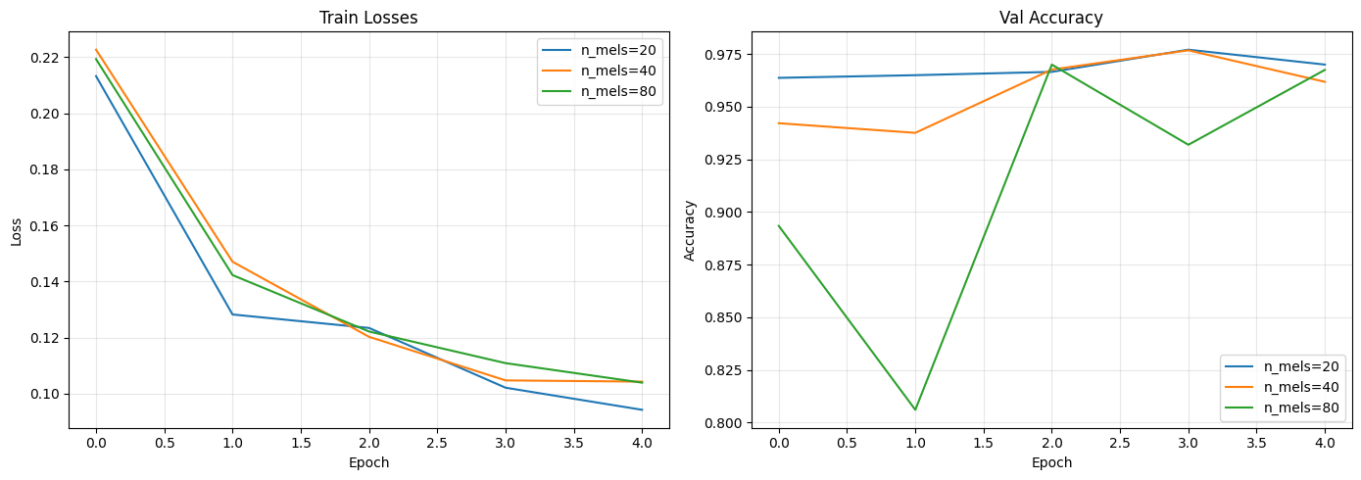
Fig. 3. The dynamics of Train Loss and Accuracy in the validation sample.
With this architecture, the model behaves almost identically regardless of the value of n_mels, and the model with n_mels=20 is marginally more efficient than the others. The model with n_mels = 80 shows Accuracy instability in the validation sample, as well as baseline.
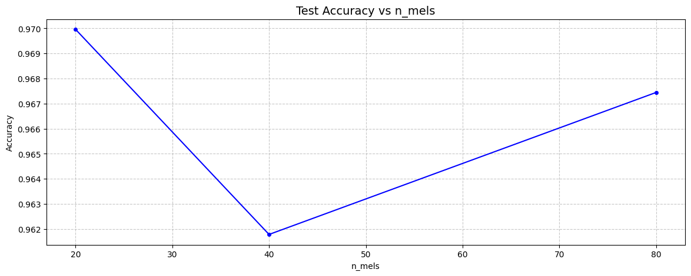
Fig. 4. Test Accuracy depending on the value of n_mels.
Так Also, as with the Val Accuracy analysis, you can see that the model with n_mels = 20 is the best.

Experiment with different groups
This experiment consists of varying the groups parameter in the Conv1D convolutional layer of the model.
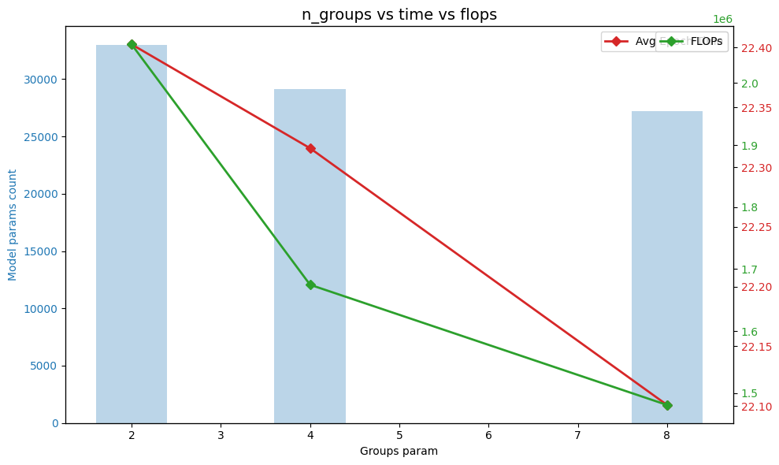
Fig. 5. The average training time of the epoch, FLOPs, and the number of model parameters depending on the groups value.
It is easy to see that as the groups parameter increases, the average training time of one epoch, FLOPs, and the number of parameters decrease.:
- The decrease in training time is insignificant: when switching from 2 groups to 8, it is only 30 ms;
- The decrease in FLOPs is more significant: when switching from 2 groups to 8, FLOPs decreased by more than 500 000 (>25%);
- The number of parameters has also changed downwards, but only slightly: < 5 000 parameters.
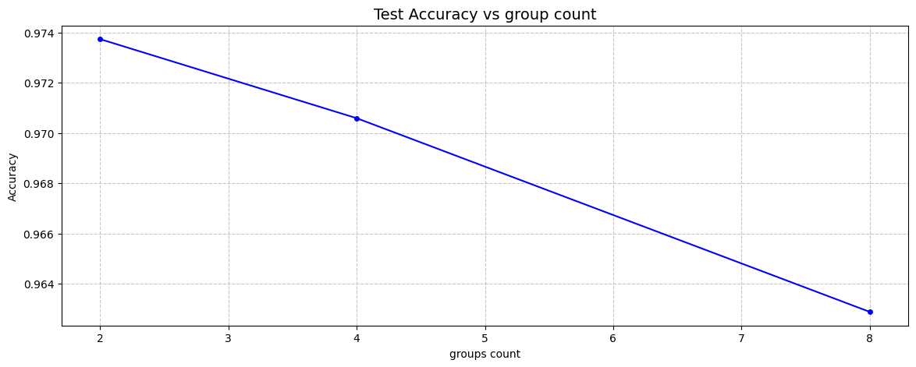
Fig. 6. Test Accuracy depending on the groups value.
Along with the "heaviness" of the model, its quality in the test sample also decreased. When switching from 2 groups to 8, the metric decreased by 1 percentage point.
In this case, it is not advisable to switch to a larger number of groups in order to "facilitate" the model.

