**A beacon of hope to the neglected**

Godaweyn is a village, in the Sahil region of Somaliland. It lies in a valley some 120km from Berbera. About 12,000 people live in Godaweyn including 12 villages dispersed across the hills and plains. The residents are pastoralists and agro-pastoralists. Most are illiterate and have minimal contact with the world beyond the valley. In Somali, the name Godawayn means “the large isolated place.”

|  |  |
| --- | --- |
| A homestead abandoned because of drought. | A new home being established. |
| The terrains to Godawayn | |

Godawayn health centre lacked basic essentials such as drugs and health personnel. As a result, the community had no interest in it. Harmful traditional practices such as FGM/C, early marriage and domestic violence have thrived unchallenged. Through the integrated essential package of health services, HPA is reaching this community. Together, the Ministry of Health, HPA and the community are upgrading the health facility to a referral health centre. HPA is providing essential drugs and supplies, referral facilities and incentives to health workers for quality care. It has also constructed a maternity ward to cater for deliveries in the area.

Although the project has just begun, Godawayn is already serving its needy community and the surrounding villages. It is no longer the isolated village but a beacon of hope to other villages surrounding the area.

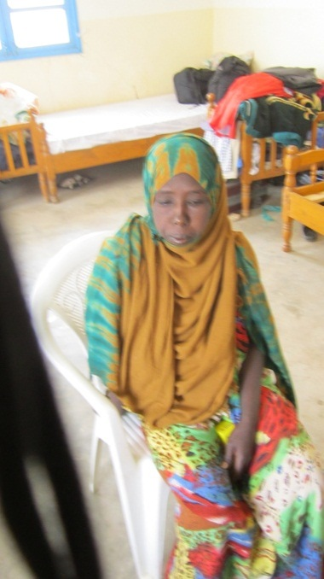Hoodo is a 19year old mother living in Dari maraa a village near Godawayn, it is her first pregnancy and now she is 34weeks. She has been under observation at the hospital for two days now. “For three weeks I have had swelling on my face and feet,” she says, “Other women told me it is the weight one gains during pregnancy which means I am healthy; but kept feeling different and tired. I could not perform any home chores. The community then called an ambulance that brought me to Godawayn. I was immediately put on treatment to stabilize my condition. I have been here for 2 days being closely monitored by the nurses and I am improving. I am also at peace because the services are free; otherwise though I need help, I would not afford it,” she says. “I did not know this is a danger sign in pregnancy and there are many women like me,” Hoodo observes.



The nurses diagnosed her condition as pitting oedema a symptom of anaemia. Hoodo’s case is not an isolated case, the report from the regional hospital management information system indicate cases of anaemia as of last year at 215, even so, they note many mothers did not visit health facility and suffered in silence. HPA is carrying out health education through radio, community theatre outreach to educate women on safe motherhood including nutrition and danger signs during pregnancy.

*******

Hawa Ahmed is a 30years old lady who has been married for 14 years. She lives in Godaweyn Village with her family, a husband and 8 children. Hawa has not had it easy in her marriage. Like many women, she has had more beatings from her husband than she can remember. On this occasion, she sought refuge in Godawayn health centre. She narrates her ordeal:

“I’m the breadwinner of my family as my husband is jobless. I am a petty trader selling local products like maize sorghum and with the proceeds, feeding and clothing my family. The drought since last year affected everybody; for me, my business collapsed. One day, my husband came home at around noon from chewing khat. That day, we had no food; there was nothing to cook. When he asked for food, I informed him that we had none as there was nothing to cook and no money to buy it. He then started shouting as he always did and after a long exchange, he picked big wooden stick and hit me with it. It caused a large wound on my back, the health workers told me that tissues were badly damaged and needed special observation.

The saddest bit is when I lost consciousness from the beating and the neighbours called the police. My brother-in-law told them I was epileptic! That it was not necessary to talk to me or take me to the hospital! Some neighbours brought me here. Though I do not want to go back, I really have no choice.”

Asked on the severity of gender based violence in the area, the police chief mentioned that although he is new and has only stayed for 4 months, the serious cases such as rape exist but are rare. He however says that domestic disagreements are common but need no police intervention.

Through the sexual and reproductive health rights programme, HPA is addressing the issues of gender based violence including FGM and rape. These practices although are almost seen as part of the societal culture, HPA has brought together stakeholders like the judiciary, police, local non-state actors and ministry of health to better understand and help reduce cases of gender based violence. Victims of GBV are supported through treatment and police notified to take action.