# Solar energy for health

Berbera Hospital is a last resort to patients seeking care in Sahil Region of Somaliland. It serves a population of about 250,000 people, most from the rural areas. Under the integrated essential package of health services implemented by Health poverty action (HPA) and funded by the UKaid from the Department of International Foreign Development, HPA is undertaking a critical role of rehabilitating existing health facilities in poor conditions and constructing health facilities where need exist in collaboration with the Regional Health Office of the Ministry of Health.

Berbera Hospital has largely depended on well-wishers. The hospital’s sorry state makes it vulnerable and its dire needs necessitate acceptance of any kinds of donations. However, most donations are never based on the priority needs of the hospital.

At the hospital and following a facility assessment survey, HPA has renovated maternity, paediatric wards and toilets for both the wards. HPA is supplying requisite (essential) hospital furniture and medical equipment while also building capacity of health workers to provide quality care to patients. HPA supports the drug revolving fund to enable the hospital serve patients from the poor rural communities. Berbera handles all the complicated cases referred from referral health centres.

|  |
| --- |
| Electric power house at Berbera Hospital |

Although the hospital is connected to the main government electric grid, the hospital has numerous challenges with electric power supply. Power is often cut as the hospital is unable to afford. As a result human lives that would have been saved have sometimes been lost. It has a standby generator but which is unable to meet the power demand of the hospital. The cost of running power is generally high but unmanageable during summer when temperatures hit 490C. Summer runs from April to October during which the average cost of power bill is US$10,000 per month.

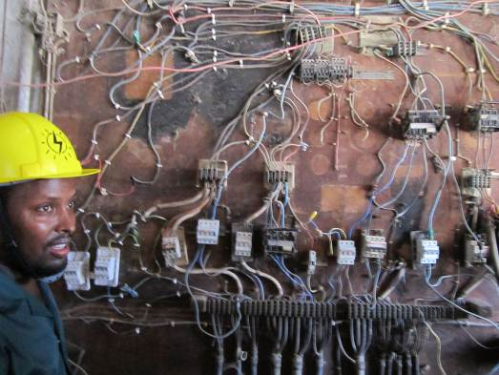

*The circuit board as is in use. It will have to be fully replaced and properly labelled*

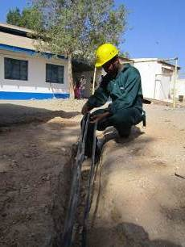

Berbera hospital has no regular income and largely depend on donations from the court, local authority and other institutions. These financial support are irregular as there is no binding memorandum of understanding for support.

HPA in collaboration with regional health office, has undertaken to install 60KW of solar power to Berbera hospital. Initially the power will support the maternity and paediatric wards especially the operation theatre when the normal power supply is out. The hospital currently runs on 170KW of power provided within the government electricity grid.

HPA is conscious of this huge deficit and has put in place a phased installation approach to help the hospital recover the cost of electricity and installation in three years. Eventually HPA hopes that Berbera hospital will not only reliably serve patients that require all kinds of care but also set an example in the sub-Saharan Africa how hospitals can operate on green energy. This is premised on the life of solar power at 25 years.

*Work in progress*

The cost of installation of the first phase (60kw) is valued at USD120,000. The second phase is expected to begin on the third year of the project. HPA has contracted an independent solar energy consultant to oversee the solar power infrastructure and installation.

|  |  |
| --- | --- |
|  |  |
|  |  |