**Just on time…**

She was only 5 years then, but 25 years later, her memory is clear of the destruction and destitution that came with the war. Muna Shabcan is the Assistant Technical officer, reproductive health for HPA in Sahil region. In her humble early life, she saw pain in the refugee camps with people sick and in pain but with an overwhelmed workforce unable to attend to them. “The suffering was too much,” Muna says. It is then that she crafted her dream; she would be a doctor one day.

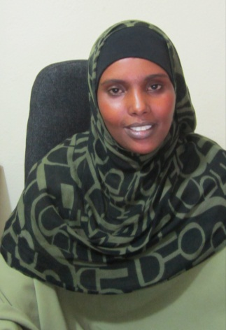

*Muna Shabcan Ali*

Although she fell short of being a Doctor as University of Hargeisa was ill equipped to train doctors then, Muna is content and beams with energy to work with the poor and the most neglected. She is a qualified Nurse Midwife and has undertaken a nurse tutor training to be able to train and mentor nurses. Muna provides technical support including training for nurses and midwives within the expansive Sahil region. She is also supporting the establishment of health systems and improved care provision in the health facilities.

Sahil region is one of the most difficult regions of the self-declared Republic of Somaliland (North Western Somalia). It is mostly rural, low literacy, high poverty, and tough terrain with harsh climatic conditions. The inhabitants are mostly pastoralists and agro-pastoralists. The tough terrain and the mobility of the people is perhaps a reason Sahil has largely been neglected in many years. Health Poverty Action is the first international Non-Governmental Organization to have presence in the entire region. With the funding from DFID, HPA is implementing an essential package for health services (EPHS). But even for HPA it is not an easy ride.

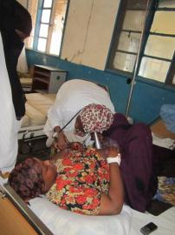

*Muna examines a mother during ANC visit at Berbera Hospital*

The aftermath of war left in its wake a health sector on its knees. Structures were destroyed and where they existed, there were no personnel and no drugs. As a result traditional and cultural practices filled the vacuum left by conventional health systems leading to a free for all practice. Women and children are most affected. HPA is trying to help build a system and save lives of mothers and children at their very point of need.

Muna narrates that even with qualified credential situation can always get bad when you have no tools of trade. In the early period of the project, Muna was traveling from Hargeisa to Berbera. When she reached Abdal, some 60 km to Berbera, HPA vehicle was flagged to stop. So the vehicle stopped. Somalis speak and soon word had gone round that HPA was going to bring drugs and doctors to help the community. Muna was informed that there was a mother who had been in labour for a long time in her house. The baby was not coming out with the head but with the legs and had gotten stack. “I was ill equipped to handle the situation, but the mother had nearly fainted. The traditional birth attendant (TBA) still wanted her to stand up and push even though she had no strength let alone bad practice. She was lying on the sandy floor in a pool of blood. I tried to bring her back. I gave her medications to reinitiate the labour and some drink. Fortunately, she responded and gathered strength. With no gloves and no equipment, I bought plastic paper used them as gloves and was able to assist. It took nearly additional 45minutes. The mother had not felt the fetus movements in 4 days. It was a still born but the mother was saved.”

Somali women are supposed to be strong, not wail while in labour; it is a sign of weakness and embarrassment. And so many die quietly and are buried quietly. Muna was just on time. And for the mother, HPA was on time.

“My name is Aamina Farah, I am 35 years old and live in Abdal with my husband who is a vehicle mechanic. I have been a very unfortunate woman in my life having lost all my eight babies. Five died before the age of five while three were stillborn. When I heard some NGO had come to help us, I went to the health centre for the first time although my house is just next to the health centre.

Previously, it was needless to go to a health centre; there were never medicine, and never personnel to care of me. All my deliveries were performed by TBAs.

On my eighth pregnancy, one day I was feeling very sick. So the TBA was called. She came and told me that I would give birth soon. After sometime I got into labour and tried to push. The process was slow and painful. After several hours, the baby’s legs started to come out but I couldn’t go any further. The TBAs said something was not right. I lost strength and felt helpless. My house is next to the police check point and after sometime there were murmurs.

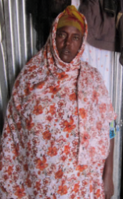

*Aamina Farah*

I don’t remember much of that day but what was clear is, I was dying. I had lost hope. Suddenly a lady appeared. I could vaguely see. She helped me, and her presence reignited my hope; bright as moonlight at night. I felt warm and calm.

HPA saved my life! HPA gave me a second chance and I thank Allah for them. Now I remember how I recovered Muna from HPA was here just on time.

HPA has shown me through action why I need regular check-up and visit antenatal care. A new building has been established and equipped. And I will be treated at no fee. I am now an advocate of life saving mobilising mothers to deliver in health centre.”