**The Superwoman of Lasadaw: Building strong, healthy communities in rural Somaliland**

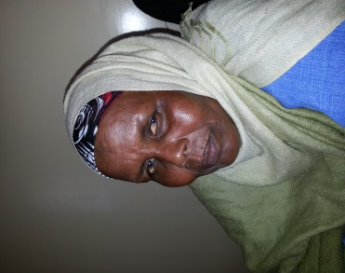Forty-eight year old Hali Abdi Omar, has brought significant changes to her community, Lasadaw village of Sahil region. She is a gender activist who serves both as vice chair-person of the community health committee (CHC) of Lasadaw Health Center and as chairperson of a community-based organization called ‘LUCKY’. Together with other four women from Lasadaw, Hali began to support her local community in 1992 when they returned from the refugee camps in Ethiopia. The women worked to raise awareness of issues related to health and education. They provided non-formal education for illiterate girls who from 1997 were then admitted into schools in the formal education system. With the inspiration of her husband and the district governor, Hali also started to help rural women raise their voices to promote child spacing and against gender-based violence, rape, female genital mutilation, and other harmful practices related to women’s health.

In 2008, she established a community-based organization called LUCKY with the help of the same four women; their membership has since grown and now includes 37 women. She has expanded her network to include 10 surrounding villages and has united 120 women in her mission against gender-based violence and FGM and to educate women about prenatal and antenatal care, child spacing, HIV, skilled delivery and regular visits to health facilities for any illness of mother or child. On top of these activities, since 2009 the CBO has collected $2 per month per member to support a fund aimed at providing skills and seed money to the poorest families of the communities. With the support of this fund, women from these families have been able to start income generation activities in the village.

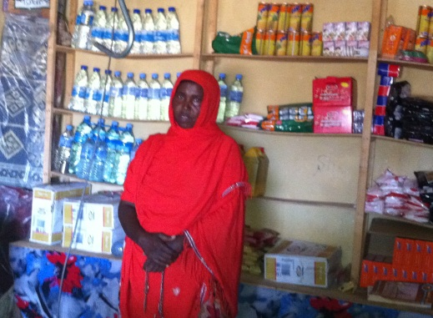For the last two years, HPA has been supporting and helping to build the capacity of CBOs in Sahil region. It has helped CBOs including LUCKY to campaign against gender-based violence, FGM, and other harmful practices and push for the Somaliland government to develop a policy for legal action to be taken against offenders. Support has also included direct support to the costs of running the health center - before HPA began to support the center, Lucky used to pay the water bills as well as the salaries of the center’s guard and cleaner.

***Aisha Awil Muse*** *is a 42 year old mother of 8 children. Her husband is handicapped, and so she is the bread-winner of the family. With the Lucky CBO’s support, Aisha has been able to start her own income generating project. Aisha explained, “Lucky CBO loaned me $150 in 2009, which I used to open a small shop in the village. Within three months I returned the money to the CBO. I received the same amount of money for the second time in 2010. Now I’m waiting to receive a fourth round. This income changed my life and my family’s life, because this became the only source of income that we have. I’m very pleased to have this kind of support.*”

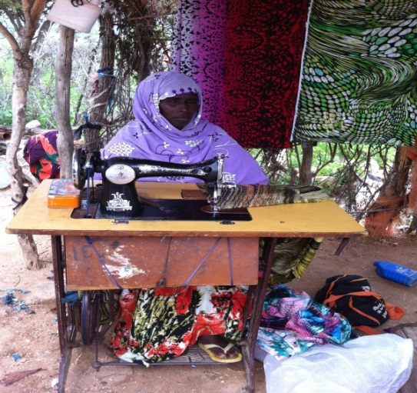***Haweeeya Abokor Ahmed*** *is a widow mother with 6 children; she received training as well as seed money from Lucky CBO to start an income generating project. She bought a sewing machine and started a sewing enterprise for the first time in Lasadaw village. Haweeya said “I received the first grant of $150 in 2009, and within 2 months I was able to return the money to the CBO. I received a second grant within the same year. My average monthly income is around $80 to $90 and depends on the seasons. Sometimes I receive more than $100. This year, 2013, I have the financial ability to send my child to university because I can afford to pay fees. This business improved my children’s life and mine too.”*

*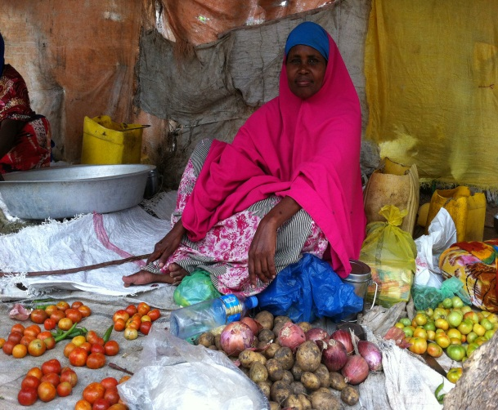Anab Ayaanle Jama is another of the mother of 9 children who has benefited from LUCKY’s support of new income generating projects. She explained, “I’m a petty trader of vegetables and meat. I started this small business in 2010 when I received the first grant of $150 from Lucky; within 5 months I returned the money to the CBO. I received a second grant in November 2011, and now I’m awaiting a third grant. My average monthly income is around $110 even without my husband’s support. My husband is a wage laborer, and so sometimes he has a job and sometimes he stays home. Although my children are young and still in intermediate school, their life has changed too because now I can buy them school books and a uniform every year and provide for their daily needs, which I was not able previously because the money that my husband was earning was not even enough for our daily needs.*

Lucky CBO has referred many rape cases to court, which has resulted in perpetrators being sentenced from 9 to 11 years in prison. Before HPA’s support, they also paid the school fees of some of the neediest students. Since last year they have been paying the university fees for one girl from their village as well as the fees of a number of secondary school students.

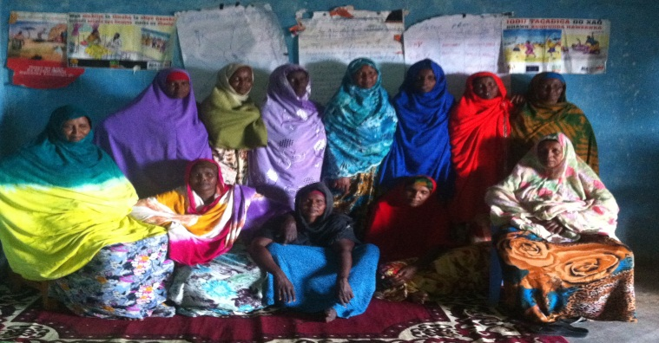Now, more than 80% of mothers visit a health facility for delivery and antenatal checkup in Lasadaw district. Common incidents of rape and gender-based violence have also significantly degreased since LUCKY’s awareness-raising campaign focused attention on the need to take legal action against the perpetrator. The original LUCKY groups as well as the ten other women’s group in the surrounding areas continue to work to empower all women and girls for better health, education and awareness of harmful practices. Hali and her LUCKY leaders have been able to convince local religious leaders, community leaders and school teachers to support their initiatives. Their leadership and relentless effort has helped bring positive and lasting changes to their society. Hopefully Hali will also inspire the next generation of women in the Somali community to build on their successes.