**INCREASING ACCESSIBILITY AND AVAILABILITY OF MODERN BIRTH SPACING METHODS THROGHOUT SOMALILAND**

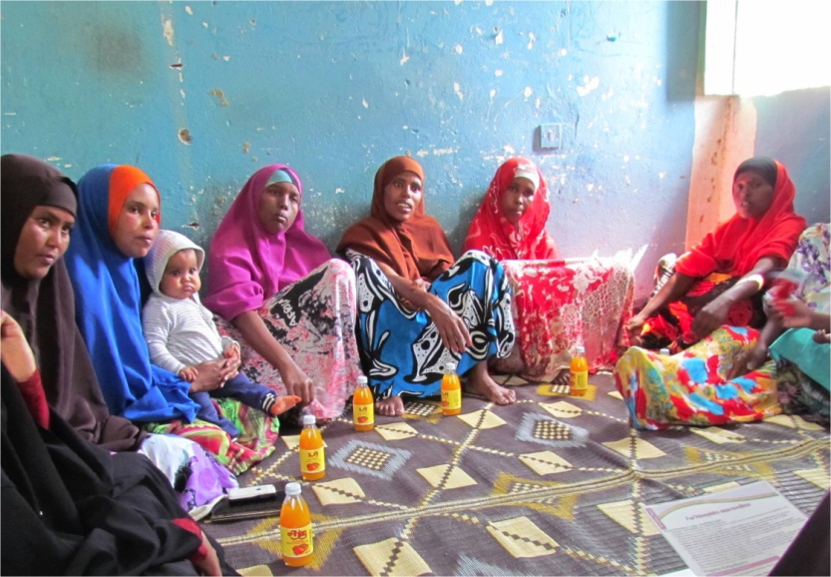Filsan Abdillahi is 32 years old and she is a mother of six children. She lives in M/Mooge IDP camp in Hargeisa, Somaliland.

Women attending PSI IPC sessions, Somaliland

“*My friend told me about IPC sessions near my village where women are discussing health information*. *I have then decided to attend the three sessions. Before attending the session I thought contraceptives were not safe. After my second child, I have discussed this with my husband but he refused to use it; he said that contraceptives cause infertility and we wanted to have more children*”.

The IPC sessions, conducted by PSI trained midwifes, are designed to increase women’s knowledge to make informed decisions regarding modern birth spacing methods as well as other safe motherhood topics. Given the strong influence of men in the family decision making, one of the desired outcomes of this intervention is that women would feel more empowered to broach the discussion about birth spacing with their husband.

**From January 2013 to June 2013, 5,357 women of reproductive age have been reached through the IPC program.**

“*During the sessions,* *I have learnt about the importance of spacing births and I discussed this with my husband again. I explained him the fact that contraceptives do not cause infertility. I have provided him with some examples of women who have used oral pills and injectable and they became pregnant again after having stopped it. He agreed and I then discussed this with the health provider. I am now using injectable and I will soon go for the next dose*”.

PSI aims at increasing availability of modern contraceptives through the private and public sector.

**From January to May 2013, 6645 oral pills and 691 injectable were distributed through private pharmacies, while 3,300 oral pills and 550 injectable through public health facilities in Somaliland.**