**Transferring Knowledge and Skills from Network Providers to Non-network Providers**

PSI/Somaliland’s social franchise network of private pharmacies, known as BulshoKaab (meaning “community helper”), was launched on 27th July 2011. To join the BulshoKaab Network, the pharmacy must satisfy certain selection criteria to ensure that the right providers are recruited to provide quality services to the clients. To better equip BulshoKaab pharmacy providers with knowledge and skills to deliver quality health services, PSI developed a 3 month, intensive training modules that help BulshoKaab pharmacy providers better understand how to provide quality counseling for reproductive health and be better skilled to conduct IMCI (Integrated Management of Childhood Illnesses). In addition, PSI also provides initial and refresher trainings, medical detailing/on-job training and training materials including trainee manual. Medical equipments (such blood pressure machine, thermometer, MUACs, baby weight scale and needle incinerator machines) are also provided to the BulshoKaab members.

Although PSI provides medical detailing visits and on-job training to non-network pharmacies, those pharmacies do not receive the initial or refresher trainings or training materials, so they must seek that extra information from their friends in the network.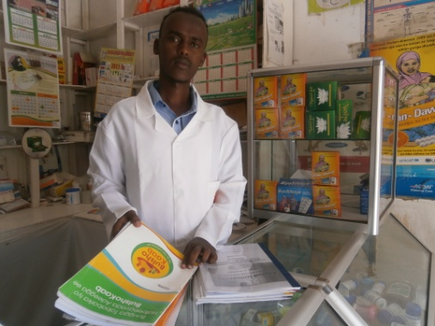

Mr. Mustafe was among the first recruits for the BulshoKaab social franchise network of pharmacies. He is a nurse and attended BulshoKaab initial training and several refresher trainings. He not only uses the skills, knowledge and practice he gained from PSI, but transfers them to his peers who did not get such opportunity. “*Three of my friends frequently come to me one at a time in my pharmacy asking me to share the knowledge and skills I gained from BulshoKaab trainings*”, he said. He added, “*some of them are interested in reproductive health, such as birth spacing counseling including assessing medical eligibility, side effects, warning signs, benefits, dealing with misconceptions, while others are interested in child health, specifically IMCI*.” “*I encourage them to learn about health areas as they need these skills every day. I give this information free as I think it is important supporting other pharmacy providers who did not get the opportunity I got to serve the community better.*”

Mr. Mustafe’s story is an interesting one, as it goes beyond the immediate objective of building the capacity of pharmacy providers of BulshoKaab network, but also arouses the interest of other non-network providers to seek knowledge and support. This is an example on how the BulshoKaab network is growing and gradually taking the responsibility of spreading the correct practices among the pharmacy community.