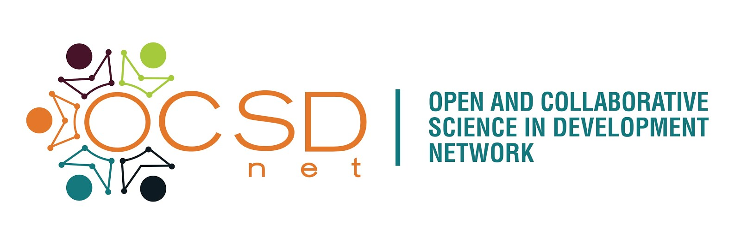
Introducing the Open and Collaborative Science in Development Network

We are pleased to announce the launch of the Open and Collaborative Science in Development Network (OCSDNet) and the public Call for Concept Notes on case studies that explore the linkages between Open Science and development initiatives.

What is Open and Collaborative Science?
Open and Collaborative Science (OCS) is a set of ideas and practices that aims to change the traditional culture of research by making the production and dissemination of scientific knowledge inclusive and publicly accessible. Open approaches to science include increased sharing of research plans and data, participatory citizen science, distributed “crowdsourced” forms of data collection, and innovative models of large or small scale scientific collaborations, enabled by networked technologies.

While principles of openness and collaboration are recognized as critical for development, they remain to be realized. Moreover, there is limited awareness about the benefits and practices of OCS in the Global South. If the global scientific community understands how scientific knowledge can be effectively made more open and inclusive, then researchers and research-users in the Global South and North can work to ensure that scientific knowledge informs development efforts.

About OCSDNet:
With funding from Canada’s International Development Research Centre (IDRC), OCSDNet is jointly coordinated by the Centre for Critical Development Studies (CCDS) at the University of Toronto Scarborough (Canada) and iHub (Kenya) . OCSDNet aims to support researchers and practitioners from the Global South to carry out research or projects that will lead to deeper understanding of whether, and the conditions under which open knowledge production processes could lead to development outcomes, such as economic and educational opportunities, improved health and food security, and policy reform. By contributing to this new area of study, OCSDNet will also build a community of open science practitioners and leaders who will influence policy dialogues pertaining to the role of science and innovation in development.

Research Focus:
OCSDNet aims to investigate a broad range of questions, including:
- How do researchers in various institutional contexts practice “openness”? How can open science approaches benefit researchers in the Global South?
- Will OCS lead to novel insights and solutions to entrenched development problems?
- Can greater participation of citizens in the planning and conduct of scientific research increase its application in addressing local development goals?
- How can the sharing of knowledge as a public good be weighed against protection of various forms of rights?

To explore these and related questions, OCSDNet will provide funding support for up to 15 case studies from eligible countries. Specifically, OCSDNet will support case studies that employ innovative and transformative open processes to address a range of development challenges in Global South contexts. The network welcomes a mix of projects that include scientific research in a specific domain to generate new knowledge (i.e. food security, health equity, citizen empowerment, renewable energies, climate change impact), as well as critical research on ongoing initiatives, focusing on behaviours, contexts, challenges and opportunities enabled by OCS principles. Projects will cover 4 cross-cutting thematic areas:

- Motivations (Incentives and Ideologies): This research theme will broadly examine the contexts and conditions under which OCS approaches are likely to be adopted by researchers and how a pro-open environment might be created at the social, cultural and policy levels.

- Infrastructure and Technologies: Open science is dependent on the availability and accessibility of scientific tools and software as well as network technologies such as smartphones, cloud-based services and high-bandwidth internet connections. This theme will explore what technologies enable and/or hinder open science, for whom and under what conditions?

- Communities of Practice: This area of inquiry will explode governance structures and how communities of actors and institutional contexts can contribute to increasing the inclusiveness of open science and inform research.

- Potential Impacts (Positive and Negative) of OCS: The aim of this research theme is to systematically work through the proposed benefits for OCSD and find evidence to support them, as well as identifying and evidencing any risks and potential negative impacts.

For details on how these themes were arrived at and how they are related, please read the background paper (http://ocsdnet.org/downloads/OCSDNetBackgroundPaper.pdf) and the call for concept notes
(http://ocsdnet.org/downloads/OCSDNetCallforConceptPapers.pdf).

Applying for OCSDNet Funding:
OCSDNet has launched an open call for concept papers for OCS development projects. The call is open to researchers and practitioners affiliated with organizations based in countries that are eligible for support by the IDRC (see here for complete list). The deadline for submissions is September 8th, 2014. Successful authors of the papers will be invited to a proposal development workshop, to be held in Nairobi, Kenya in October 2014. (For details of the call, visit the OCSDNet web site: www.ocsdnet.org).

Website and Support
The OCSDNet Virtual Hub (http://ocsdnet.org) will further support resource sharing and the cross-fertilization of ideas and knowledge between research teams. The OCSDNet team will also support regional workshops, preparation for presentations and publications of research findings at appropriate international meetings and open access venues, and policy interface with funders and decision makers wherever applicable.

Contact: info@ocsdnet.org

