**Course:** ENSF 607 – Fall 2020

**Term Project:** Pre-Project UML Diagrams

**Student Names**:

* Nathan Jack 10123758
* Jordan Joorisity 30117950

**Submission Date**: November 18, 2020

# Client-Server UML

# serverModel UML:

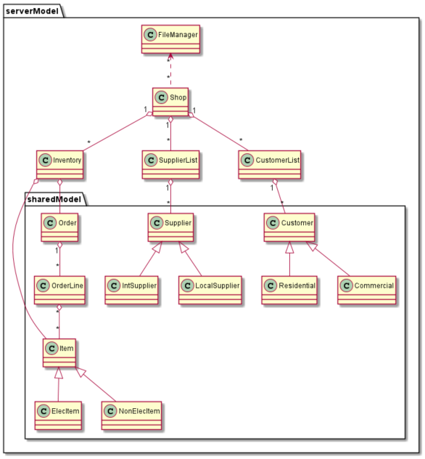

# Front End UML:

