Polling Station Officer Guide

Josh MacKay

INET2005

1. Logging in

Click the “Log in” button on the home page. Enter your username and password and click “Log in” again. The usernames/passwords for testing are:

|  |  |  |
| --- | --- | --- |
| Username | Password | Role |
| admin | adminpw | Admin |
| user1 | 123 | User |
| user2 | 234 | User |
| user3 | 345 | User |
| user4 | 456 | User |

1. Admin Panel

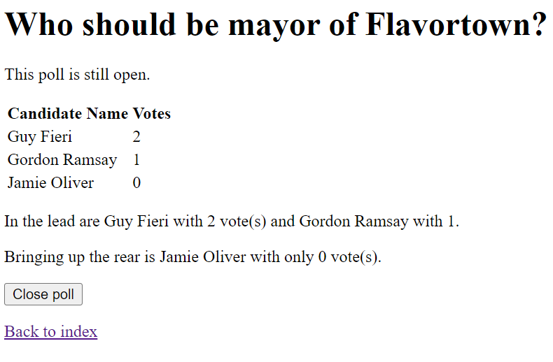

The admin panel will show you the votes cast for every candidate in the current poll, as well as summarize which candidates are leading and trailing.

You can select “Close poll” to end the voting process. The candidate with the highest votes will automatically be declared the winner, and users will no longer be able to vote in the current poll.

If you close the poll prematurely, you have the option of reopening the poll.



This will unset the winner and allow users to vote again.