**INDEX**

|  |  |  |  |
| --- | --- | --- | --- |
| ***S.no*** | ***Name of program*** | ***Page number*** | ***Signature and remarks*** |
| ***1.*** | **To prepare your bio data using MS Word.** | 2 – 4 |  |
| ***2.*** | **To prepare the list of marks obtained in different subjects and show with the help of chart/graph the average, min, max in each subject.** | 5 |  |
| ***3.*** | **Prepare a presentation explaining the facilities/infrastructures available in your college/institution.** | 6 - 9 |  |
| ***4.*** | ***Create a webpage for bill invoice using <p>, <br>, <pre>, <em>, <i>, <u> and other basic tags..*** | 10 – 12 |  |
| ***5.*** | ***Create a webpage that display short write-up on internet tools using <font>,heading tags.*** | 13 - 15 |  |
| ***6.*** | ***Create a webpage to display table using cell spacing and cell padding for various data types available in C++ including .*** | 16 – 21 |  |
| ***7.*** | ***Create a webpage to display nesting of computer memory using <ol> and <ul> tags.*** | 22 - 24 |  |
| ***8.*** | ***Use the align attribute of an image tag to align images of secondary storage devices (top, middle, bottom)*** | 25 – 27 |  |
| ***9.*** | ***Create a webpage to display glossary for IPV4 address classes using <dl> and <dd> tag*** | 28 - 30 |  |
| ***10.*** | ***Create a webpage to demonstrate user sign up form using <form>, <input>, <select>, <radio>, <textarea> and <button>.*** | 31 – 33 |  |
| ***11.*** | ***Create a webpage using frameset and anchor tag to divide the page into 3 sections and create hyperlinking in different sections.*** | 34 - 35 |  |

**Practical - 1**

***Aim – To prepare your bio data using MS Word.***

**Practical - 2**

***Aim –* To prepare the list of marks obtained in different subjects and show with the help of chart/graph the average, min, max in each subject.**

***Output –*** 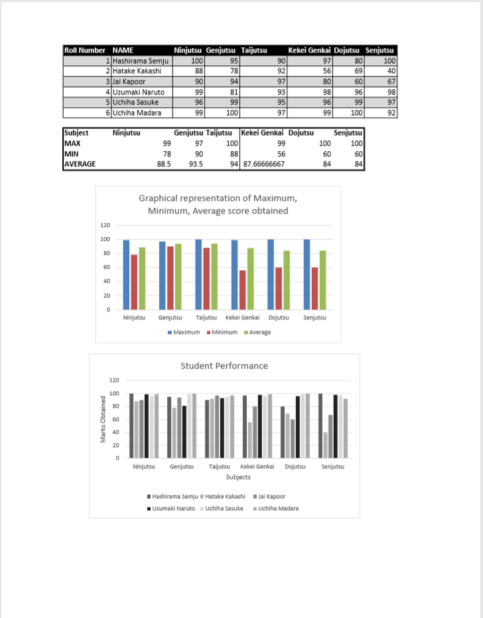

**Practical - 3**

***Aim –* Prepare a presentation explaining the facilities/infrastructures available in your college/institution.**

***Output –***

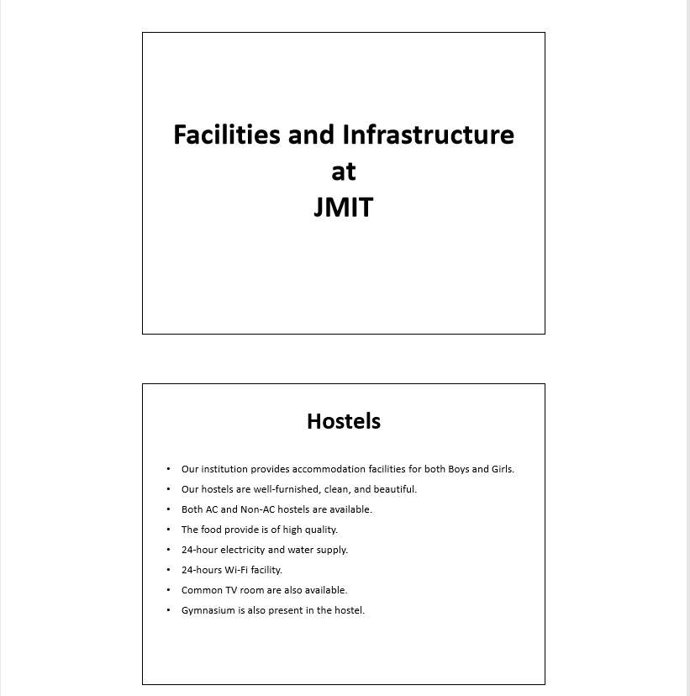

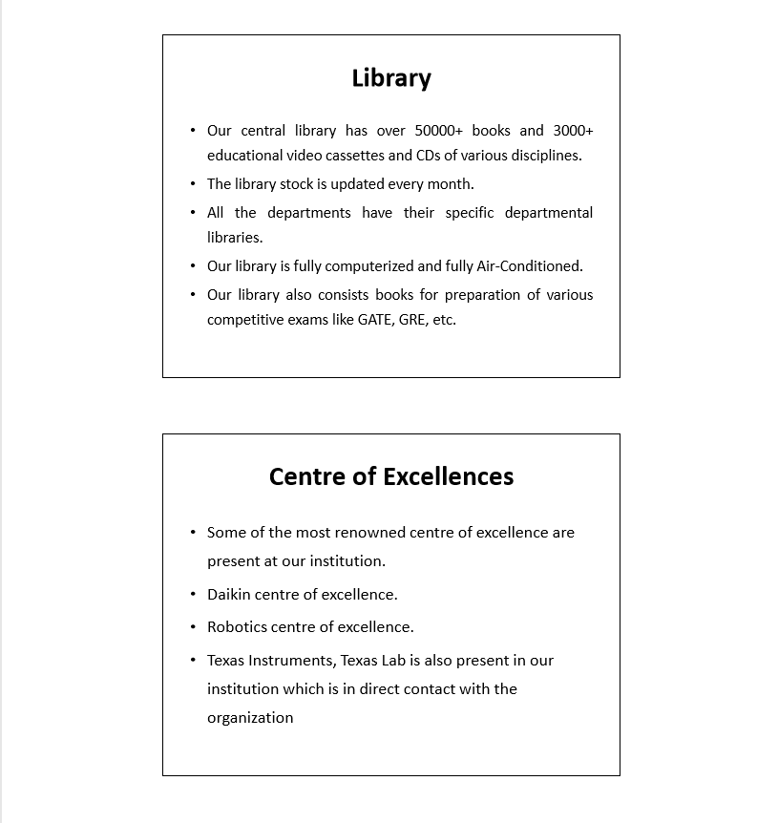

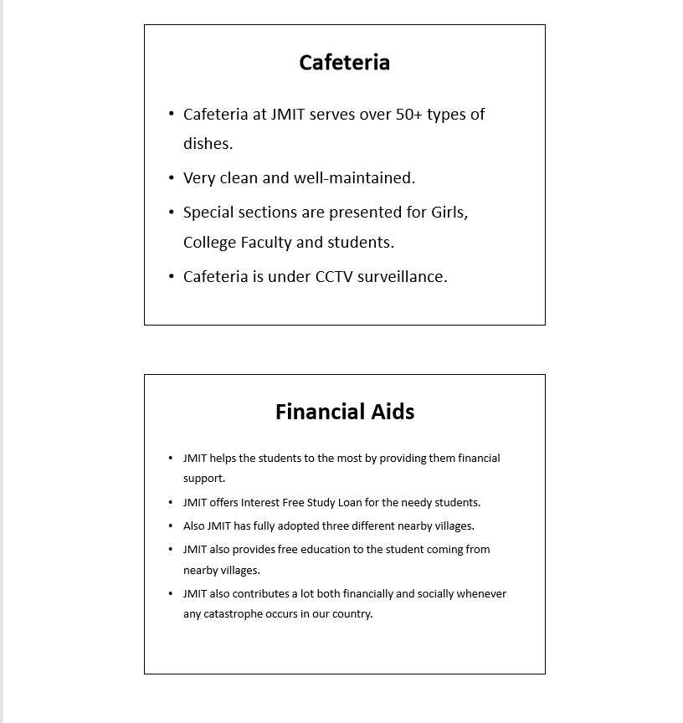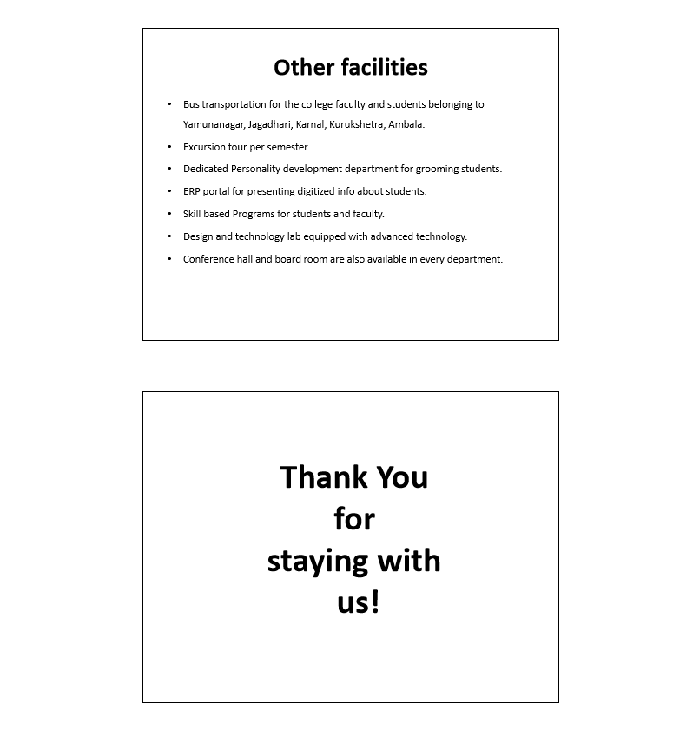

**Practical – 4**

***Aim – Create a webpage for bill invoice using <p>, <br>, <pre>, <em>, <i>, <u> and other basic tags.***

***Code -***

<!DOCTYPE html>

<html>

<head>

<title>THE CODEX</title>

</head>

<body>

<table align='center' border='1px'>

<tr><td colspan="4">

<h1 align='center'><p><b>THE CODEX</b></p></h1>

<h4 align='center'>Shop No.245, Lincon Street, <br> Washington DC, USA</h4>

<h3 align='center'><u>CASH MEMO</u></h3>

<h4 align='center'><pre><i> S.No............. DATE:.............. </i></pre></h4>

</td></tr>

<tr>

<td width="100">QUANTITY</td>

<td>ITEM</td>

<td width="100">RATE</td>

<td width="100">TOTAL</td>

</tr>

<tr valign="top">

<td height="600"><h3>1 <br> 3 <br> 1 </h4></td>

<td><h3>Nvidia RTX 2080 Graphics Card<br> Zompron 35 CPU fan <br> Intel i9 9900k proccessor </h3></td>

<td><h3>$1000 <br> $25 <br> $850 </h3></td>

<td><h3>$1000 <br> $75 <br> $850 </h3></td>

</tr>

<tr>

<td colspan="4">

<pre>AMOUNT IN WORDS: One thousand nine hundred and twenty five dollars only/- G.TOTAL:$1925 </pre><br>

________________________________________________________________________SIGN:_________________

</td>

</tr>

</body>

</html>

***Output –***

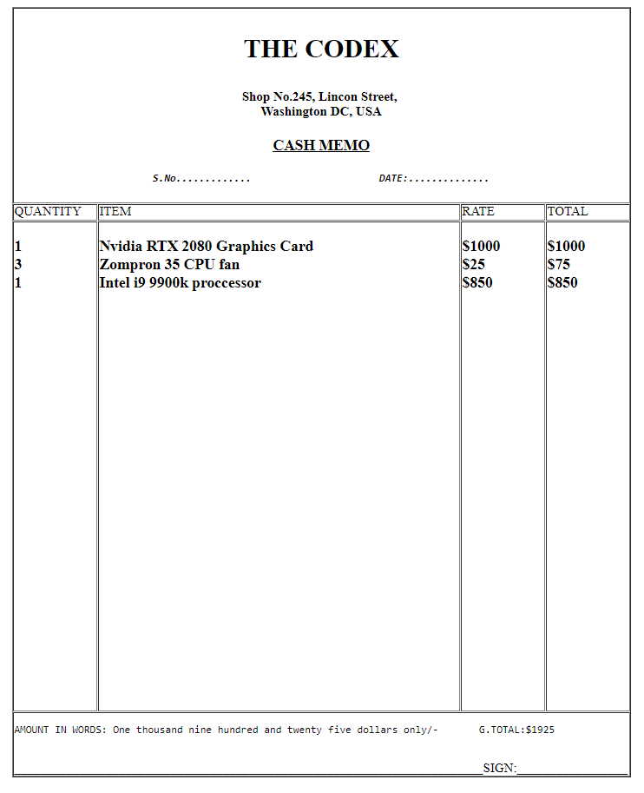

**Practical – 5**

***Aim – Create a webpage that display short write-up on internet tools using <font>,heading tags.***

***Code –***

<!-- create a webpage that display short write-up on internet tools-->

<!DOCTYPE html>

<html>

<head>

<title>INTERNET TOOLS</title>

</head>

<body>

<h1 align="center"><font size="20" color="red" face="jokerman"><u>INTERNET TOOLS</u></font></h1>

<p>

<h2><u><font size="6" color="black" face="jokerman">Major Internet tools are as follows :-</font></u></h2></p>

<br>

<ol>

<li>

<h3><font size="5" color="red" face="jokerman"><u>Electronic Mail (E-Mail) :</u></font></h3>It is a method of exchanging digital messages from an author to one or more recipients. <br>To use e-mail on the internet, you must first have access to the Internet and an e-mail account<br> set that provides you an e-mail address.

</li>

<li>

<h3><font size="5" color="green" face="jokerman"><u>Newsgroups :</u></font></h3> Newsgroups are often arranged into hierarchies, theorectically making it simpler to find related groups.<br>

The term top level hierarchy refers to the hierarchy defined by the prefix before the dot.<br>

</li>

<li>

<h3><font size="5" color="magenta" face="jokerman"><u>Internet Relay Chart (IRC) :</u></font></h3> It allows you to pass the message back and forth to other IRC users in real time, as you<br> would on a citizens band (CB) radio. It is mainly designed for group commmunication in discussion forums, called channels.

</li>

<li>

<h3><font size="5" color="blue" face="jokerman"><u>Telnet and SSH :</u></font></h3> It allows us to log into another computer system and use that system's resources just as if they were<br> your own. SSH uses public-key cryptography to authenticate the remote computer and allow<br> it to authenticate the user.

</li>

<li>

<h3><font size="5" color="orange" face="jokerman"><u>File Transfer Protocol (FTP and FTPS, SFTP) :</u></font></h3> It is a standard network protocol used for transfer files rfrom one host to another host over a TCP based network

</li>

<li>

<h3><font size="5" color="maroon" face="jokerman"><u>World Wide Web (WWW) :</u></font></h3> The World Wide Web (WWW) is a network of online content that is formatted in HTML and accessed via HTTP.<br> The term refers to all the interlinked HTML pages that can be accessed over the Internet.<br> The World Wide Web was originally designed in 1991 by Tim Berners-Lee while he was a contractor at CERN.

</li>

</ol>

</body>

</html>

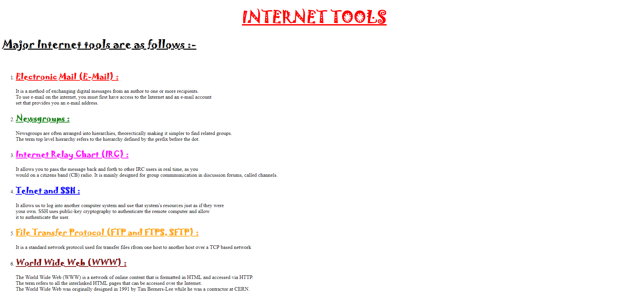***Output –***

**Practical – 6**

***Aim – Create a webpage to display table using cell spacing and cell padding for various data types available in C++ including: -***

***Serial No. Name of Data type Specification***

***Code –***

<!DOCTYPE html>

<html>

<head>

<title></title>

</head>

<body>

<table border="2px" align="center" cellspacing="5" cellpadding="5" >

<tr>

<th>S.No</th>

<th>Name of Data Type</th>

<th>Keyword</th>

<th>Size (In Bytes)</th>

<th>Range</th>

<th>Description</th>

</tr>

<tr>

<td>1.</td>

<td>INTEGER</td>

<td>int</td>

<td>4</td>

<td>-2147483648 to 2147483647</td>

<td>Used to store integer number in the given range</td>

</tr>

<tr>

<td>2.</td>

<td>SIGNED INTEGER</td>

<td>signed int</td>

<td>4</td>

<td>-2147483648 to 2147483647</td>

<td>Used to store integer number in the given range </td>

</tr>

<tr>

<td>3.</td>

<td>UNSIGNED INTEGER</td>

<td>unsigned int</td>

<td>4</td>

<td>0 to 4294967295</td>

<td>Used to store integer number in the given range </td>

</tr>

<tr>

<td>4.</td>

<td>SHORT INTEGER</td>

<td>short int</td>

<td>2</td>

<td>-32768 to 32767</td>

<td>Used to store integer number in the given range </td>

</tr>

<tr>

<td>5.</td>

<td>UNSIGNED SHORT INTEGER</td>

<td>unsigned short int</td>

<td>Range</td>

<td>0 to 65,535</td>

<td>Used to store integer number in the given range </td>

</tr>

<tr>

<td>6.</td>

<td>LONG INTEGER</td>

<td>long int</td>

<td>4</td>

<td>2,147,483,648 to 2,147,483,647</td>

<td>Used to store integer number in the given range </td>

</tr>

<tr>

<td>7.</td>

<td>UNSIGNED LONG INTEGER</td>

<td>unsigned short int</td>

<td>4</td>

<td>0 to 4,294,967,295</td>

<td>Used to store integer number in the given range </td>

</tr>

<tr>

<td>8.</td>

<td>CHARACTER</td>

<td>char</td>

<td>1</td>

<td>-127 to 127 or 0 to 255</td>

<td>Used to store characters in the given range</td>

</tr>

<tr>

<td>9.</td>

<td>SIGNED CHARACTER</td>

<td>signed char</td>

<td>1</td>

<td>-127 to 127</td>

<td>Used to store characters in the given range </td>

</tr>

<tr>

<td>10.</td>

<td>UNSIGNED CHARACTER</td>

<td>unsigned char</td>

<td>1</td>

<td>0 to 255</td>

<td>Used to store characters in the given range </td>

</tr>

<tr>

<td>11.</td>

<td>FLOATING POINT</td>

<td>float</td>

<td>4</td>

<td>+/- 3.4e +/- 38 (~7 digits)</td>

<td>Used to store floating point number in the given range </td>

</tr>

<tr>

<td>12.</td>

<td>DOUBLE FLOATING POINT</td>

<td>double</td>

<td>8</td>

<td>+/- 1.7e +/- 308 (~15 digits)</td>

<td>Used to store floating point number in the given range </td>

</tr>

<tr>

<td>13.</td>

<td>LONG DOUBLE FLOATING POINT</td>

<td>double</td>

<td>8</td>

<td>+/- 1.7e +/- 308 (~15 digits)</td>

<td>Used to store floating point number in the given range </td>

</tr>

<tr>

<td>14.</td>

<td>VALUELESS</td>

<td>void</td>

<td>N/A</td>

<td>N/A</td>

<td>The data type void actually refers to an object that <br>does not have a value of any type. </td>

</tr>

<tr>

<td>15.</td>

<td>WIDE CHARACTER</td>

<td>wchar_t</td>

<td>2 or 4</td>

<td>1 wide character</td>

<td>Wide char is similar to char data type, except <br>that wide char take up twice the space and can take<br> on much larger values as a result. char can take<br> 256 values which corresponds to entries in the ASCII table.</td>

</tr>

</table>

</body>

</html>

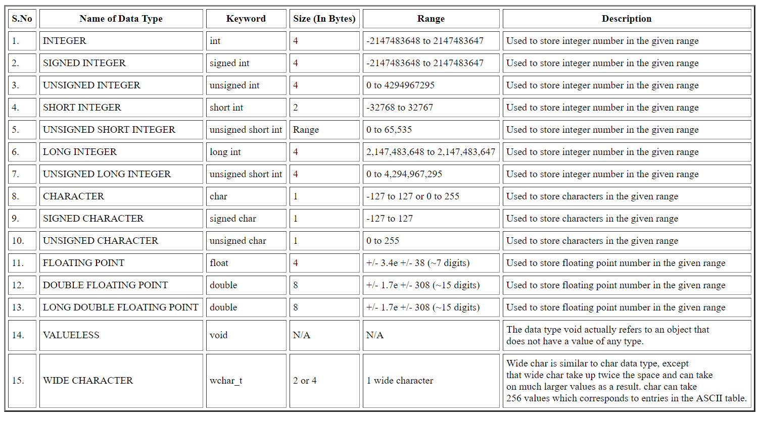***Output –***

**Practical –7**

***Aim – Create a webpage to display nesting of computer memory using <ol> and <ul> tags.***

***Code –***

<!doctype html>

<html>

<head>

<title> Computer Memory </title>

</head>

<body>

<h1>Computer Memories are of the following types:</h1>

<ol>

<li>Primary/ Internal / Main Memory</li>

<ol type = "i">

<li>Random Access / Volatile Memory</li>

<ul>

<li>DRAM</li>

<ul>

<li>SDRAM</li>

<li>RDRAM</li>

<li>DDR SDRAM</li>

<ul>

<li>DDR1</li>

<li>DDR2</li>

<li>DDR3</li>

<li>DDR4</li>

<li>DDR5</li>

</ul>

</ul>

<li>SDRAM</li>

</ul>

<li>Read Only Memory</li>

<ul>

<li> PROM</li>

<li>EPROM</li>

<li>EEPROM</li>

<li>EAPROM</li>

</ul>

</ol>

<li>Secondary / External Memory</li>

<ul type="square">

<li>Compact Disk</li>

<li>Solid State Drive</li>

<li>Hard Disk Drive</li>

<li>USB Flash Drive</li>

</ul>

</ol>

</body>

</html>

***Output –***

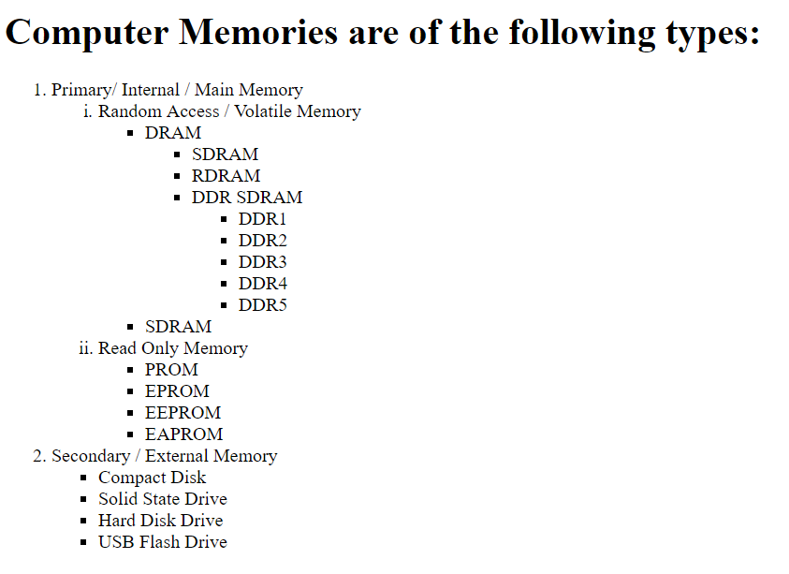

**Practical – 8**

***Aim – Use the align attribute of an image tag to align images of secondary storage devices (top, middle, bottom).***

***Code-***

<html>

<head>

<title>Secondary Storage Devices</title>

</head>

<body>

<h1 align="center"><u> SECONDARY STORAGE DEVICES</u></h1>

<pre>

<center>

<img src="Compact-disc-rom.jpg" alt="Example" align="center">

</center>

CD-ROM (Compact Disc Read Only Memory) is a Compact Disc contains data accessible by a computer.

While the Compact Disc format was originally designed for music storage and play back,

the format was later adapted to hold any form of binary data.

<br>

</pre>

<pre>

<img src="Hard-disk-drive.jpg" alt="Example" align="left">

A hard disk drive [HDD], commonly referred to as a hard drive, hard disk or fixed disk drive.

It is a non-volatile secondary storage device which stores digitally encoded data on rapidly <br>rotating platters with magnetic surfaced.

The hard disk is an electro mechanical device. The hard disk is also known as Winchester disk.<br> HDDs record data by magnetizing a ferromagnetic material directionally to represent<br> either a “0” or “1” binary digit.

They read the data by detecting the magnetization of the material.

<br>

<br>

<br>

<br>

<br>

<br>

<br>

</pre>

<p>

<img src="Floppy-disc-drive.jpg" alt="Example" align="right">

These are also called as flexible disks. These are used in the smallest micro computer systems as well as mini computers.<br>

Floppy disks have higher storage capacity and offer direct access capability.<br>

The floppy disk is permanently sealed in a plastic coated jacket and the whole<br> package is inserted the floppy drive for data recording and retrieval.

<br>

</p>

</body>

</html>

***Output –***

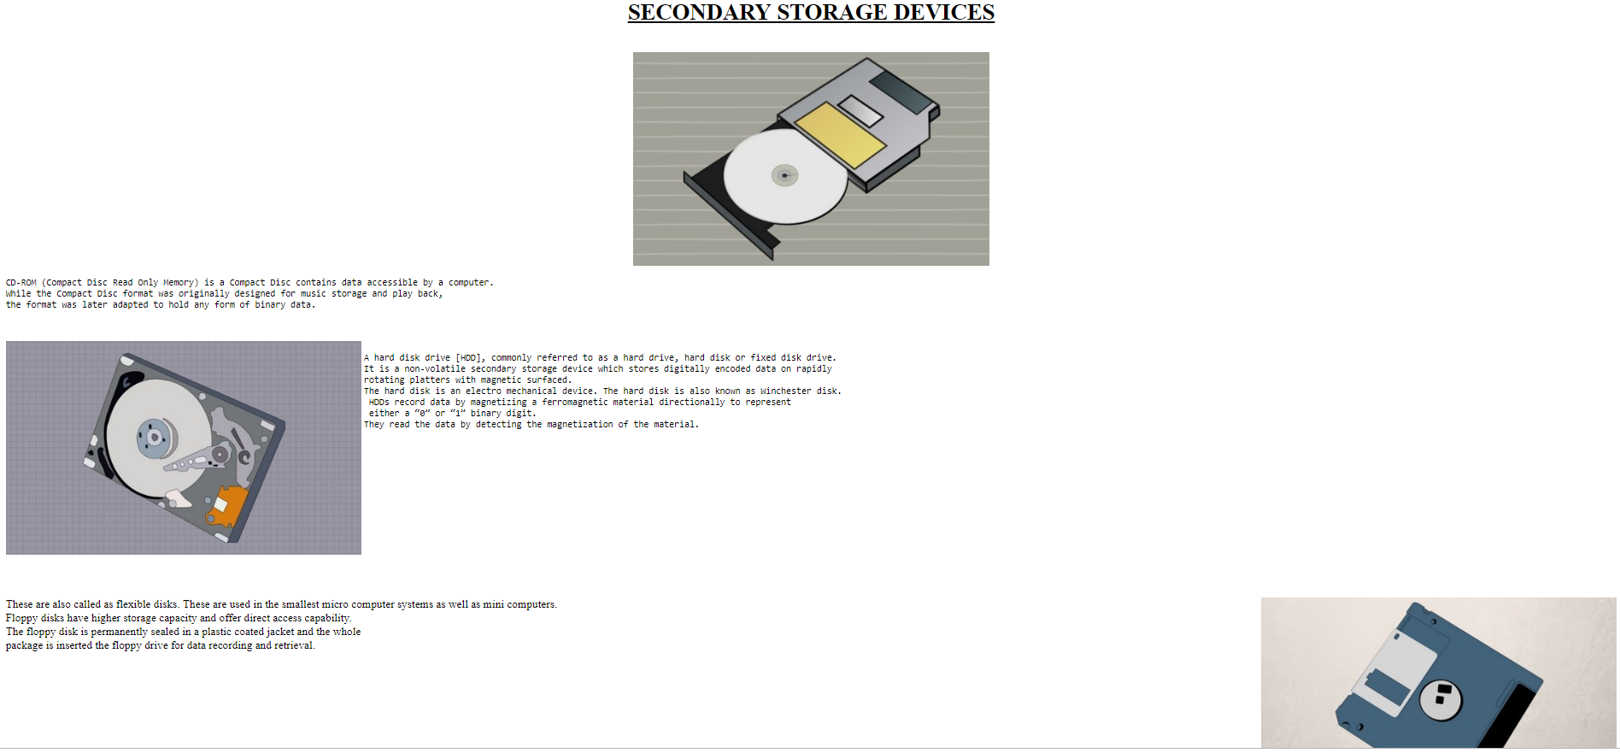

**Practical –9**

***Aim – Create a webpage to display glossary for IPV4 address classes using <dl> and <dd> tag.***

***Code –***

<!DOCTYPE html>

<html>

<head>

<title>HTML dl Tag</title>

</head>

<body>

<dl>

<dt align ="center"><font face="comic sans ms">IP Addresses</font></dt>

<dd align="center">A list of terms and their definitions/descriptions.</dd>

<dt>Class A addresses</dt>

<dd><pre>The first bit of the first octet is always set to 0 (zero). Thus the first octet ranges from 1 – 127, i.e.

00000001 - 01111111

1 - 127

Class A addresses only include IP starting from 1.x.x.x to 126.x.x.x only. The IP range 127.x.x.x is reserved forloopback IP addresses.

The default subnet mask for Class A IP address is 255.0.0.0 which implies that Class A addressing can have 126 networks (27-2) and 16777214 hosts (224-2).

Class A IP address format is thus: 0NNNNNNN.HHHHHHHH.HHHHHHHH.HHHHHHHH</pre></dd>

<dt>Class B addresses</dt>

<dd><pre>An IP address which belongs to class B has the first two bits in the first octet set to 10, i.e.

10000000 - 10111111

128 - 191

Class B IP Addresses range from 128.0.x.x to 191.255.x.x. The default subnet mask for Class B is 255.255.x.x.

Class B has 16384 (214) Network addresses and 65534 (216-2) Host addresses.

Class B IP address format is: 10NNNNNN.NNNNNNNN.HHHHHHHH.HHHHHHHH</pre></dd>

<dt>Class C addresses</dt>

<dd><pre>The first octet of Class C IP address has its first 3 bits set to 110, that is:

11000000 - 11011111

192 - 223

Class C Addresses Class C IP addresses range from 192.0.0.x to 223.255.255.x. The default subnet mask for Class C is 255.255.255.x.

Class C gives 2097152 (221) Network addresses and 254 (28-2) Host addresses.

Class C IP address format is: 110NNNNN.NNNNNNNN.NNNNNNNN.HHHHHHHH</pre></dd>

<dt>Class D addresses</dt>

<dd><pre>Very first four bits of the first octet in Class D IP addresses are set to 1110, giving a range of:

11100000 - 11101111

224 - 239

Class D has IP address range from 224.0.0.0 to 239.255.255.255. Class D is reserved for Multicasting.In multicasting data is not destined for a particular host,

that is why there is no need to extract host address from the IP address, and Class D does not have any subnet mask.</pre></dd>

<dt>Class E addresses</dt>

<dd><p>This IP Class is reserved for experimental purposes only for R&D or Study. IP addresses in this class ranges from 240.0.0.0 to 255.255.255.254. Like Class D,this class too is not equipped with any subnet mask.</p></dd>

</dl>

</body>

</html>

***Output –***

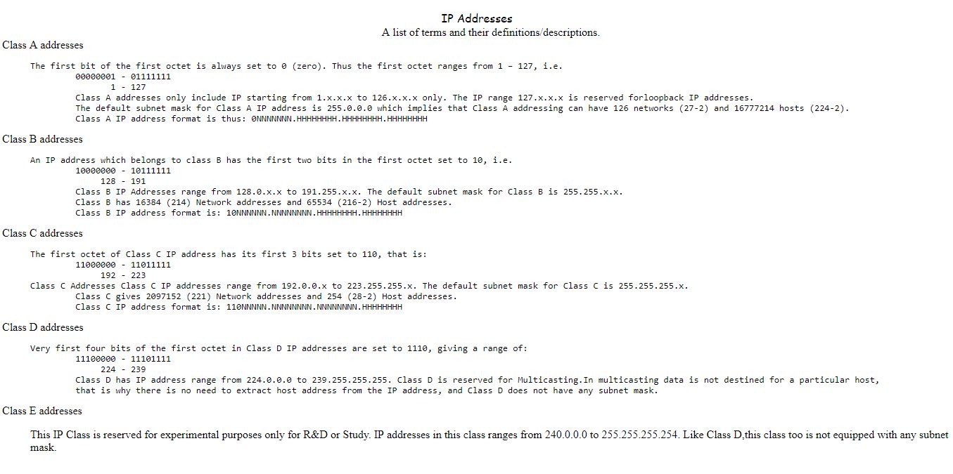

**Practical – 10**

***Aim – Create a webpage to demonstrate user sign up form using <form>, <input>, <select>, <radio>, <textarea> and <button>.***

***Code –***

<!DOCTYPE html>

<html>

<head>

<title>Sign Up form</title>

</head>

<body>

<h2><u>Sign Up</u></h2>

<h4>Please enter your details :</h4>

<form>

<p>First Name: <input type="text" name="First Name" placeholder="Enter First Name" required></p>

<p>Last Name: <input type="text" name="Last Name" placeholder="Enter Last Name" required></p>

<p>Roll Number: <input type="text" name="Roll Number" placeholder="Enter Roll Number" required></p>

<p>Branch:

<select>

<option name="Select">--Select--</option>

<option name="CSE">CSE</option>

<option name="CSE">IT</option>

<option name="CSE">ME</option>

<option name="CSE">ECE</option>

<option name="CSE">ELE</option>

</select>

</p>

<p>E-mail ID: <input type="text" name="email" placeholder="Enter Email Id"></p>

<p>Phone Number: <input type="text" name="Phone Number" placeholder="Enter Phone Number" required></p>

<p>Gender:

<input type="radio" name="gender" value="male"> Male

<input type="radio" name="gender" value="female"> Female<br>

</p>

<textarea rows="4" cols="50" name="comment" placeholder="Feedback..."></textarea><br><br>

<button name="submit" value="Submit">Submit</button>

</form>

</body>

</html>

***Output –***

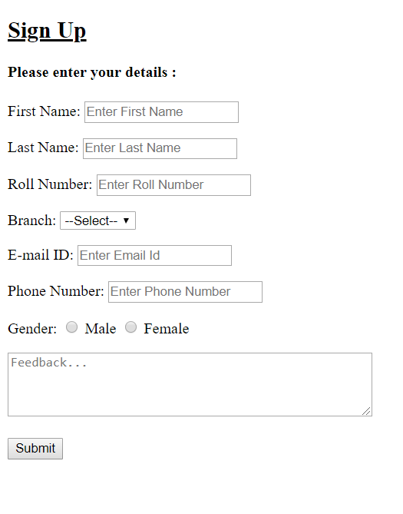

**Practical – 11**

***Aim – Create a webpage using frameset and anchor tag to divide the page into 3 sections and create hyperlinking in different sections.***

***Code –***

**Practical – 12**

***Aim – Create a webpage that display Inline CSS.***

***Code –***

<!DOCTYPE html>

<html>

<head>

<title>Inline CSS</title>

</head>

<body style='background:cyan'>

<h1 style='color:red'>

Hello World

</h1>

<h2 style='font-family:comic sans ms'>

This is Inline CSS

</h2>

<p style='color:green'>

Thank You!

<p>

</body>

</html>

***Output –***



**Practical – 13**

***Aim – Create a webpage that display Internal CSS.***

***Code –***

<!DOCTYPE html>

<html>

<head>

<title>Internal CSS</title>

<style>

body{

background: cyan;

color: green;

}

h1{

color:red;

}

h2{

font-family: jokerman;

}

p{ color:blue;}

</style>

</head>

<body >

<h1 >Hello World</h1>

<h2 >This is Internal CSS</h2>

<p>Thank You!<p>

</body>

</html>

***Output -***



**Practical – 14**

***Aim – Create a webpage that display External CSS.***

***Code –***

<!DOCTYPE html>

<html>

<head>

<title>External CSS</title>

</head>

<body >

<link rel="stylesheet" href="style.css">

<h1 >Hello World</h1>

<h2 >This is External CSS</h2>

<p>Thank You!<p>

</body>

</html>

***CSS Code-***

body{

background: cyan;

color: green;

}

h1{

color:red;

}

h2{

font-family: jokerman;

}

p{ color:blue;}

***Output –***



**Practical – 15**

***Aim – Light a bulb using JavaScript in HTML***

***Code –***

<html>

<body>

<p>Click the light bulb to turn on/off the light.</p>

<img id="myImage" onclick="changeImage()" src="C:\Users\jai\Desktop\bulboff.gif" width="100" height="180">

<script>

function changeImage() {

var image = document.getElementById('myImage');

if (image.src.match("bulbon"))

{

image.src = "C:\Users\jai\Desktop\bulboff.gif";

}

else {

image.src = "C:\Users\jai\Desktop\bulbon.gif";

}

}

</script>

</body>

</html>

***Output –***

