Jeremiah Kellam

CSD380 Module 5.2 Assignment

7/22/2024

Value Stream Map

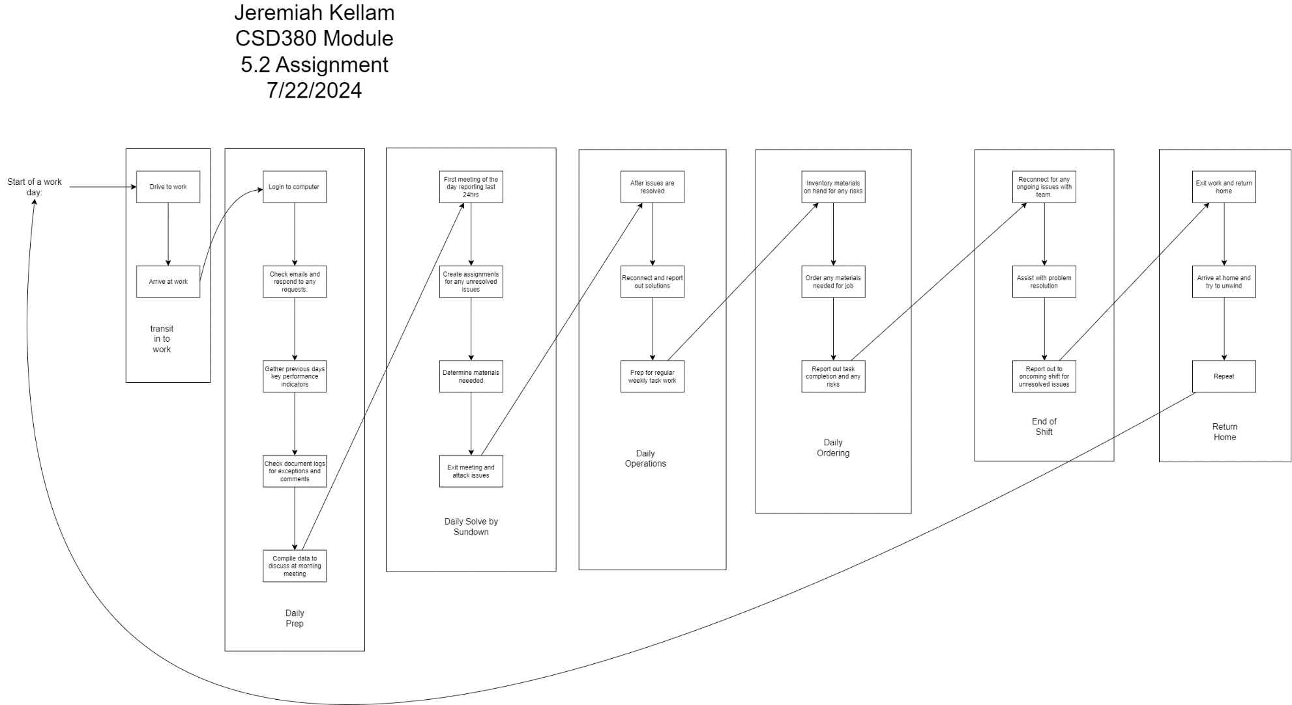

Transit to work = 45 min

Daily Prep = 2.5 hours

Daily Solve by Sundown = 1 hour

Daily Operations = 3 hours

Daily Ordering = 2 hours

End of shift = 1 hour

Return home = 1.5 hours

Total Cycle Time = 11.75 hours

Optimizations:

Transit to work can be reduced by having an earlier departure that will save 15 minutes but increase time at work.

Daily Prep can be reduced by delegating tasks to employees but will result it inadequate information and corrective actions needed.

Daily Solve by Sundown meeting can be short if template is followed, and no immediate reoccurring issues have not been resolved.

Daily Operations cannot be reduced as this is time spent doing production and job tasks for workflow.

Daily Ordering can only be reduced if prep work is done to know current inventory on hand before starting process.

End of shift can be improved if more training occurs where there is more accountability and expectations on other shifts to handle situations properly.

Return home can be reduced by leaving before or after rush hour. There is nothing to be done about traffic, only departure time.